Myroslav I. Zhaldak
Yuriy V. Goroshko
Evgeniy F. Vinnychenko
Ganna Y. Tsybko

MATHEMATICS
with a computer

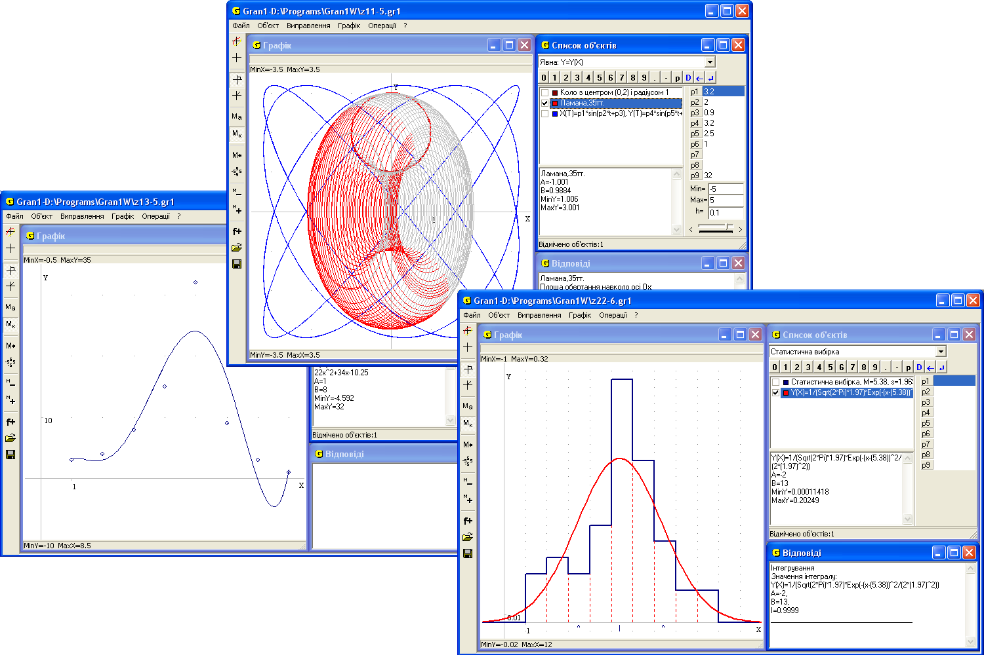
M. I. Zhaldak, Y. V. Goroshko, E. F. Vinnychenko, G.Y. Tsybko

Mathematics
with a computer

The teacher's guide
Translated from Ukrainian

Third Edition, supplemented

Approved by decision of the Scientific Council
of the National Dragomanov Pedagogical University

Kyiv, National Dragomanov Pedagogical University, 2016
ББК

УДК 681.31-181.48:51(075)

Approved by decision of the Scientific Council
of the National Dragomanov Pedagogical University
(protocol №7 of 24 February 2015)

Reviewers: Prof. V.I.Klochko;
Prof. S.O.Semerikov;
Prof. Y.V.Tryus.

The manual deals with the possibility of using computer to support teaching of mathematics in secondary schools. Numerous examples demonstrate solving of various problems in algebra and elementary analysis, geometry, stochastic items that are reduced to finding solutions of equations and inequalities and their systems, research of functions, calculation of definite integrals, statistical processing of experimental data and others with the use of computer. The manual is intended for teachers of mathematics and computer science. It may be also useful to students of senior classes, vocational education, students of teacher training colleges and junior courses of higher education institutions, where they learn mathematics.
Preface
Modern means of search, collection, storage, processing, presentation and transfer of various messages are being actively applied in modern process of study. It opens wide perspectives for humanitarian education and human teaching, promotes deepening and widening of theoretical basic for knowledge, provides practical significance for study results, makes conditions for opening a creative potential of children, taking into account their age features and experience, individual queries and abilities.
At the same time there arise a lot of problems dealing with the content, methods, organization forms and means of study, necessary knowledge levels in various subjects for every pupil.
In this book the authors have a purpose to open up some aspects of use of modern information technologies in the process of study of mathematics in the secondary schools of various profiles.
Therewith teacher is not forced to use any concrete method of presentation, knowledge fixing and control, any certain content, methods, organization forms and means of study, adhere to certain balance between pupils’ self-study and group work etc. Teacher should determine all these aspects according with his own preferences, with specific conditions of work, with individual features of pupils and of whole class.
It’s clear that it’s impossible and unnecessary to teach all the children equally, to form equal knowledge in various subjects for all the children, to claim reaching equal level of logical and creative mentality development, equal perception of reality. It also relates to teaching mathematics, methods of problems solving, plotting and analysis of mathematical models for various processes and phenomena, results interpretation and generalization of results of this analysis.
Nowadays there designed a lot of specialized mathematical software products. These are applications like Derive, Gran1, Gran-2D, Gran-3D, DG, Maple, Mathematika, MathLab, Maxima, Numeri, Reduce, Statgraph and others. Some of them are oriented on mathematicians with high qualification. Others are intended for pupils or students, who have started to study school mathematics or Higher Mathematics recently.
The most suitable applications for supporting of teaching mathematics in secondary school are the software set Gran (Gran1, Gran-2D, Gran-3D) and Derive. These applications are simple in use, they are provided with convenient and “friendly” graphical interface (like an interface of text processors, database management systems, spreadsheets, graphical and music processors etc) and help system. It isn’t necessary for user to have a special knowledge in computer science, electronics and programming, except the simplest notions, which are simple for secondary school pupils.
Usage of such programs gives for a pupil an opportunity to solve separate problems without knowing an analytical basis, methods and formulas, rules of expressions transforming etc. For example, a pupil can solve equations, inequalities and sets of them, without knowing any formulas for finding the roots, method of variable excluding, interval method etc. He can calculate derivatives and integrals without remembering any their tables. He can explore functions without knowing algorithms of their investigation. He can find optimal decisions for problems of linear and non-linear programming without use of simplex method and gradient methods etc. At the same time owing to possibilities of graphical support for computer-aided problem solving a pupil will solve quite difficult problems precise, easy and confidently. Use of such programs often gives an opportunity to make a process of solving as easy as simple looking at pictures or graphical images. Usage of corresponding software transforms some chapters and methods of mathematics into the “mathematics for all”, which becomes easy and clear for use. The person, who solves a problem, becomes a user of mathematical methods, perhaps without being familiar with their structure and justification. It is similar to how he uses other computer programs (text, graphical and music processors, spreadsheets, databases, operation systems, expert systems) without knowing how they are plotted, which programming languages they are written, what theory they are based on.
From the other hand such approach to teaching mathematics gives visual introduction to the notions that are being studied, develops creative thinking, spatial imagination, allows to understand an essence of investigated phenomenon, to solve a problem by informal way. In this case the most important is elucidation of a problem, formulation of a task, working out of corresponding mathematical model, material interpretation of the results obtained with the help of a computer. All operations concerned with processing of a mathematical model, realization of solving method, data presentation are shifted to the computer.
Programs of this type are very important in the deep study of mathematics as well. The use of such software gives to a researcher the following significant opportunities: numeric experiment, fast calculations and plotting of graphs, checking of hypotheses, choice of solving method, elucidation of limitations of opportunities of use of computer or bounds of the mathematical method that has been selected for solving a problem.
The foregoing shows that the content and structure of training activity of pupils can change depending on scientific branch, direction of instruction, individual inclinations and abilities. Computer based support of teaching mathematics by use the mentioned type of software gives a significant pedagogical effect. It makes learning and understanding of mathematical methods in the secondary educational establishments of various profiles easier, wider and deeper.
It should be noted that the mentioned software can be used in all the mathematical classes, from the fifth-sixth forms, particularly in the process of study coordinate system on a line and on a plane, notion of function, elementary functions and their features, methods of solving equations, inequalities and sets of them, elements of limits theory, differential and integral evaluation and their applications, elements of mathematical statistics and the theory of probability. It’s clear that teacher can use not only mentioned software, but various types of training programs, knowledge control programs, statistic programs etc. The use of such software allows a teacher to communicate with pupils more effective, to put more attention to such kinds of problems as proofs, formulation of a problem, construction of mathematical model for a problem, finding and investigation of a solving method, examination of results, logical analysis of problem conditions, search of creative approach to solving, finding of regularities in processes and phenomena. It gives a possibility to shift on the computer all the routine, technical operations, that are non-interest for the children and don’t develop their intelligence.
Therewith the usage of computer in educational process should be pedagogically balanced, built on the principles of harmonious combination of educational achievements of the past and modern information and communication technologies
The mathematical lessons, which are oriented to use of mentioned types of educational software, must be carried out in classes with special high level hardware and software. Such classes must be intended for the study of various subjects, not only the principles of computer science. This will be directed to widening of inter-subject relations, integration and mutual influence of different training courses. This will give an opportunity to learn elements of modern information technologies and information culture in the process of study various subjects, not only the separate training course “The principals of informatics and computer engineering”.
In this book the software product GRAN1 is considered in detail in correspondence with the program of mathematical course for the school. This product is intended for a solving of separate types of problems by graphical methods. It can be classified as a solver.
In the book there described the rules of work with software product GRAN1, which had been created to support teaching mathematics in a school. The use of GRAN1 in the study of various mathematical subjects in the secondary educational establishments of various levels is analyzed.
All the paragraphs of the book are accompanied by the number of examples, visual graphic images, problems and exercises for self-execution, questions for self-control.
It is supposed, that the user has simple habits of work with a computer, which is specially fitted out and uses an operating system Windows or Linux.

§1. Start of working with the program.
Use of services of the program
The software product GRAN1 is intended for graphic analysis of functions. The name of the program comes from “GRaphic ANalysis”.
For use the program GRAN1 it is necessary to install it on a disk. Two files are necessary for program working: gran1.exe and gran1.lng (the full size is about 1M). The help files gran1.hlp and gran1.cnt (the full size is about 1M) are also desirable.
Further the terms “to indicate a file name”, “to select an option” will mean “to set the pointer of file names or options (using arrow keys or the mouse) on a necessary name and to press “Enter” or the left mouse button.
After the program start, one can see the image on the screen like in the figure 1.1. In the upper line of the screen the “main menu” is placed. This is a list of commands, which can be used if necessary. After selection of an option the corresponding sub-menu appears (Fig 1.2).
In the commands of a sub-menu may be present corresponding subordinate items lists.
To define a subordinate item of a command we will use a single command, where the names of commands and subordinate items are separated by the symbol “/”, e.g. “Object / Delete”.
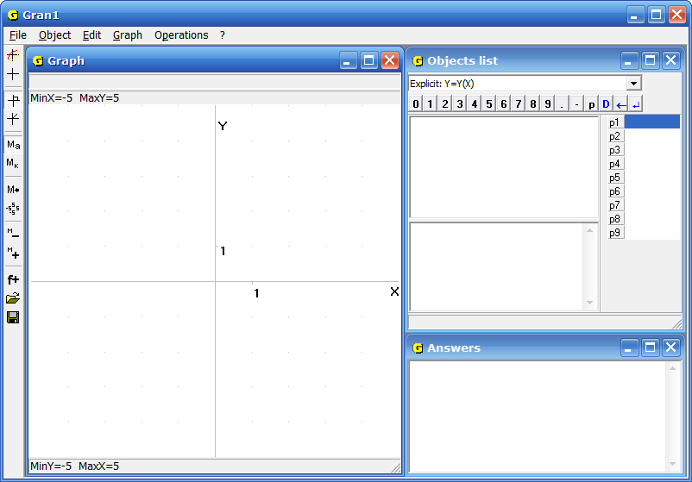
Fig. 1.1
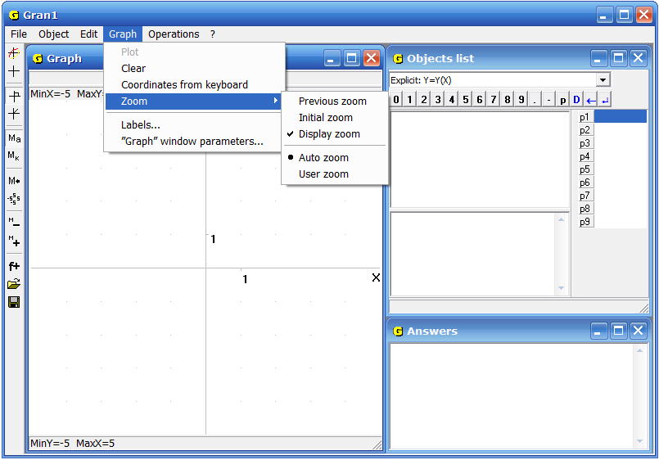
Fig. 1.2
The names of the commands that are out of use at the moment are represented by paler color. For example, use of the commands “Object / Modify”, “Object / Delete” at the beginning of working is incorrect, because we haven't entered data and there is nothing to change or delete.
The program is supplied with a help system. If a command is highlighted and “F1” is pressed, a help window with standard interface is being displayed. In this window one can see short messages about the command, and rules of its usage (Figure 1.3). To open help window one can also select the command “? / Help” from the main menu.
At the very beginning of work with the program it is necessary to set some parameters by choosing the command “Edit / Program setup...” Here it is possible to choose the interface language and the accuracy of calculations – the quantity of decimal digits in numbers, which changes from 0 to 6 (Fig. 1.4).
To use services of the program (without choosing of commands and subordinate items of the menu) one can apply the functional keys or key combinations.
The correspondence between separate functional keys and key combinations and the menu commands is shown in sub-menus of the main menu.
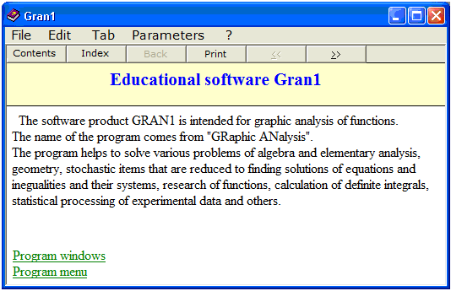
Fig. 1.3
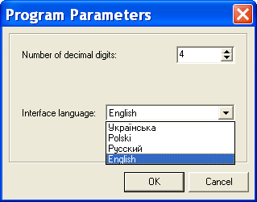
Fig. 1.4
To refuse a command and return to main menu the key “Ecs” is used. For the same purpose it is possible to use the button for close the auxiliary window or the button "Cancel" (Fig. 1.4).
Execution of the command "Edit / Copy" depends on the current window. If the current window is "Graph", the image of coordinate plane together with the graphs is copied to the clipboard. If the current window is "Objects list", the selected text from the window is copied to the clipboard. If no text had been selected, the name of the current object is copied to the clipboard. If the current window is "Answers", the text selected in the window is copied to the clipboard.
If the command "Edit / Copy current window" is used, the full image of the current program window is written to the clipboard.
To save the object created with the use of the program, it is necessary to use the command “File / Save” or “File / Save as…” If the objects are saved at first time with the use of any of these commands, a standard saving dialog box is displayed, where it is necessary to enter a file name and to choose a folder. If the file has been saving previously, the use of the command “File / Save” overwrites all the objects in the same file.
If it is necessary to save new objects or rewrite existing ones in a file with another name, the command “File / Save as…” is used.
The files are saved with the default extension “.gr1”. It corresponds to the name of the program”GRAN1”.
The file can be loaded into the program by the command “File / Open”. It is necessary to enter the file name in the standard opening dialog box. The name of a current file is displayed in the heading of the main program window.
Use of the main menu command “File / New” implements deleting of all the objects created before, i.e. prepares the program for a new stage of work.
The sizes and positions of program windows are changeable. To change window sizes, it is necessary to drag a window border in a certain direction. Besides it is important to mind the state of the command “Edit / Auto sizes of windows”. If the check-box is turned on, then size changing of one window causes size changing of others so that all the windows occupy the whole work space. If the check-box is turned off, the windows can cross one another. To move a window into another place, it is necessary to drag its heading. The command “Edit / Initial sizes and position of windows” is intended for returning sizes and positions of all the windows in initial state.
To finish work with the program it is necessary to use the command “File / Exit” or press the button “Close” in the heading of the main window. If some created objects were not saved, there appears a message with warning about necessity of saving the data.
Questions for self-checking
- How many commands are there in the program main menu? What are their names?
- What and where will appear on the screen if user sets the pointer of menu on a certain command and presses “Enter”?
- How to use a command of a sub-menu?
- How many commands are there in the command “Operations”? What are their names?
- How to recognize whether the use of a command is correct at the moment?
- How to use the mouse in the process of working with the main menu?
- How to use the mouse in the process of working with the subordinate menus?
- How to find out about appointment of a command?
- How to refuse a chosen command?

§2. Data input
Before inputting expressions or tables with which one can characterize some dependence between variables, it is necessary to assign the type of dependence in the window “Objects list” (shown on the screen at the top to the right, figure 1.1, 2.1). To go over the window, one can use the mouse or the command “Object / Objects list”.
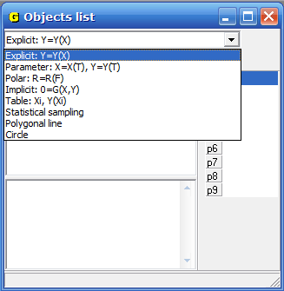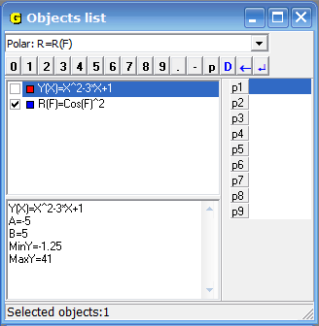
Fig. 2.1 Fig. 2.2
The window is divided into three parts (Fig. 2.1). At the top of the window there is a combo box with a list of eight possible dependence types:
- Explicit: is a dependence between the variables and defined as , where is some expression of variable (explicit dependence definition);
- Parameter: , is a dependence between the variables and defined through the parameter t : , , where , are some expressions of variable (parameter) t (parametric dependence definition);
- Polar: is a dependence defined in polar coordinates as , where is an expression of variable , is a polar radius of a point on a plane, is a polar corner. The relation between polar and corresponding rectangular coordinates and can be defined by use the formulas , ;
- Implicit: is a dependence between the variables and implicitly defined as , where is some expression of variables and (implicit dependence definition);
- Table: is a dependence defined tabular (in this case using the program one can construct and plot a polynomial of degree not higher than 7, to approximate a tabular dependence in the best way in the sense of mean square deviation);
- Statistical sample – a statistical sample is defined and explored;
- Polygonal line – a dependence between the variables and is defined with the help of polygonal line;
- Circle – a circle is defined.
It is possible to choose a dependence type by with the help of the mouse from the combo box or using arrow keys and “Tab” key.
The last chosen dependence type becomes fixed and all new inputted dependences will be of the same type until it will be changed. If no type is assigned, the default type is set as (Explicit)
All inputted dependencies can be of any type described above in any combinations.
In the other part of the window “Objects list” there is the list of the expressions of all inputted objects. The notions “current” and “marked” object are distinguished. The object is called “current” if the program’s pointer is set on it. The “marked” object is indicated by the check-box . One can switch the check-box with the help of the mouse or the space bar.
In the program one can see for every object its type and the color of corresponding dependence plot. In the figure 2.2 the first of two objects is current (it is described by the explicit dependence) and the second is marked (it is described by the polar dependence).
The majority of the operations with the objects (solving of systems of equation and inequalities, calculations of integrals, transformations of polygonal lines) deals with marked objects only. If no objects are marked, the operations execute with a current object.
One can change dependence by the command “Object / Modify”. In this case the equality of types of a new dependence and a changed one is being automatically controlled. A segment of definition can be changed as well. If it is necessary to change not only expression of the dependence, but also it's type, the previous dependence should be deleted. For this purpose the command “Object / Delete” is intended. Using this command one can delete all marked objects. With the help of the command “Object / Delete last” it is possible to delete the last object of the list, even if it is not marked.
In this part of the window the pop-up menu is available (Fig.2.3). The majority of its items coincide with the items of the command “Object” of the main menu. Also two additional items are available: “Select all” for marking all objects in the window and “Deselect” for switching off check-boxes on all objects.
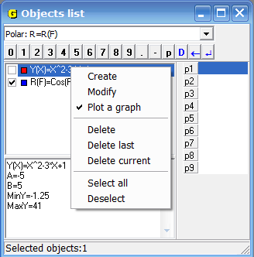
Fig. 2.3
Besides that with the item “Plot a graph” one can define whether the graph of the current object will be plotted. The graph is plotted, if the item is checked.
In the third part of the window a report about a current object is indicated. For example, for explicit dependence it is an expression, a segment, minimum and maximum function values in the segment etc (Fig.2.2).
One can review this report with the help of the scroll bars in the window or arrow keys. Since the report is presented in a text form, it can be selected and copied into the clipboard for further use in other applications.
The clipboard can be used with the help of the main menu (command “Edit”), pop-up menu or keyboard.
The following options are available:
- Cut. Text will be placed in the clipboard and removed from the window (the key combination CTRL+X).
- Copy. Text will be placed in the clipboard (the key combination CTRL+C).
- Paste. Text will be pasted from the clipboard (the key combination CTRL+V).
- Delete. Selected text will be removed (the “Del” key).
- Select all. All text in the window will be selected.
The clipboard can be also used for moving graphs created with the use of the program. For this it is necessary to go to the window “Graph” and make it current by click in any place of it. Then the image from the window can be placed in the clipboard by the command “Edit / Copy”.
In the fourth part of the window (on the right) there is a list of “dynamic parameters” and means of operating with them.
If one uses a command connected with data input / modification, the data input panel appears in the corresponding auxiliary window. There are two types of such panels.
The first type is used in necessity to input an expression, which contains numbers, variables, functions and arithmetical symbols (Fig.2.4). The corresponding commands are “Object / Create” (when a functional dependence is being created), “Operations / Calculator” etc.
The second type is used only for digital data input (Fig.2.5). The corresponding commands are “Object / Create” (for a statistical sampling or polygonal line), “Operations / Integrals / Integral” “Graph / “Graph” window properties” etc.
To use the data input panel the cursor must be placed in the data input line. The cursor can be moved by the mouse or Tab key.
The beginning of the data input line can be marked variously. It depends on inputted data type:
- – when entering an expression . A dependence is given explicitly;
- – when entering an expression , where the arguments are variables and ;
- , , , – when entering a user’s scale (limit values along the axes and , to display graphic images);
- , – when entering limits of a segment of definition a dependence;
- Expression: – when entering an expression, whose values should be calculated by the command “Operations / Calculator” etc.
Moreover in the input line may be present variables values or expressions, which are anticipated in the program or inputted before. If these values or expressions must not be changed, it is enough to press “Enter” or “OK” in the panel. As a result, the expression, the limits of the argument and some additional characteristics appear in the window “Objects list”(Fig. 2.2).
It is possible to input data using the keyboard and the mouse.
With the help of the keyboard all necessary symbols are inputted as usual – by typing. The numeric values and expressions are being written by the rules that are similar to the principles, stated in such programming languages as BASIC, Pascal etc. All available signs of functions and operations are indicated in the input data panel (Fig. 2.4).
When a numeric value is being written, the fractional part of the number is separated from the whole part with point. Arithmetical operations are defined as follows:
+ – addition,
– – subtraction,
* – multiplication,
/ – division,
^ – raising to power.
The priorities of the operations are general. Desirable order of operations execution can be indicated by brackets. Expression in brackets is considered
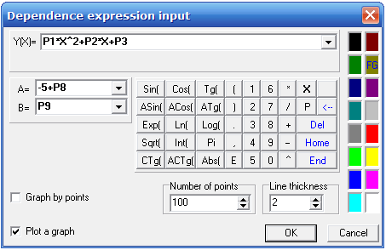
Fig. 2.4
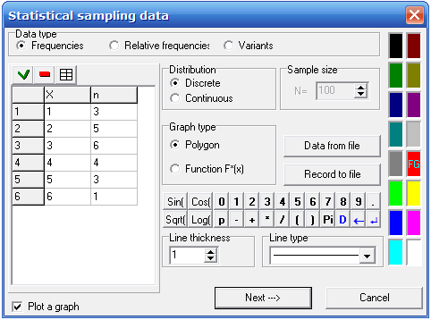
Fig. 2.5
as a single whole and should be calculated at first. In brackets there can be other expressions also given in brackets. Foe every left bracket must be a corresponding right bracket.
In expressions also can be present designations of some functions. All of them are indicated in the input data panel (Fig. 2.4).
Sin – sin (sine),
Cos – cos (cosine),
Tg – tg (tangent),
Ctg – ctg (cotangent),
Asin – arcsin (arc sine),
Acos – arccos (arc cosine),
Atg – arctg (arc tangent),
Actg – arcctg (arc cotangent),
Exp – exponent (),
Lоg – logarithm to any base
(base and argument of the logarithm are written in brackets by comma. For example, means ),
Ln – natural logarithm (to the base ),
Abs – modulus,
Int – integer part of the argument,
Sqrt – square root,
Pi – π (= 3.141592654).
On the panel also may be located some buttons, which correspond to cursor keys:
← – Back Space,
Del (D) – Delete,
Home – Home,
End – End,
↵ – Enter.
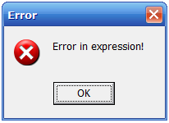
Fig. 2.6
In the case of mistake in one of the input lines the corresponding message will be displayed (Fig. 2.6). Then cursor should be moved to the line with the mistaken expression. This expression is to be corrected with the usual instruments of editing: Back Space, Delete; arrow keys. It should be noted that only insert mode exists in the program.
After inputting or editing an expression one must press Enter or corresponding button in the auxiliary window. It will mean that the expression is entered in the computer memory and corresponding object is ready for further operating (plotting of graph etc.).
During entering data with the help of the mouse and input panel one should click on a necessary symbol in the panel. As a result the symbol will be shown in the input line. After entering all symbols of expression it is necessary to click on the button Ok.”.
To edit an expression in the input line one needs to click on a necessary position in the line. To insert a symbol, it is necessary to click on it, to delete a symbol, it is necessary to click on item “←” or “Del” in the panel. To refuse a command or stop it one may click on the button “Cancel” or press Esc.
In expressions may be included some parameters: , , … , . Their values are shown in a table in the right side of the window “Objects list”. Every table row corresponds to one of dynamic parameters, which can be used in exercises when creating some object types. If no parameter is used, the table is empty (Fig.2.2). For parameters used at the moment in the corresponding table rows current values of the parameters are displayed (Fig.2.7). If a parameter is not used in objects, the corresponding row is empty.
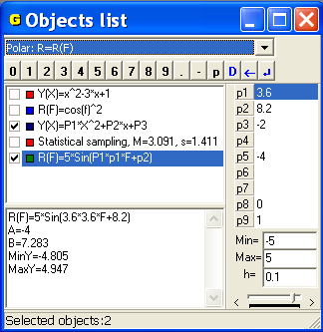
Fig. 2.7
A value of a marked parameter can be changed by scroll box in the bottom of the parameter window. If any graphs have been plotted, modification of a parameter value involves dynamic modification of the graphs. To determine limits and step of change of a parameter one can use the data input panel that is placed over the list of parameter values (Fig. 2.7). To mark one of nine parameters it is enough to click on corresponding row. The same parameter can be presented in several expressions. Changing of its value involves re-plotting of graphs that correspond to expressions with the parameter. To input a parameter into expression it is necessary to input the letter with the help of the input panel (Fig. 2.7) and then a corresponding digit (from 1 to 9).
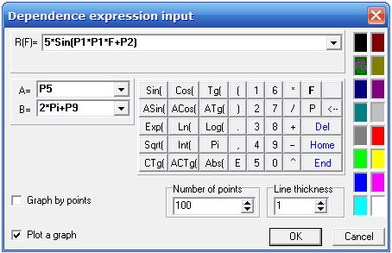
Fig. 2.8
In expressions of limits of segment of a dependence also can be used parameters , , … , (Fig. 2.8). But it should be remembered that the low limit must not exceed the high limit.

Questions for self-checking
- What types of dependencies between variables are available in the program Gran1?
- How to assign a necessary type of dependence between variables?
- What data is shown in the window “Objects list”?
- Is it possible to input an expression and later assign a type of dependence?
- What will be a dependence type if not to change or assign a type of dependence in the window “Objects list”?
- How to assign a type of dependence with the help of the mouse?
- Is it necessary for different dependencies to have the same type?
- How to check what expression has been entered? Where it is possible to read it?
- What designations of operations and functions are available during writing an expression? Where it is possible to see them?
- How the priorities of operations are determined?
- How to input data by the keyboard without using the data input panel?
- How to input data with the help of the data input panel?
- How to input parameters, , … , in expressions?
- How to modify entered expressions:
  - with the help of the keyboard?
  - without the help of the keyboard?
- Is it possible to consider that an expression has been entered in the computer memory, if it is typed and its image is shown in the input line?
- How to refuse a command or stop it?

§3. Coordinate plane.
Rectangular and polar coordinates
After loading of the program GRAN1 one can see a coordinate plane with coordinate dotted grid in the window “Graph”. On the X-axis and Y-axis scales are indicated (Fig.1.1 etc.). The scales can be modified by the command “Graph / Zoom / User zoom” (Fig. 3.1).
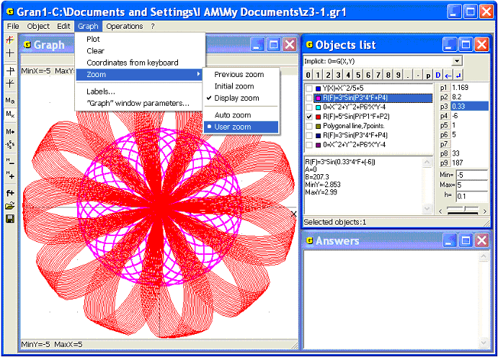
Fig. 3.1
In the case of use the command “Graph / Zoom” it is possible to choose one of two sub-items “Auto zoom” and “User zoom”.
In the mode “Auto zoom” the axes and are scaled automatically. The scales depend on the limits of variation of abscissa and ordinate in concrete graphs.
In the mode “User zoom” it is possible to set free limits along the axes for further plots. It is enough to choose the command and then in the window ”Graph” window properties”, tab “Zoom” (Fig.3.2) input minimum () and maximum () values of coordinates along the axis, and also minimum () and maximum () values of coordinates along the axis, that are desirable for plotting various images (graphs, histograms, polygonal lines etc). The zoom type can be also changed by the buttons on a tool bar at the left of the window “Graph”. The button “M_{a}” corresponds to the auto zoom mode, the button “M_{k}” – to the user’s zoom mode.
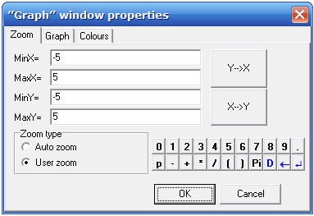
Fig. 3.2
Minimum and maximum coordinate values for two axes are also indicated in the window “Graph”, if the command “Graph / Zoom / Display zoom” is marked by the check-box (Fig. 1.1, Fig. 1.2 etc). The values and are shown in separate line in the top-left corner, the values and - in the bottom-left corner. Using the command “Graph / Zoom / Display zoom” one can switch zoom parameters displaying on / off. Presence of the check-box means the zoom display is on (Fig. 3.1).
It is possible to modify the zoom by the mouse if extend a part of the window “Graph” up to the whole window size. For this purpose one must indicate two opposite apexes of the rectangle that will contain a part of image to be extended, and drag the mouse cursor from one apex to another.
When the second apex of the rectangle is fixed, the part of the image in the window “Graph” is extended to the whole window size. At that the -axis and -axis zooms are being modified automatically. This operation is used in necessity to precise a part of a graph image, a certain point coordinates etc.
A part of the extended image can be extended, if necessary.
On the toolbar there are buttons “M₊” and “M₋“, intended for the zoom modification. Pressing the button “M₊” (Zoom in) allows to double the value of every zoom parameter, the button “M₋“( Zoom out) – to halve the value of every zoom parameter. Using the command “Graph / Zoom / Previous zoom” allows returning to previous zoom values. The button “M←” on the toolbar is intended for the same function.
The default zoom values are , , , (Fig.3.2). This is so-called “initial zoom”. It can be set by the command “Graph / Zoom / Initial zoom” or by the button of the toolbar.
It is also possible to display the auxiliary window ”Graph” window properties” by the command “Graph / ”Graph” window parameters”, since arrangement of the window parameters means not only setting of the zoom.
In the tab “Graph” (Fig. 3.3) one can see the following items:
- to display coordinate axes or not;
- to display coordinate grid or not;
- axes labeling (for solution of some problems the axes must be named not X and Y but another way);
- coordinate system type;
- font type and size for labeling of the axes.
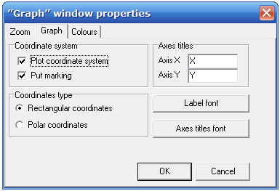
Fig. 3.3
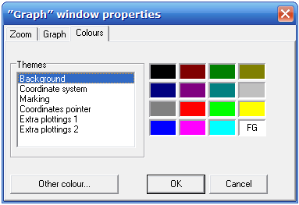
Fig. 3.4
The use of the tab “Colors” allows changing of the background color, the text color, the color of axes and other elements (Fig. 3.4). Chosen color has the mark “FG”.
In the rectangular coordinate system a point position on the plane is determined by its projections on the axis (abscissa) and on the axis (ordinate).
In the polar coordinate system a point position on the plane is determined by its distance from the origin of coordinates (polar radius) and angle between positive direction of polar axis (horizontal semi-axis, which comes out from the origin of coordinates and straights to the right) and a segment, which connects the point with the origin of coordinates. This angle (polar angle) is put from the polar axis anticlockwise and is changing from 0 to 2π.
To assign the desirable coordinate type one should set the check-box on the necessary item “Rectangular coordinates” or “Polar coordinates” on the tab “Graph” of auxiliary window ”Graph” window parameters”(Fig. 3.3). If the type “Polar coordinates” is chosen, there isn’t labeling of the axes, though it isn’t forbidden to plot the axes or coordinate grid.
It is also possible to assign the coordinate type by the tool bar buttons.
There are two ways of determination of a point coordinates, depending on using the mouse or the keyboard.
- To move the mouse cursor into the window “Graph”. In this case the cruciform cursor appears in the window. Its center coincides with the end of the mouse cursor. In the top-left corner of the window coordinates of a point under cursor are shown (Fig. 3.5). While the mouse cursor is located in the window “Graph”, it moves simultaneously with the cruciform cursor. If the mouse cursor moves out of the window, the cursor is fixed in the last position or disappears;
- To use the command “Graph” / Coordinates from keyboard”. In this case the window “Graph” becomes current. The cursor that is controlled by arrow keys becomes available. If the cursor reaches a window border, it automatically moves to the opposite border of the window.
This is the way to find coordinates of the preassigned point or set the cursor in the point with preassigned coordinates.
For the case of the rectangular coordinate system the window “Graph” is presented in the figure 3.5: the axes are displayed (if their displaying is turned on) and perpendiculars to the axes are plotted from the cursor (even if the axes aren't displayed). The coordinates and of the point marked by the cursor are displayed in the special row in the window “Graph” (on the left top). In the Fig.3.5 , .

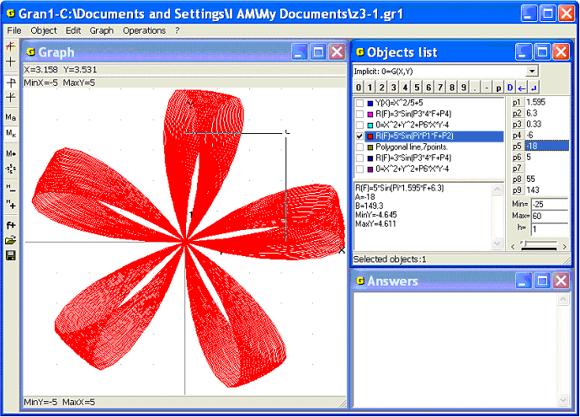
Fig. 3.5
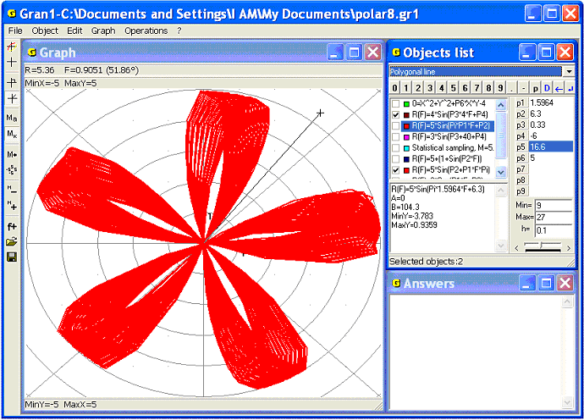
Fig. 3.6
In the case of the polar coordinate system the window “Graph” is different: the cursor is linked with the origin of coordinates by the segment, in the coordinate row the polar coordinates of the point are displayed: polar radius (designated in the program as ) and polar angle in radians and degrees, designated as (Fig.3.6). In the Fig.3.6 , .
It is possible to pass from the polar coordinates to the rectangular and vice versa using the following formulae:
; ; ; .
The use the program GRAN1 makes the corresponding calculations unnecessary.

Questions for self-checking
- How to set the zoom along the axes and ?
- How to change the zoom of measurement of the polar angle?
- Is it possible do not display the axes? How to change the names of the axes?
- How to change the colours of the background, the axes, the text?
- How to determine the rectangular or polar coordinates of a point?
- How to set the cursor in a point with certain coordinates?
- How to find the polar coordinates of a point if its rectangular coordinates are preassigned? How to find the rectangular coordinates if the polar coordinates are preassigned?
- Could the polar angle take the following values -2? 4? 2?
§4. Polygonal line. Length of a polygonal line
To plot a polygonal line it is necessary at first to assign the type of dependence between the variables and as “Polygonal line”. For this it is enough to set the corresponding type in the window “Objects list” (Fig.4.1).
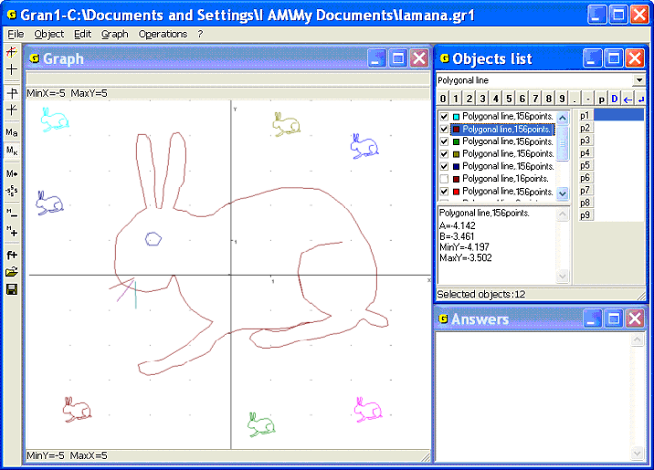
Fig. 4.1
Then it is necessary to use the command “Object / Create” or to press the button “f+” on the tool bar. As a result the window “Polygonal line vertex coordinates” will be displayed (Fig.4.2).
For entering vertices of a polygonal line it is possible to use the keyboard, the mouse or to read coordinates of vertices from a text file.
For entering coordinates of vertices of a polygonal line by the keyboard the table of entering is used. The coordinates should be entered by pairs: the abscissa in the column X, the ordinate in the column Y. To enter coordinates of the next vertex one may press Enter or use the arrow keys. The ordinal numbers of the vertices are displayed in the table at the left. The whole quantity of the vertices must be less than 10000. At the left top over the table one can see three buttons:
- The button is used when a new vertex should be pasted between the vertices that had been entered previously. For this purpose one should move the cursor in the position after the line where the new coordinates should be pasted, and press the button . As a result there appears a pair of new empty cells for writing new coordinates;
- The button is used for deleting a vertex entered before. For this purpose one should move the cursor in a corresponding row of the table and press the button . The row will be deleted and all the next rows will move up;
- The button is used to clear the whole table.
After entering coordinates of the polygonal line vertices one should set the polygonal line colour by moving the pointer “FG” (Fig.4.2) in the corresponding position. After pressing “OK” the new object of the type “Polygonal line” will be formed. Its name will be indicated in the window “Object list” in the form “Polygonal line,165 points” (Fig.4.3). The number of polygonal line pieces is also shown.
If the switch “Locked polygonal line” is turned on (Fig. 4.2), the locked polygonal line with linked first and last vertices is created. Otherwise the polygonal line is not locked. If to assign the polygonal line of two points, a segment that links them will be created.
Vertices of the polygonal line can be entered from the screen by the mouse. For this it is necessary to press a button “Data from screen” in the window “Polygonal line vertices coordinates” (Fig.4.2). As a result the window “Graph” is displayed in a different way (Fig.4.3).
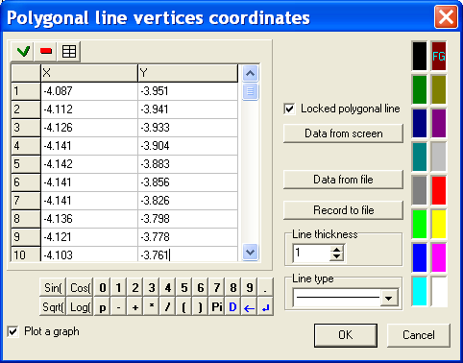
Fig. 4.2
It differs from the standard by the button “OK” in the top right corner. For entering vertices of the polygonal line one should alternately move the cursor to necessary points, clicking each time. Every vertex is marked by the small cross and the vertex number near it. After fixing a cursor in every vertex a set of polygonal line vertices will be obtained (Fig.4.3). After entering the last vertex it is necessary to press “OK” at the right top of the window “Graph”.
After pressing “OK” the numbers and coordinates of vertices are shown in the table in the auxiliary window “Polygonal line vertices coordinates” (Fig.4.2, Fig.4.3). If necessary, the coordinates can be modified, it is possible to add rows (by the button ) or delete rows (by the button ). To finish creation of the object one should press “OK” in the window “Polygonal line vertices coordinates”. Then it is possible to operate with the object as it is provided in the program: plot graphs, modify the object etc.
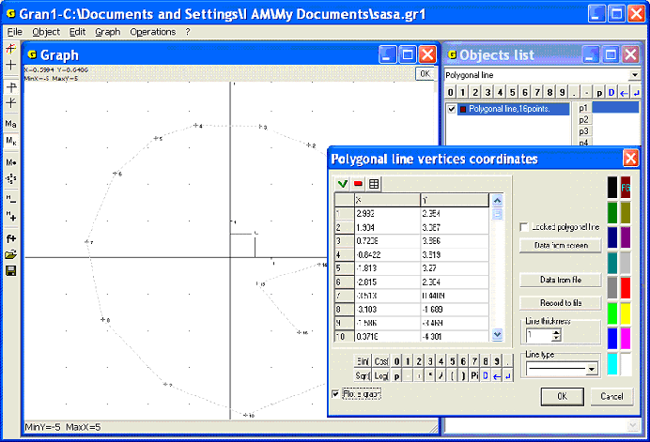
Fig. 4.3
When it is necessary to insert new points in the list, one should choose the command “Object / Modify”, then in the window “Polygonal line vertices coordinates” indicate the row before which a new row will be inserted (by click). Then one should press the button . As a result the number of indicated row and all next rows will be increased by a one, and empty row will appear at the place of the indicated row. The coordinates of the new point can be inputted in the new row.
If a row is to be deleted, one should indicate it and then press the button . As a result the row is deleted and the numbers of all next rows are decreased by a one.
Modification of a polygonal line can be also executed “from the screen”. For this purpose one should choose the command “Object / Modify”, then in the auxiliary window “Polygonal line vertices coordinates” use the command “Data from screen” (Fig.4.2, Fig.4.3). As a result the auxiliary window “Graph” with the vertices of the polygonal line will be displayed (Fig. 4.4). Then one should set the cursor on the required point (it will be included in a square frame) and open the pop-up menu.
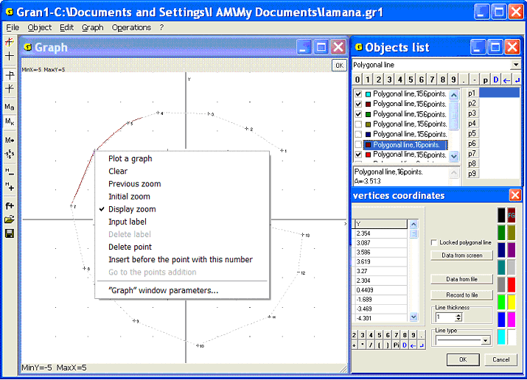
Fig. 4.4
After that one should use the command “Paste” before the point with this number (for inserting new points) or the command “Delete point” (if the point should be deleted). It is possible to insert several points before the indicated point. At that the numbers of next points are increased by a one. At the deleting of a point the next points numbers are decreased by a one.
It is also possible to move points on the screen. For this one should use the option “Object / Modify”, set a cursor on the required point and drag it in required direction. As a result the point will be moved into new place (Fig.4.5). The initial and modified polygonal lines are represented in the window “Graph” by different colors. After pressing “OK” the coordinates of the shifted points undergo the relevant modification.
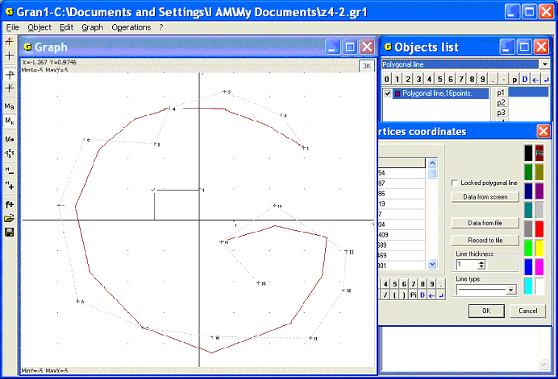
Fig. 4.5
Coordinates of the polygonal line vertices can be also inputted from a disk file. It can be done with the help of the button “Data from file” in the auxiliary window “Polygonal line vertices coordinates” (Fig.4.2). In this case standard auxiliary window for entering the required file is displayed (Fig. 4.6).
The data file is an ordinary text file. Its lines contain pairs of coordinates of vertices of the polygonal line. The file can be created in any text editor. If the polygonal line is created by the foregoing ways, its coordinates can be written to the text file by the button “Write to file” in the auxiliary window “Polygonal line vertices coordinates” (Fig.4.2, Fig.4.3).
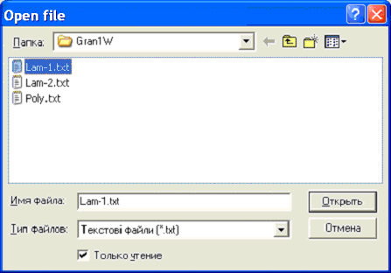
Fig. 4.6
After inputting all the polygonal line vertices one may obtain its graphical image by the command “Graph / Plot”. In the window “Graph” only images of the objects marked by check-box will be plotted (Fig.4.2). The button is also intended for graphs plotting.
If there are several objects in the window, it is possible mark or unmark all the objects by the pop-up menu (Fig.4.7).
For removing of the graphs it is possible to use the command “Graph / Clear” or button of the tool bar. For restoring deleted graphs the command “Graph / Plot” is used.
To compute the length of the polygonal line or of its piece the command “Operations / Polygonal lines processing / Polygonal line length…” can be used (Fig.4.8). By this command the auxiliary window for inputting numbers of vertices of the polygonal line is displayed (Fig. 4.9). To compute the length of the polygonal line part one should indicate the first vertex number “N1=” and the last vertex number “N2=” of the polygonal line piece in this window. However the vertex number should not be less than 1 or more than quantity of the polygonal line vertices.
If the polygonal line is locked, then bypass of vertices becomes cyclic, i.e. the max vertex number is followed by number one etc. When the length of a piece of the locked polygonal line should be calculated, the vertices will be scanned by a circle from maximum number to minimum. This allows calculate the length of any piece of the locked polygonal line without changing a direction of its contour rounding. To calculate the whole polygonal line length one should indicate the same number for the first and the last vertices.
For unlocked polygonal line the first vertex number should be less than the last one. If numbers of the vertices vertex are assigned incorrectly the error message “Incorrect vertex numbers” is displayed. After that one should repeat data input.
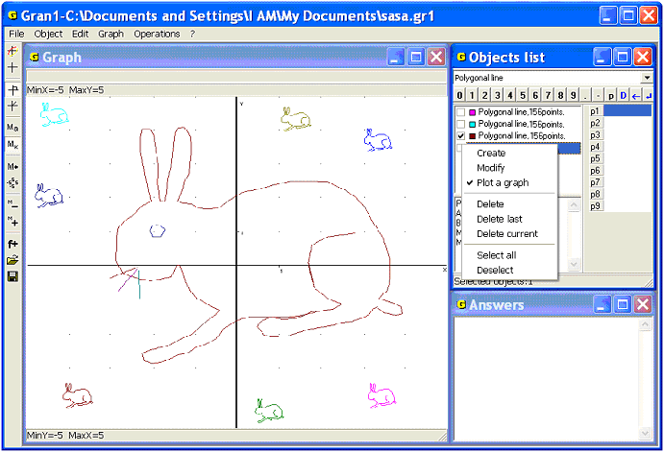
Fig. 4.7
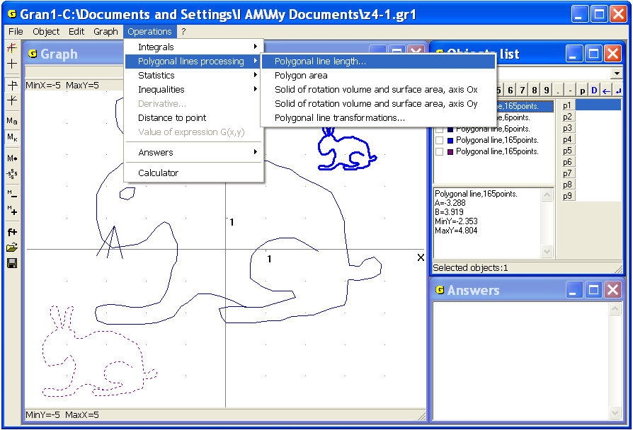
Fig. 4.8

After correct vertex numbers input the declared piece is painted by the color selected in the item “Extra 1” of the tab “Colors” in the window ”Graph” window properties” (Fig.3.4). In the window “Answers” the new message with the text “Polygonal line length”, numbers of the piece vertices and piece length is displayed (Fig. 4.10). To move to the window one can use the mouse or the command “Operations /Answers /Answers review” (Fig.4.11).
The messages in the window “Answers” are the ordinary texts, thus it is possible to select the whole text or its part and move it to the clipboard for use in other applications.

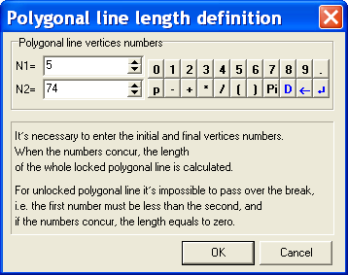
Fig. 4.9
The command “Object / Modify” can be used for changing a polygonal line created before. As a result the window of input vertices of the polygonal line will be displayed (Fig.4.2). In this case the pointer in the window “Objects list” should be set on the object of the “Polygonal line” type. The coordinates of the vertices of current polygonal line will be entered in the coordinate table. One can edit the coordinates of any vertex, delete separate vertices by removing corresponding rows from the table, or add new vertices between existing ones according to the fore-said rules.

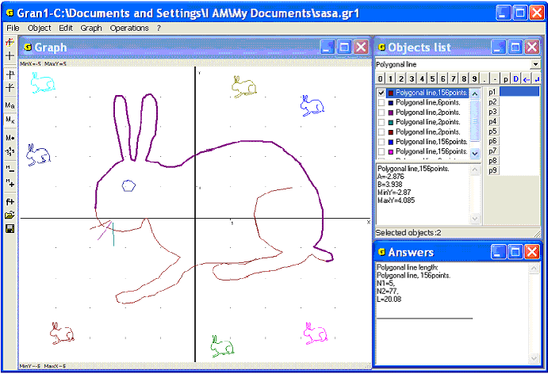
Fig. 4.10
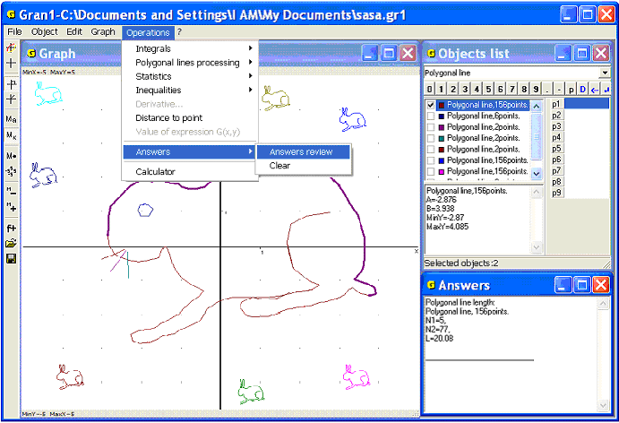
Fig. 4.11

Questions for self-checking
- What type of dependence between the coordinates and should be declared before input a set of vertices of a polygonal line?
- How many vertices can be in the table of coordinates of vertices of a polygonal line?
- How to assign whether the polygonal line is locked or unlocked?
- How to denote whether entering of the polygonal line is finished?
- How to define the number of vertices of the polygonal line?
- How to calculate the length of a piece of the polygonal line?
- How to calculate the perimeter of a polygon represented by a polygonal line?
- How to calculate the length of a polygon segment between vertices assigned as the first and the last one?
- How to input a table from a file created before?
- How to input a table from the screen?
- How to edit a table?
- What result will be obtained when to declare a polygonal line as a locked one, if it was declared before as unlocked one (and vice versa)? The table stays unchangeable.
- How to plot only several polygonal lines labeled in the window “Objects list”?
- How to assign the polygonal lines for plotting?
- How to calculate the distance between two points using operations with the polygonal line?
Exercises for self-fulfillment
- Input polygonal lines from preassigned files and determine the number of vertices and the length of each polygonal line.
- Input a polygonal line with 10 vertices from the screen, then use the command “Object / Modify” to insert 2 vertices between 3rd and 4th and between 7th and 8th ones. Don’t input existing vertices again.
- Plot graphs of the 1st and the 3rd polygonal line, if there exist 5 different polygonal lines.
- Input 4 different polygonal lines from the screen such that their graphs are of the shape of the word ”PLOT”.
- The triangle is defined by the vertices coordinates (0, 0), (3, 4), (4, 2). Plot the triangle on the screen and calculate the length of each side and the perimeter of the triangle.
- Input a locked polygonal line with 20 or more vertices from the screen. Calculate the length of the polygonal line.
§5. Transformations of a polygonal line
To execute some operations with polygonal lines one can use the command “Operations / Polygonal lines processing / Polygonal line transformations…” (Fig. 5.1). The current object of the type “Polygonal line” undergoes processing. When the command is used, the auxiliary window with 3 tabs: “Deformation”, “Turn”, “Parallel transfer” is displayed.
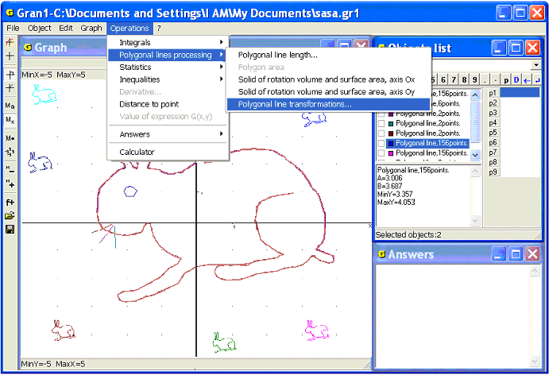
Fig. 5.1
To execute deformation of a polygonal line one should enter the coefficients of deformation: along the axis and along the axis . For input of the data it is possible to use the keyboard or the data input panel. To finish inputting one should press “OK”. The new object is a polygonal line where vertex coordinates are multiplied by and coordinates are multiplied by . It doesn’t matters whether the graph of the current polygonal line is plotted in the window “Graph”.
If , , there will be obtained the figure symmetrical to the current one about the axis . If , the figures will be symmetrical about the axis ; if , , the figures will be symmetrical about the origin. If , there will be obtained the figure similar to the initial one (Fig. 5.3).
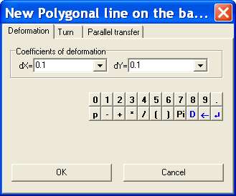
Fig. 5.2
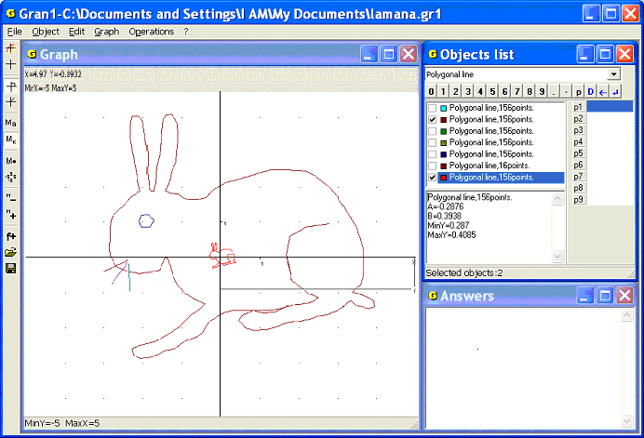
Fig. 5.3
For turning a polygonal line one should use the tab “Turn” and specify a value of rotation angle around the origin (Fig. 5.4). The value of the angle can be input with the help of the keyboard, the data input panel or the screen. A new object (turned polygonal line) will be created after pressing “OK”.
In this case for the marked polygonal line the coordinate system makes clockwise rotation on the angle and the polygonal line itself rotates anticlockwise on the angle around the origin.

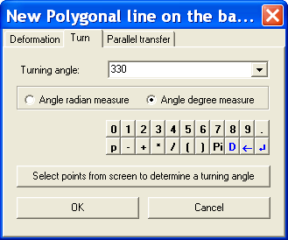
Fig. 5.4
To enter the rotation angle from the keyboard one should use the corresponding input line. The radian measure of the angle is default; the degree measure can be used as well. It is possible to use the mouse or arrow keys for choosing the measure (Fig.5.4).
If coordinates x,y of a vertex are represented by its polar coordinates:
,
then after turning of the coordinate system on the angle the new coordinates of the same vertex will be as follows:
, ,
that is the new coordinates can be expressed through the initial in the following way:
Similarly, to express the initial coordinates of a vertex through its new coordinates , it is enough to turn new coordinate system on the angle . If the angle between radius-vector of the point and the axis equals , then and after the coordinate system turning on the angle (on the angle clockwise) there will be obtained:
The foregoing formulas are used for calculating coordinates of vertices of the transformed polygonal line on the base of coordinates of the vertices of initial polygonal line. Thus the new polygonal line is obtained as the result of turn of the initial polygonal line on the angle around the origin of the coordinate system. In the figure 5.5 the results of turns of the polygonal line on the different angles are shown.
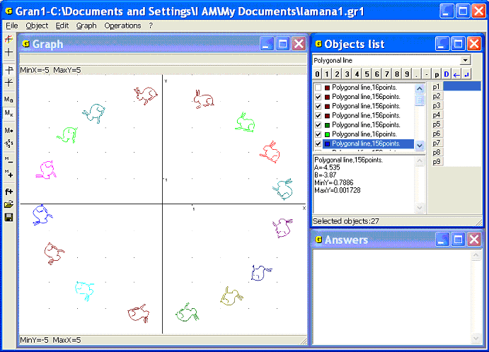
Fig. 5.5
The angle of turning can be inputted with the help of the button “Select points from screen to determine a turning angle” (Fig. 5.4). Using this command one can output the coordinate cursor that is linked with the origin by a segment, and the marking of the polar coordinate system. Setting the cursor in two different points on the plane in series makes it possible to determine the angle between the radius-vectors of the points. That angle is the angle of the figure turning around the origin (Fig. 5.6). The choice of the points is realized the same way as vertices of a polygonal line are inputted from the screen, i.e. two points are indicated and after that the button “OK” in the window «Graph» is pressed (Fig. 5.6).

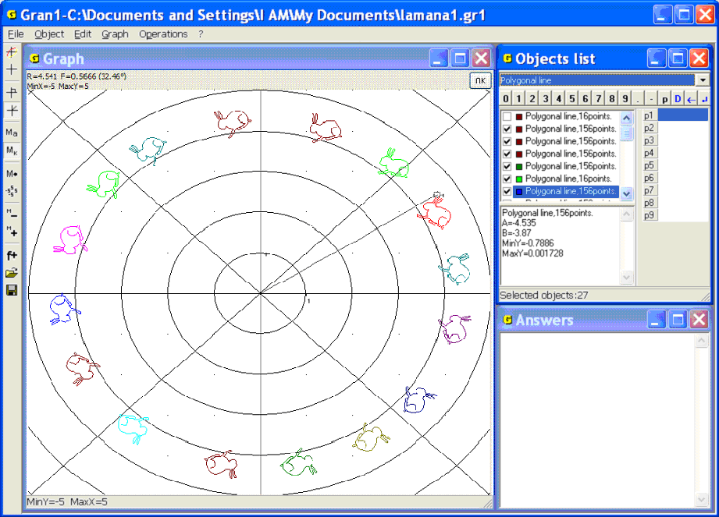
Fig. 5.6
In this case in the top left corner of the window «Graph» the polar coordinates (polar radius and polar angle) of the points 1 and 2 are indicated. After assignment of the points 1 and 2 one should press “OK” in the top right corner of the window «Graph» to display the auxiliary window “New Polygonal line on the basis of the existing one”. In the line “Turning angle” of the window the turning angle of the polygonal line is shown. The angle is obtained as difference between the polar angles of the points 2 and 1 (Fig. 5.4). The turning angle can be edited if necessary. Then one should press “OK” in the auxiliary window. As a result a new object will be created – new polygonal line on the basis of the one marked before. The image of the object will be plotted as well.
In the case of three indicated points the first point disappears and the second one is renumbered as the first and the third is considered as the second point. If there indicated less than two points, the message “It is necessary to select 2 points” is displayed.
In the tab “Parallel transfer” one should input coordinates of the start and the final points of the transfer vector. In the entry field “Vector start point” one should input the start coordinates of a point, and in the entry field “Vector final point” – the new coordinates of the point where the point should be moved (Fig. 5.7). After pressing “OK” the new polygonal line will be obtained (Fig. 5.8). All the vertices of the polygonal line are obtained from the vertices of the initial polygonal line by adding the increments to the abscissas and to the ordinates.
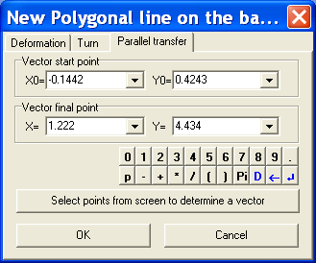
Fig. 5.7
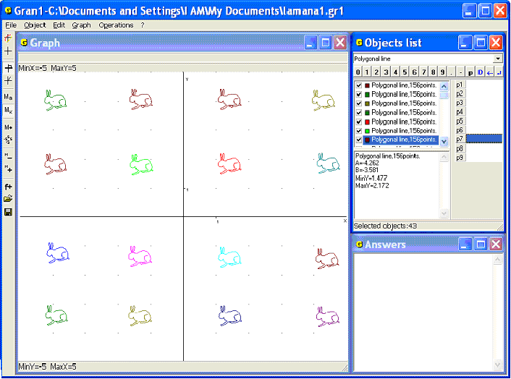
Fig. 5.8

After pressing the button “Select points from screen to determine a vector” it is possible to choose the start and the final points of the vector the same way as determination of the turning angle. One can assign only start point of the vector, the final point can be input with the help of the keyboard or the data input panel.
Some polygonal lines obtained as a result of parallel transfer of one of them on different vectors are shown in the Fig. 5.8.
It should be kept in mind that the initial polygonal line stays unchangeable and a transformed one is placed in the end of the objects list. The object color is set automatically.

Questions for self-checking
- What transformations of a polygonal line can be executed with the help of GRAN1?
- How to assign the polygonal line that should be transformed?
- How to get the polygonal line symmetrical to the initial one about:
the axis? the axis? the origin of coordinates?
- How to get the figure similar to the given one?
- How to execute parallel transfer of a polygonal line using the keyboard for data input?
- Is it possible to save a transformed polygonal line as a particular object?
- How to specify an angle for turn of a polygonal line?
- Is it possible to indicate a negative turning angle?
- Is it possible to indicate a similarity factor, a turning angle or a transfer vector without keyboard?
- How to turn a polygonal line around an arbitrary point of the coordinate plane with the help of GRAN1?

Exercises for self-fulfillment
- Plot a segment to join two arbitrary points on the screen.
- Turn the segment obtained as the result of ex.1:
- on the angle ,
- on the angle .
- On the base of the segments obtained as the result of ex.1, 2 plot two parallelograms by means of parallel transfer.
- Plot an arbitrary polygonal line, then execute the following operations of its deformation with the coefficients: ; ; ; ; ; ; .
- Plot a triangle with vertices (1, 1), (1, 4), (3, 2). Plot triangles on the base of the given one: by turning on around the vertex (1,1); by turning on around the vertex (1, 4); by turning on around the vertex (3, 2); by turning on around the origin; by deformation with the coefficients: ; ; ; .
§6. Polygon area. Polygon angles
If it is necessary to calculate area of a polygon bounded by a locked polygonal line (without self-intersections, quantity of vertices no more than 10000), it is possible to use the command “Operations / Polygonal lines processing / Polygon area” (Fig. 6.1). Previously one should mark the corresponding sign in the window “Objects list”. If no polygonal line is marked, the area is being calculated for the current object (if the object is a closed polygonal line). When the area is being calculated the message with data about the polygonal line and polygon area is displayed in the window “Answers” (Fig. 6.2). When the polygon is plotted in the window «Graph», it is being shaded.
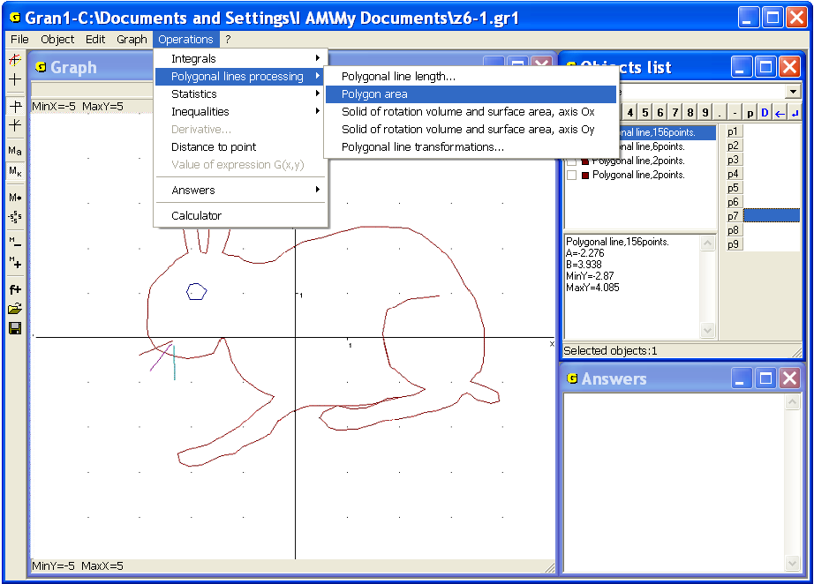
Fig. 6.1
If in the window “Objects list” several polygonal lines are marked, the program calculates the area of every polygon and adds the results. In the window “Answers” one can see the report about all polygonal lines and sum of their areas (Fig. 6.3). If polygons are intersected their common areas can be not shaded.
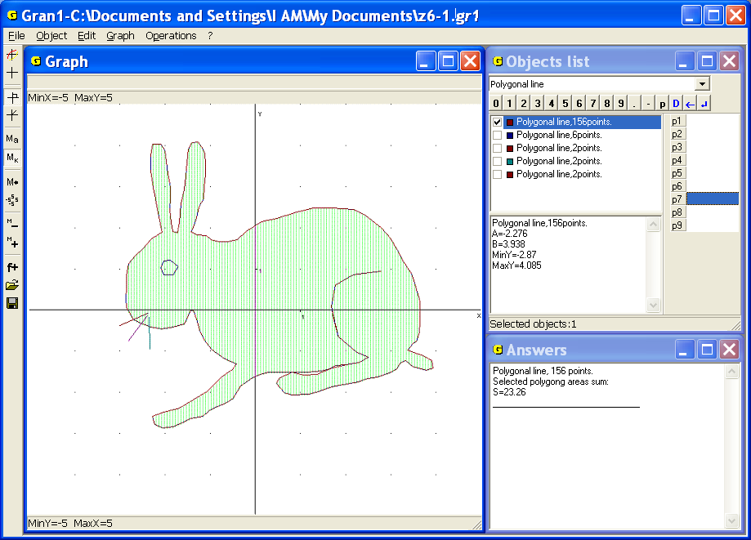
Fig. 6.2
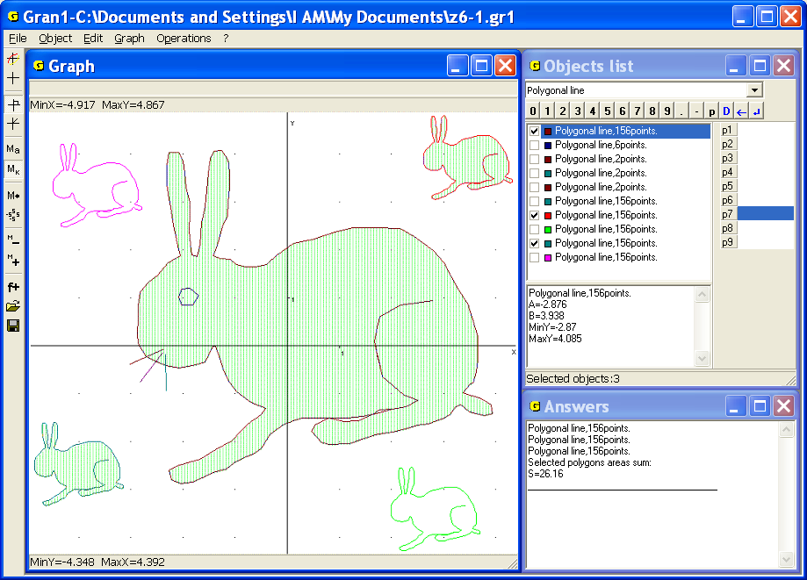
Fig. 6.3

Examples
1. Calculate an area of a triangle with the vertices (1, 1), (4, 2), (3, 4).
Set the object type “Polygonal line” in the window “Objects list” and use the command “Object / Create” for entering vertices of the polygonal line from the keyboard or the screen. The polygonal line should be assigned as closed. It is also possible to choose a color for the lines (Fig. 6.4). Use the command “Graph / Plot” to plot a graphical image of the polygonal line. With the help of the command “Graph / Zoom / User zoom” choose the corresponding zoom for getting the best image. Use the command “Operations / Polygonal lines processing / Polygon area” to get the answer in the window “Answers” . The area of the polygon equals (Fig. 6.5).
2. Coordinates of vertices of a closed polygon are determined by the formulas. Get an area of the closed 29-polygon, see the coordinates of the vertices in the table:

 | -1 | -0.995 | -0.99 | -0.98 | -0.95 | -0.9 | -0.8 | -0.7 | -0.6
 | 0 | 0.10 | 0.14 | 0.20 | 0.31 | 0.44 | 0.60 | 0.71 | 0.80

 | -0.5 | -0.4 | -0.3 | -0.2 | -0.1 | 0 | 0.1 | 0.2 | 0.3 | 0.4 | 0.5
 | 0.87 | 0.92 | 0.95 | 0.98 | 0.99 | 1 | 0.99 | 0.98 | 0.95 | 0.92 | 0.87

 | 0.6 | 0.7 | 0.8 | 0.9 | 0.95 | 0.98 | 0.99 | 0.995 | 1
 | 0.80 | 0.71 | 0.60 | 0.44 | 0.31 | 0.20 | 0.14 | 0.10 | 0

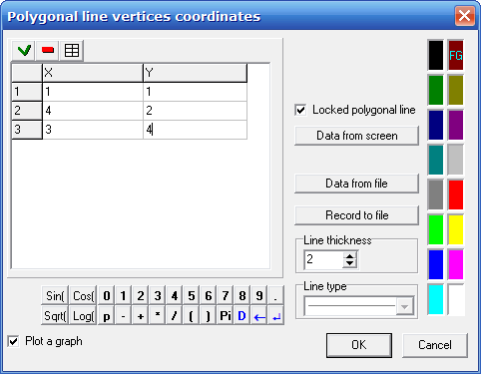
Fig. 6.4
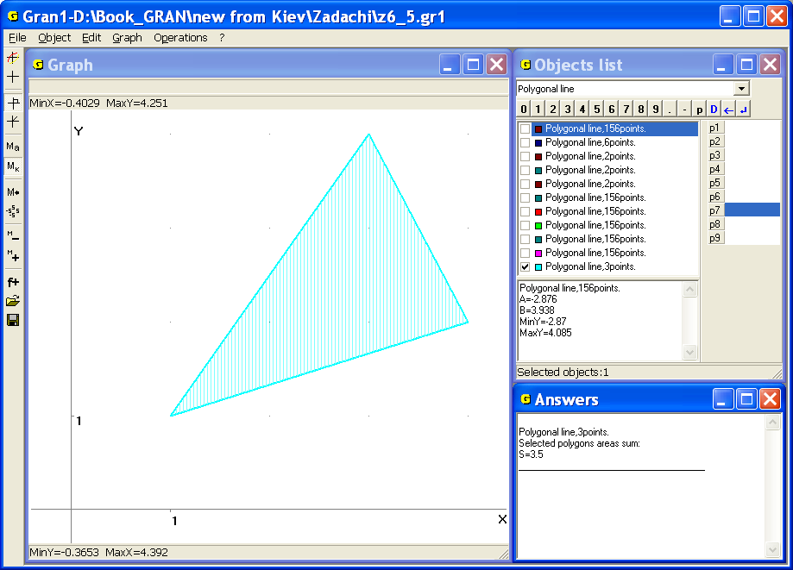
Fig. 6.5
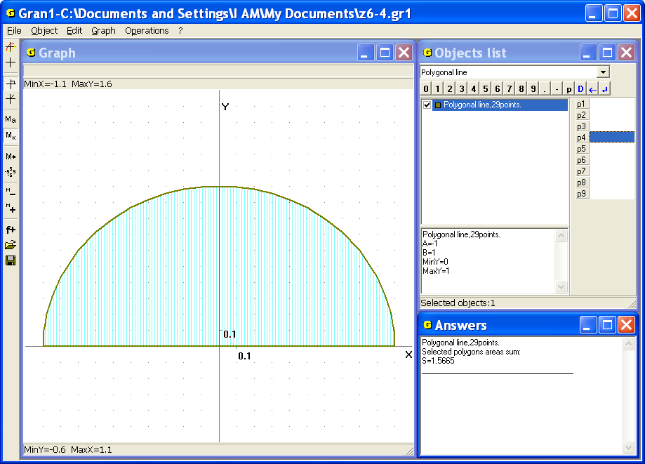
Fig. 6.6
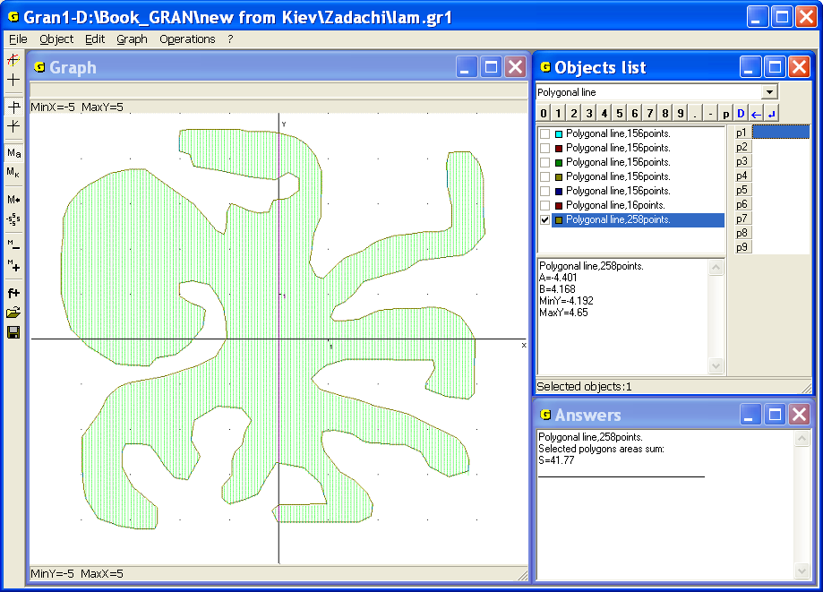
Fig. 6.7
Set the type of dependence “Polygonal line”, input a new polygonal line with 29 vertices and plot its graphical image using the command “Graph / Plot”. Then use the command “Operations / Polygonal lines processing / Polygon area” to get the answer: the area of the polygon equals 1.5665≈1.57 (Fig. 6.6).
Note that the obtained area approximately equals the area of the semicircle of the radius 1, i.e.
3. 258 vertices of a closed polygonal line have been entered from the screen. Find an area of the polygon bounded by the polygonal line.
Plot the image of the polygonal line and use the command “Operations / Polygonal lines processing / Polygon area” to get the answer: the area of the polygon equals 41.77 (Fig. 6.7).
If it is necessary to determine an angle at some polygon vertex one should make parallel transfer of the polygon so that the vertex coincides with the origin. Then with the help of the command “Graph / “Graph” window properties”, tab “Graph”, set the type of coordinates “Polar coordinates”. Determine the angles between the sides that withdraw from the vertex (after transfer this vertex is the origin) and the axis. Find the difference of the angles. As a result obtain the required angle.
Another way to solve the problem is as follows: make parallel transfer, then make a turn of the polygon so that the direction of one of the sides that withdraws from the origin coincides with the direction of the axis . It can be done with the help of the command “Operations / Polygonal lines processing / Polygonal line transformations...”, tab “Turn”, button “Select points from screen to determine a turning angle”. One should denote the initial direction of the radius-vector for determination the turning angle. The initial direction must coincide with the direction of one of the sides that withdraw from the vertex. The final direction must coincide with the direction of the axis . After the turn the polar coordinate type should be selected and further one can determine the angle between another side that withdraws from the vertex and the axis (i.e. the first side).
The angle of turning can be entered from the keyboard after the parallel transfer. Previously one should set the polar coordinate type with the help of the command “Graph / “Graph” window properties”.
4. Determine angles of a triangle with the vertices (-4, 2), (-3, -3), (-1, 4).
Plot a locked polygonal line with given vertices. Move the vertices one by one in the origin with the help of the parallel transfer. Then turn obtained triangles till the direction of one of the sides that withdraw from the origin coincides with the direction of the axis . Set the polar coordinate type with the help of the command “Graph / “Graph” window properties” and get (Fig. 6.8): the angle at the vertex (-4, 2) equals 1.96 radian (112.3º), the angle at the vertex (-3, -3) equals 0.48 radian (27.3º), the angle at the vertex (-1, 4) equals 0.70 radian (40.4º).
5. Determine angles of a pentagon with the vertices (-3, 1), (0, 2), (1, 4),
(-2, 5), (-1, 3).
Plot a pentagon with given vertices and consequently determine the angles at every vertex. Use the command “Operations / Polygonal lines processing / Polygonal line transformations...”, tab “Turn”, if necessary. Get the answer: the angle at the vertex (-3,1) equals 0.47 (≈27º); the angle at the vertex (0, 2) equals 2.36 (≈135.2º); the angle at the vertex (1, 4) equals 1.43 (≈82º); the angle at the vertex (-2, 5) equals 0.78 (≈44.7º); the angle at the vertex (-1, 3) equals 4.40 (≈251.8º) (Fig. 6.9).
Questions for self-checking
- Is it necessary to plot a polygon before using the command “Operations / Polygonal lines processing / Polygon area”?
- How many vertices should be in a polygonal line that bounds the polygon whose area should be calculated?
- Is it possible to use the command “Operations / Polygonal lines processing / Polygon area” for a polygonal line with self-intersections?
- How to use the command “Operations / Polygonal lines processing / Polygon area” for calculating an area of a triangle? a parallelogram? a trapezium? an arbitrary quadrangle? a pentagon?

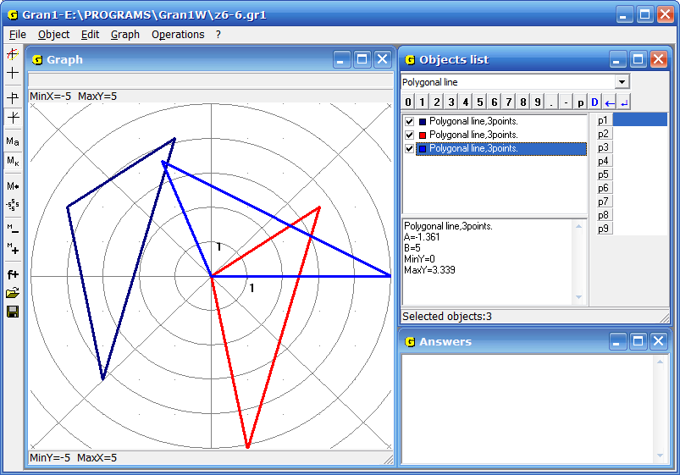

Fig. 6.8
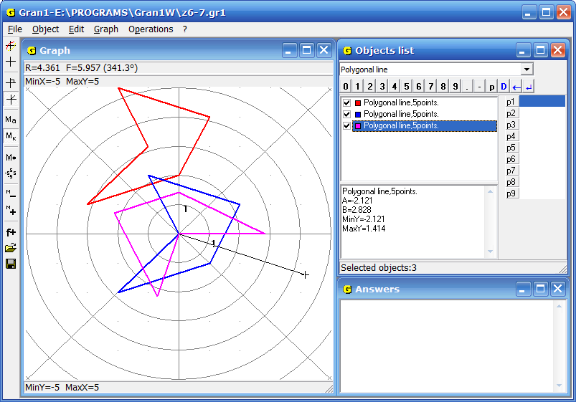
Fig. 6.9

- Is it necessary for a polygon, whose area should be calculated, to be convex?
- Is it possible to use the command “Operations / Polygonal lines processing / Polygon area” if coordinates of the vertices are entered from the screen? from a file?
- How to calculate areas of separate polygons made by a polygonal line self-intersection?
- How many vertices should be in a polygonal line to make self-intersection?

Exercises for self-fulfillment
- Calculate areas of the following polygons: the triangle with the vertices (-1, 3), (3, -2), (4, 5); the trapezium with the vertices (0, 0), (2, 5), (4, 5), (6, 0); the parallelogram with the vertices (0, 0), (0, 3), (4, 4), (4, 7).
- Calculate an area bounded by a locked polygonal line with the vertices (0, 0), (0, 5), (4, 0), (4, 6), if the vertices are given in the order of their bypass.
- Calculate an area bounded by a locked polygonal line with coordinates of the vertices if abscissas take the values 1, 2, 3, 4, 5, 6, 7.
- Calculate an area bounded by unlocked polygonal line with the vertices from the exercise 3 and the lines.
- Calculate areas of polygons obtained from the polygons in the exercises 1-4 by deformation with the coefficients: ; ; ; .
- Determine angles of polygons assigned by coordinates of the vertices in the order of their bypass: (-1, -4), (-4, 2), (4, 4); (0, 0), (4, 1), (1, 4); (-4, -4), (4, -2), (3, 4), (-4, 3), (0, 2), (-2, -1); (4, 4), (4, 7), (0, 3).
- Find a sum of angles of the polygon with the vertices given in the order of their bypass: (-5, -4), (0, -3), (-5, 4), (2, -1), (5, 2), (2, 2), (0, 5), (-2, 2), (-5, 2), (-2, -1).

§7. The simplest planimetric problems. Calculation of triangles
The process of solution of many planimetric construction problems requires a possibility to plot a circle with a certain radius, center and arbitrary point on a circle; a circle that passes through three certain points etc. If an application is provided for commands to plot such circles, segments that link certain points, make parallel transfer and turn of segments and polygonal lines, it is possible to solve traditional planimetric problems with the help of a computer.
To plot a circle with the help of GRAN1 one should set the object type “Circle” in the window “Objects list”. In the case of using the command “Object / Create” the auxiliary window with two tabs is displayed.
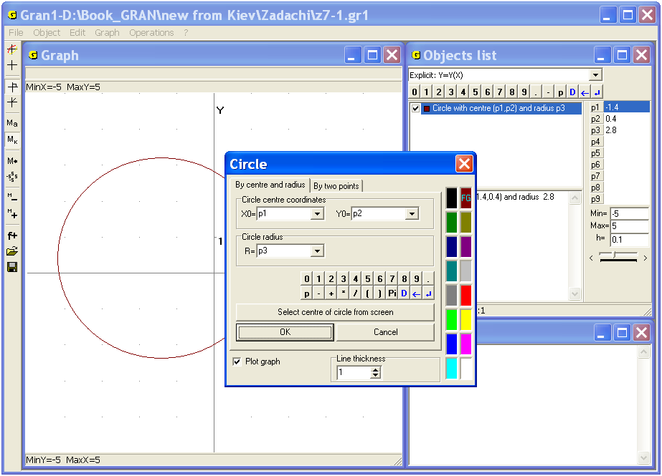
Fig. 7.1
The first tab is used for assignment a circle by the center coordinates and radius. One should input coordinates of the center in the lines “Х0=” and “Y0=” and radius in the line “R=” using the keyboard or the input data panel. (The center coordinates and radius can be expressed through the parameters , , … , ) (Fig. 7.1). The lines for data input are drop-downs, thus if several circles are created all the data inputted before are enrolled in the lists.
If a circle is re-created, the center coordinates or the radius can be entered with the help of the list (Fig. 7.2). A corresponding list is being created for
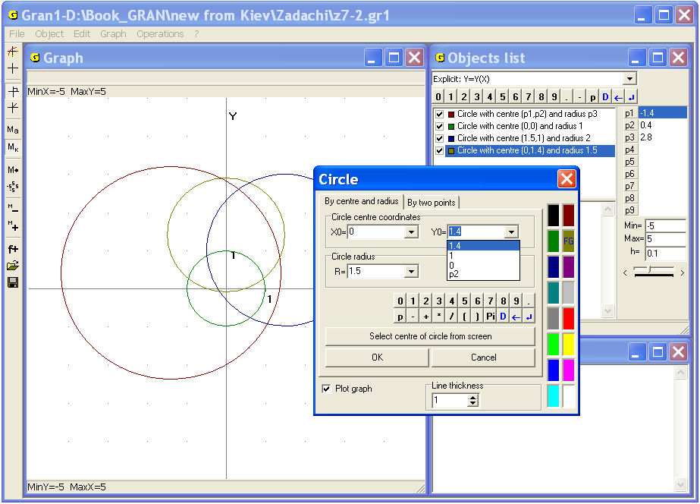
Fig. 7.2
each input line. The use of the button “Select centre of circle from screen” allows assign a circle centre on the coordinate plane with the help of the mouse or the keyboard.
The second tab of the window “Circle” allows create a circle using coordinates of a center and any point on a circle (Fig. 7.3).
For this purpose one should input coordinates of the center in the lines “Х0=” and “Y0=” and coordinates of the point in the lines “X1=” and “Y1=” using the keyboard, the input data panel or the drop-down list. The center coordinates and radius can be expressed through the parameters , , … , .
It is also possible to assign the points from the screen. For this one should use the button “Select points from screen”, then in the window “Graph” set and fix the coordinate cursor firstly in the center of the circle and secondly in any point on the circle. This way is similar to entering points for making a polygonal line, a transfer vector etc.
After pressing the button “OK” in the top right corner of the window “Graph” there will be created the circle, whose characteristics (center coordinates, radius, maximum and minimum coordinates) are displayed in the window “Objects list” (Fig. 7.4).
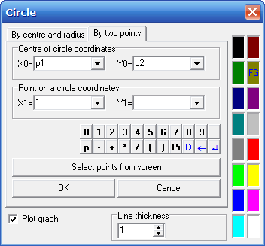
Fig. 7.3
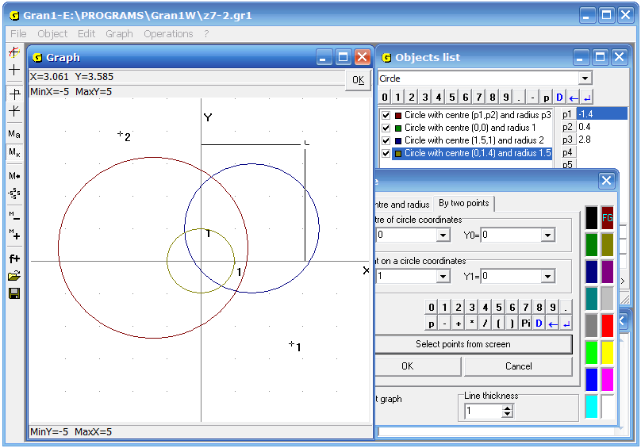
Fig. 7.4
To plot a new object of the type “Circle” one can use the command “Graph / Graph”. It should be kept in mind that the zooms along the axes and must be equal for plotting a circle but not an ellipse. This condition should be also met for plotting other graphs.
The command “Operations / Distance to point” can be useful for solving several problems. For use the command it is necessary to assign two points (like input a polygonal line vertices from the screen). During moving the mouse cursor there will be determined the distance from the fixed point to the point where the mouse cursor is placed. At the beginning the origin is accepted as the first point, the current position of the mouse cursor is accepted as the second one. The distance is indicated in the top left corner of the window “Graph”. If the coordinate type was determined as “Rectangular” then coordinates of the cursor position and the distance between the points are indicated, in the case of polar coordinate type the polar coordinates of the point and the distance between the points are indicated.
While cursor moves (with the help of the mouse or arrow keys), the second point coordinates and the distance between the points undergo change. After pressing the left mouse button the first point in the cursor position becomes fixed. Further the distance will be calculated from this new point to the cursor position (Fig. 7.5). Pressing “OK” in the top right corner of the window “Graph” interrupts executing of the command.
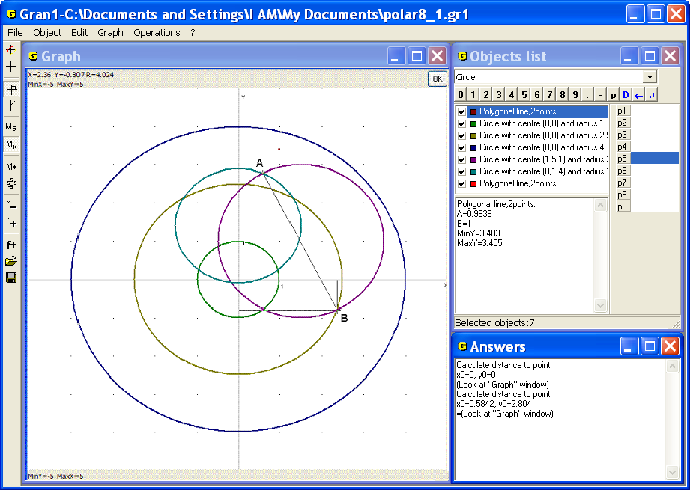
Fig. 7.5
The command “Operations / Distance to point” is convenient to find a point from the set that is minimally remote from certain point, e.g. to find a point on a line or curve that is minimally remote from a point out of a line or curve. That gives a possibility to define, for example, a base of a perpendicular from a given point on a line, an altitude of a triangle or a parallelogram etc.
It should be noted that in the case of different values of the zoom along the axes and a point on a line that is minimally remote from a point out of a line visually is not placed on a perpendicular that is put from a given point on a line.
In the figure 7.5 the initial point has the mark “А”. Such marks are convenient for simplification solving of problems. It is possible to use the following ways to set the mark:
- in any place in the window “Graph” with the help of pop up menu (Fig. 7.6). The place of the mark coincides with the coordinates of the cursor position that was set before use the command;
- with the help of the command “Graph / Labels…” By this command auxiliary window “Labels on graph” with the table of labels is displayed (Fig. 7.7). In the columns “X” and “Y” coordinates of the top left corner of a label are placed.
At any change of the zoom the labels stay on the screen and correspondingly move in the window “Graph”. The process of choosing the objects in the window “Graph” also doesn’t affect labels. Labels can be saved in files with the objects.
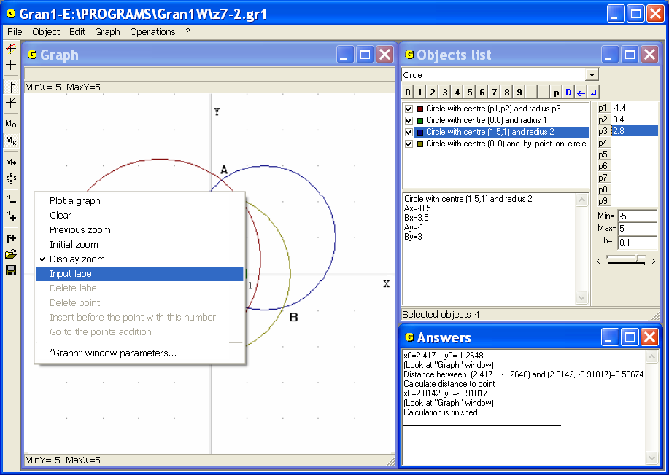
Fig. 7.6
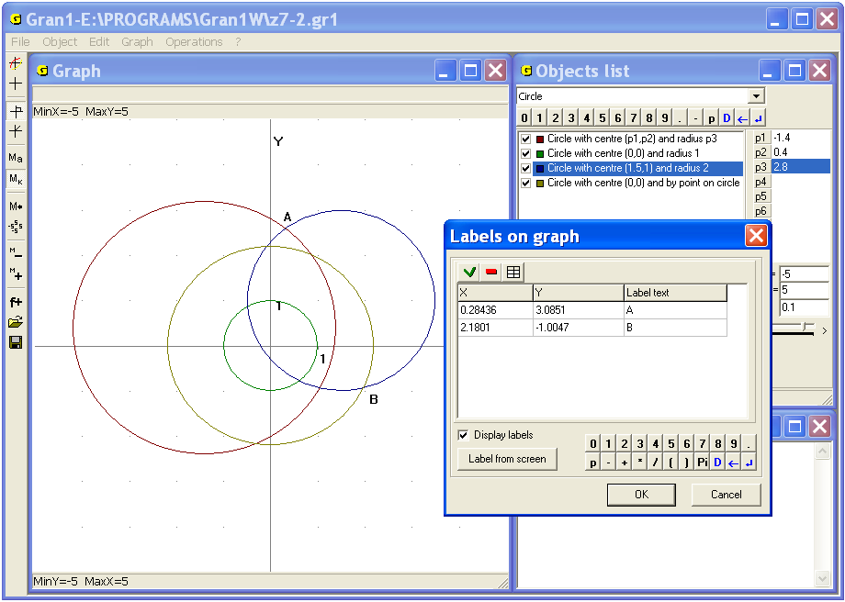
Fig. 7.7
Examples
1. Three segments are plotted on the screen. Each of them is a polygonal line with two vertices. Plot a triangle where lengths of sides equal to lengths of the segments (Fig. 7.8).
Use parallel transfer (the command “Operations / Polygonal lines processing / Polygonal line transformations...”) to superpose one of the ends of some of the segments with any end of any other segment, and one end of the third segment with some of the remaining ends of one of the two preceding segments (Fig. 7.9). Remove check boxes at the command “Graph” in pop-up menus of corresponding objects to delete initial segments. Then plot two circles with centers in the ends of the segment that two other segments are linked to. The circles should pass through free ends of the segments that withdraw of the centers (Fig. 7.10).
If the circles intersect then their centers and the intersection point are the vertices of the desired triangle. Remove segments that don’t link the circles centers and plot the new locked polygonal line with vertices in the centers and intersection point of the circles (Fig. 7.10). This is the required triangle (there are two such triangles) (Fig. 7.11).
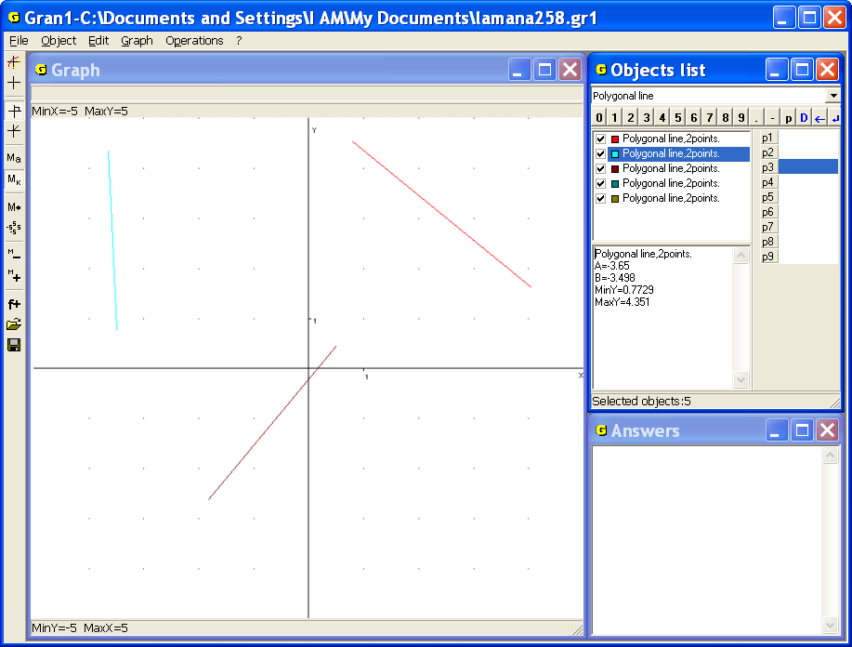
Fig. 7.8
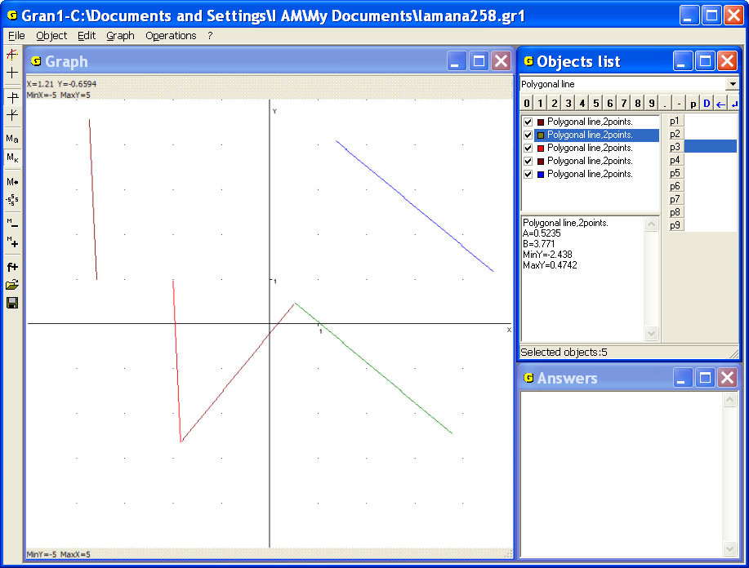
Fig. 7.9
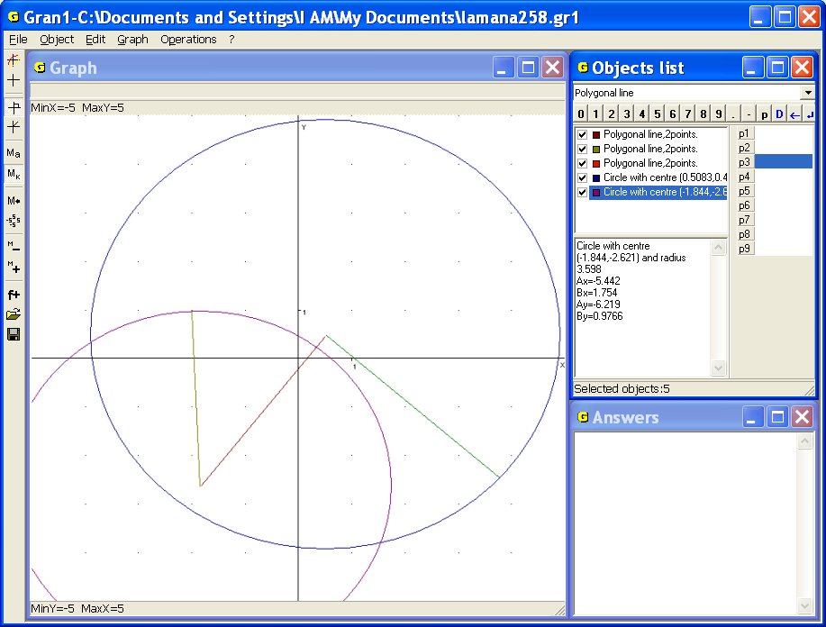
Fig. 7.10
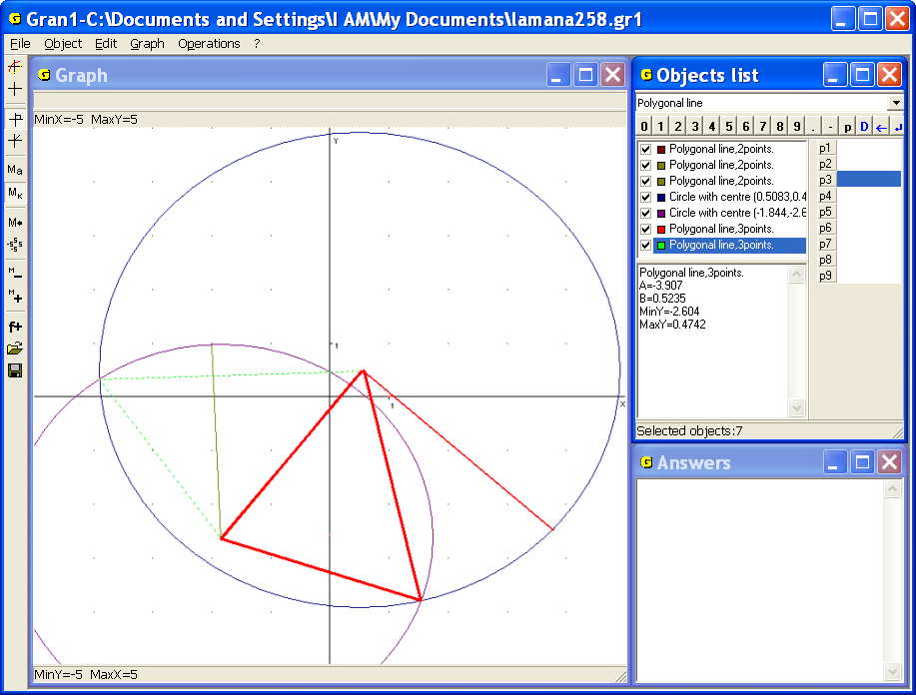
Fig. 7.11
2. The lengths of a triangle sides are preassigned as 3, 4, 5. Determine the area of the triangle, its angles and altitudes.
Without limiting the generality we assume that one of the triangle vertices coincides with the origin (0,0). Choose a point on the axis. The abscissa of the point must be equal to one of the triangle sides. Then construct two circles with the so-defined centers on the axis and radiuses equal to the length of two remaining sides. The third vertex of the triangle will be defined by the intersection point of the circles. The ordinate of this point would be the altitude that is put to the side laid along the axis . Create the object “Polygonal line” (locked) to plot a triangle with so-defined vertices. Then use the command “Operations / Polygonal lines processing / Polygon area”. As a result get that area of the triangle is (Fig. 7.12).
The altitude of the triangle that is put to the side of length 5, laid along the axis, equals 2.39 (Fig. 7.13), the angle at the vertex that coincides with the origin approximately equals 0.64 radians (36.7º) (Fig. 7.14).
Combine the vertices of the triangle one by one with the origin, while one of the sides should be placed along the axis (use operations of parallel transfer and rotation available in the command "Operations / Polygonal lines processing / Polygonal line transformations...").
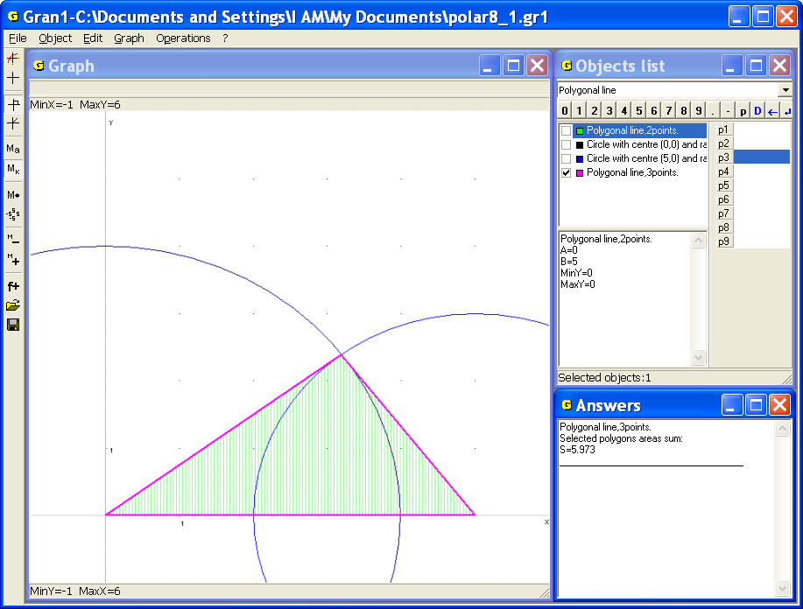
Fig. 7.12
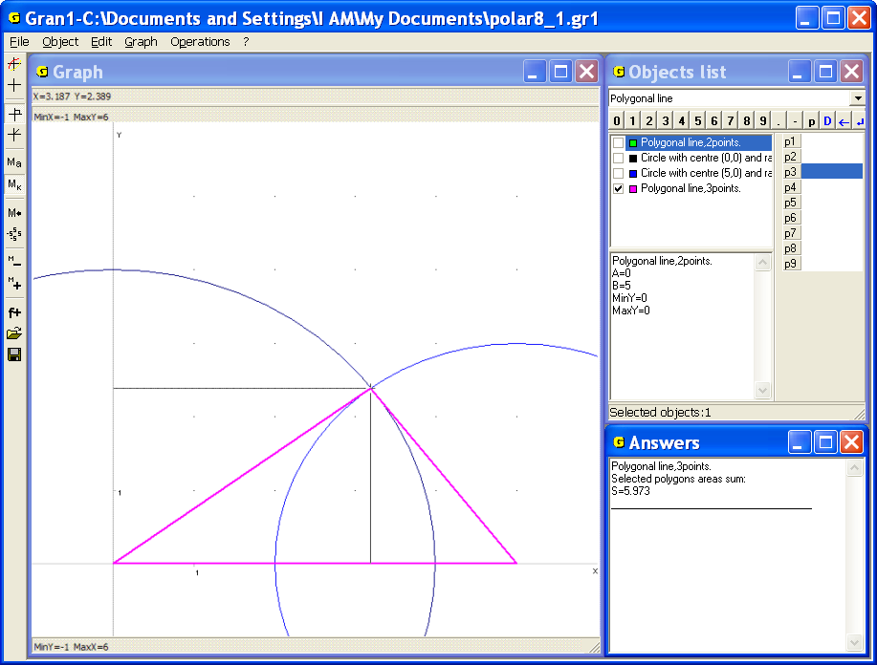
Fig. 7.13
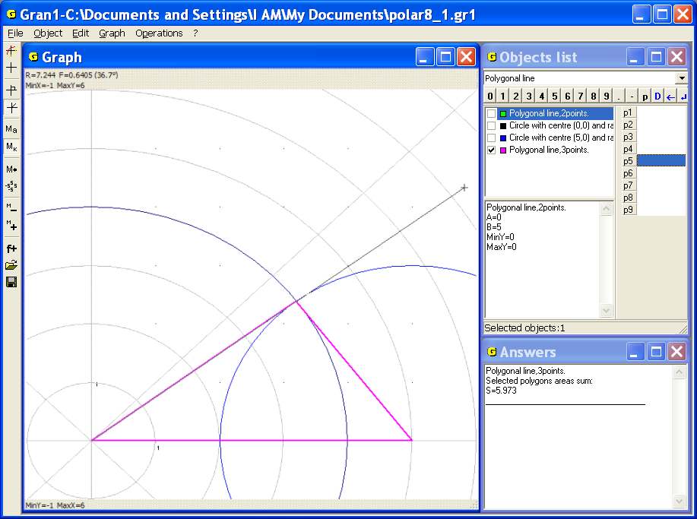
Fig. 7.14
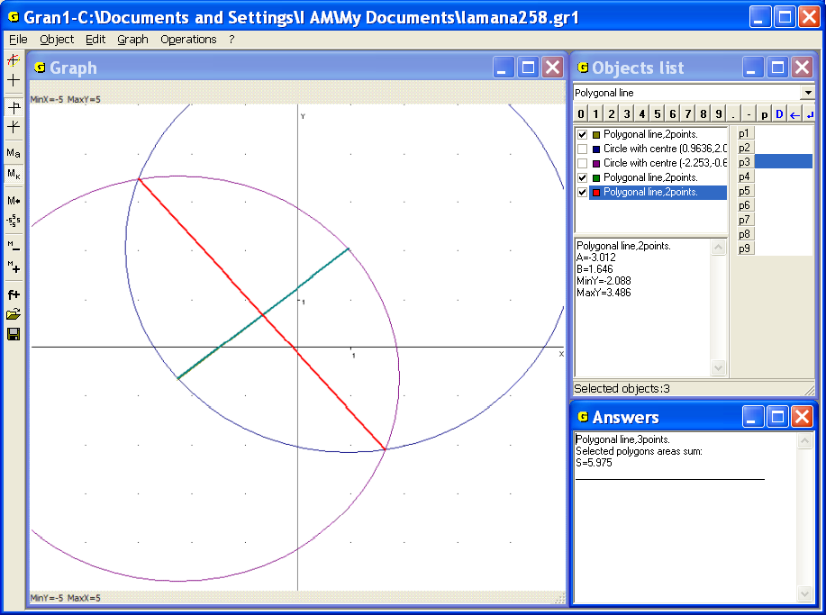
Fig. 7.15
The answer is as follows: the altitude of the triangle, dropped to the side of length 5, equals 2.39, to the side of length 4, equals 3, to the side of length 3, equals 4, the angles adjacent to the side of length 5 are 0.93 and 0.64, to the side of length 4 – 1.57 and 0.64, to the side of length 3 – 1.57 and 0.93.
3. A segment is plotted on the screen. It is required to construct a segment that is perpendicular to given one, and passes through its middle
Plot two circles of the same radius (the radius shouldn’t be less than half of the given segment length) with the centers in the segment’s ends. Plot a new polygonal line with two tops that passes through the points of intersection of the circles. This is the required perpendicular (Fig. 7.15).
4. A straight line and a point out of it are plotted on the screen. It is required to construct a perpendicular to the line through the point.
It is possible to solve this problem using different ways with the help of the program GRAN1. One of the ways is to plot a circle with a center in given point that intersects the line in two points. Then divide the segment (chord) in half (like in the example 3) and assign the ends of the chord as centers of the circles and given point out of the line as points on the circle. Plot a segment (new polygonal line with two vertices) to join the intersection point of the circles and get required perpendicular (Fig. 7.16).
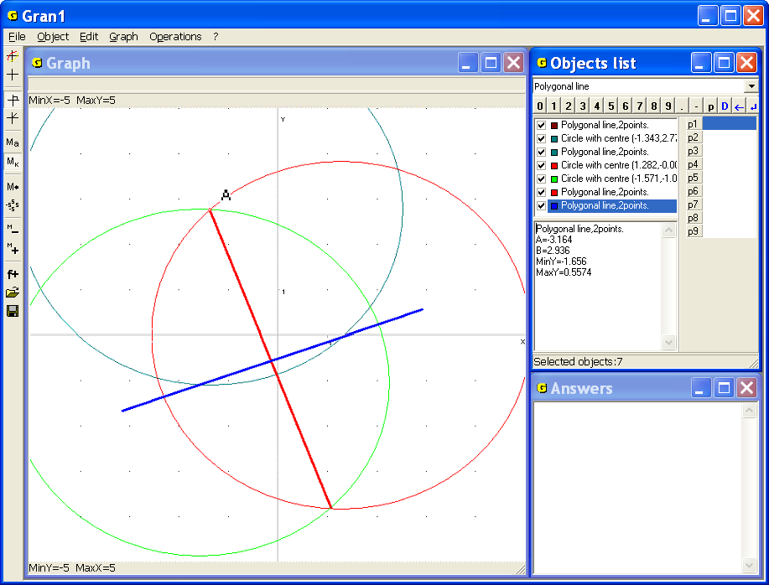
Fig. 7.16
Another way is to use the command “Operations / Distance to point”. Assign the point out of the line as the first point and choose the second point on the line. Move the second point along the line to find a point minimally remote from the point out of the line. That will be the base of required perpendicular. The perpendicular could be constructed as previously (Fig. 7.17).
The third way is as follows. The point , through that the required perpendicular passes, can be defined as a point, at which a circle with center in the point and radius r tangents to given line.
Define a circle centered at the point with radius , and choose the parameter so that the circle tangent to given line. This is the way to find the point (Fig. 7.17).
5. In the segment find the point minimally remote from the point out of the segment.
It is obvious that the solution is a point that lies on the interval and on a circle of the least radius and centered at certain point out of the segment. The circle and the segment must have a point of intersection. The required point in the segment (namely the radius of the circle) can be defined with the help of the command “Operations / Distance to point”. Another way is to define a circle centered at the given point with the radius and to choose the parameter so that the circle of minimal radius has a common point with the segment (Fig. 7.18).
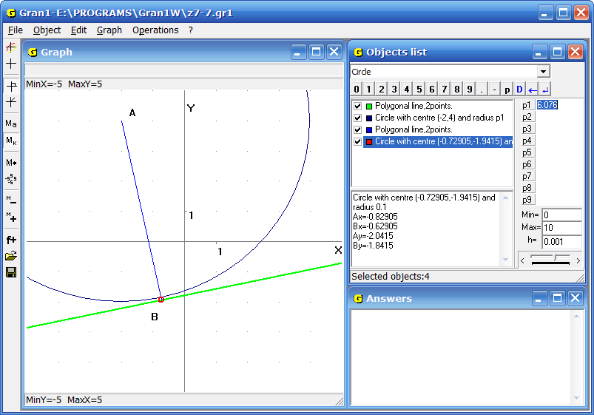
Fig. 7.17
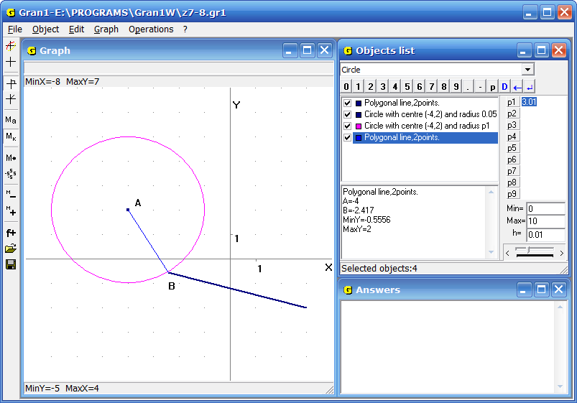
Fig. 7.18
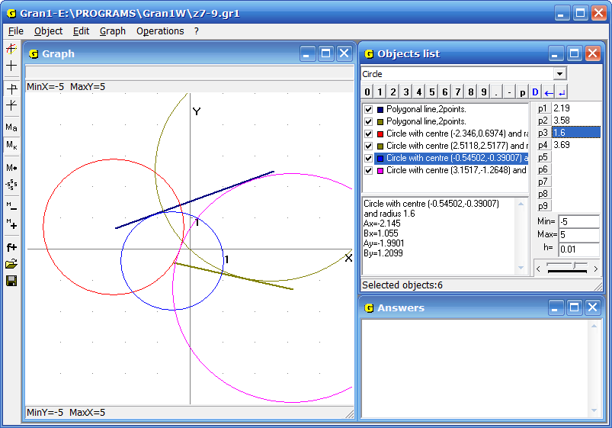
Fig. 7.19
6. Two segments are shown on the screen. It is required to find a distance between them i.e. the least distance between two points one of which belongs to one segment and another point belongs to another one.
It is obvious that the distance between intersecting segments equals to zero. If the segments don’t intersect, it is necessary to define a distance from both ends of one segment to another and vice versa. Thus four values can be found. One should choose the least of them. This is the distance between the segments (Fig. 7.19). In this example we get .
7. Two figures (a triangle and a pentagon) that are defined by coordinates of the vertices are plotted on the screen. It is necessary to find a distance between locked areas bounded by the polygonal lines (without self-intersections) i.e. the least distance between two points that belong to different areas.
It is obvious that the distance between areas that are bounded by closed polygonal lines and have common points equals to zero. If the areas do not intersect, it is possible to find a distance between them by calculating distances of all the sides of one bounding polygonal line to all the sides of another one and choosing the least of such distances.
In the example calculate distances from each of three triangle sides to all the five sides of the pentagon and choose the least from obtained 15 values. You get the result 1.56. This is the required distance (Fig. 7.20).
8. An angle is defined by a polygonal line of two segments that have a common point. It is necessary to plot a bisector of the angle.
Plot a circle centered at the common point of the segments that intersects both segments. Then plot two circles centered at the intersection point of the first circle and the segments. The circles must pass through the common point of the segments. Connect the points of intersection of two last circles and get a segment that belongs to the required bisector (Fig. 7.21).
9. To given circle it is necessary to plot tangents that pass through given point out of the circle.
Divide at half the segment between the center of the circle and given point out of it and construct a circle that have a center at the point in the middle of the segment and passes through the center of given circle and the point out of it. The points of intersection of the circles and are required points of the tangent (Fig. 7.22).
10. Two circles and a segment are given. It is necessary to plot a segment with ends on the circles. Length of the required segment must be equal to length of the given one. The segments must be parallel.
Make parallel transfer of the given segment so that one of its ends coincides with the center of one of the circles . Use another end of the transferred segment as a center of a new circle of the same radius.
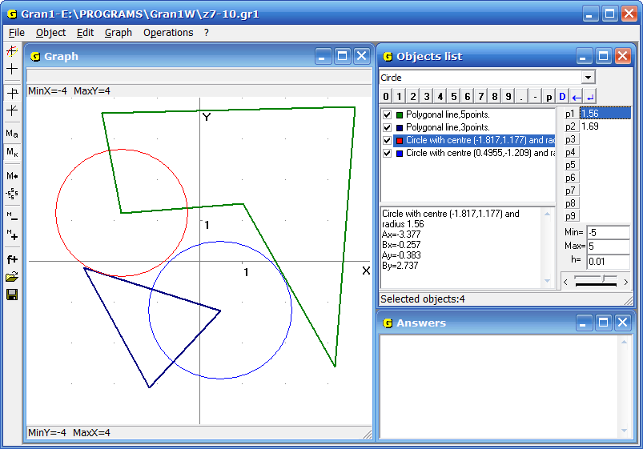
Fig. 7.20
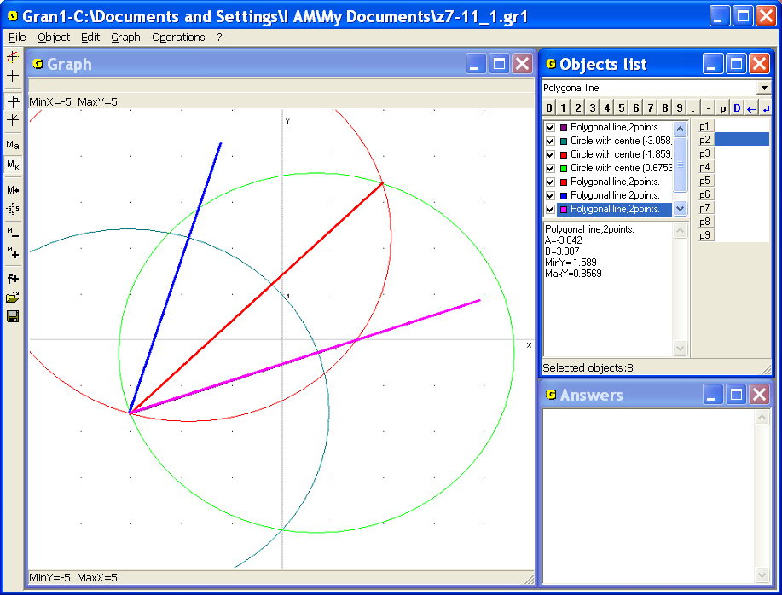
Fig. 7.21
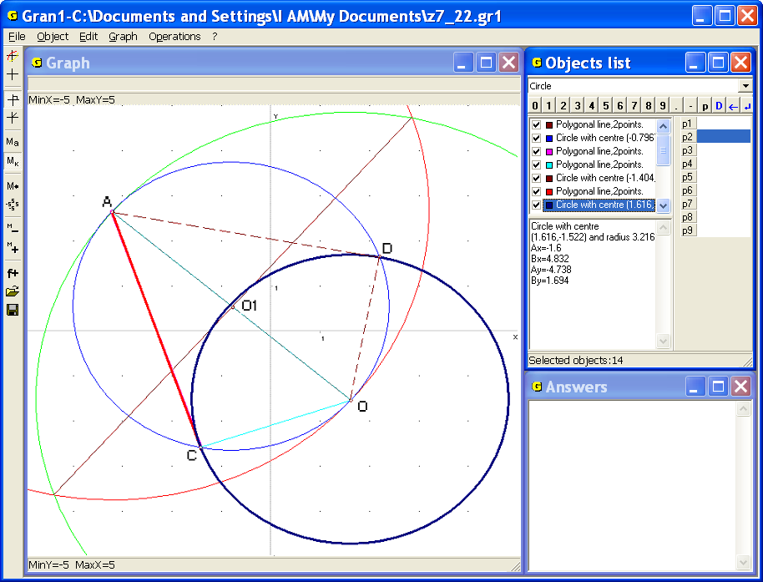
Fig. 7.22
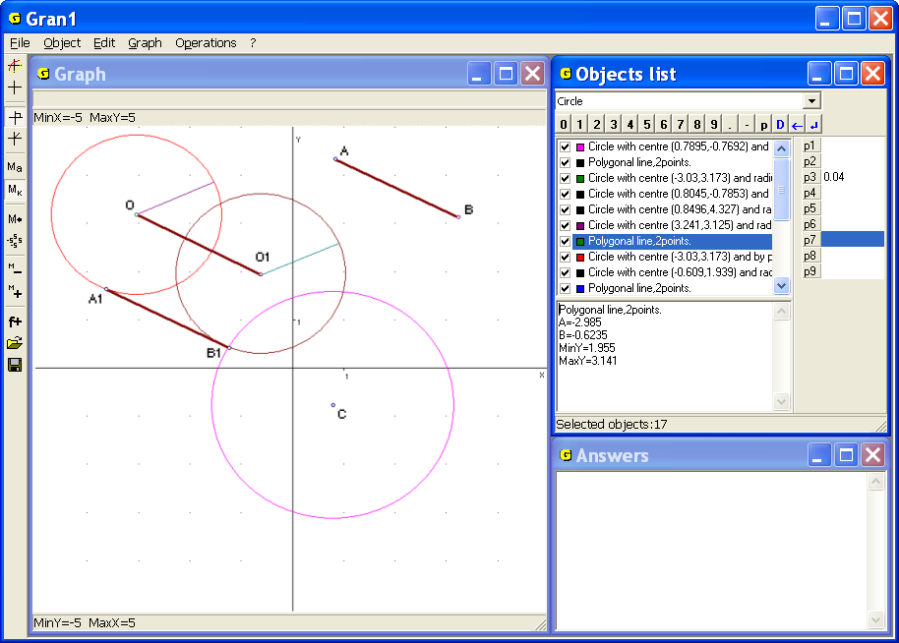
Fig. 7.23
If transferred circle has at least one common point with the given circle, make parallel transfer of the given segment so that one of its ends lies in the common point of the circles , and another one () lies on the circle that has been transferred. (Fig. 7.23).
If there exist two common points, one can obtain two corresponding solutions. If there the one common point exists (tangent inside or outside) – there is the one solution. If there is no common point there is no solution.
11. It is necessary to plot an equilateral triangle so that its vertices lie on three given parallel lines.
Accept that the triangle has been plotted. Mark the parallel lines top-down by the letters , , . Mark the corresponding triangle vertices on the lines by, , Plot the line perpendicular to the parallel lines through the vertex that lies on the middle line . The angle between the triangle side and the line mark by . Then the angle between the side and the line equals. Mark the distance between the top and the middle lines by , the distance between the down to the middle one by , the length of required triangle side by.
Then
is a point of intersection of lines and . Plot a circle with the center in this point of radius. Then the distance between the perpendicular and the point of intersection of the circle and the top line (point ) equals . Plot a circle centered in of the radius and mark the point over the top line on the perpendicular by . Plot a line parallel to the given lines. On the line make the label by the circle centered in the point of the radius . Thus get the point . Connect with , to get the segment that makes the angle with the perpendicular . The vertex of the required triangle will be defined by intersection point of the segment and the top of given lines . Now plot a circle that has the center on the middle line and passes through the vertex on the top line to get the vertex of the required circle on the down line. The vertex is the intersection point of the circle and the down line (Fig. 7.24).
Another way of solution can be as follows. Choose a triangle vertex on the middle line in the origin. Turn the top line around the vertex on the angle (on the angle clockwise). The second vertex of the required triangle will be defined by intersection point of the turned line and the down line. Plot a circle centered in , that passes through the vertex to find the third triangle vertex. The vertex is the point of intersection of the top line and the circle (Fig. 7.25).
12. Three points, not lying on the line, are given. These points are feet of the altitudes of a triangle. It is necessary to plot the triangle.
Suppose , , are the given points. Choose on of them (for instance, ) and connect it with two other points. Continue every segment in opposite side from the chosen point and lay on it an interval to the third point that does not lie on the segment. The points and will be obtained (Fig. 7.26).
Consider two following segments. The first connects two given points that were unconnected; the second one connects two unconnected points that were obtained by foregoing way (segments and in the Fig. 7.26). Now one should plot central perpendiculars to the segments and . Mark the intersection point of the perpendiculars by . Plot a circle centered in the point that passes through the ends of the segments and . The ends of the diameter passing through the point are the vertices of the required triangle (points and ).
The third vertex can be found as the intersection point of the extensions of the legs and of the right-angled triangles and , that lean on the diameter as on the hypotenuse, and vertices of the right angles of the triangles coincide with the given points and (Fig. 7.27).
It can be shown that the segment that connects the third vertex with the first of the given points is perpendicular to the circle diameter. If any of given points is assigned as the first point, the same triangle will be obtained. Thus the problem has the one solution.
13. Plot a triangle by its medians.
Firstly plot the triangle with the sides equal to the given medians (Fig. 7.28). Choose any point and lay segments bi-sides from it. The segments should be parallel to the sides of the triangle and have equal lengths with them. Thus get six segments with one common point. The polygonal line that connects other ends of the segments makes the hexagon centered in the chosen point.
Connect any three hexagon vertices next nearest to get a triangle whose medians are one and a half longer than given segments – in the figure. Plot a line through the hexagon center parallel to any side of the triangle till the intersection with two other sides and get the required triangle (Fig. 7.28).
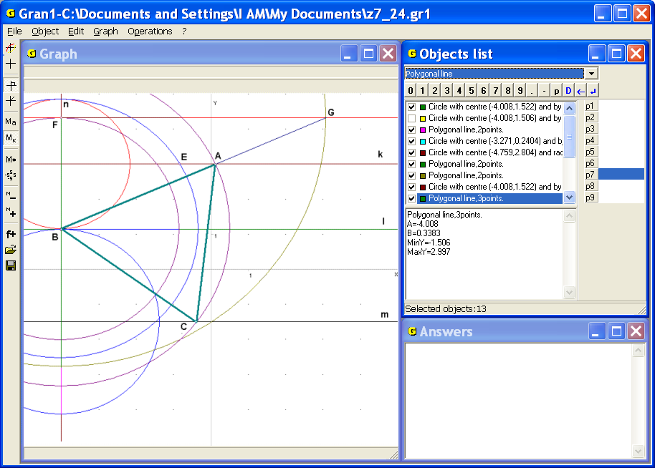
Fig. 7.24
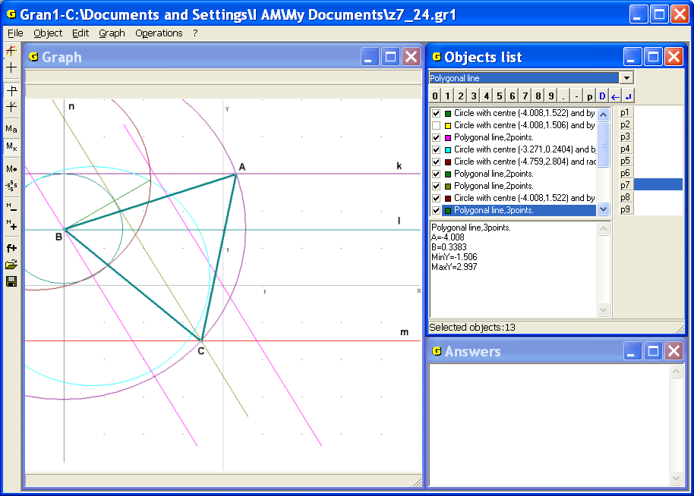
Fig. 7.25
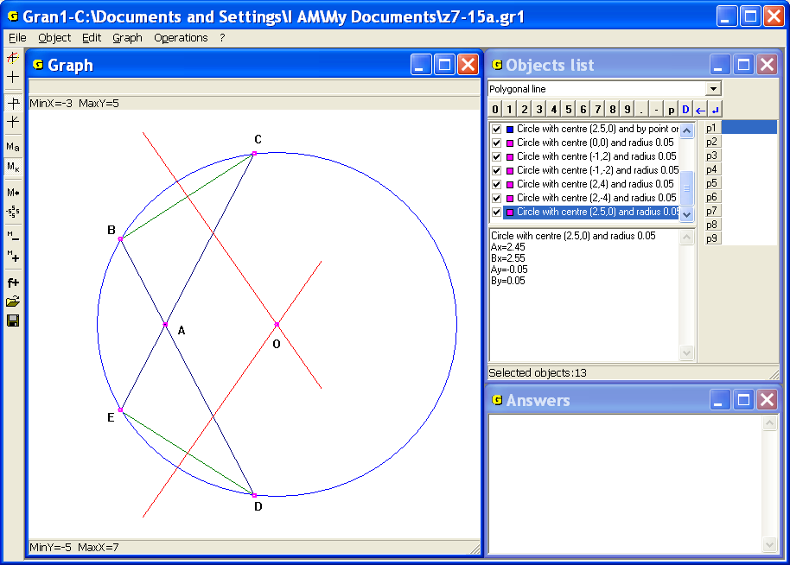
Fig. 7.26
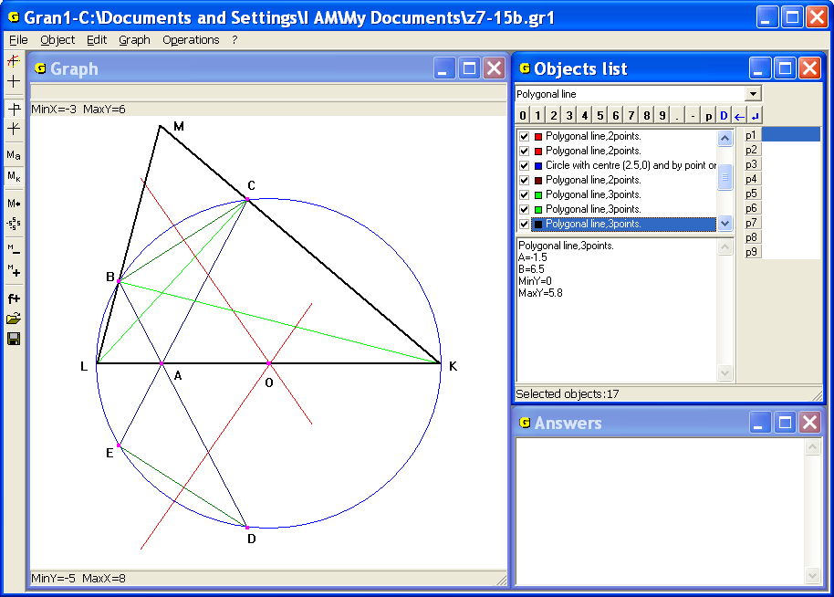
Fig. 7.27
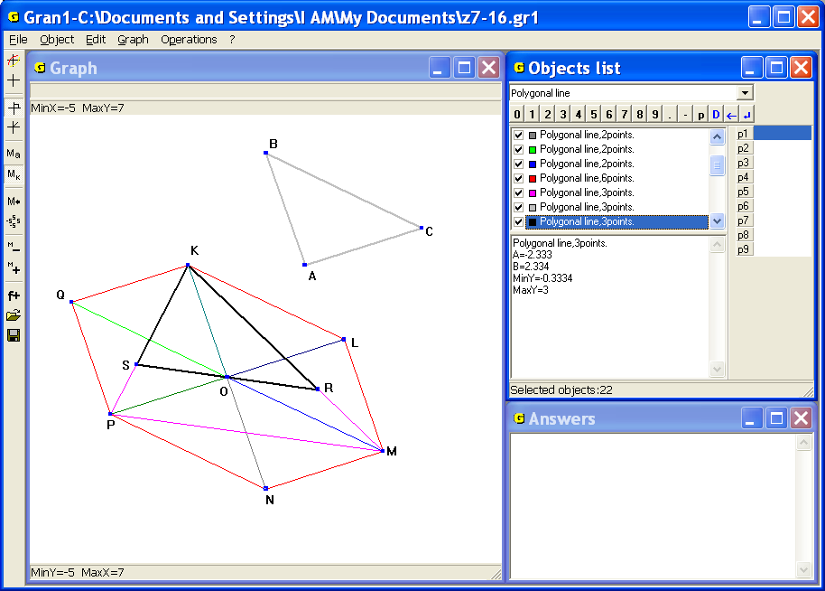
Fig. 7.28
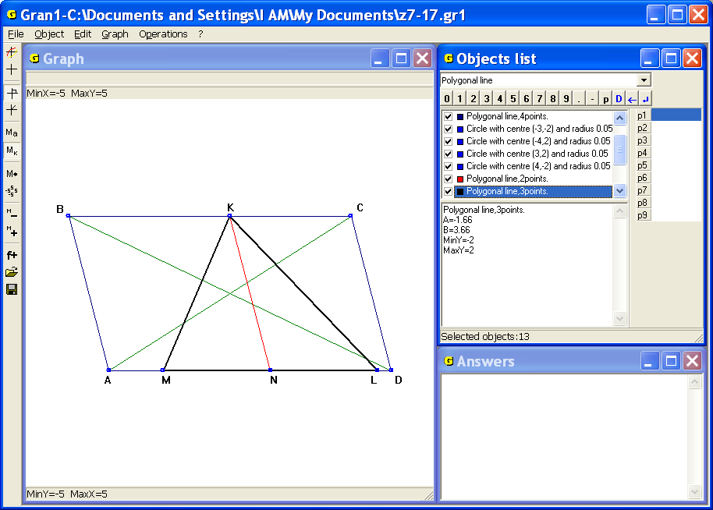
Fig. 7.29
14. Plot a triangle by given side and the medians to two other sides.
Plot parallelogram with diagonals equal to doubled medians and the side with length equal to of length of given side (Fig. 7.29).
On the parallelogram side take an arbitrary point as one of the vertices of the required triangle. Through the point plot the line parallel to two other sides till the intersection with the opposite side. On this side from the intersection point lie bi-sides the segments and of length . Another two vertices of the required triangle will be defined by two obtained points (Fig. 7.29).
Another way is to plot the parallelogram with the side of length equal to the medians and diagonal equal to of the given side. Then plot a segment of length on this diagonal from one of its ends and obtain a point. Plot a point symmetrical to the obtained one about the parallelogram vertex that doesn’t lie on the diagonal. This point and the ends of the segment are three vertices of the required triangle.

Questions for self-checking
- How with the help of GRAN1:
  - to plot a circle? a segment? an angle?
  - to find a distance from the given point to another given point? to a line? to a segment? to a circle? to a triangle side? to an unlocked polygonal line?
  - to find a middle of a segment? of an arc?
  - to plot an angle bisector? a triangle median?
  - to determine a triangle angles? a triangle altitudes? a triangle area?
- How to get approximately the minimal distance between points of two disjoint lines?
- Is it possible to use the command “Operations / Distance to point” if in the window “Graph” the zooms along the axes and are different?

Exercises for self-fulfillment
- A triangle is given by the coordinates of vertices: (-3, -4), (4, 4), (-4, 3). It is necessary to determine: lengths of the triangle sides; perimeter; angles; altitudes; medians; area. Explore how the results will be changed if the triangle will be deformed with the coefficients: ; ; .
- Two segments are given by the coordinates of ends: (1, 1), (3, 2) and (2, 2), (4, 5). Plot a parallelogram with the sides equal by length and parallel to given segments. Calculate its area, angles, altitudes, diagonal lengths and perimeter.
- Plot circumcircles and incircles for the triangles from the example 1. Find coordinates of centers and radiuses of the circles.
- Plot a triangle by two sides and and the median, drawn to the side.
- Plot a triangle by the angle, altitude and bisector, drawn from the vertex .
- Determine a length of a tangent drawn to the given circle from the given point out of the circle and a distance between the point to the circle center and also a distance between the points of contact. How the distance between the points of contact will change if the point out of the circle will be gradually approached to the circle center?
- Plot a triangle by the altitude and median, drawn from one vertex and by the radius of the circumcircle.
- Plot a right-angled triangle by the cathetus and the difference between the hypotenuse and other cathetus.
- Plot a triangle by two sides , and the median , drawn to the third side.
- Plot a triangle by two sides , and the altitude.
- A segment and two points are given. Find the distances from the points to the segment and the distances between the points and the line where the segment lies on.

§8. Plotting graphs of dependencies.
Evaluation of expressions
For plotting graphs of dependencies between the variables of different types and execution of some other operations with graphs the command “Graph” is used.
The subcommand “Graph” is used for plotting graphs of one or several inputted dependencies. If graph of a dependence shouldn’t be plotted it is necessary to remove the check-box from the option “Graph” in the pop-up menu of the object or in the window “Dependence expression input” (Fig. 8,2, Fig. 8.3) that is displayed by the command “Object / Modify”. The dependencies that marked by the check box in the window “Objects list” will be accounted during processing the objects.
Expressions of dependencies are written in the window “Objects list” by the symbols of the same colors as corresponding graphs in the window “Graph”. The objects quantity is limited only by the hardware.
To define explicit type of dependence between the variables and in the rectangular coordinate system one should set the type of dependence “Explicit: Y=Y(X)” in the window “Objects list” (Fig. 8.1). Then the command “Object / Create” or the button “f+” on the toolbar can be used.
As a result the auxiliary window “Dependence expression input” is displayed. In the line “Y(X)=” one should input the expression of dependence (Fig. 8.2). The line belongs to drop-down list, thus, when a new dependence is being created, the corresponding expression is inputted in the list and can be used later (Fig. 8.3). If the expression is inputted incorrectly, an error message is displayed.
An explicit dependence is always set on certain finite interval. In the window “Dependence expression input” in the line “А=” one should input an expression of the left end of the segment, in the line “В=” – an expression of the right end of the segment. It should be kept in mind that the condition should be met. Otherwise an error message is displayed.
The data can be inputted both from the keyboard and with the help of the mouse using the data input panel in the auxiliary window (Fig. 8.3).
In both expressions of dependencies and limits of dependencies can be included parameters , , … , (Fig. 8.2). If the parameters undergo change (with the help of the slider or input data panel) then the expressions of dependencies and of limits are changed correspondingly.

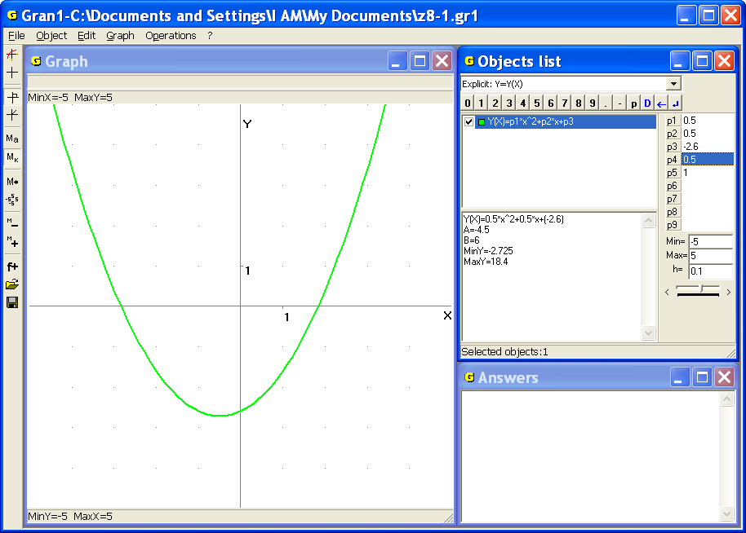
Fig. 8.1
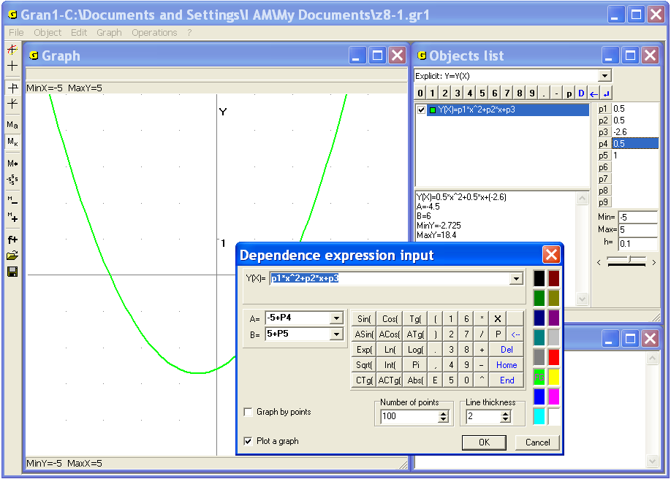
Fig. 8.2
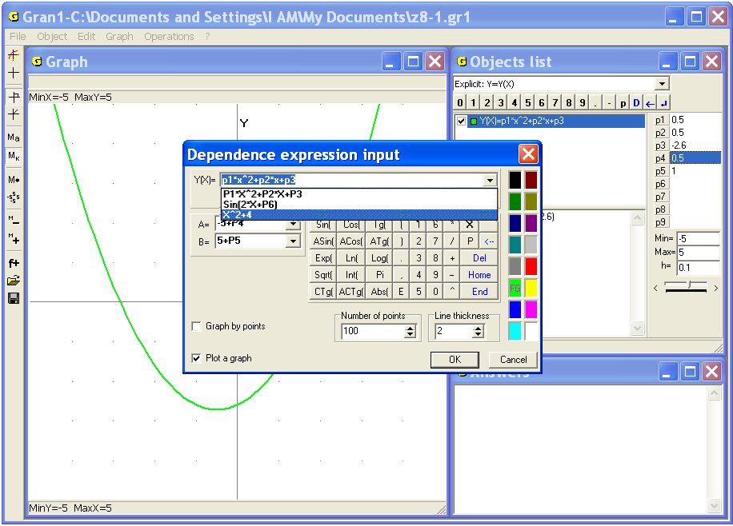
Fig. 8.3
For fixation the object with certain values of parameters the command “Object / New object with fixed parameters”can be used. As a result a new object with fixed values of parameters is created while the values of parameters of the previous object can be changed.
One can set a graph color and line thickness for inputted expression with the help of selector “FG” (Fig. 8.2).
One can set the number of points for graph plotting (from 10 to 1000, default value is 100) in the auxiliary window. It should be noted that increasing of the number of points causes decreasing the speed of computation and plotting, while decreasing of the number of points causes decreasing accuracy of plotting.
Sometimes it is convenient to plot not entire graph but just its nodal points. In this case the inscription “Not connect the point by segments” should be marked by the check box (Fig. 8.4).
In the figure 8.1 the continuous graph of the dependence is represented (100 points on the graph are connected by line segments). In the figure 8.4 one can see the unconnected points on the graph of the same dependence, in the figure 8.5 – the graph of the same dependence but number of the points is 10.
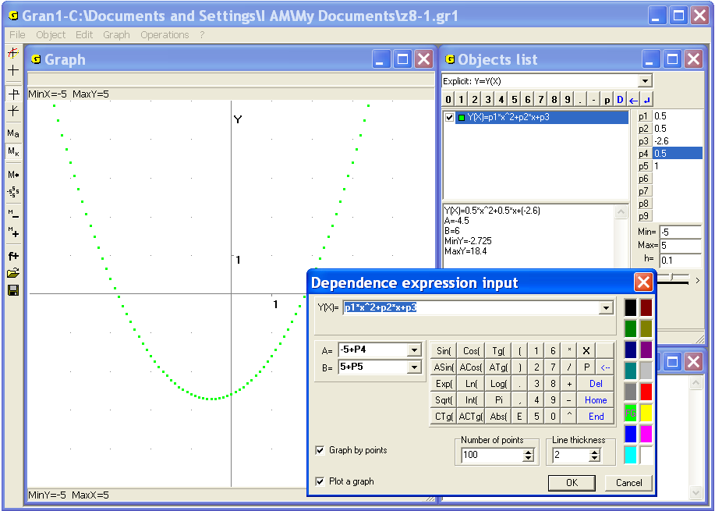
Fig. 8.4
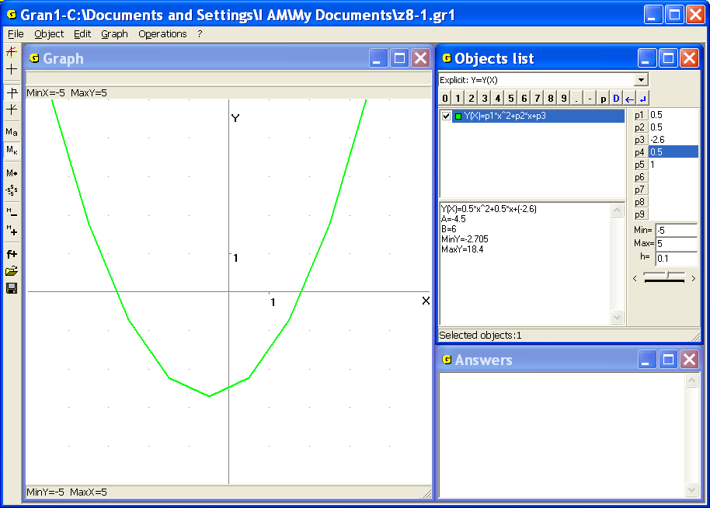
Fig. 8.5
If in expressions of dependencies or limits of dependencies are included parameters , , … , , and graphs of the dependencies had been plotted, the change of a parameter causes automatic re-plotting of the corresponding graphs.
If one uses the command “Object / New object with fixed parameters” after setting some parameters, in the program will be created a new object with fixed parameters, and corresponding graph is fixed. In the figure 8.6 the first object is basic. The next objects are obtained of the first by changing of one of the parameters , , and creating a corresponding object with fixed parameters.
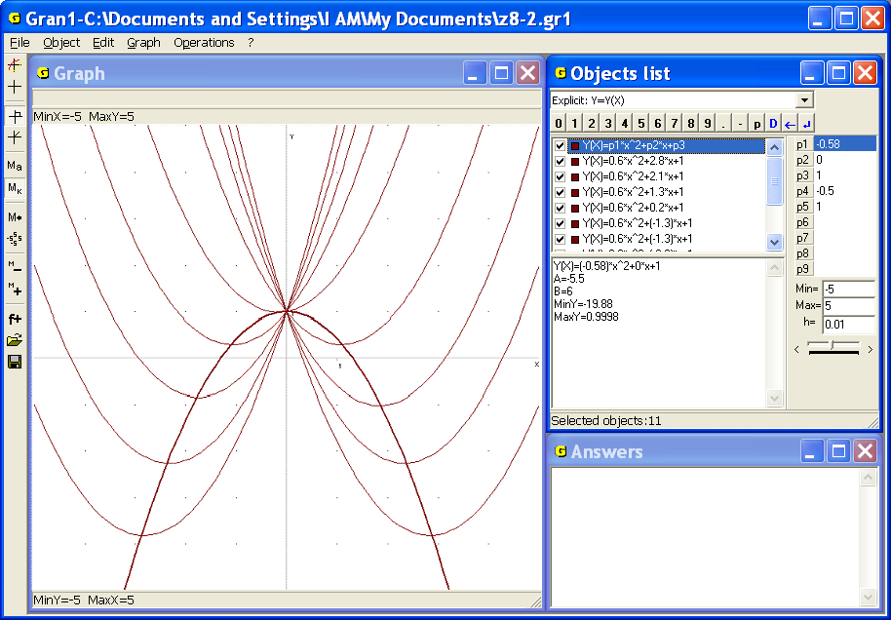
Fig. 8.6
After pressing “OK” creating a new object in the window “Objects list” will be finished. After pressing “Cancel” all actions about the object creation will be canceled (Fig. 8.2).

Examples
1. Suppose it is necessary to plot a graph of the function on a segment.
Set the type of dependence “Explicit: Y=Y(X)” in the window “Objects list”. Then use the command “Object / Create…” As a result the auxiliary window “Dependence expression input” is displayed (Fig. 8.2). Input expression in the line “Y(X)=”.
In the line “А=” input the value of the left end of the segment “”, in the line “В=” input the value of the right end of the segment “”. Dynamic parameters and will be used below to define the segment borders. The color and the number of points for graph plotting left defined by default. Assign the line thickness as 2 and press “OK”.
As a result in the window “Objects list” the new object will be obtained. Set the dynamic parameters values , that correspond to the segment [–2.7, 1.4]. At the bottom of the window some characteristics of the dependence are shown: , , , .
Now use the command “Graph / Graph”. As a result the graph of the dependence on the segment [–2.7, 1.4] will be plot in the window “Graph” (Fig. 8.7).
If to clear the “Graph” window with the help of the command “Graph / Clear” and then use the command “Graph / Graph” the graphs of the dependencies with inscription “Graph” marked by the check box will be plotted. It is possible to set the check box or remove it in the pop-up menu of the object in the window “Objects list”.
2. Let the dependence is defined on the interval [–7, 7] as follows:
Set the type of dependence “Explicit: Y=Y(X)” and input three dependencies:
- on the interval [−7, −1],
- on the interval [−1, 1],
- on the interval [1, 7].
If the inscription “Graph” was marked by the check box for the expressions, the corresponding graphs will be plotted in the “Graph” window after using the command “Graph / Graph” (Fig. 8.8). If the window “Graph” is cleared with the help of the command “Graph / Clear” one should use the command “Graph / Graph” for plotting graphs again.

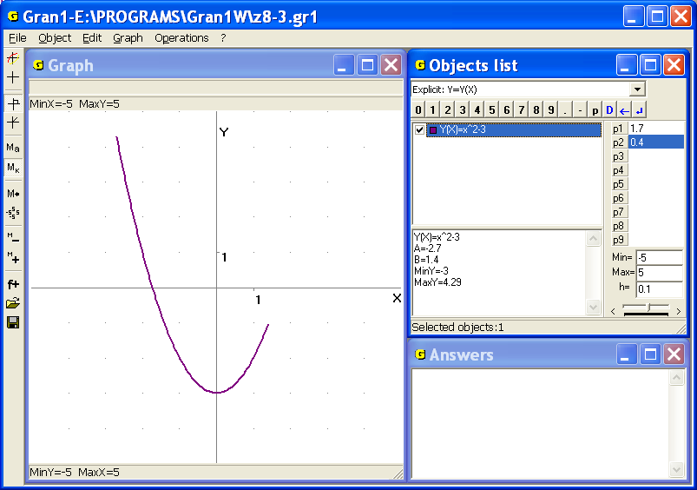
Fig. 8.7
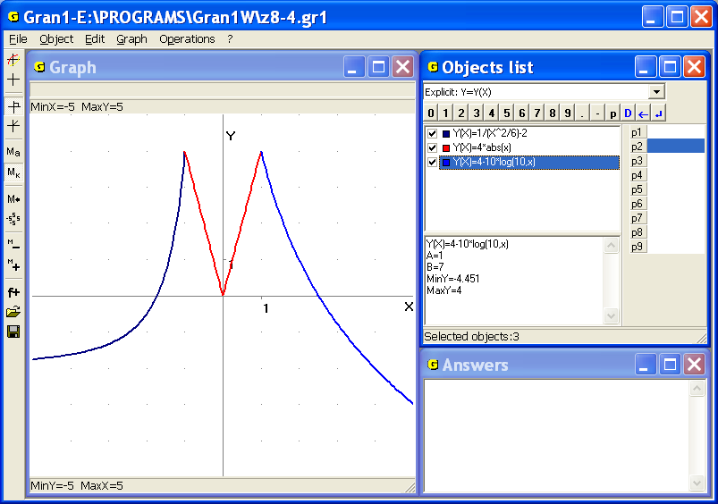
Fig. 8.8
Sometimes it is necessary to enlarge an image in some part of the window “Graph” up to the whole window size. For this purpose one should indicate a rectangle containing the image to be enlarged by dragging the mouse cursor.
The zoom along the axes and is being changed automatically after dragging. The part of the image inside the rectangle enlarged up to the window size is plotting in the “Graph” window. This command is used when it is necessary to precise a graph part, to determine character points etc.
3. It is necessary to determine whether the graph of the dependence has a common point with the axis in the area bordered by the rectangle in the Fig. 8.9.
At the first sight the answer is affirmative (if the accuracy of calculation is not high). But with the enlargement of the graph in a suburb of analyzed point one can see that there isn't a common point of the lines in the suburb (Fig. 8.10).
Enlargement of the zoom in fact causes increase of the calculation accuracy in the suburb of the analyzed point.
To return to previous zoom one can use the command “Graph /Zoom /Previous zoom” or press the button “M←” on the toolbar.
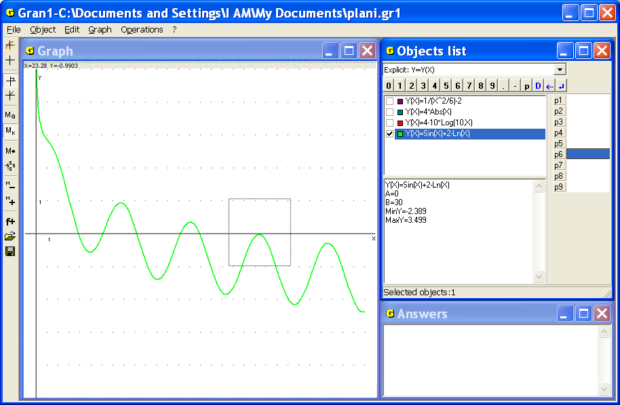
Fig. 8.9
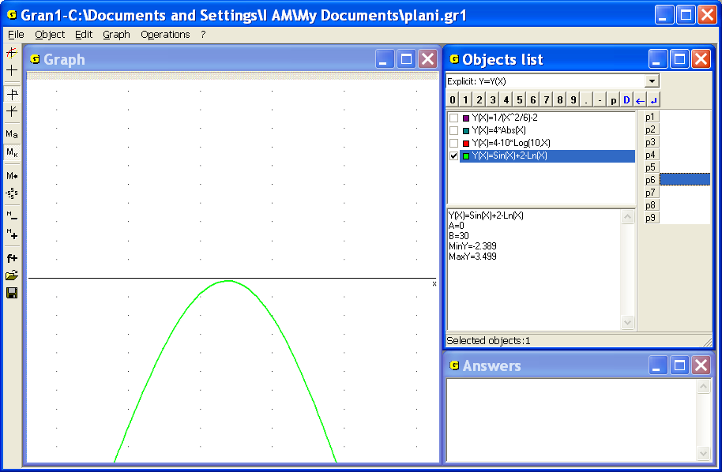
Fig. 8.10
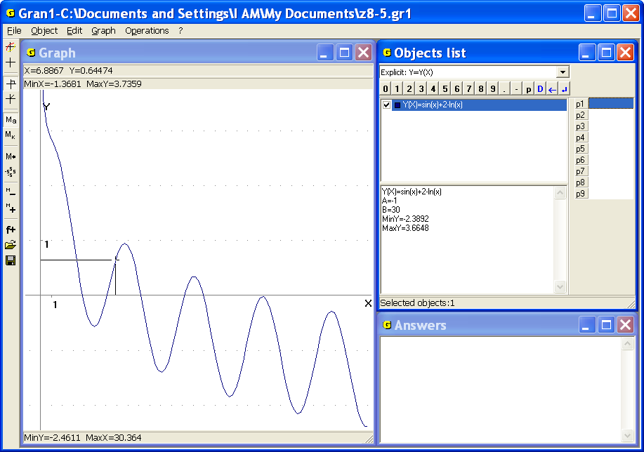
Fig. 8.11
To remove images from the window “Graph” the command “Graph /Clear” is used.
In necessity to calculate a value of an expression of the form for given the graph of dependence can be used. For this purpose one should move the mouse cursor to the point on the graph and read coordinates of the point in the top left corner of the window “Graph” (Fig. 8.11). The same result can be obtained with the help of the keyboard. One should use the command “Graph /Coordinates from keyboard”. In this case increasing of the zoom makes the results more precise.
In the Fig. 8.11 the cursor is set in the point with the abscissa . Then the value .
Another way to calculate a value of expression is to use the command “Operations /Calculator”. As a result the window “Calculator” is displayed. In the window are present the data input panel, the field labeled “Expression:” at the beginning of the input line and answers field (Fig. 8.12). One should enter the expression in the input line (like any other expression) to get its numeric value.
The expression that is situated in the line “Expression” may include any function presented in the data input panel, but can't include variables, that is instead arguments their values must be assigned.
In the expression also may be included parameters: , , … , . If their values are previously determined and shown in a table in the right side of the window “Objects list”, they are used in the expression. If no parameter is previously determined, in the window “Calculator” they take value 1.
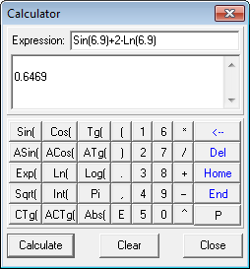
Fig. 8.12

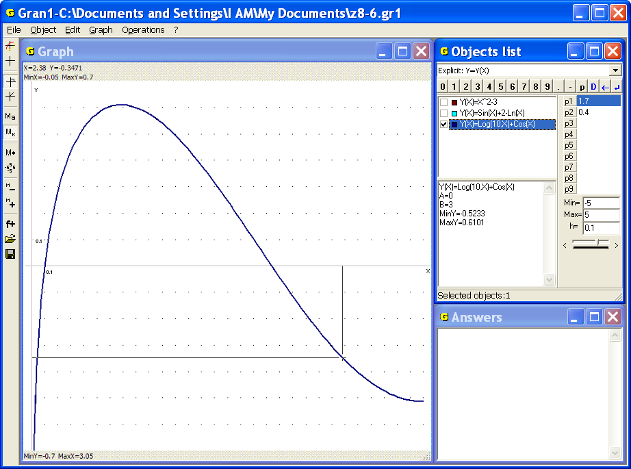
Fig. 8.13
One can input expressions with the help of the keyboard or data input panel.
When an expression is entered one should press the button “Calculate”. In the field below the line “Expression:” a value of the expression will be shown. The answer can be copied to the clipboard for use in other programs.
The button “Clear” clears the line “Expression:” and answer fields. After pressing the button “Close” the window of calculator will be closed.
4. It is necessary to calculate a value of the expression for the value .
Plot a graph of the dependence on the segment [0, 3], then use the command “Coordinates”, set the cursor in the point with the abscissa , and move the cursor up or down up to the point on the graph. The ordinate of the point is the required value of the expression – (Fig. 8.13). The use of the calculator gives the value
To increase the calculation accuracy one should change the segment for choosing , for example, put , , etc, or enlarge a part of the graph.

Questions for self-checking
- Using of what command of the program Gran1 allows to plot graphs of dependencies?
- How many graphs can be plotted at the same time?
- How to determine a correspondence between graphs and expressions?
- How to plot graphs of two dependencies if more dependencies are entered?
- Should all the dependencies, whose graphs are to be plotted, have the same type?
- How to enlarge a part of a graph?
- How to renew a graph if its part had been enlarged?
- How to find a value of expression for preassigned value , with the help of GRAN1?
- How to plot a graph of a dependence defined by different expressions on neighboring segments?
- How to increase the accuracy of coordinates of the points laying on a graph in area of a point?
- How to remove all plots from the window “Graph”?
- How to remove a part of plots in the window “Graph” and leave just several plots?

Exercises for self-fulfillment
- Plot graphs for the dependencies given below. For given values determine corresponding values .
  - ; 0; 1; 1.57; 2; 3; 3.14.
  - ; 0; 1; 1.57; 2; 3; 3.14.
  - ; 0; 1; 2; 3.
  - ; 1; 2; 4; 8.
  - ; -2; -1; 0; 1; 2.
  - ; -3; -1; 0; 1; 2; 3.
  - ; -3; -1; 0; 1; 2; 3; 4.
  - ; -8; -4; -2; 0; 1; 2; 4; 8.
  - ; -4; -2; -1; 0; 1; 2; 4 (hyperbolic cosine).
  - ; -4; -2; -1; 0; 1; 2; 4 (hyperbolic sine).
  - -4; -2; -1; 0; 1; 2; 4.
  - ; 0; 1; 2; 3; 4; 5; 6; 7; 8.
- Plot graphs of two dependencies, ; where the values are changing from to . Consider several values of : 2, 4, 6 and for every several values :
– 0.1, – 0.5, – 1, – 2.
- Plot graphs of the functions: : , , , . Use parameters and, in the expression and fix the required objects.
- Plot graphs of the functions: , , , , . Use parameter in the expression and fix the corresponding objects.
- Plot graphs of the functions: , , , , , . Use parameter in the expression .
- Plot graphs of the functions: ,
- Plot graph of the function. Where the value of the function approaches, if the argument value approaches to ?
- What function increases faster on the segment : or ? (put 2, 3, 4).
- Prove the following statement: if the parameter is being changed and , are fixed, the vertices of the parabola move along a parabola (see Fig. 8.6). Consider the following cases , .
§9. Implicit dependencies
If a dependence between the variables and is assigned in the form , where is an expression from two variables and , determined in an area of change the values and , it is said, that the dependence of the variable upon the variable (or vice versa upon ) is assigned implicitly. If for every value of from a segment a value exists that together with obeys the equation , then thereby the dependence is defined. For this dependence the equality is obeyed for all values on the given segment (becomes identical relatively to ). The expression may contain some of the parameters , , … , .
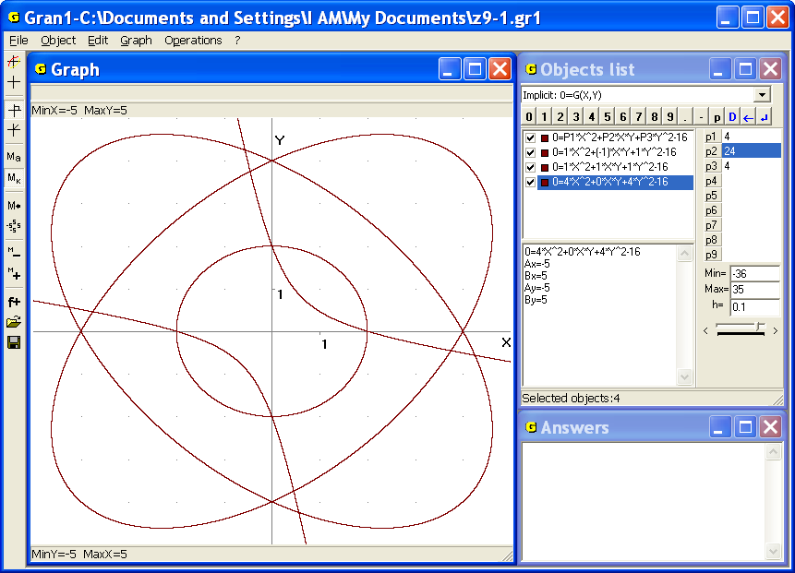
Fig. 9.1
Before inputting an expression , it is necessary to set the type of dependence “Implicit: 0=G(x, y)” in the window “Objects list” (Fig. 9.1). Then a new object the way like in the case of explicit dependence will be created.
As a result of the use the command “Object /Create” the auxiliary window “Dependence expression input” is displayed (Fig. 9.2). In the line “0=” one should input an expression , that may contain two variables and or just one of them, and also some of the parameters , , … , .
Unlike the explicit dependence one should specify the segments of assignment of both variables and . In the lines “А=” and “В=” it is necessary to set lower and upper boundaries of the segment for variable , in the lines “Аy=” and “Вy=” – lower and upper boundaries of the segment for variable . The expressions for boundaries of definition of and also may contain the parameters (Fig. 9.2).
The switch “Quality of graph plotting” is intended for acceleration of graph plotting. If the switch is set in the most left position the speed of plotting increases, but the accuracy of plotting decreases.
All the other rules about plotting stay the same.
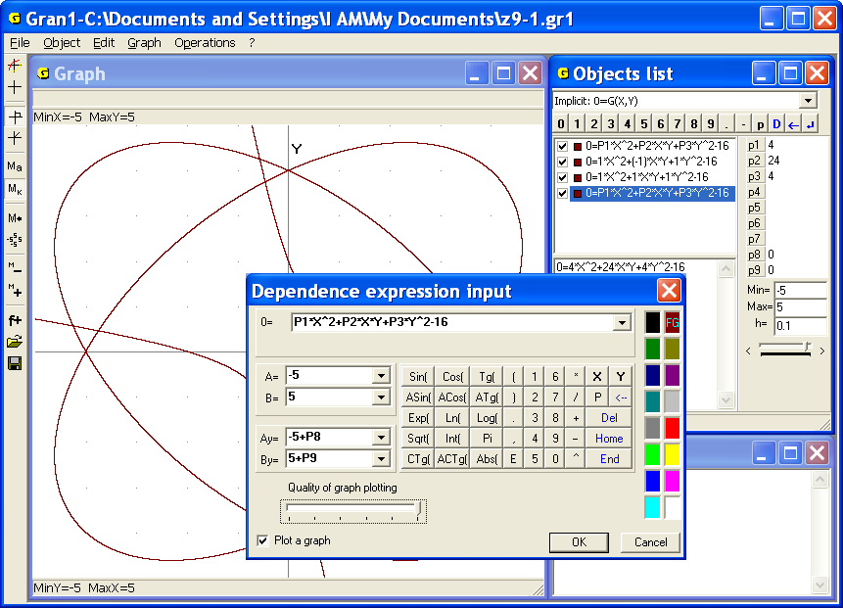
Fig. 9.2
Examples
1. With the equation of the form a straight line is described. Put dynamic parameter in correspondence to the parameter of equation , parameter – to , parameter – to and create the object . At certain values of the parameters, , the object has different corresponding lines. In the figure 9.3 the lines at different values of the parameters, , are demonstrated.
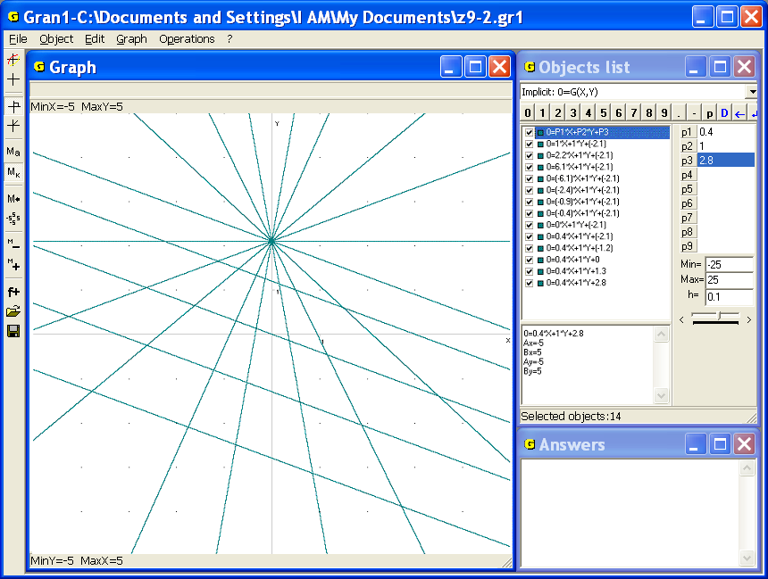
Fig. 9.3
2. Equation of the form is equation of a circle of radius centered in a point with the coordinates, . In the Fig. 9.4 the images of circles at different values of the parameters , , are shown.
3. Equation of the form is equation of the ellipse with the center of symmetry in the origin and semi axes and along the axes and . In the Fig. 9.5 the images of ellipses at different values of the parameters and are represented.
4. In the Fig. 9.6 the image of a curve is shown. This is so called Decart leaf. The curve at different values of the parameter that correspond to the dynamic parameter of the program is represented in the figure.
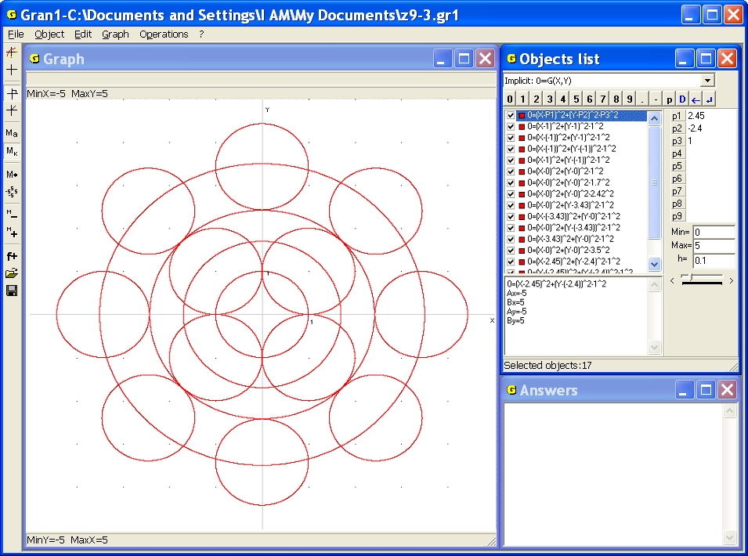
Fig. 9.4
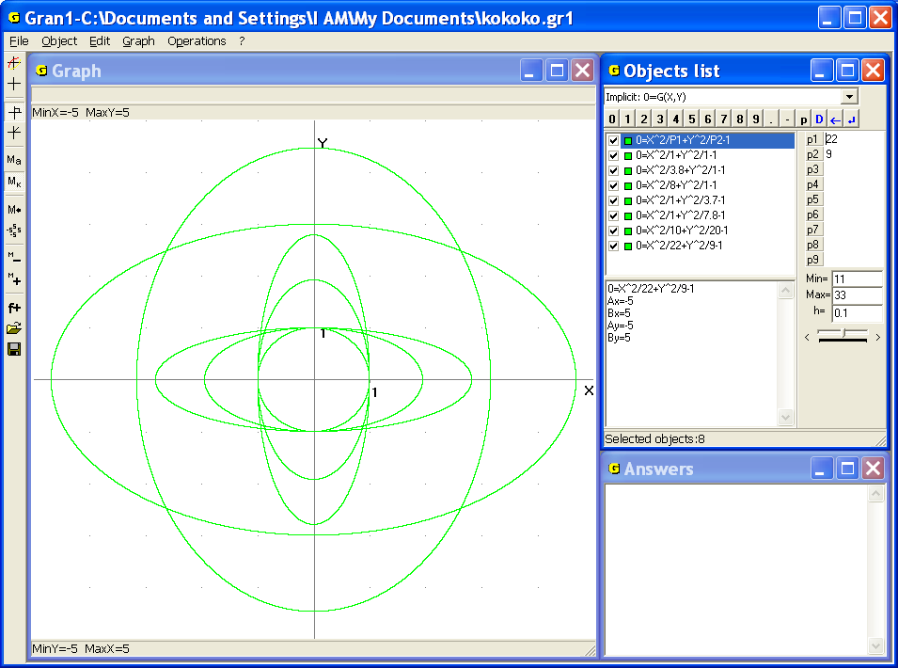
Fig. 9.5
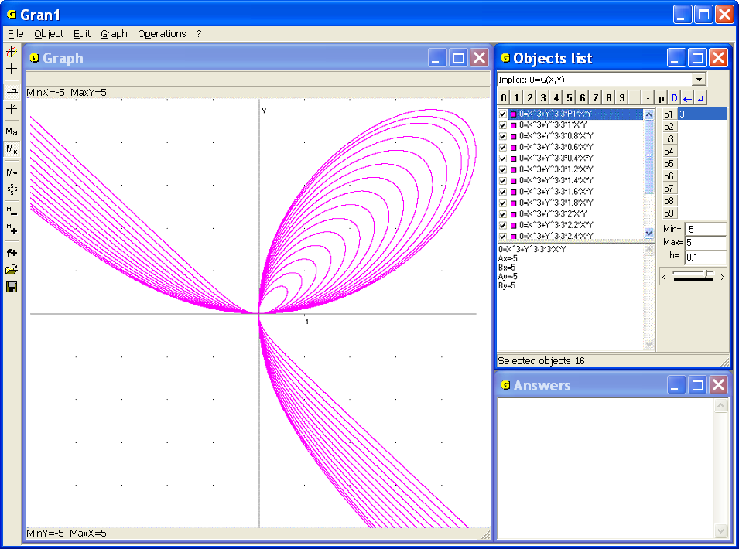
Fig. 9.6
5. In the Fig. 9.7 the graphical image of the dependence is represented.
6. In the Fig. 9.8 the graphical image of the dependence , () at the different values of the parameter is shown. The corresponding dynamic parameter of the program is . Such curve is called astroid.
7. In the Fig. 9.9 the graphical images of the dependencies at the different values of the parameter is shown. The corresponding dynamic parameter of the program is .
If it is necessary to calculate a value of an expression of two arguments in a point one can use the command “Operations / Value of expression G(x,y)” (Fig. 9.10).
While using this command one can see a cursor in the field of the window “Graph”, and also coordinates and of the point under cursor and value of the corresponding function upon the window “Graph” (Fig. 9.11).

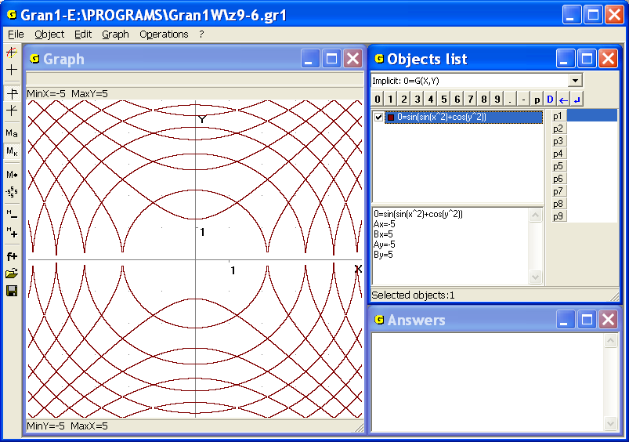
Fig. 9.7
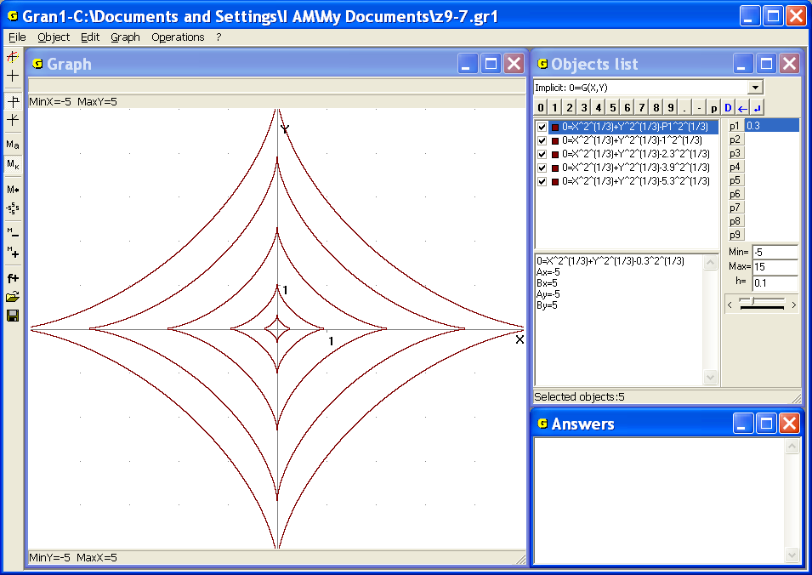
Fig. 9.8
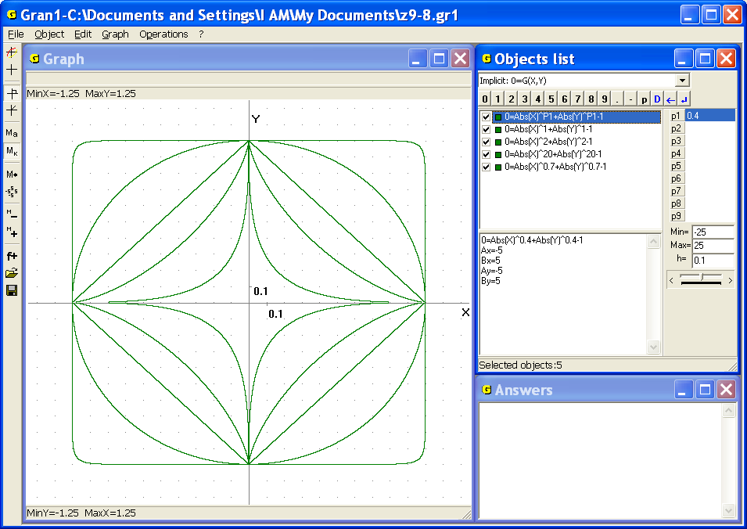
Fig. 9.9
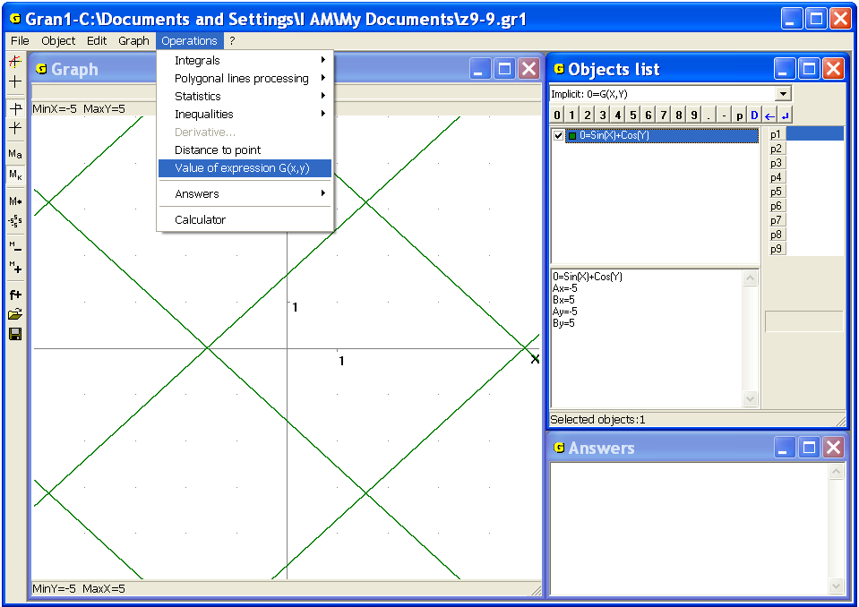
Fig. 9.10
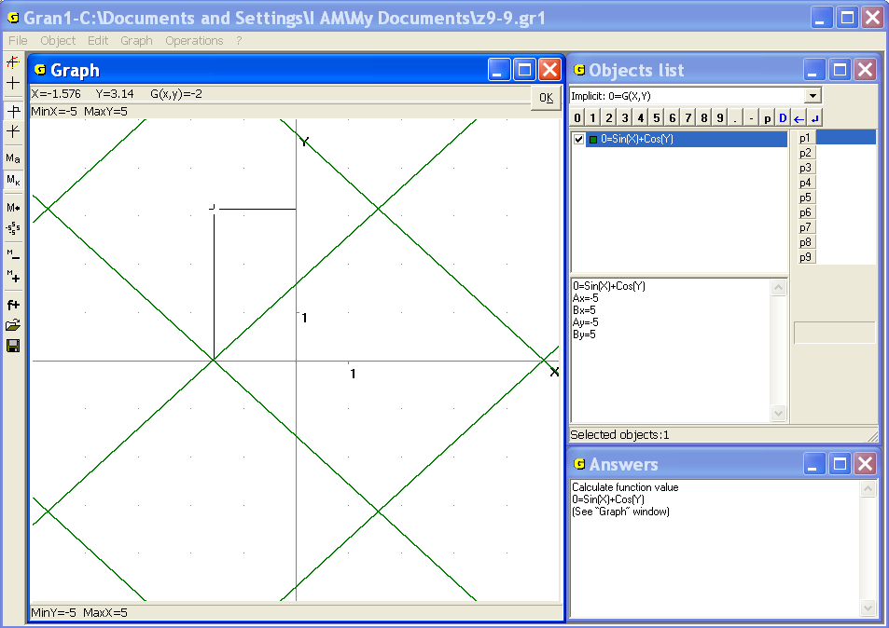
Fig. 9.11
If the cursor moves on the plane then coordinates of a point under cursor and value undergo the corresponding change.
To calculate a value for the preassigned values and it is also possible to use calculator (the command “Operations /Calculator”).

Questions for self-checking
- What dependence between variables and is called implicit?
- How to plot a graph of a dependence between and , defined as ?
- Is it necessary to express the variable explicitly through the variable in the form (or vice versa through in the form ), for plotting a graph of a dependence between the variables and ?
- How many graphs of dependencies of the form can be represented on the screen simultaneously?
- Can an expression be a constant? What is the image of the dependence in this case?
- Can the variable or be omitted in expression?
- How to transform an explicit dependence between the variables and into its implicit form ?
- How to calculate a value of a function of two arguments with the help of the program GRAN1?

Exercises for self-fulfillment
- Assign the type of dependence between the variables and in the form then use the command “Object /Create”, in the line “0=” enter the constant 0 (zero) and plot the graph of this dependence. Explain the result.
- At the conditions like in ex.1, enter an arbitrary constant (not zero). Explain the result.
- Use the implicit type of dependence between the variables and (the type ) to plot graphs of the following dependencies:
- ; | - ; | - ;
- ; | - ; | - ;
- ; | - ; | - .
- ; | - ;
Explain the results.
- Plot graphs of the following dependencies. Use dynamic parameters if necessary:
- Plot graphs of the following dependencies:
- , for different values of the parameter from -5 to 5 with the increment ;
- for values 1 / 4, 1 / 2, 1, 2, 4, 8, 16;
- for values 1 / 4, 1 / 2, 1, 2, 4, 8, 16, 20, 25, 32.
- Plot graphs of the following dependencies. Use dynamic parameters if necessary:
- , for values 0.5; 1; 1.5; 2; 2.5 (so called semi-cubic parabola);
- ; | - ;
- ; | - .
- Plot graphs of the following dependencies , if:
- ; | - ;
- ; | - .
Explain the results.
- Calculate a value of the function in intersection points of the lines , .
§10. Inverse dependencies and their graphs
Suppose some dependence is assigned on a set (a domain of the function) and suppose is a set of the values of the expression, which it takes while the variable takes values of the set. If to chose a value from the set , then in the set one can find such a value , at that the expression takes the value , that is . Thus for every value a corresponding value exists. Thus on the set the dependence , that is called inverse for the dependence , is defined. If the dependence , that maps the set into the set (it is written), is bijective (that is for every by the rule a unique corresponding value is assigned, and for different values different values are assigned), then the inverse dependence is bijective too. If the correspondence isn’t bijective then the inverse dependence is not bijective.
If the correspondence () is univocal, then it is spoken about the functional dependence () or the function (inverse function ). Inverse function sometimes is denoted as follows .
Some examples of bijective inverse dependence are considered below:
1) linear function , ();
2) power function at odd (, 0, 1, 2, …);
3) exponential function , (,);
4) logarithmic function , (,);
5) function (,);
6) any monotonically increasing or monotonically decreasing function.
In the foregoing examples for any allowable value (from the domain of the expression) always exists the one value in the range of , and any value from the range corresponds to only one value from the domain of . In this way the bijective correspondence between the elements (points) of the set (the domain of ) and the elements (points) of the set (the range of ) is assigned.
In the case of the bijective correspondence there always exists unique function , (), inverse to the function so that for any , (, , ), and for any , (, , ). In the considered case the functions and are mutually inverse to each other.
Some examples of ambiguously defined inverse dependencies are given below:
1. , (), when the domain contains more than one point.
Since the same value is associated with any value from the domain of, it is impossible to uniquely identify the value, to which the value corresponds. In this case an inverse correspondence exists but inverse function doesn’t exist.
2. Any function, that takes equal values on the interval or on several intervals. Particularly so-called piecewise constant functions (Fig. 10.1).
3. Function.
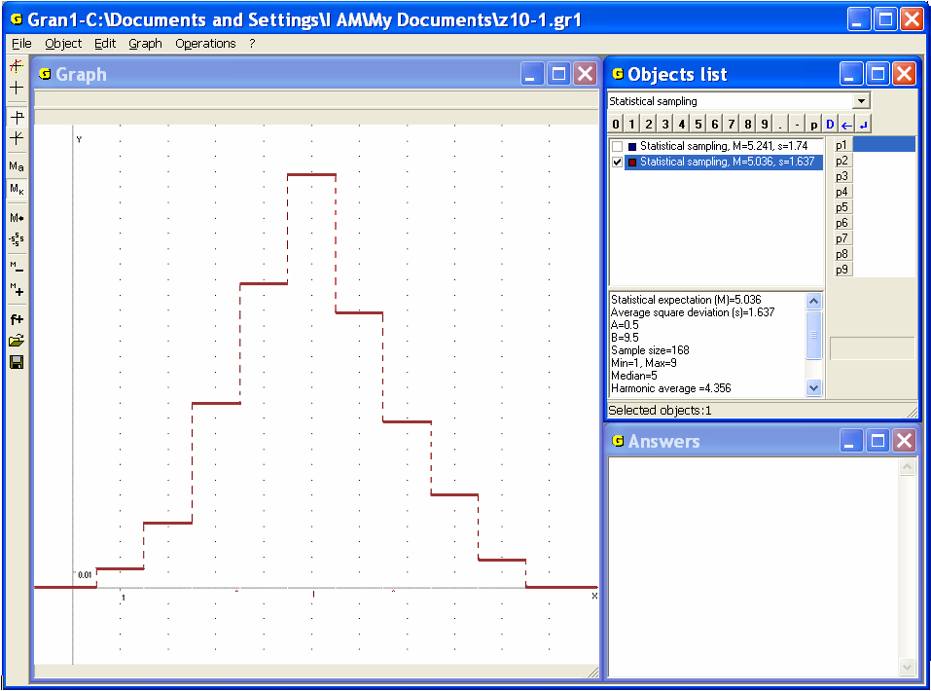
Fig. 10.1
If then using the function it is defined the bijective correspondence, and for each value a unique value is defined, and for different from there exist different corresponding values from . Thus, in this case the function inverse for is defined uniquely: , .
If and, then arguing similarly we can conclude that in this case the function inverse for is defined uniquely as well: , .
If the set is accepted as the domain of then it is impossible to uniquely define a function inverse for, because the same value is associated with two different values.
Therefore the inverse dependence is not unique: , implies , .
Thus:
for
and for ;
for
and for ;
for
and for ;
thus and are functions, but is not a function, because the dependence upon is not unique – for one value there exist two different corresponding values .
4. . Arguing similarly to the previous case one can make conclusions: if domain of the function is such that for two different values of the same value doesn’t exist, then the inverse dependence is defined uniquely. Usually as such a domain the interval is selected.
If the domain of dependence is such that for two different values of by the rule the same value can exist, then the inverse dependence is not functional. If the function is considered on the different parts of the domain, where the function only increases or only decreases, then for the function on such parts exist different inverse functions.
Suppose some dependence is defined in some domain. After plotting a graph of the dependence it is possible to define an inverse dependence in the following way: on the axis choose a value (the argument for ) from the range of ) and through chosen point on the axis plot a straight line parallel to the axis . Intersection points of the line with the graph should be projected on the axis . Thus one can obtain values such that . So if the argument of is chosen on the axis (in the range of ), then the graph of the dependence is at the same time the graph of inverse dependence . If the argument is chosen on the axis , then one should swap the variables and and at first plot a graph of , and after that choose the argument of on the axis (from the range of ), through the chosen point on the axis plot the line parallel to the axis , intersection points of the line and graph of project on the axis , and in this way the values can be obtained. Thus the graph of is at the same time the graph of the dependence , that is inverse for .
Thus, the graph of dependence can be obtained as the mirroring of the graph about the line (bisector of the first coordinate angle).
To plot graphs of and of the inverse dependence with the help of GRAN1, it is convenient to represent dependencies between the variables and in the form and , then to plot graphs of the dependencies and .

Examples
1. Plot graphs of the dependencies: , .
It is easy to see (Fig. 10.2) that the graph of is at the same time the graph of dependence, that has inverse one . In this case , .
2. Plot graphs of the dependencies and , for make sure (Fig. 10.3) that graph of the dependence is at the same time graph of the dependence (defined on the interval
[-1, 1]), if the interval [0, π] is the range of the function .
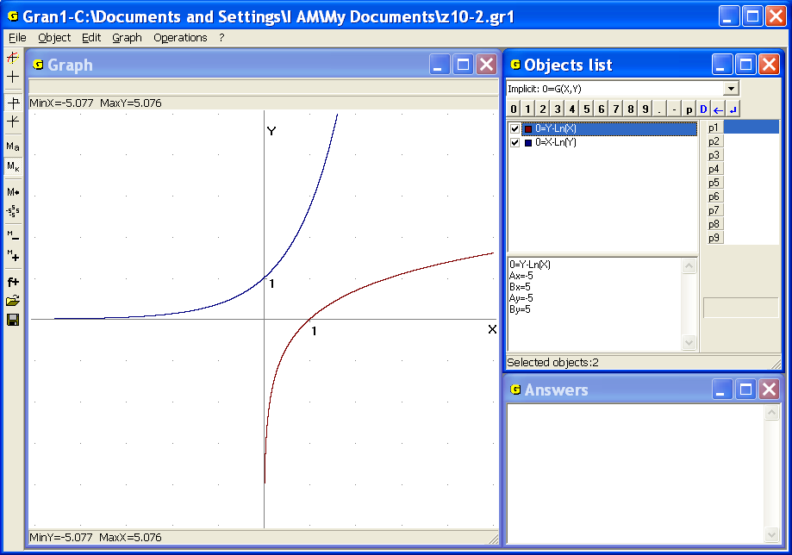
Fig. 10.2
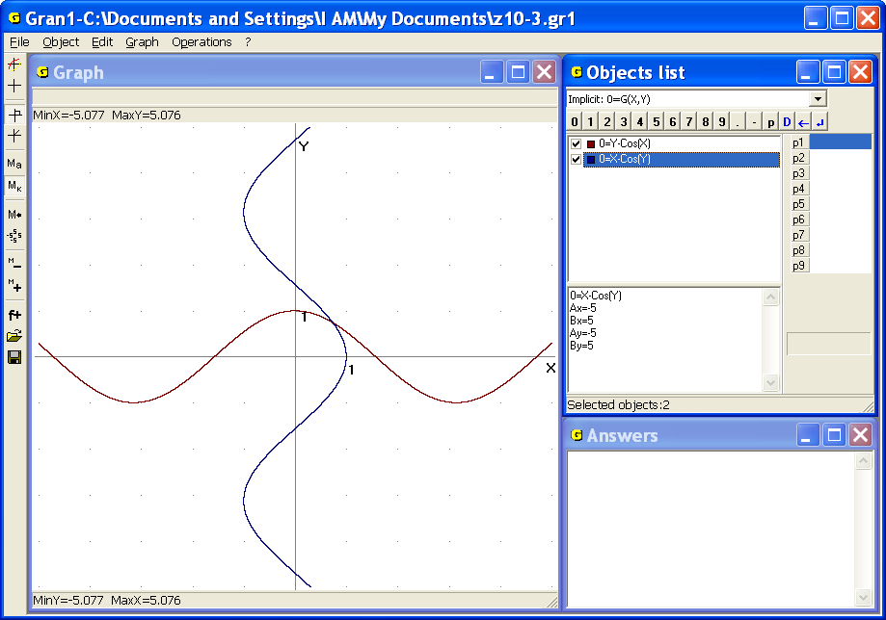
Fig. 10.3
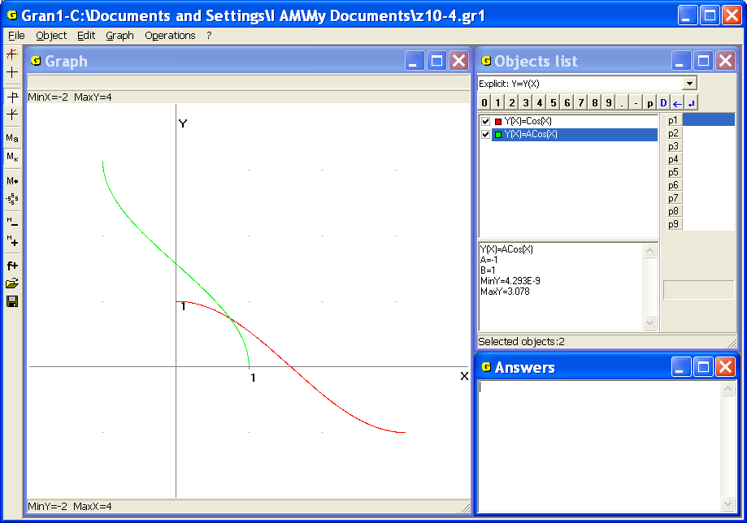
Fig. 10.4
In this case a bijection between sets [0, π] and [-1, 1] is set: the function maps the interval [0, π] on the interval [-1, 1], the function maps the interval [-1, 1] on the interval [0, π] (Fig. 10.4). In this case , .

Questions for self-checking
- When dependence is inverse one for dependence ?
- Could dependence be inverse to itself? Give examples.
- When a dependence inverse for is defined uniquely?
- Does the existence of inverse dependence depend on area where dependence is defined?
- How to define values corresponding to the value , if there is only plotted graph of the dependence ?
- Can a graph of dependence be treated at the same time as a graph of inverse dependence ?
- How to plot a graph of dependence , inverse for dependence ?
- How graph of dependence and graph of corresponding inverse dependence are placed on a coordinate plane ?
- How graph of a dependence will be changed if to trade places of variables and ?

Exercises for self-fulfillment
- Plot graphs of the following dependencies and the corresponding inverse dependencies: ; ; ; ; ; .
- Plot graphs of the dependencies:
- and ;
- and ;
- for the values -3, -2, -1, , .

§11. Parametric definition of dependencies
It is often convenient to express a dependence between variables and not through equivalence of expressions with the variables and but through an auxiliary variable in the form: .
If for the dependence there exists an inverse dependence so that , , it is possible to set an immediate relation between the variables and in the form .
Representation of dependence between the variables and in the form , is called parametric, the variable is called parameter. Excluding the parameter from the equalities , , by different ways one can get an expression of dependence immediately between the variables and . Parametric representation of dependencies is especially convenient for investigation of trajectories of move of points with coordinates and that change in time . With the help of dependencies and one can describe a trajectory of move of a point on the plane.
For plotting a graph of dependence between and , that is defined through the parameter in the form , with the help of GRAN1 one should set the type of dependence “Parameter: X=X(T), Y=Y(T)” in the window “Objects list” (Fig. 11.1). After that auxiliary window “Dependence expression input” will be displayed (Fig. 11.2). In the line “X(T)=” one should input an expression for , in the line “Y(T)=” – an expression for . In the lines “А=” and “В=” it is necessary to assign upper and lower bounds of the parameter correspondingly (Fig. 11.2).
All the rules concerning plotting stay the same.
Examples
1. A circle of radius centered in the origin is determined by equations , where parameter is changing on . Indeed . For different values of the corresponding graphs are represented in the Fig. 11.1.
2. The circle of radius rolls without sliding along the axis . A fixed point on the circle at the start moment coincides with the origin and is a point of contact of the line and the circle.
Parameter is the angle of turn of the radius that joins the center of the circle and the point on the circle.
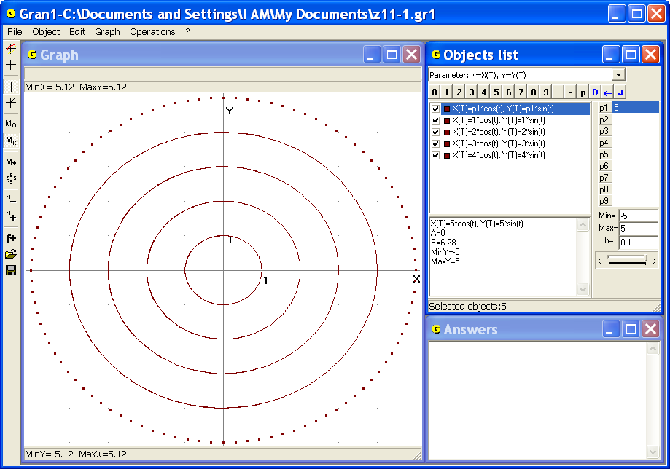
Fig. 11.1
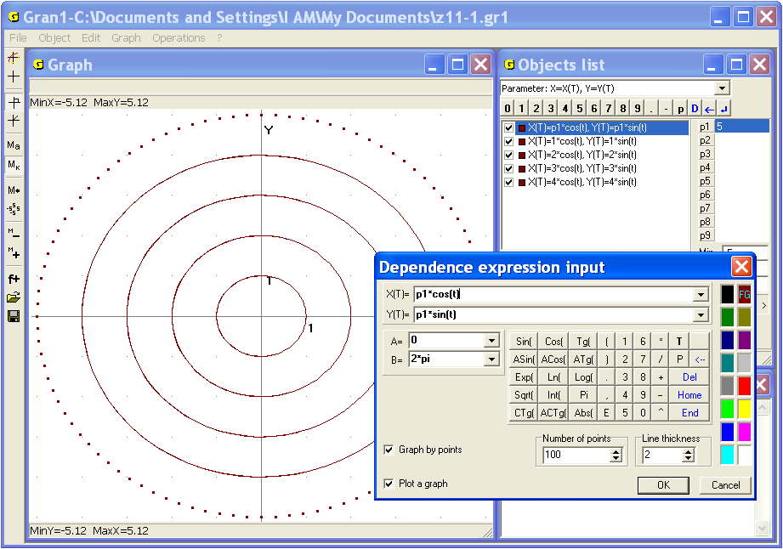
Fig. 11.2
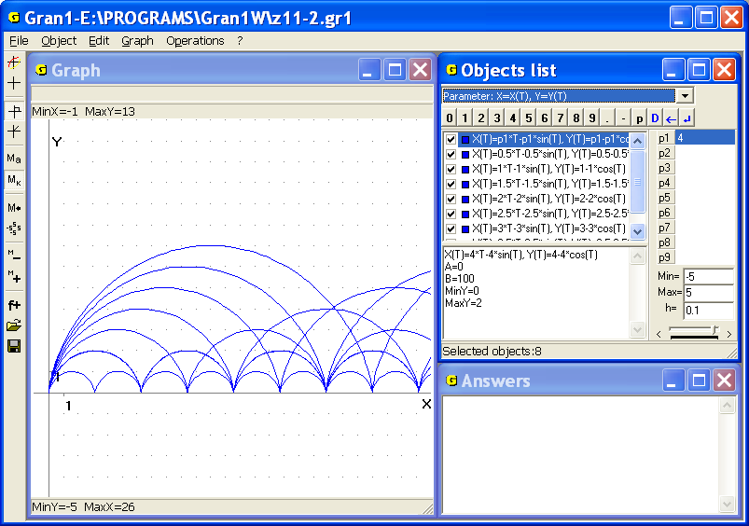
Fig. 11.3
It is easy to see that the trajectory of the point is described by equations , . A curve that the point circumscribes in the time while the ordinate will be equal to zero again (at ), is called cycloid. Cycloids for different values of parameter are represented in the Fig. 11.3.
The example is more visual if the model of cycloid is expanded by two objects: generative circle and a point on it. For this purpose the following objects should be created in the program:
- a curve defined parametrically , . Put bounds for , ;
- a circle centered in the point of radius ;
- a circle centered in the point of radius 0,05.
Put , for the parameter, , for the parameter .
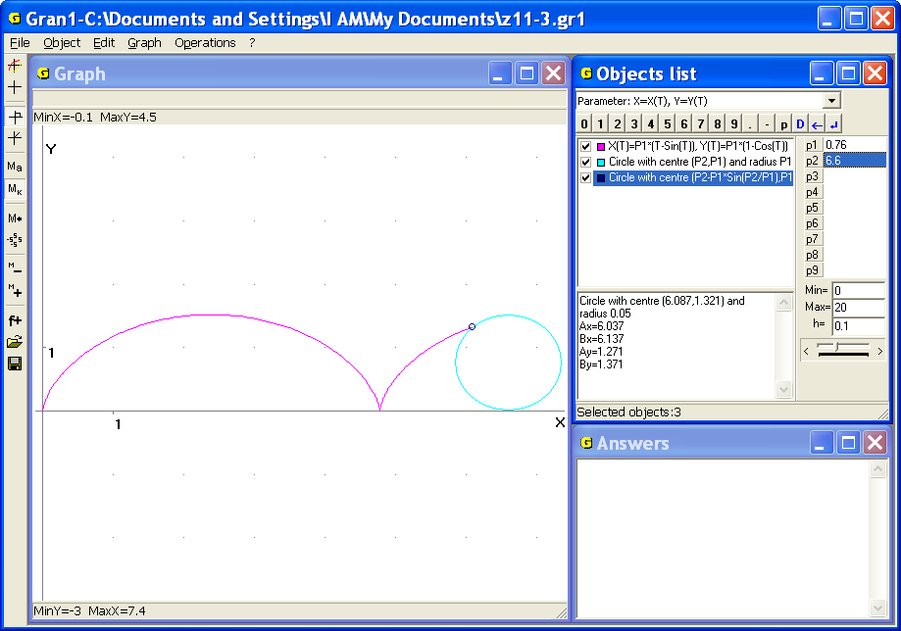
Fig. 11.4
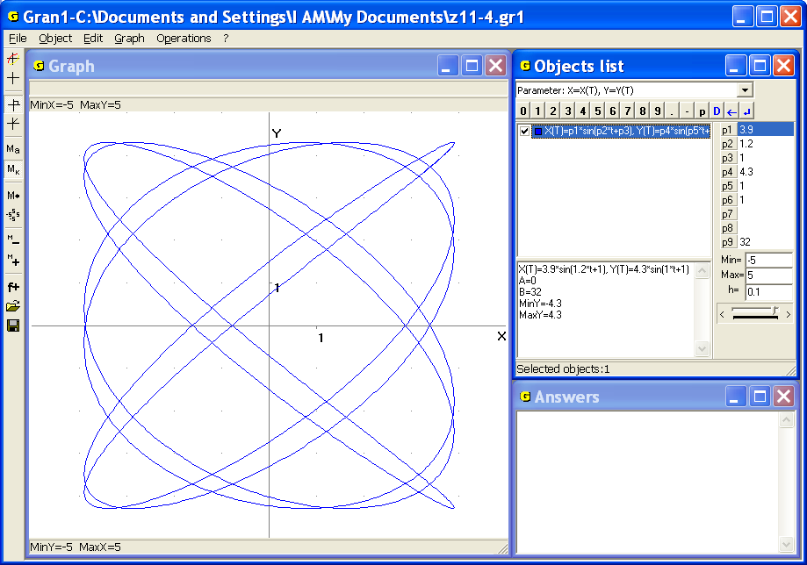
Fig. 11.5
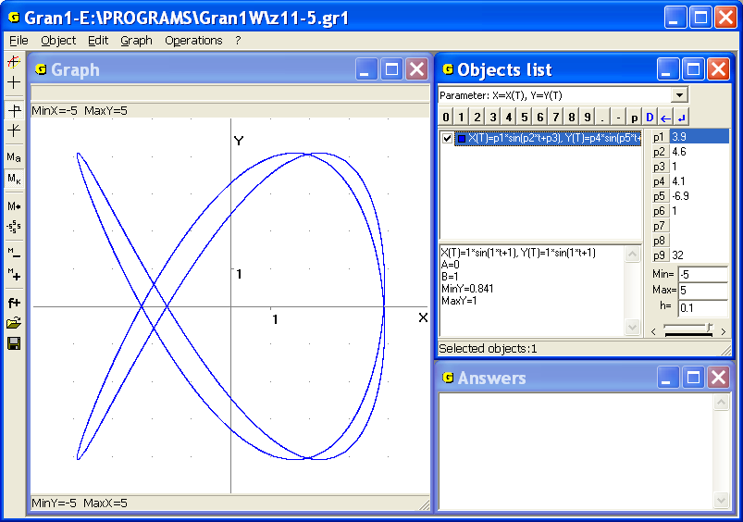
Fig. 11.6
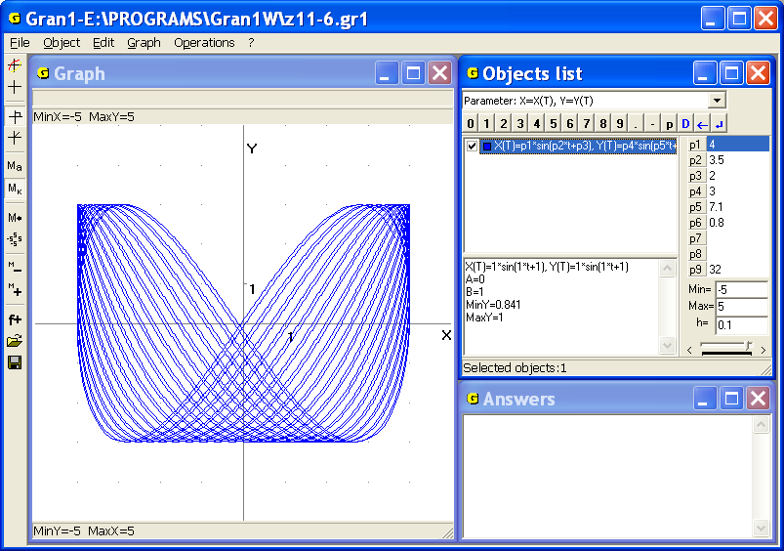
Fig. 11.7
The first object defines a cycloid, the second – generative circle, the third – a point on it. It is possible to get various cycloids by changing value of (the generative circle radius). It is shown in the Fig. 1.3. By smooth changing of value , it is possible to model moving of the circle along the line while a point on the circle circumscribes a cycloid (Fig. 11.4).
Similar models can be plotted also for other interesting curves: epicycloid, hypocycloid, epitrochoid, hypotrochoid etc.
3. Lissajous figures – graphs of dependencies of the form , . In the Fig. 11.5, 11.6, 11.7 one can see some of the figures that correspond to the objects in the program , , at different values of parameters , , , , , when the parameter is altered in the bounds from 0 to .

Questions for self-checking
- How to assign an immediate relation between variables and with the help of parametric definition of corresponding dependence?
- How to get a graph of dependence between variables and with the help of parametric definition of the dependence with the help of GRAN1?
- How to get a value of variable, that corresponds to assigned value of variable , if dependence between and is set in parametric form?
- If the following equations , are given and corresponding curve has been plotted, how will be placed the curve that is defined by the equations , relatively to the first curve??
- Suppose the following equations are given: , and it is necessary to plot graph of corresponding dependence between variables and with the help of GRAN1. What of the expressions and should be entered the first? What will be obtained if the order of input of the expressions will be changed?
- If a dependence between variables and is defined explicitly in the form , can it be expressed in the parametric form?

Exercises for self-fulfillment
- Plot graphs of dependencies defined parametrically:
- , at different values of parameters and (ellipse);
- , at different values of parameters and , (epicycloid circumscribed by point on a circle of radius , that moves outside on a circle of radius );
- , at different values of parameters and , (hypocycloid circumscribed by point on a circle of radius , that moves inside on a circle of radius );
- , (cardioid – a particular case of epicycloids at );
- , (astroid – a particular case of hypocycloid at ).
- Plot Lissajous figures , for the following values:
- , , , , , ;
- , , , , , ;
- , , , , , ;
- , , , , , ;
- , , , , , ;
- , , , , , ;
- , , , , , .
- Coordinates of the body thrown with the initial speed angularly towards the horizon, are changing in time t according to the law:
, , .
Find at given and :
3.1. Maximum height that the body reaches;
3.2. Distance between the start point and the drop point of the body if
;
;
3.3. What should be the angle in order to at given the drop point of the body was remoted from the start point to the distance , if 8, 9, 10, 11, 12, 13, 14?
3.4. What must be a value, in order to at given the drop point of the body was remoted from the start point to the distance , if ?
- The target is placed behind the cover whose top has coordinates . Coordinates of the target are , (,). The gun is placed in the point with coordinates , (,). What must be the initial speed of the shell and corresponding pitch to the horizon of the throw direction, in order to the shell hit the point , flying over the top of the cover on the height ?
- For concrete calculations put , , , , , , .

§12. Dependencies in the polar coordinates
Denote the polar radius of a point on plane by , and corresponding polar angle by . For any dependence of the form (explicit) or of the form (implicit) there exists corresponding graph (a set of points whose polar coordinates fit the equality) in the polar coordinate system. Besides suppose that if the value of the angle is negative, then from the polar axis the corresponding angle is put clockwise and absolute value of the angle is equal to the given one.
If the angle is larger than 2π, it means that at first one should put anticlockwise an integer number of angles 2π (full circles) that is hold in the given, then one should put the angle anticlockwise from the polar axis. To go from polar to rectangular coordinates it is necessary to solve the system of equations , of variables and and then in the expression instead and put their expressions through and (or omit variables and from equalities , , some other way).
In the program GRAN1 it is permitted only explicit type of definition of dependence between the polar coordinates and in the form .
To plot graph of dependence between the polar coordinates and with the help of GRAN1 one should set the type of dependence “Polar: R=R(F)” in the window “Objects list” (Fig. 12.1).
As a result the auxiliary window “Dependence expression input” is displayed (Fig. 12.2). In the line “R(F)=” one should enter the expression . In the lines “А=” and “В=” it is necessary to assign upper and lower bounds of the segment where the variable is changing (default values of the bounds are 0 and 2π ).
Entering of expressions and assignment of other parameters (color, number of points for plotting etc) is being realized like before. In expressions of dependencies and bounds of argument changing can be included parameters , , …, .
Then with the help of the command “Graph” (and other commands) one can execute all operations of the program with graphs concerning the dependence between the variables and .
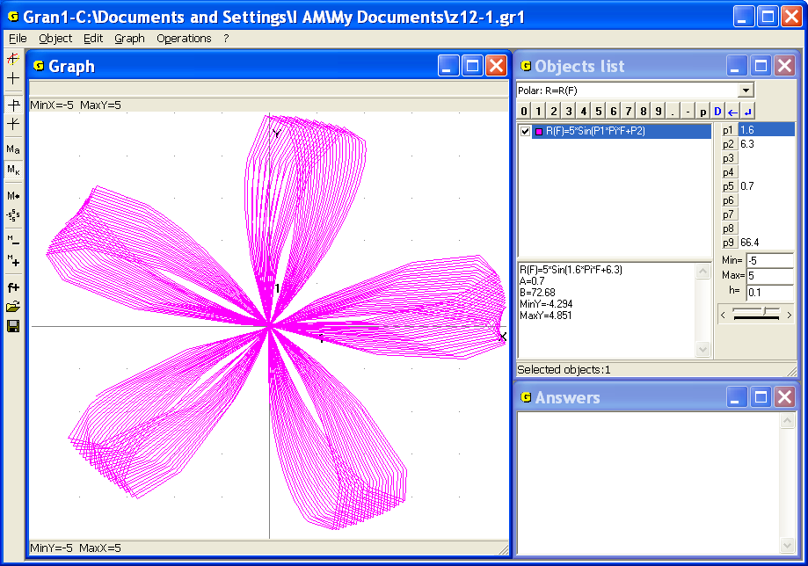
Fig. 12.1
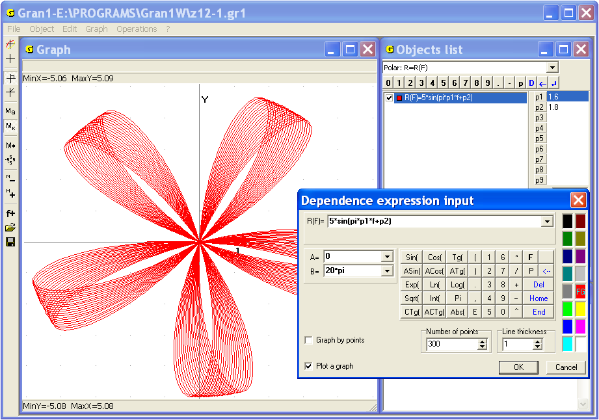
Fig. 12.2
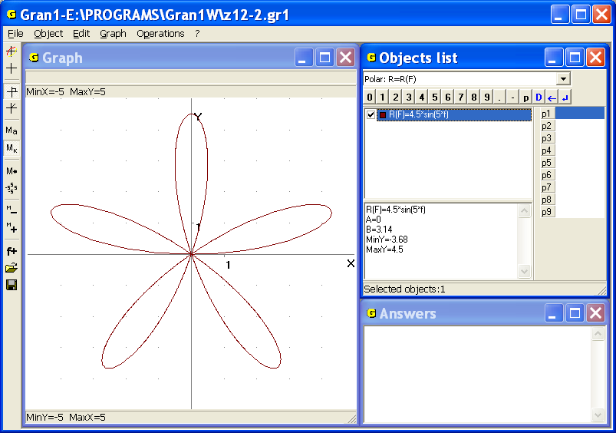
Fig. 12.3
Examples
1. In the Fig. 12.3 graph of the dependence (pentapetalous rose) is represented.

2. A graph of the dependence , (, ), is a circle of radius (Fig. 12.4).

3. A graph of the dependence , (), is the ray that goes out the pole and is inclined to the polar axis under the angle (Fig. 12.5) (it should be noted that the in program GRAN1 it isn’t permitted to plot graph of the function .

4. A graph of the dependence, (, ) is the line perpendicular to the polar axis and remoted from the pole along the polar axis at ; the line parallel to the polar axis (Fig. 12.6).
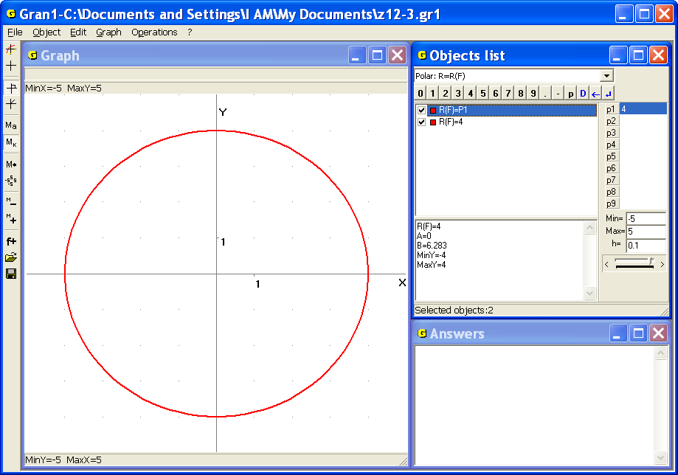
Fig. 12.4
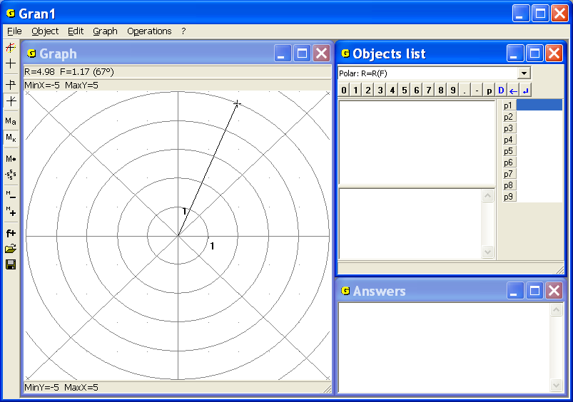
Fig. 12.5
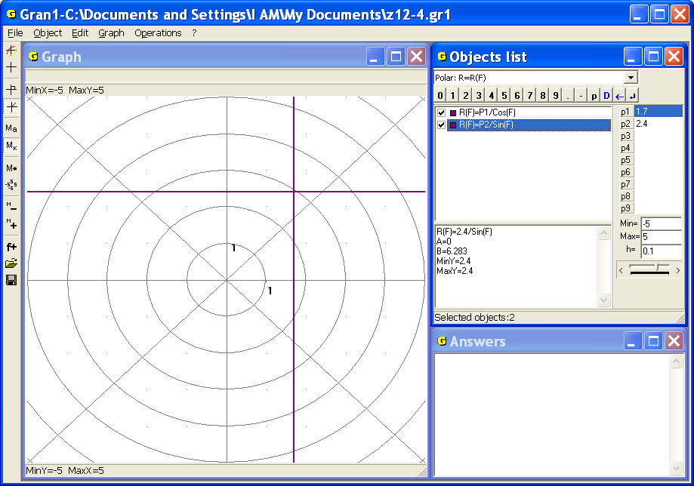
Fig. 12.6
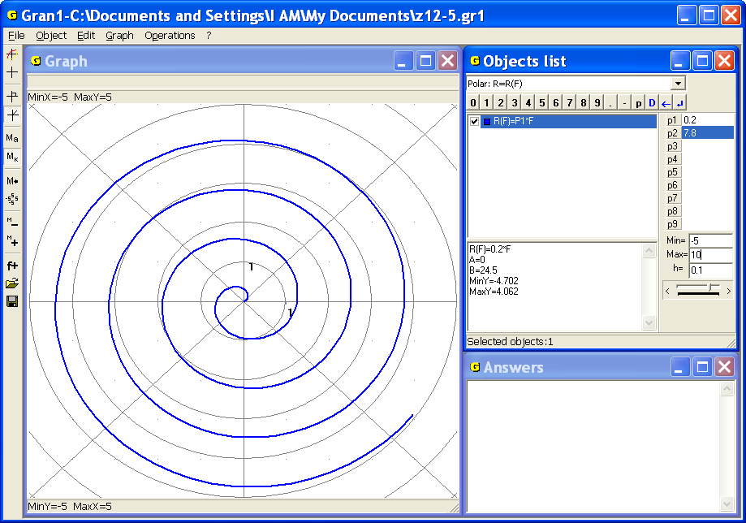
Fig. 12.7
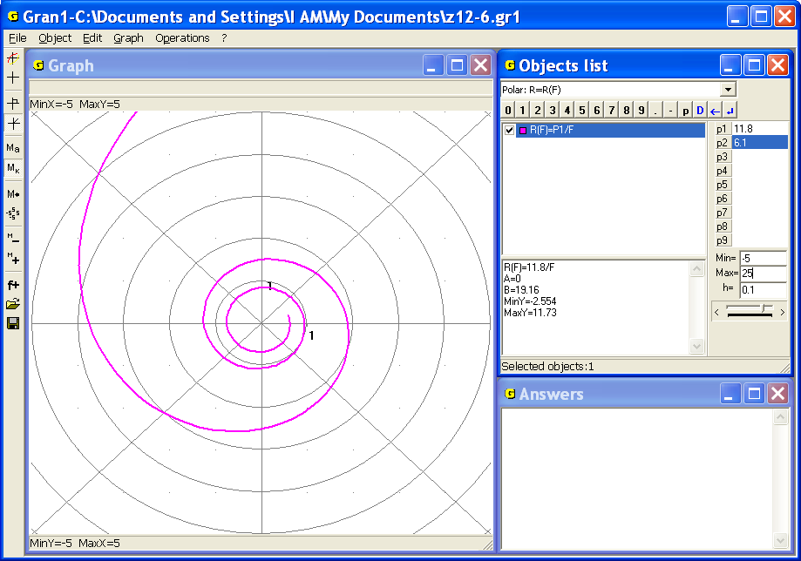
Fig. 12.8
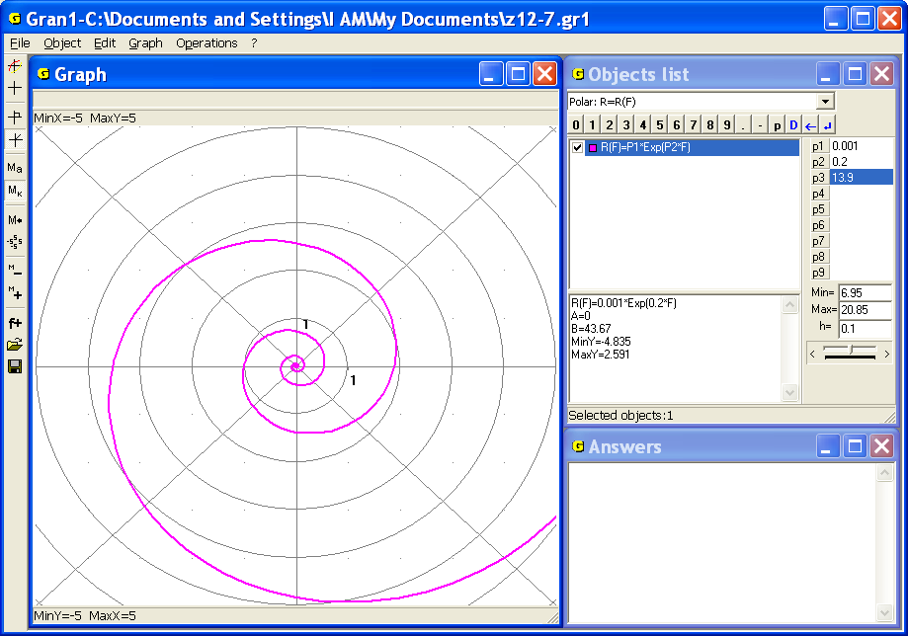
Fig. 12.9
A graph of the dependence , (, , ), is the Archimedean spiral (Fig. 12.7); of the dependence , (, , – the hyperbolic spiral (Fig. 12.8); of the dependence , (, , ) – the logarithmic spiral (Fig. 12.9).

Questions for self-checking
- How to transform an expression given in the polar coordinates into expression in the rectangular coordinates?
- How the points with negative polar angles are represented on the coordinate plane?
- How the points with polar angles larger than are represented on the coordinate plane?
- How to plot graph of dependence , given in the polar coordinates, with the help of GRAN1?
- Is it possible to use GRAN1 for plotting graph of the implicit dependence between the polar coordinates?
- How the set [0, 2π] of argument values of function will be changed, if to put instead?

Exercises for self-fulfillment
      - Use GRAN1 for plotting graphs of dependencies between the polar coordinates and (at various values , , ) in the bounds of from to , changing from 0 to 200:
- , (, ). Consider the following cases:
- ;
- ;
- .
- and .
- .
- , , , .
- .
- .
- .

§13. Tabular- defined functions
and their approximation by polynomials
In many cases some dependence can be defined with the help of a table of values of the expression in the finite number of points in the form
 |  |  | … |  | .
 |  |  | … |  | .
Sometimes analytical form of the expression is unknown and only values of the expression in some separate points are available. These values can be found as a result of observation or measuring in an experiment. If one sets the points , (), on the coordinate plane accordingly to the table, it is possible to obtain an approximate presentation of the observed dependence. If the quantity of the points is large enough, they are placed close enough, and one can state that values of the expression are changing smooth enough with changing the argument on the interval then the graphical presentation in full measure characterizes the dependence .
But sometimes it is necessary to find at least approximate analytic presentation of a tabular-defined dependence. In some cases it is possible to select expression such a way that the values are near enough to the values given in the table for all the values (). As a rule, the process of selection of expression is quite difficult without special research.
The expression whose values in the points , that are given in the table, are marginally differ of the values of the observed dependence , is searched in the form of the polynomial of degree . Unknown coefficients are selected so that the sum of squares of differences of values of the polynomial and values of expression in the points , given in the table, should be minimal. Such a method of finding a polynomial of degree no more than preassigned value , that minimally in certain sense deviates from the tabular-defined function, is called the least-squares method.
As a rule the degree of polynomial is preassigned. The degree must be much less than quantity of points in the table. If , then coefficients of the polynomial can be selected so that for all (), the equalities are true, since the system of equations
always has unique solution.
In the program GRAN1 it is provided finding a polynomial of degree no more than 7 to get the best approximation of a table-defined function on the base of the least-squares method no more than in 10000 points.
Before assignment of the table it is necessary to set the type of dependence “Table: Xi, Y(Xi)” in the window “Objects list” (Fig. 13.1).
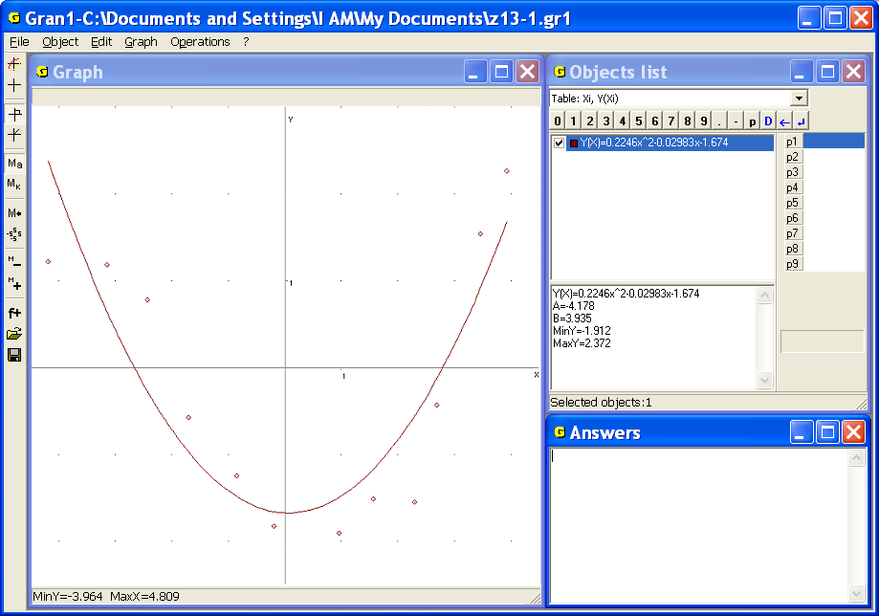
Fig. 13.1
When some dependence is tabular-defined (like in the case of polygonal lines and statistical sampling) one should input the data in the table form from the keyboard, data input panel, the screen or from some text file.
After assignment of the type of dependence “Table: Xi, Y(Xi)” and appeal to the command “Object / Create” the auxiliary window “Data for approximation by polynomial” will be displayed (Fig. 13.2).
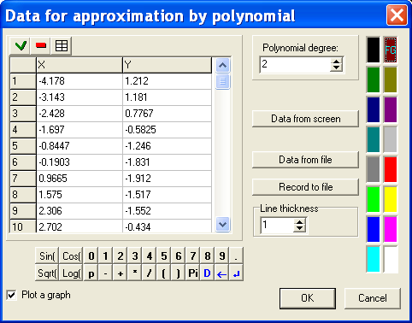
Fig. 13.2
The numbers are entered by pairs, the first number is an argument, the second is corresponding value of expression.
As in the case of the object type “Polygonal line”, coordinates of points can be entered in the table as follows:
- with the help of the keyboard;
- with the help of the mouse and the data input panel in the window;
- with the help of the button “Data from screen”. After that one should indicate points on the coordinate plane by the mouse;
- with the help of the button “Data from file”. After that one should read the data from the selected file (if such file had been created before).
The data can be saved in a text file with the help of the button “Record to file”.
It is also necessary to set a degree of the polynomial from 0 to 7, a color and a thickness of graph lines in the auxiliary window (Fig. 13.2).
As a result in the window “Objects list” a new analytic expression of the form is displayed. is a polynomial of defined degree that the dependence approximates the best way given tabular-defined dependence in the mean square sense (Fig. 13.1).
In necessity to get graphical image of the points and graph of the dependence, one should use the command “Graph/Plot” or press corresponding button on the toolbar.
If it is necessary to view the table or change it one should use the command “Object/Modify…” or choose the item “Modify” of pop-up menu of corresponding row in the window “Objects list”. Changing of the table is executing like in the case of polygonal lines.
It is also possible to change the degree of polynomial. If graph of the dependence has been plotted, then after change of the degree in the window “Objects list” a new analytic expression of the dependence will be displayed and a corresponding graph in the window “Graph” will be ploted.

Examples
1. Find equation of a line that going through the points (-3, -1) and (2, 3).
Set the type of dependence “Table: Xi, Y(Xi)” and use the command “Object/Create…”, then enter the table
 | -3 | 2 | .
 | -1 | 3 | .
Indicate the degree of polynomial equal to 1 to get the answer: .
Use the command “Graph / Plot” to get graphic image of the segment of the line that goes through given points (Fig. 13.3).

2. Find equation of a parabola that passes through the points (1, 2), (3, 1), (6, 5).
Set the type of dependence “Table: Xi, Y(Xi)” and use the command “Object/Create…”, then enter the table
 | 1 | 3 | 6 | .
 | 2 | 1 | 5 | .
Indicate the degree of polynomial equal to 2 to get the answer.
Use the command “Graph / Plot” to get graph of required parabola in the window “Graph” (Fig. 13.4).

3. The gun is placed in the point with coordinates (0, 0), the target is placed in the point with coordinates (7, 0). Determine an angle of inclination to the horizon of the direction of throwing of the shell and initial speed of the shell in order to the trajectory of the shell passed through the point over the cover (5, 3.01) while the shell hit the target.
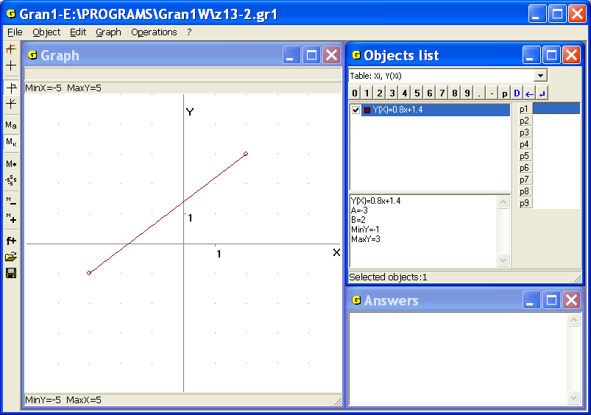
Fig. 13.3
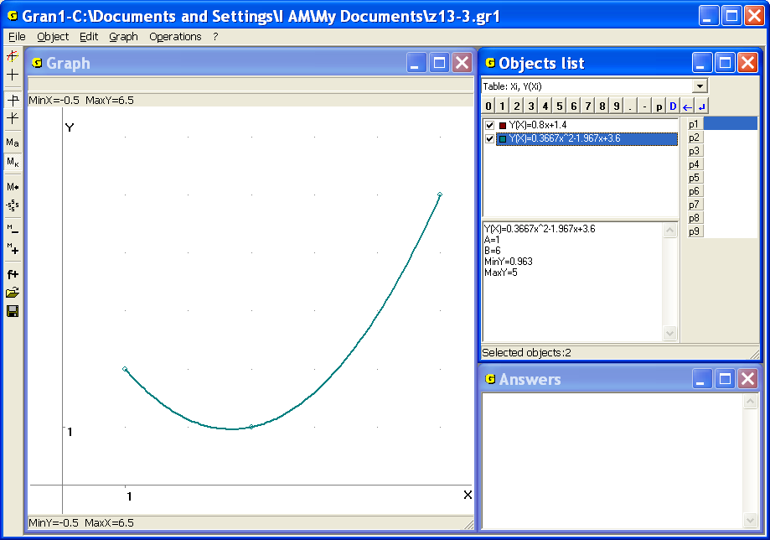
Fig. 13.4
Set the type of dependence “Table: Xi, Y(Xi)” and enter the table
 | 0 | 5 | 7 | ,
 | 0 | 3.01 | 0 | ,
Then plot the polynomial of the degree 2 (parabola) so that the graph of dependence passes through given points. As a result get (Fig. 13.5).
To determine approximately the angle of inclination to the horizon of the direction of shell throwing, it is possible to use the command “Graph /”Graph” window parameters...” and set the type of coordinates “Polar coordinates” on the tab “Graph”. As a result get (Fig. 13.6).
Taking into consideration parametric determination of the dependence between and : , , whence
and also the fact that the trajectory must pass through the point , get .
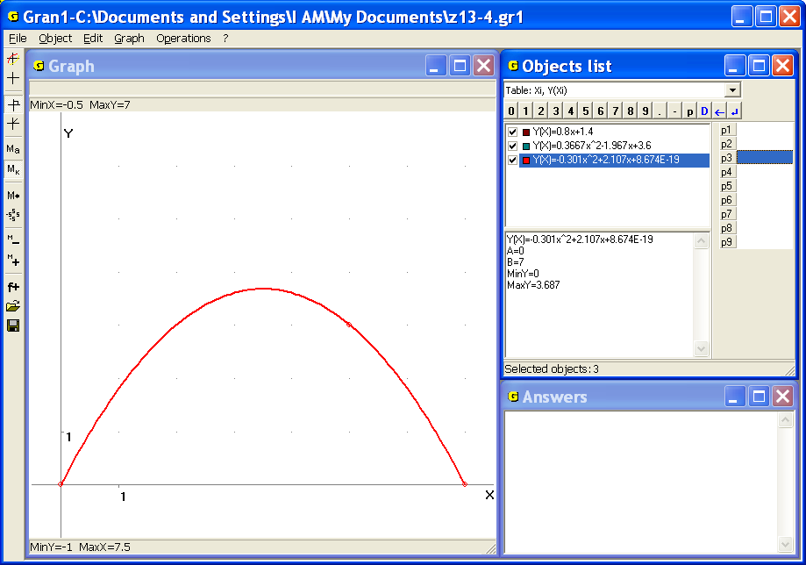
Fig. 13.5
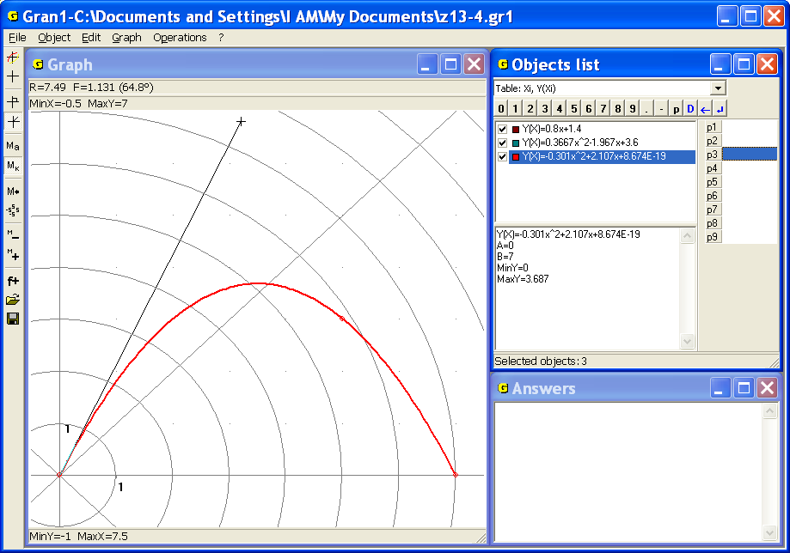
Fig. 13.6
4. Enter a table from the file Poly, plot corresponding polynomial of the best approximation of tabular-defined dependence and plot graphical image of table points and graph of the obtained dependence .
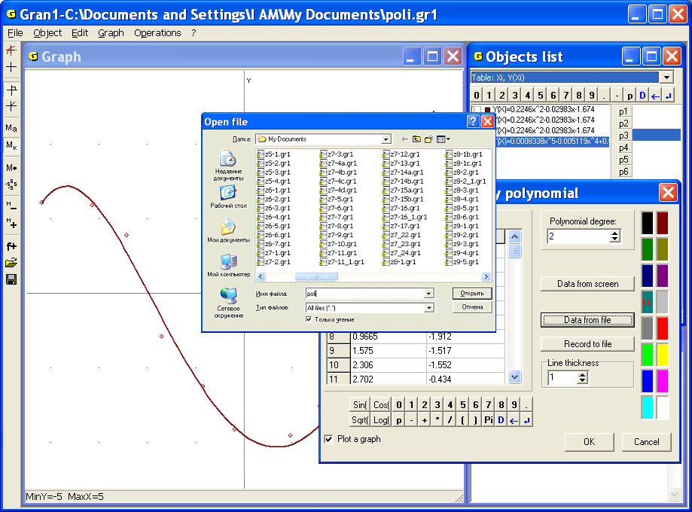
Fig. 13.7
Set the type of dependence “Table: Xi, Y(Xi)” and use the command “Object/Create”. In the window “Data for polynomial approximation” press the button “Data from file” and in the new window select the file Poly (Fig. 13.7). The data will be entered into the table.
The data can be also entered with the help of the command “File/Open” (Fig. 13.8). Using this command there opens the folder with the files created with the help of GRAN1 (of type gr1) (Fig. 13.9).
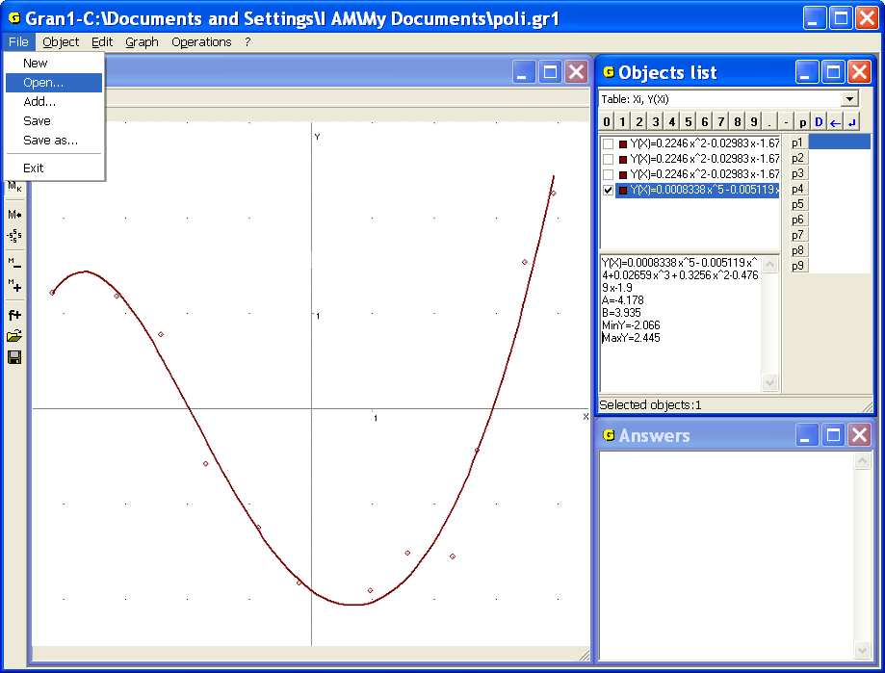
Fig. 13.8
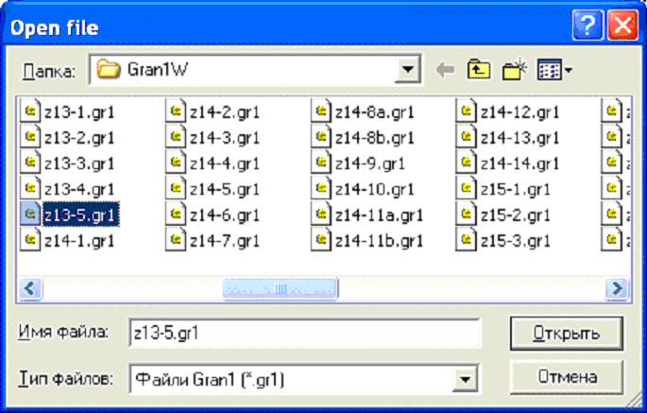
Fig. 13.9
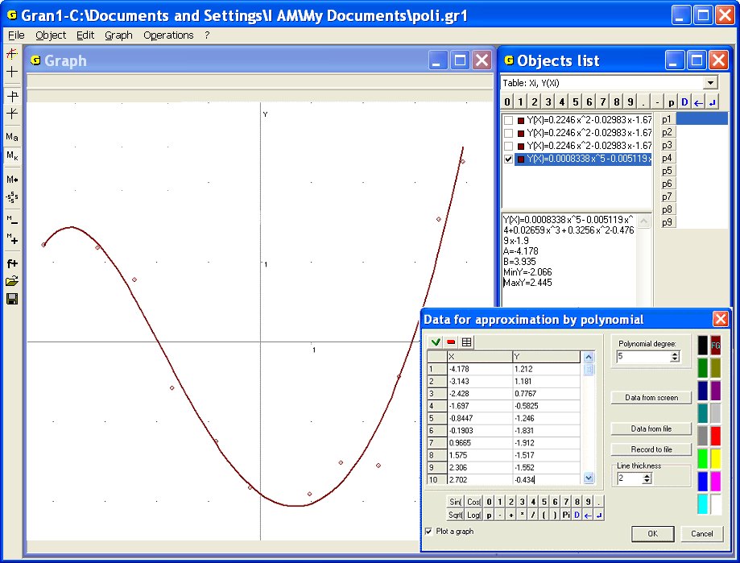
Fig. 13.10
Then enter the number 5 in the line “Polynomial degree” and set color and thickness of the line (Fig. 13.2). As a result required polynomial appears in the window “Objects list”. Use the command “Graph /Graph” to get graphical image of the table and the dependence (Fig. 13.10).
In the figure one can see that the formula of the polynomial is quite long, therefore it is placed incompletely in the window “Objects list”. To see the whole expression one can expand the window or make the object current. In the last case the whole expression is indicated in the lower part of the window “Objects list”.

Questions for self-checking
- What type of dependence should be assigned while entering a table of arguments and corresponding dependent values?
- Is it possible with the help of GRAN1 to enter firstly all values of the argument and then corresponding dependent values?
- Is it possible to input the table using the data input panel and the mouse?
- How to input data in the table?
- How to save the table for further work with the program GRAN1?
- How to input the table from file?
- Is it possible with the help of GRAN1 display images of points from the table without displaying the graph of the corresponding polynomial?
- Is it possible with the help of GRAN1 display graph of the polynomial that approximates tabular-defined dependence without displaying points from the table?
- How to modify a table?
- Can the approximate polynomial be of degree 1 if the table contains 5 pairs of numbers?
- Should the differences stay constant at all ?
- Should the arguments in the table be ordered by increase?
Exercises for self-fulfillment
- Find equation of the form of a curve that passes through the points: (1, 1), (2, 2), (3, 3), (4, 4), (5, 4) and plot the curve where is algebraic polynomial.
- Find equation of the form of a curve that goes through the points
(-2, 4), (-1, 1), (0, 0), (1, 1), (2, 4) and plot the curve where is algebraic polynomial.
- Find a polynomial (of degree no more than 5), that approximates in the best way the dependence defined by the following table
 | 0 | 0.5 | 1 | 1.5 | 2 | 2.5 | 3 | 3.5 | 4 | 4.5 | 5
 | 0 | 1 | 1 | 2 | 4 | 5 | 9 | 10 | 16 | 20 | 18
- View the table from the file with indicated name. In the file there are 15 pairs of numbers. Determine how many pairs have negative dependent value.
- Plot a table of values of the function for argument values Use the command “Operations /Calculator”. Use the table to find a corresponding polynomial of the best approximation of degree 2. Plot graphs of dependencies and and compare them. Calculate values and in the points , , and compare them.
- Plot a table of values of the function for argument values -0.10,
-0.05, 0, 0.05, 0.10 with the help of the command “Operations /Calculator”. Plot for the table a polynomial of the best approximation of degree 4. Plot graphs of dependencies , and compare them. Use the command “Operations /Calculator” and the graph to determine the values and in the points 0.025, 0.075 and compare them.
- The shell is thrown from the point (0,0) angularly to the horizon with the initial speed . The target is placed behind the cover with coordinates of the top .
- What should be the distance between the cover toe and the target in order to the target could not be hit at given , , ?
- What should be the height of the cover in order to the shell could not be thrown over the cover at given , ?
- What should be and , in order to at given , the shell fly over the cover and fall not far than in the distance from the cover toe?
- In what distance from the cover toe should start the shell in order to at given it fly over the cover (if it is possible) and fall not far than in the distance from the cover toe?
- Is it possible to hit the target at given , , if it is placed behind the cover in the distance from the toe?
- For the concrete calculations put:
  - , , ; , , ;
, , ; , , ;
  - , ; , ;
, ; , ;
, ; , ;
  - , , ; , , ;
, , ; , , ;
, , ; , , ;
  - , ; , ;
, ; , ;
, ; , ;
  - , , , ; , , , ;
, , , ; , , ,
§14. Graphical solution of equations and systems of equations
Suppose it is necessary to solve an equation, i.e. in domain of dependence find all the values of the argument that their corresponding values are equal to zero.
When the dependence is represented graphically, to find a solution of the equation means to find all the points on the graph of dependence that have zero ordinates. In other words, it is necessary to find points that lie both on the graph of dependence and on the axis that is described by equation. That is one should find points that lie on the line (straight or curve) that has equation as well as on the line, that has equation.
Plotting graph of the dependence with the help of the command “Graph /Plot” and setting cursor in corresponding points for getting their ordinates makes it easy to determine abscisses of all the points on the graph of dependence that also lie on the axis .
Examples
1. Find solutions of the equation .
Plot a graph of the dependence and set cursor so that the cursor’s abscissa coincides with the intersection point of the graph and the axis . The result is as follows , (Fig. 14.1).
If it is necessary to precise the roots one can enlarge a part of the graph or change the segment of function determination, and plot the graph in quite small areas of the points defined before, with the help of enlarged zoom.

2. Find solutions of the equation.
Plot a graph of the dependence and make sure that any point on the axis of the segment lies on the graph of a considered dependence (Fig. 14.2). Thus for the equation exists unlimited set of solutions and any value is a solution of the equation.

3. Find solutions of the equation.
Plot a graph of the dependence on the segment (Fig. 14.3) and make sure (taking into account properties of functions and ), that out of the segment there aren’t roots of the equation.
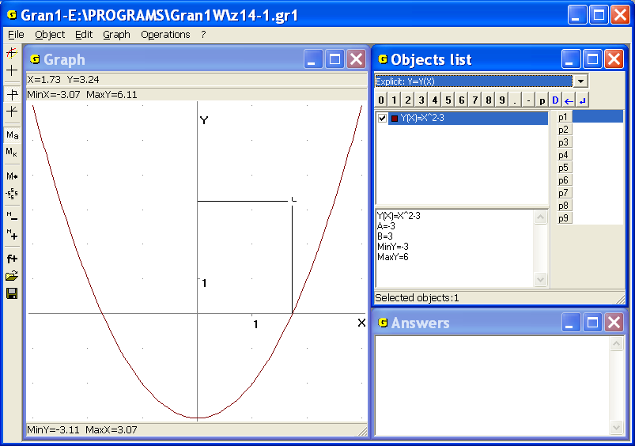
Fig. 14.1
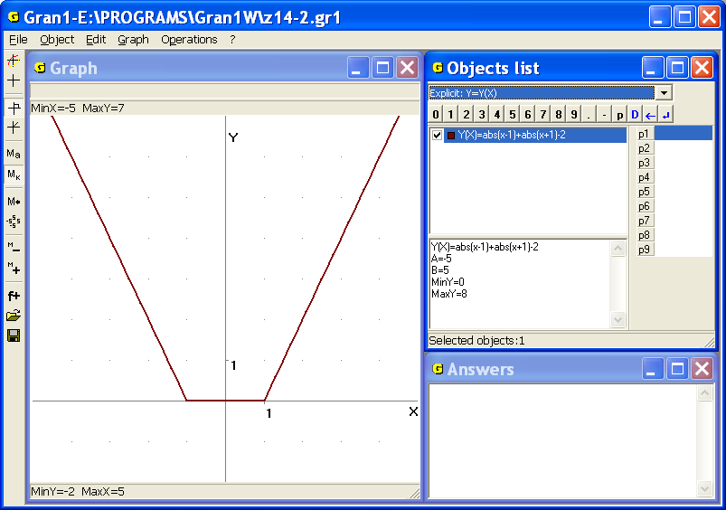
Fig. 14.2
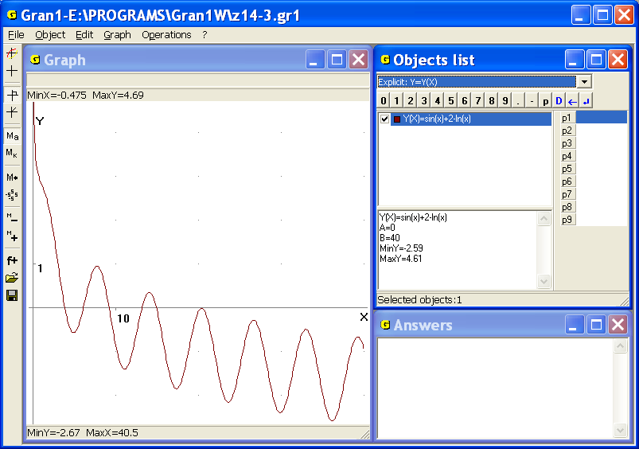
Fig. 14.3
While considering the graph of dependence , represented in the Fig. 14.3, one can suppose that the equation has 6 solutions:
; ; ; ; ; .
If high accuracy of calculation is not necessary such conclusion can be accepted.
However if higher accuracy of results is required one should enlarge the zoom of plotting in quite small areas of the points , , , , , (Fig. 14.4, 14.5) to sure that the equation has 5 solutions:
; ; ; ; .
It should be noted that precise analytical solution of the equation cannot be found, while the search of its approximate solutions without graphical plotting requires laborious calculations and careful analysis of the results.
The calculus mathematics investigates special methods of search approximate solutions of equations of the form on given segment (bisection method, chord method, tangent method, iteration method etc.).
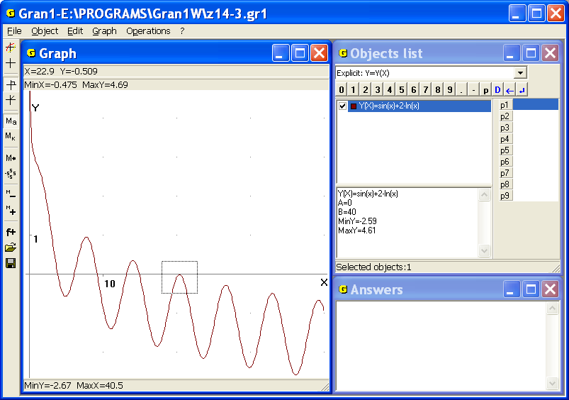
Fig. 14.4
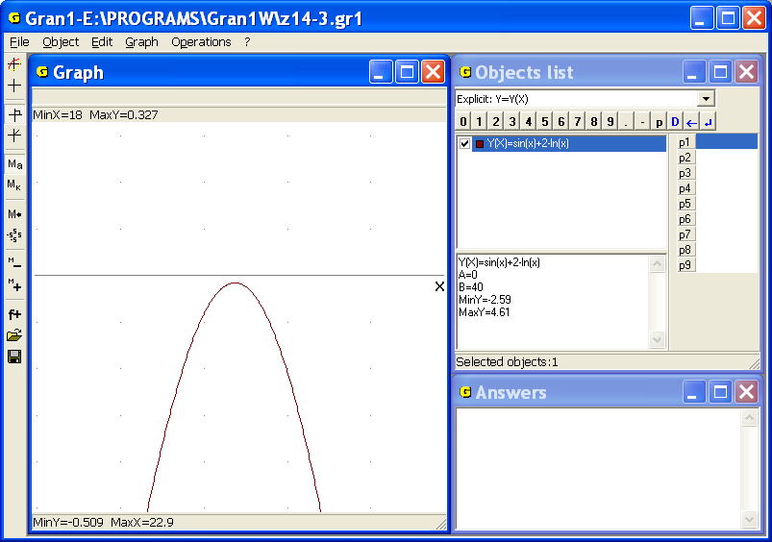
Fig. 14.5
Sometimes it is convenient to represent the equation in the following form: , where , or a problem leads to searching solutions of equation of the form . In this case it is convenient to plot graphs of the dependencies and , then set cursor in intersection points of the graphs and determine coordinates of the points lying on both graphs simultaneously. Abscissas of the points are solutions of the equation . If the values are found in a such way, the values and are equal.
4. Find solutions of the equation:
Plot graphs of the dependencies and and make sure that the equation has unique solution. Set cursor in the intersection point of the graphs to get (Fig. 14.6).
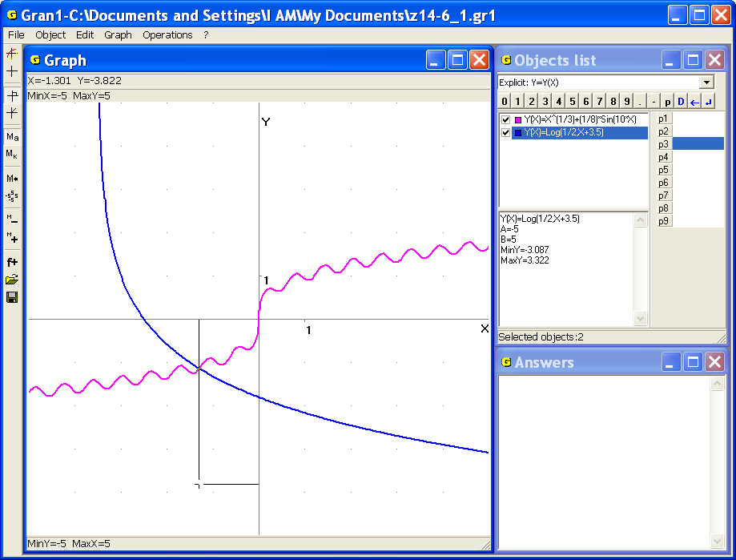
Fig. 14.6
Now solve the system of equations of the form
where and are some expressions of two variables and .
Set the type of dependence and plot graphs of the dependencies and , then set cursor in intersection points of the graphs and determine coordinates of the points that meet both equations and i.e. coordinates of intersection points of the lines described by the equations and.
5. Solve the system of equations
Represent the equations in the following form: , and plot graphs of the dependencies (Fig. 14.7).
Set cursor in each of intersection points of the graphs and obtain:
1) , ; 3) , ;
2) , ; 4) , .
For more precise determination of coordinates of the intersection points of graphs one should enlarge the zoom of plotting, i.e. use the command „Zoom in” or change bounds for the variables and . For example, if we change the zoom by setting the bounds , , , and plot the corresponding graphs, we obtain the image represented in the Fig. 14.8. Use the coordinate cursor to get,
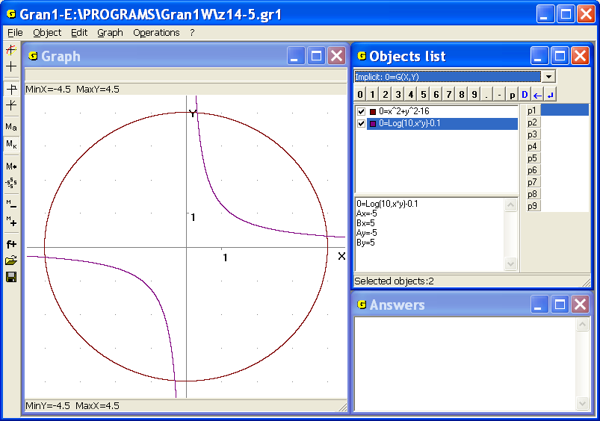
Fig. 14.7
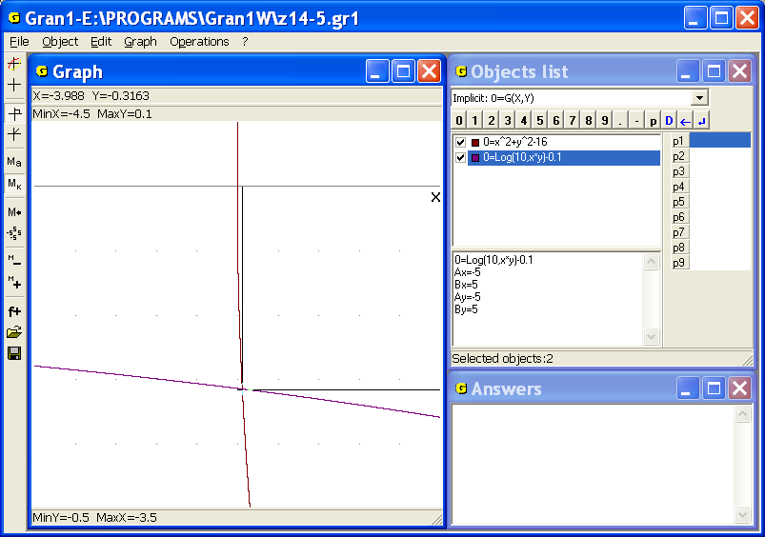
Fig. 14.8
, and while cursor is moving, the third digit after comma is changing (is defined more exactly).
One can put , , , (using the command “Graph / Zoom / User zoom”) to obtain , , and while cursor is moving, the fourth digit after comma is changing (is defined more exactly).
It should be noted that the problem of finding solutions of the equation can be also considered as the problem of solving the system of equations
and the problem of finding solutions of the equation as the problem of solving the system of equations
In many cases finding solutions of the system of equations
{, }
with the help of plotting is unique suitable method for practical use since the method of variable exclusion or other methods are very difficult or lead to wrong results.
6. Solve the system of equations (Fig. 14.9):
In this case it is impossible to exclude one of the variables or and it is difficult to offer any practically suitable way of solution besides the graphical method.
It is obvious that plotting can be used for determination of intersection points of lines independently of types of the dependencies. For example, if it is required to determine coordinates of points of the circle , that lie on the parabola or on the pentapetalous rose (Fig. 14.10), one should plot the graphs and obtain coordinates of the required points (with accuracy up to hundredths) with the help of the coordinate cursor:
1) , ; ,;
2) , ; ,;
3) , ; , ;
4) ,; ,;
5) , ; , ;
6) ,; ,.
7. The body is thrown from the point (1,0) in the moment with initial speed angularly 0.6 (radian) to the horizon. Another body is thrown from the point (2, 0) in the moment with initial speed angularly 1.2 (radian) to the horizon.
a) Is the clash of the bodies possible? What must be to avoid the clash?
Coordinates of the first body are changing in time under the law
,
,
where is the start point, – acceleration of gravity.
Coordinates of the second body are changing under the law
,
.
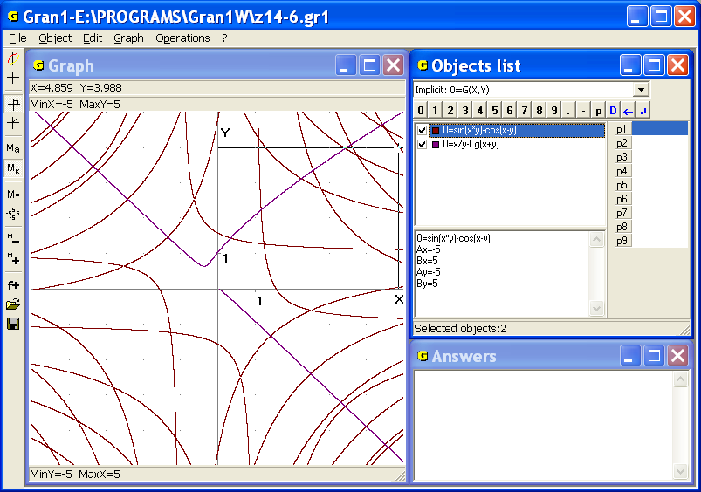
Fig. 14.9
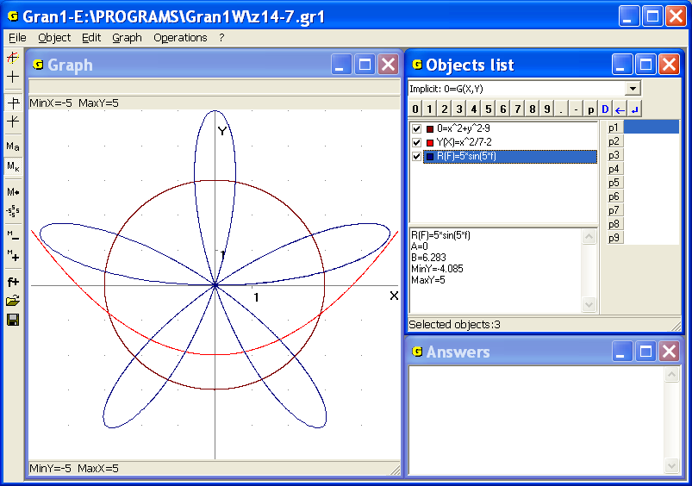
Fig. 14.10
Choose and arbitrary, for example , and taking into account concrete data of the example, plot the trajectory of fly of the first body
,
,
and of the second body
,
.
Since the trajectories are intersected in the points , and , , then if the moment is chosen arbitrary, the clash of the bodies is possible (Fig. 14.11).
The moment of throwing of the second body in order to avoid the clash can be determined by different ways. For example, one can determine the time of fly of the first body from the start point to intersection point of the trajectories and thus fix the moment when the first body will be in the point . Then one can set the time required for the second body to arrive at the point . After that it is easy to determine the start moment of the second body so that both bodies couldn’t reach the point at the same moment. The time required for the first body to reach the point , can be determined graphically by selection the segment of assignment of the first dependence so that the trajectory could stop in the point . One can change the corresponding way to determine the moment when the first body reaches the point . The same argumentation concerns the trajectory of the second body.
In the Fig. 14.12 is shown that the first body reaches the intersection point of the trajectories in the moment, i.e. the first body flies from the start point to the point in the time 0.27 (the upper bound for parameter is set with the help of the parameter).
The second body reaches the point in the moment (Fig. 14.13), if it starts in the moment , i.e. the second body reaches the point after the time 0.137 from the start moment (the upper bound of the parameter in expressions that describe trajectory of the second body is set with the help of the parameter).
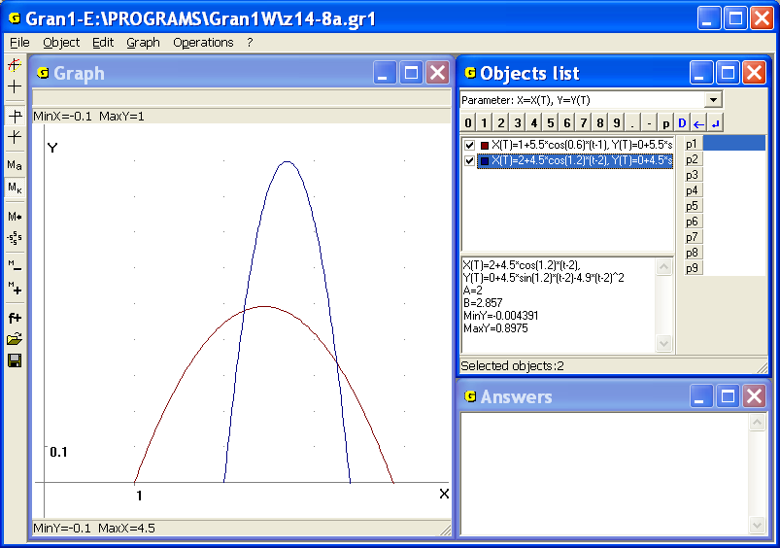
Fig. 14.11
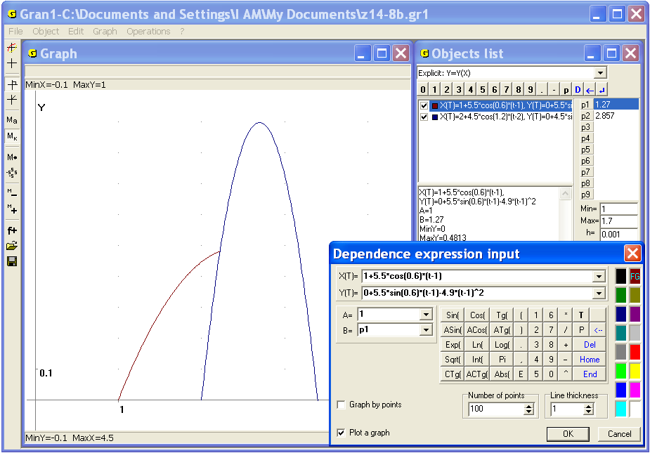
Fig. 14.12
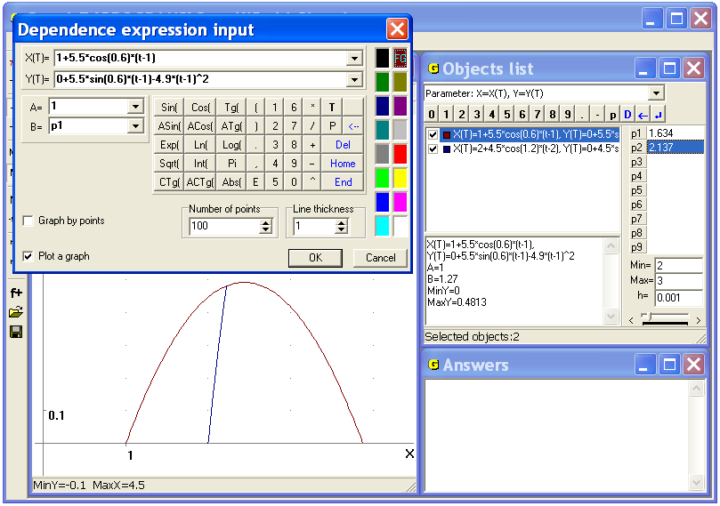
Fig. 14.13
Since the first body will reach the point in the moment , then to avoid the clash the second body should not start in the moment .
It can be determined similarly that to avoid the clash in the point ≈ (3.25, 0.34), it is necessary that the start moment for the second body differ from 0.729.
Another way is to equate the coordinates and , and and determine the values and from the equalities
,
.
Define as and as , plot graphs of obtained implicit dependencies between the variables and (i.e. between the values and ), and find their intersection points (Fig. 14.14). This way the system of two equations with two unknown and will be solved.

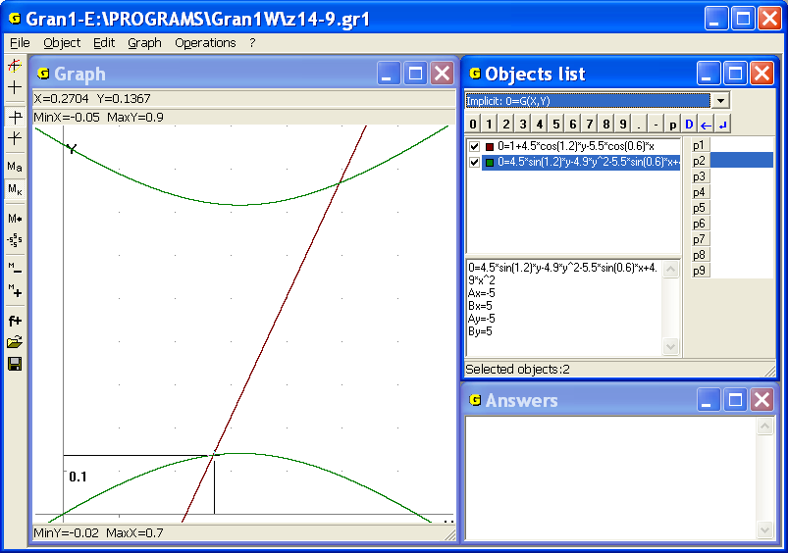
Fig. 14.14
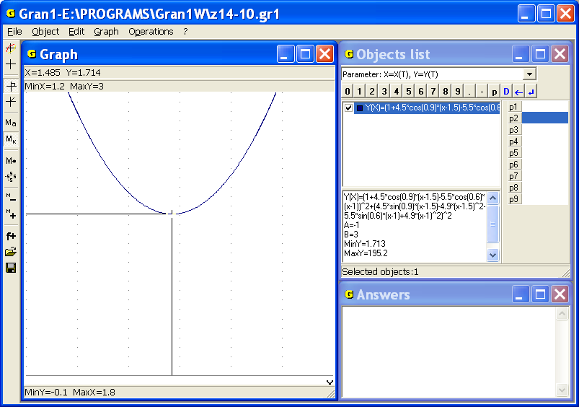
Fig. 14.15
In the Fig. 14.14 it is shown that the first body reaches the point in the time 0.27, the second one – in the time 0.137. In such way it is possible to determine the time necessary for both the bodies to reach the point , hence, also the start moment of the second body in order to avoid the clash.
As regards the point , one can similarly fix that the first body reaches this point in the time 0.496, the second one – in the time 0.767.
Thus to avoid the clash in the point , the second body shouldn’t start in the moment .
b) If , , , , , , , , , , what will be the least distance between the bodies during the fly and in what time it will be reached?
Since in the moment the distance between the bodies equals , re-label the variable as , plot graph of the function , and then (after enlargement) change the zoom and get the following answer: the least distance between the bodies will be in the moment (Fig. 14.15).
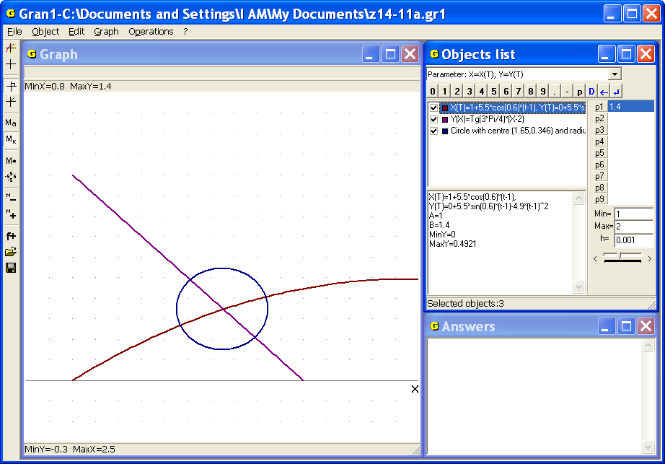
Fig. 14.16

c) What should be and , in order to the second body, that starts in the moment when the first body intersect the line , in the same moment with the first body could reach the point, in that the first body goes out the area of radius 0.2 centered in the intersection point of the line and the trajectory of the first body? (Fig. 14.16).
The first body reaches the line in the moment (the upper bound of the parameter is determined by the parameter) in the point , (Fig. 14.17), and goes out of the area in the moment in the point , (Fig. 14.18). Thus the second body should start in the moment and reach the point , in the moment .
Thus the following equalities must be complied
,
.
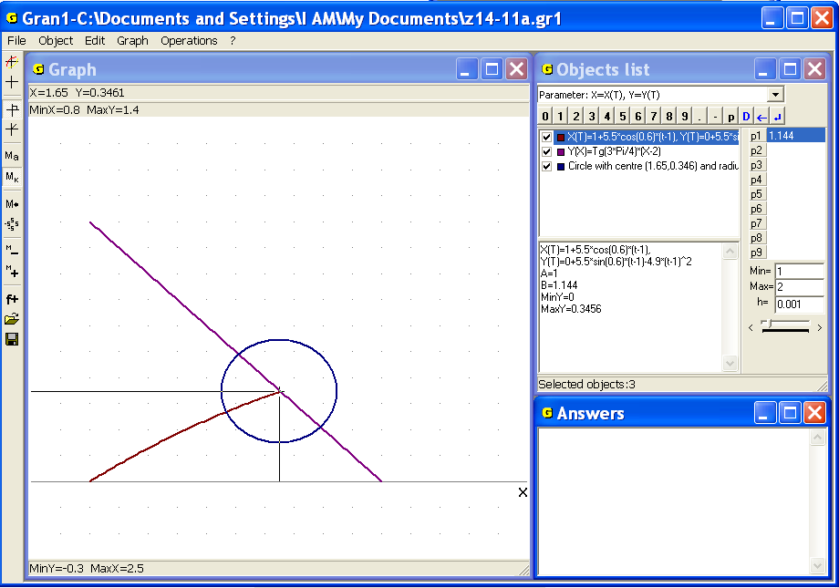
Fig. 14.17
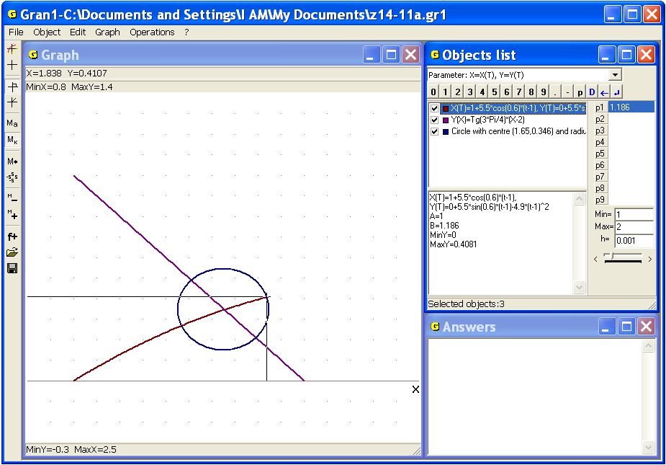
Fig. 14.18
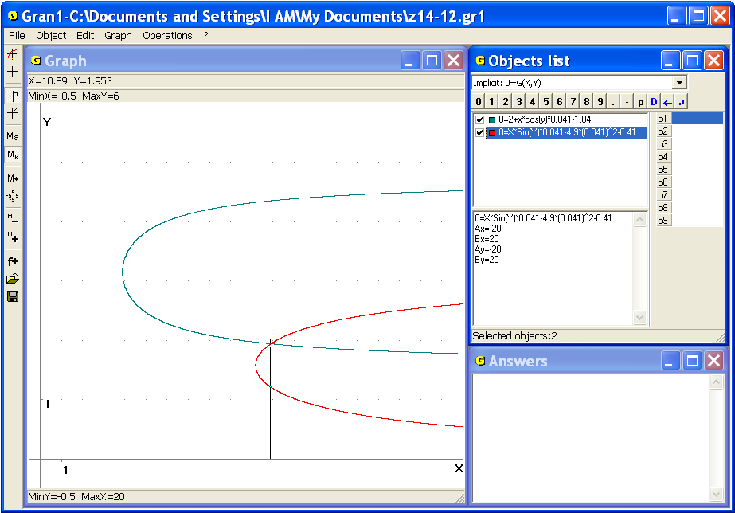
Fig. 14.19
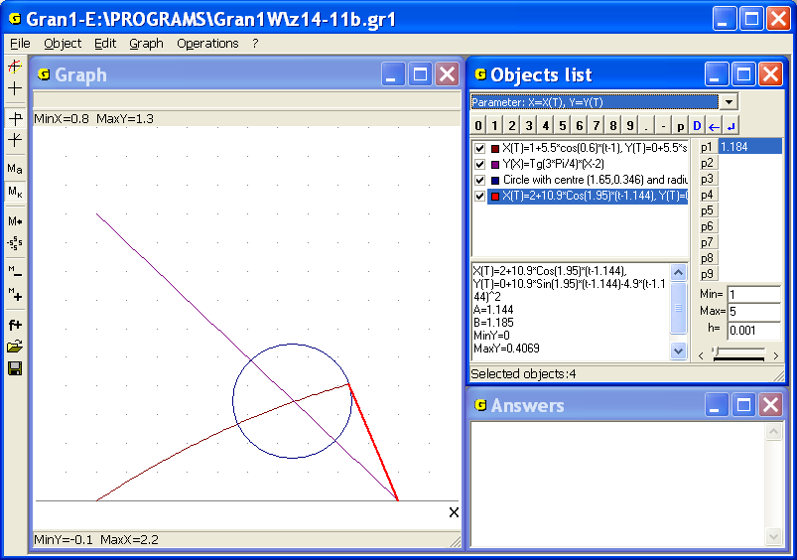
Fig. 14.20
Re-label unknown values as , as and find solution of the system of equations:
In the figure 14.19 it is shown that approximate solution of the system is , .
Thus if the second body starts from the point in the moment with the speed angularly (radian) to the horizon (positive direction of the axis ), in the moment it simultaneously with the first body will reach the point , in which in this moment the trajectory of the first body intersects the area or radius centered in the point , where the trajectory of the first body intersects the line (Fig. 14.20).
It should be noted that not all the examples can be solved with the help of graphical methods. It is connected with some restrictions of computer graphics and computer mathematics in general.

8. How many real roots has the equation ?
In the figure 14.21 graphs of functions that correspond to both parts of the equation are displayed. One can see that at the graphs are very close to each other, hence it is impossible to say about the number of their points of intersection (and correspondingly solutions of the equation). Change the zoom or changing given equation by the equivalent one also doesn't allow to get the answer.
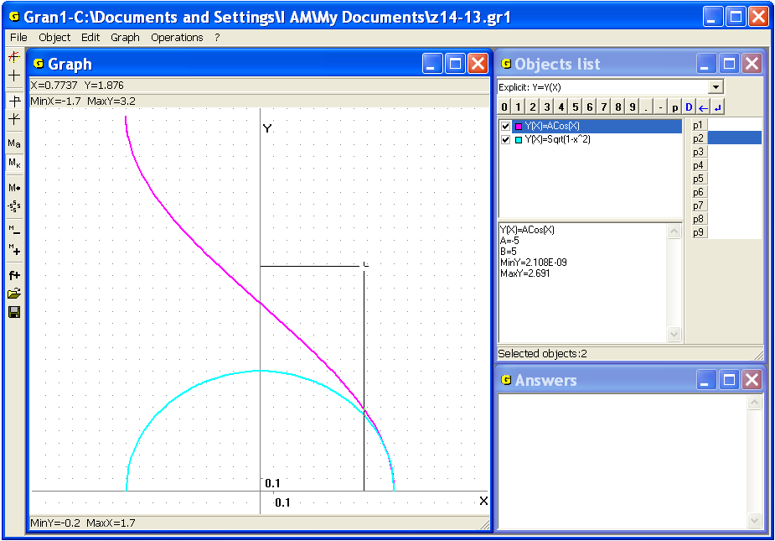
Fig. 14.21
9. Determine the number of roots of the equation on the segment.
Attempt to plot graph of the function on given segment will be unsuccessful since the function has infinite number of points of discontinuity in the neighborhood of the point (Fig. 14.22). That is why it is impossible to solve this problem graphically.
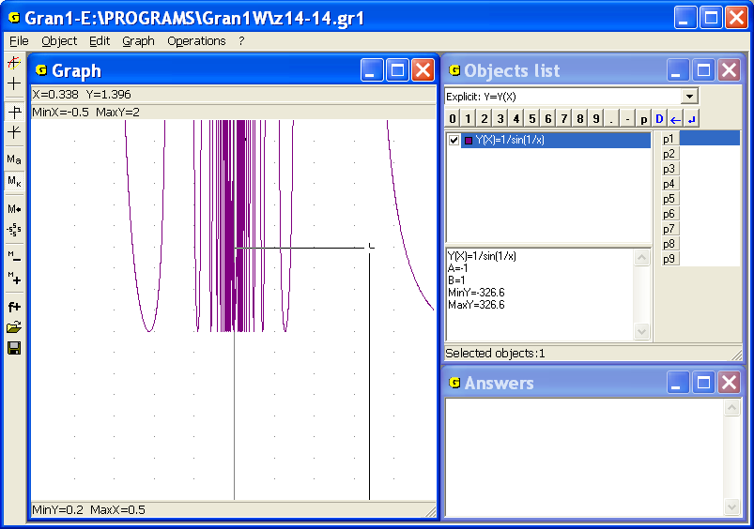
Fig. 14.22
These examples show that the use of software for solving mathematical problems should be well-grounded, and analysis of solutions of the problems and substantiation of their propriety stays very important.

Questions for self-checking
- What points on the graph of dependence correspond to solutions of the equation?
- What points on the graphs of dependencies , correspond to
solutions of the equation ?
- What points on the graphs of dependencies , correspond to solutions of the equations system
- How to represent the equation in the form of the system of equations
What should be expressions and in this case?
- How to represent the equation in the form of the system of equations
What should be expressions and in this case?
- How with the help of plotting one can specify solutions of equation? equation ? system of equations of the form

Exercises for self-fulfillment
- Find approximate solutions of the equations with the help of GRAN1:
; ; ;
; ; .
- At what the equation has the most quantity of solutions? The least quantity of solutions? Three solutions?
- At what the equation has the most quantity of solutions? The least quantity of solutions?
- At what the equation has the most quantity of solutions? The least quantity of solutions?
- At what the equation has on the interval the most quantity of solutions? The least quantity of solutions? 1 solution?
- Find approximate solutions of the systems of equations with the help of GRAN1:
- The body is thrown from the point in the moment angularly to the horizon with the initial speed . Another body is thrown from the point in the moment angularly to the horizon with the initial speed .
- How to determine whether both the bodies can be simultaneously in the neighborhood of the point on the trajectory of the first body?
- Determine a radius of the least neighborhood of points on the trajectory of the first body where both the bodies can be at the same time.
- What must be , , , in order to at given , , , , the second body appear simultaneously with the first one:
- in given neighborhood of a certain point on the first body trajectory?
- in the neighborhood of certain radius of a point on the first body trajectory in the previously set moment , (, )?
Determine coordinates of such point.
- What must be , , in order to at given , , , , , the second body appear simultaneously with the first one:
- in given neighborhood of a certain point on the first body trajectory?
- in the neighborhood of certain radius of a point on the first body trajectory in the previously set moment?
Determine coordinates of such point. Solve the problem at concrete values , , , etc.
- The body starts from the point at the moment and moves along a circle centered in the point anti-clockwise with constant speed . Another body starts from the point in the moment and moves along a circle centered in the point anti-clockwise with constant speed .
- Is the clash of the bodies possible if the speeds and and the start moments and are chosen arbitrary?
- If the clash is impossible at any , , ,, in what moment the distance between the bodies is minimal at given , , , , , , , ?
- Is it possible to choose the start moments and and the speeds and so that the clash couldn’t take place if under arbitrary choice of , , , the clash can occur?
Consider the following cases
- at the data:
- at the data:
- at the data:
    - ,.

§15. Graphical solution of inequalities and systems of inequalities
Suppose it is necessary to solve graphically inequality of the form , where is an expression defined on the interval . For that one should plot graphs of the dependencies and (for values from ) and determine with the help of the command “Coordinates”, at what values the graph of lies not higher the graph of . Set of such values is the set of solutions of inequality. The set of solutions of inequality of the form can be obtained the same way. Besides the later case can be reduced to the previous one since the inequality is equivalent to . The set of solutions of inequality of the form or of the form can be determined analogously to the previous case.
If the function is convex downwards then for any the set of solutions of inequality is empty or such that if points and belong to the set then all the points of the interval also belong to the set. Remind the function is called convex downwards if for any two points taken on the graph and joined by a segment, the graph of function between the points is placed not higher the graph of the segment (the chord). As examples of functions convex downwards the following functions can be considered , , , , , on the interval and others.
Solutions of system of inequalities of the form , , …, are being searched as set of points M, that meet all the inequalities simultaneously: , where is set of solution of inequality .
For graphical solution of system of inequalities of mentioned kind in the program GRAN1 is intended the command “Operations / Set of inequalities y(x)<(>)с...” (Fig. 15.1). In the case of use this command there appears a window where one should input the sign of inequalities (> or <) and the number (Fig. 15.2). The dependencies (of the type), that make up the system (or ), should be marked by the check-box , and their graphs should be plotted in the window “Graph”. In the system there can be only one inequality.
As a result of solving system of inequalities of the form (or ) the points that meet all the inequalities simultaneously, are marked on the axis by red color. In the window “Answers” one can see the list of approximate values of coordinates of ends of segments on the axis , the points of which are the solutions of all inequalities of the system (Fig. 15.1). Using the program one can calculate the roots on the interval that is common for all the definition segments of functions that represent inequalities of the system.
Example
Solve the inequality for .
Plot graph of the dependence on the interval . Then use the command “Operations / Inequalities / Set of inequalities y(x)<(>)c…”, set sign “>” and value . As a result get the image represented in the Fig. 15.3.

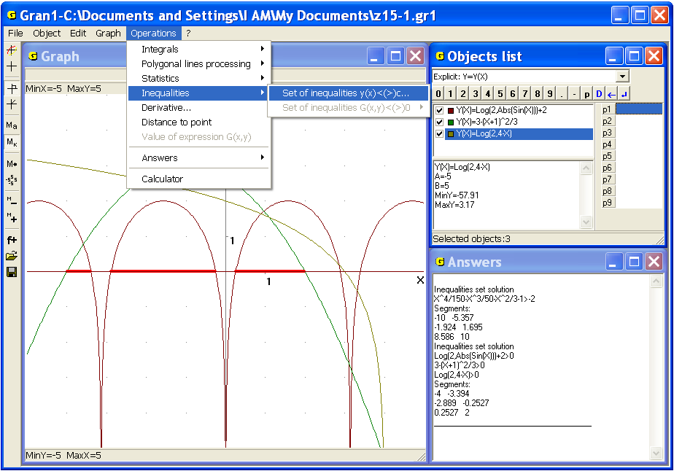
Fig. 15.1
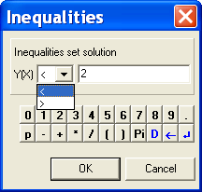
Fig. 15.2
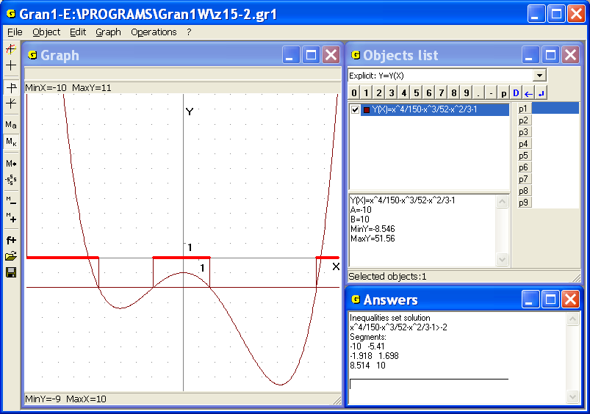
Fig. 15.3
Take into consideration the list of segments from the window “Answers” to get: the set of solutions of the inequality is
(-10, -5.41) (-1.92, 1.70) (8.51, 10).
Suppose now it is necessary to find set of solutions of system of inequalities of the form
This problem is much more difficult than the previous one. But in particular cases the problem can be solved graphically. One of them is such an important case when functions convex downwards are determined by expressions .
The process of solution may require some additional calculations and plots, analysis of particular features of expressions for clarification of the matters concerning the problem, particularly, the question whether the set of solutions is empty or not.
The set of solutions for the system of inequalities under consideration is the set , where is the set of solutions of the inequality . Particularly, if the function is convex downwards then the set is empty or convex i.e. such that any two points from can be joined by segment all the points of which belong to the set .
Plotting graphs of dependencies and , where is quite small positive number allows to determine points where and points where . The set of points where simultaneously at all is the set of solutions of the system of inequalities under consideration. It should be noted that if the function is convex downwards, then for any the set of solutions of the inequality is empty or convex.
As examples of functions convex downwards the following functions can be considered , and others.
Additional plotting of graphs of the dependencies can be removed after clarification of the matters about set of points that meet the inequality, and are not obligatory if the matter can be clarified without such plotting.
For graphical solution of system of inequalities of the form (or ), , the program GRAN1 is provided with the command “Operations / Inequalities / Set of inequalities G(x, y)<(>)0”. In the case of use this command one should set sign of inequalities (“>” or “<”). As a result the set of points that meet all the inequalities simultaneously is marked (shaded) on the plane . Before using the command the dependencies (of the type ) should be marked by the check-box and their graphs should be plotted (Fig. 15.4). The difference between the solutions of the systems and ( and ) is in the question whether the points of the graphs are included in the solution or not.
Examples
1. Find a set of solutions of the system of inequalities
Plot graphs of the dependencies , , and use the command “Operations / Inequalities / Set of inequalities G(x, y)<(>)0” (set the sign “>”) to get the result: any internal point of the triangle shaded in the Fig. 15.4 is a solution of the system of inequalities.
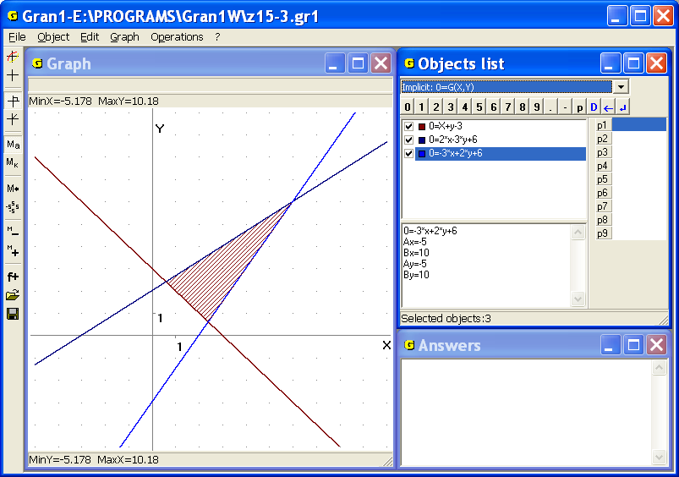
Fig. 15.4
2. Find a set of solutions of the system of inequalities
Plot graphs of the dependencies , and use the command “Operations / Inequalities / Set
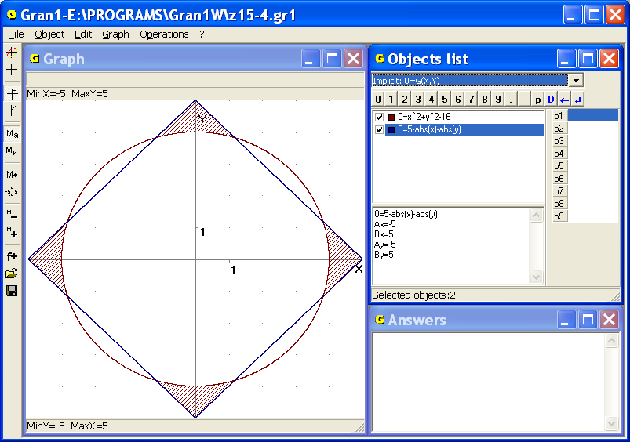
Fig. 15.5
of inequalities G(x, y)<(>)0” (set the sign “>”) to get the result: points of the set shaded in the Fig. 15.5 is a solution of the system of inequalities.
3. Find a set of solutions of the inequality.
Plot graph of the dependence and use the command “Operations / Inequalities / Set of inequalities G(x, y)<(>)0” (set the sign “>”) to get the result: points of the set shaded in the Fig. 15.6 is a solution of the inequality.
4. Find all the values of the parameter a, at each of that the inequality has at least one positive solution, if .
To use the program change the inequality by the equal one: . Create a new object with the parameter instead a: , assign the interval . Parameter should be also changed in the bounds with the increment . Plot graphs of the objects.
This inequality has solutions if any part of the graph lies under the axis . Change value of the parameter and observe the graph (Fig. 15.7),

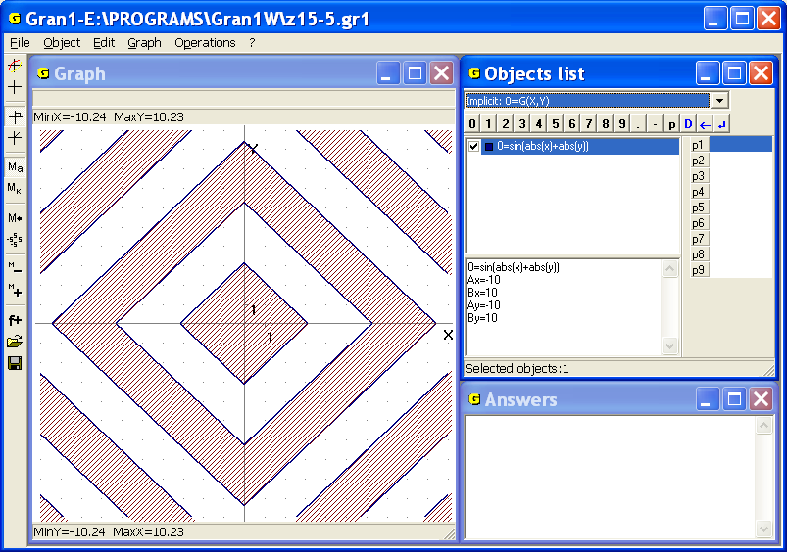
Fig. 15.6
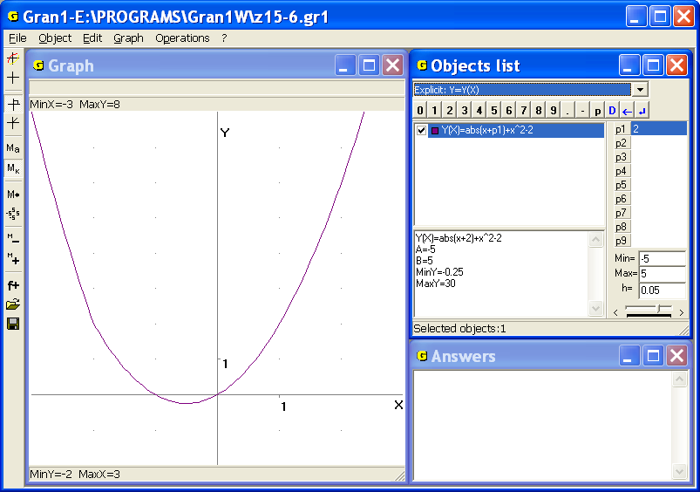
Fig. 15.7
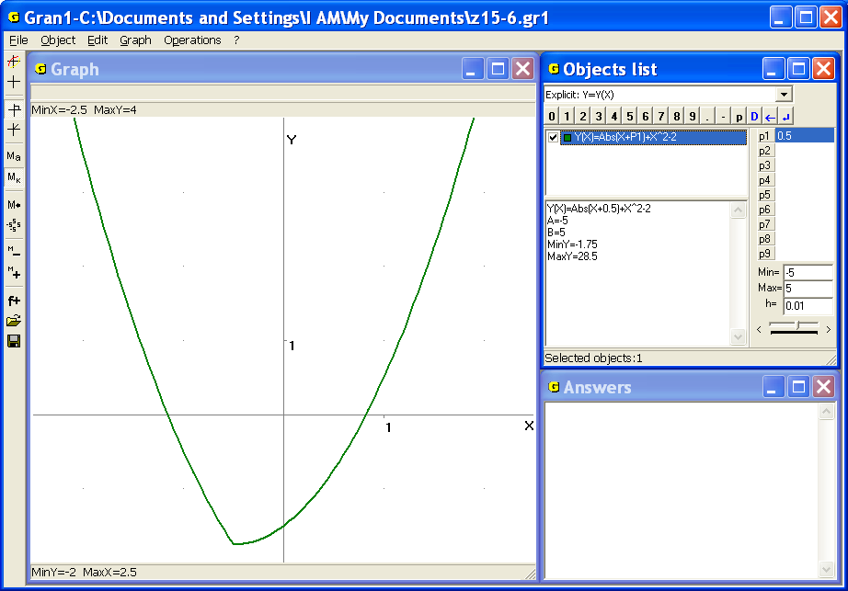
Fig. 15.8
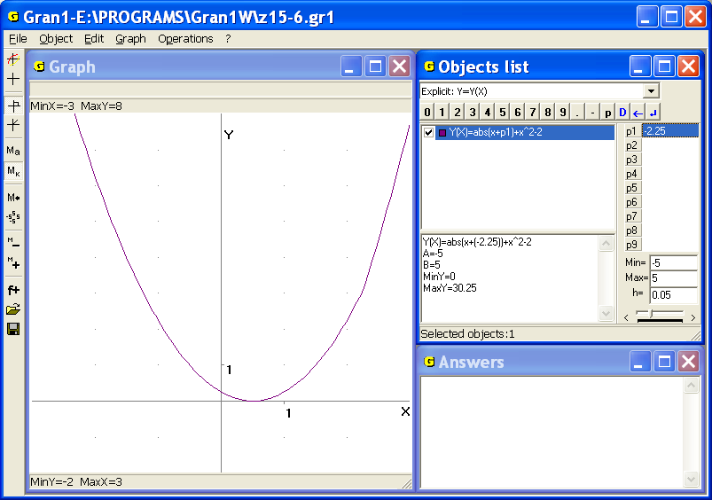
Fig. 15.9
to make the following conclusion: if , the inequality has positive solutions (Fig. 15.7, Fig. 15.8, Fig. 15.9).

Questions for self-checking
- What is called a solution of inequality of the form: ? ? ?

What is called a solution of inequalities system of the form:
- , , … , ?
- , , … , ?
- What function of the form is called convex downwards?
- What are the properties of a set of solutions of inequality, if the function is convex downwards?
- How with the help of GRAN1 to find solutions of inequality of the form if the function is defined on ?
- What function of the form is called convex downwards?
- Can the function be convex downwards if the set of solutions of inequality is empty?
- Is the function convex downwards if for a constant the set of solutions of is convex?
- How with the help of GRAN1 to find solutions of inequality of the form , where is a function convex downwards?
- Is the set of solutions of the system of inequalities , … , , convex, if this set is not empty and the functions , … , are convex downwards?

Exercises for self-fulfillment
- Find a set of solutions of the inequalities:
;  when ;  ;  ; | ;  ;  ;  when , .
- Find a set of solutions of the systems of inequalities:

- Find a set of solutions of the linear inequalities:

§16. Finding of maximum and minimum values of functions
on given set of points
With the help of the program GRAN1 one can use graphical methods for finding approximate solutions of some problems concerning with finding maximum or minimum values of functions of one or two variables on the sets defined through the systems of inequalities or another way. The functions under investigation and the functions that determine a set of allowable points can be linear or nonlinear, convex or non-convex.
In general case the problem of the form
is called the problem of mathematical programming.
If the functions , are convex (downwards) the problem is called the problem of convex programming, if the functions are linear – the problem of linear programming.
If integer solutions are searched (or the set is discrete) the problem is called the problem of integer (or discrete) programming.
Any point is called feasible point. The point , where is reached is called the optimal point of the problem of mathematical programming, the value is called the optimal value of the function in the problem.
In order to find maximum and minimum values of the function on the interval with the help of GRAN1 one should plot graph of the dependence for and determine coordinates of the highest and the lowest points on the graph , using the coordinate cursor. Additionally with the aid of the program there automatically calculated maximum and minimum values of on the interval (Fig. 16.1 and others), that are shown in the bottom of the window “Objects list”.
In this case it is not necessary to search roots of the equation to analyze peculiarities of the derivative or the second derivative in the neighborhood of solutions of equation etc. It should be noted that the algorithm of research of the function is used generally in order to plot graph of the function and clarify its behavior on the interval. Since it is not difficult to plot graph of the dependence on the interval , and with the coordinate cursor it is easy to determine all the characteristic points and peculiarities of graph (intersection points of graph and coordinate axes, the highest and the lowest points on graph, the intervals of function increase and decrease, the intervals of convexity downwards and upwards etc), execution of all the items of such cumbrous algorithm is not always necessary.
Examples
1. Find a maximum value of the function on the interval , and a value of argument , where the maximum value of the function is reached.
Plot graph of the dependence and set cursor in the highest point on the graph to get , (Fig. 16.1). Besides in the window “Objects list” the maximum and the minimum values of the function on certain interval are always shown.
Note that the search of solution of the problem by classical analytic methods is quite difficult.
2. It is necessary to make a box without a cover with the help of the rectangular tin plate of the measure (decimeters) of the maximum volume. Find the volume of the box.
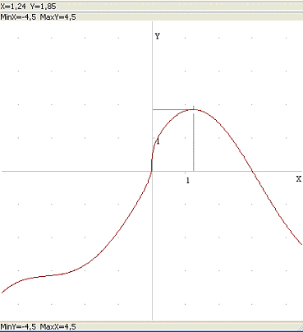
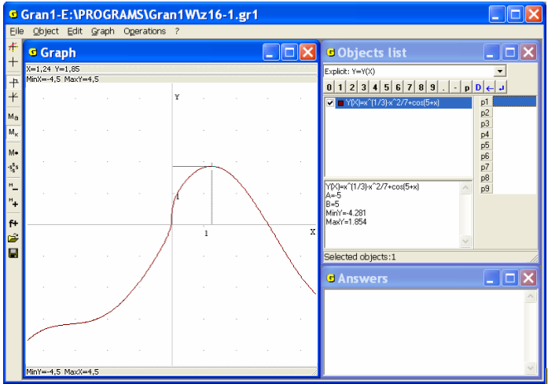
Fig. 16.1
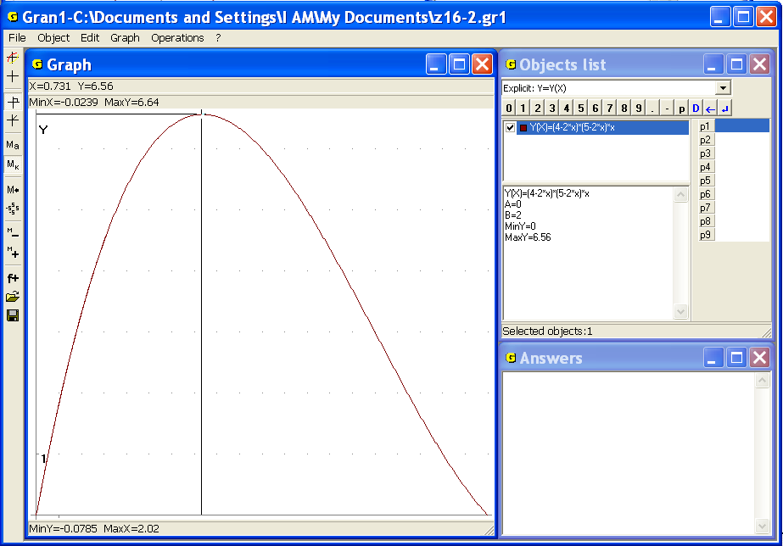
Fig. 16.2
Denote the height of the box as , . Then the volume is .
Plot graph of the dependence on the interval and determine coordinates of the highest point on the graph to get, . Thus the volume of the box is the maximum when the height of the box is 0.73 decimeters (Fig. 16.2).
If it is necessary to find the maximum or the minimum value of function on the set of solutions of system of inequalities of the form , ... , with the aid of the program GRAN1 one can do the following way. Firstly plot graphs of the dependencies , ... , and find what set of points meets all the inequalities simultaneously. The set can be determined with the help of the command “Operations / Inequalities / Set of inequalities G(x, y)<(>)0”. Then select the constant to plot graph of the dependence (for this purpose one can use one of the parameters , , … , ). This way one can gradually determine a subset of points of the solutions set of the system of inequalities , ... , , where the function takes the maximum (or the minimum) value.
In separate cases the corresponding analysis can be realized with the help of the command “Operations / Value of expression G(x,y)”, where beside the coordinates “x=...”, “y=...” of the point on the coordinate plane the value of the function in the point is shown in the top of the window “Graph”.
However it should be kept in mind that in the program GRAN1 are provided quite restricted features to solve problems of such kind. The program can be used for solving two-dimensional problems of considered type or for additional calculations and plotting during solving such problems.
3. Find the minimum value of the function on the set of solutions of the inequality .
Plot graph of the dependence .
After use the command “Operations / Inequalities / Set of inequalities G(x, y)<(>)0” it is easy to see that any point inside the square is a separate solution of the inequality (Fig. 16.3).
Then plot graphs of the inequalities for various values of the parameter . In the Fig. 16.3 it is demonstrated that the set of solutions of the inequality is the interior of the square with tops in the points (5, 0), (0, 5), (-5, 0), (0,-5), and the function takes the minimum value (-23) in these four points that belong to the set of solutions of the inequality .
Another way to get the solution is to set the cursor on the expression in the window “Objects list” and use the command “Operations / Value of expression G(x,y)”. It is possible to observe values of the expression by moving coordinate cursor in the set of solutions in the window “Graph”.
4. Find a point on the plane , so that the sum of distances between it and the points , , , , should be minimal (Steiner problem).
Take into account that the sum of distances between the point and the points , , , , is determined by the expression
.
Plot graphs of corresponding dependencies of the form for separate values of the parameter. As can be seen in the Fig. 16.4, the function takes the minimal value that is approximately equal 17.983 in the point, .
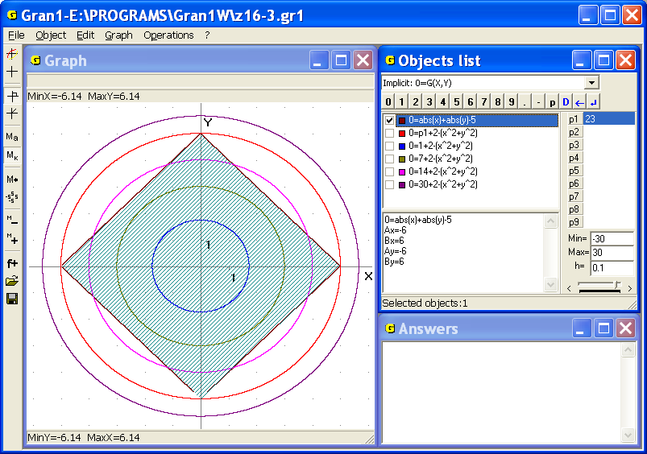
Fig. 16.3
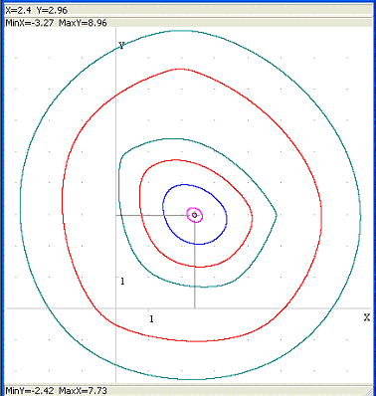
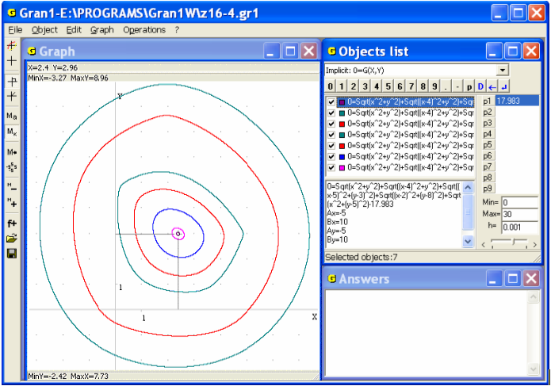
Fig. 16.4
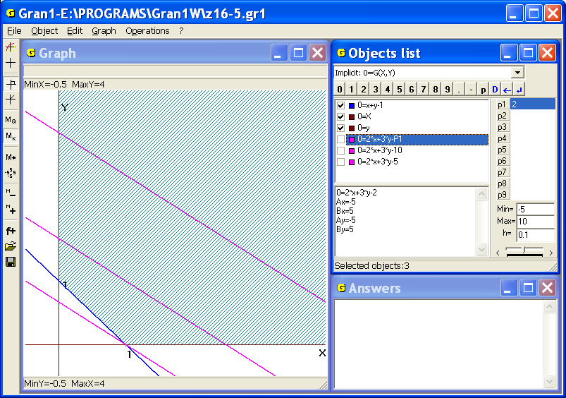
Fig. 16.5
5. Find the minimal value of the function on the set of solutions of inequalities , , .
Plot graphs of the dependencies , , to make sure that the set of solutions of the inequalities , , is set of points of the first quadrant that are lying above the line described by the equation (Fig. 16.5).
Then define the dependence and gradually change value of the parameter and fix objects at some values to find that the function takes the minimum value that is equal to 2 on given set of points in the point , (Fig. 16.5).
6. For the production of two types of products four kinds of materials are used. The quantity of materials of each type is limited and equals correspondingly , , , units. For the production of one unit of product of the first type it is necessary units of the first type of material, units of the second type of material, units of the third type of material and units of the fourth type of material, and for the production of one unit of product of the second type it is necessary correspondingly , , , units of the first, the second, the third and the fourth types (all the numbers are nonnegative).
Let the profit from the sale of one unit of the first type of product is units of value, of the second type – units of value. It is necessary to produce such quantity of units of each types to maximize profits in given conditions. In other words, the program of production at given restrictions should be optimal.
Suppose it is planned to produce units of the first type of product and units of the second type of product. Then the costs of materials are as follows: – units of material of the first type, – units of material of the second type, – units of material of the third type, – units of material of the fourth type. Therewith the following restrictions should be met , , , .
Under such terms of output the following profit would be got , (, ). It is necessary to find such a point in the set of solutions of the inequalities, in which the function takes the maximum value.
In the Fig. 16.6 the solution for specific values is shown:
, , , ,
, , , ,
, , , ,
, ..
If we change the value of parameter in the expression (or using the command “Operations / Value of expression G(x,y)”), we obtain that the optimal value of function , that is approximately equal to 23.1, is reached in the point , (Fig.16.6). This point is called the optimal solution (or optimal point) of the problem. If the numbers , should be integer, the integer solution of the problem can be found the same way. In the example we obtain, .
7 The traveler wants to go from the point to the point . In the points where , he can move with a speed , in the points where – with a speed , in the points where – with a speed (it is supposed, that , ).
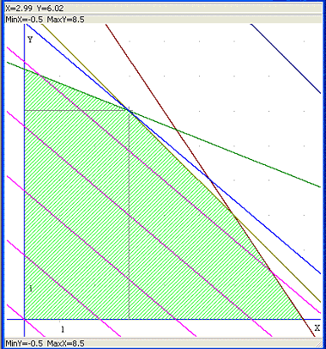
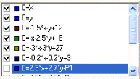
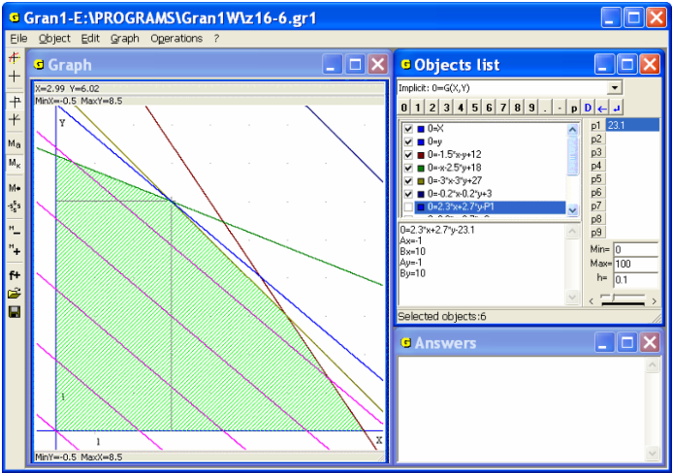
Fig. 16.6
To what points , on the lines and he should go up, in order to come from the point to the point as quickly as possible?
The whole time that is required for the whole way is expressed in terms of unknowns and as follows:
(where , , , , , , , , – are given). Thus, it is necessary to find the minimum value of the function of two unknowns. Suppose , , , , , , , , . Define unknowns and in terms of and , – in terms of and plot graphs of the dependencies
for various values of . Assigning various values to one can get the following: the minimum value, that is equal to 4.8, the function reaches in the point , (Fig. 16.7).
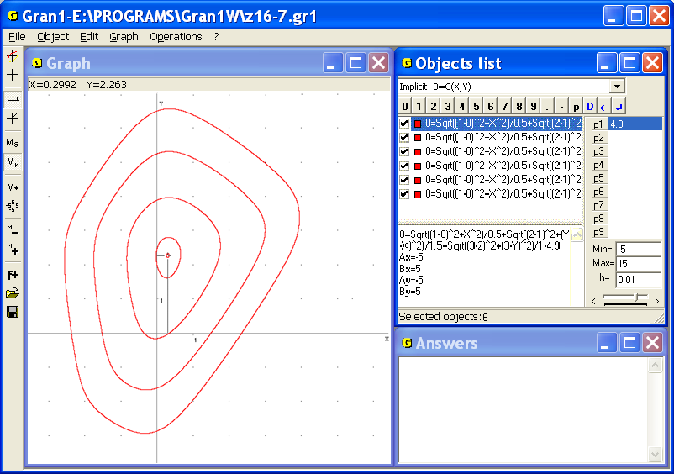
Fig. 16.7
Thus, to come from the point to the point as quickly as possible at given conditions, the traveler should go initially from the point (0, 0) to the point (1, 0.30), then to the point (2, 2.26), and further to the point (3, 3).
If on each of the lines , (), the traveler can go not to any point but to one of finite set of certain points, then the problem of discrete optimization is obtained.
Suppose it is permitted to go through only one of points (1, 0), (1, 1.5), (1, 3) of the line and through one of points (2, 0.5),(2, 2.5) of the line . Then we determine value of the function (at ) in the points (0, 0.5), (1.5, 0.5), (3, 0.5), (0, 2.5), (1.5, 2.5), (3, 2.5), with the help of the command “Operations / Value of expression G(x,y)” to get the result: the traveler could go the most quickly in given conditions from the point to the point , if the route will be as follows: (0, 0) – (1, 0) – (2, 2.5) – (3, 3).
One more way of solving is as follows: if to assign various values to the parameter one can find that the line of the lowermost level (among allowable) of the function goes through the point (0, 2.5) (Fig. 16.7).

Questions for self-checking
- How with the help of the program GRAN1 one can find the maximum and the minimum values of the function at the interval ?
- How with the help of GRAN1 one can find the maximum and the minimum values of the function on the set of solutions of inequality of the form ?
- Is it necessary to find roots of the equation for finding the maximum and the minimum values of the function at the interval with the help of GRAN1?
- How with the help of GRAN1 to define intervals of increasing and decreasing of the function at the interval ?
- Is it possible with the help of GRAN1 to set approximate direction where the function increases the most quickly in the point ?

Exercises for self-fulfillment
- The sum of two positive numbers and equals to 1. Find the maximum value of product of the numbers.
- Two points are given , . Find a point on the axis , the sum of distances of which to two given points is minimal.
- Find a point on the edge of the cube , the sum of distances of which from the tops and is minimal if the length of edge of the cube equals to 3.
- The circle of radius 1 is inscribed in the isosceles triangle. Find the minimal square of the triangle.
- Among the points with integer coordinates, that lie in the set of solutions of inequality , find a point, at which the function takes the maximum value.
- Find the maximum value of the function on the set , that is defined by the inequalities:: , , , , , , for the values = 0, 1, 3, 5, 7, 9.
Under the same conditions find integer solutions of the problem (for each of the values of ).
- The traveler stays in the point and wants to reach the point . The points are situated on different half-planes from the axis , (). On one half-plane he can move from the start point with the speed (=3 kph). On other half-plane he can move with the speed (=15 kph). To what point on the axis he should move up from the start point in order to reach the point as quickly as possible?
Consider the following cases:
- , , , ;
- , , , ;
- , , , .
- How graph of the dependence is changing when values of the parameter are changing? Consider the values .
- Solve the Steiner problem (see example 4) for the cases:
- , , , , ;
- , , , , ;
- , , , , ;
- , , , ;
- , , , .
- Find the minimal value of the function and the point, where it is reached, , .
- Find the approximate direction where the function increases the most quickly in the point , and define the speed of the increment.
- Find a straight line on the plane , the sum of distances to which from given points is minimal. Put for the concrete calculations:
- , , , ;
- , , , ;
- , , , ;
- , , , .

§17. Plotting secants and tangents to graphs of functions
In necessity to plot a secant of graph of the dependence , that goes through the points , on the graph of the dependence , or a tangent to graph in the point on the graph, and to calculate the angular coefficient of the secant (the ratio of the increment of function to the increment of argument ) or the angular coefficient of the tangent (the value of derivative in the point ) one can use the command “Operations / Derivative...”.
In this case current dependence in the window “Objects list” is being processed. After use the command “Operations / Derivative...” the auxiliary window “Derivative” is displayed (Fig. 17.1).
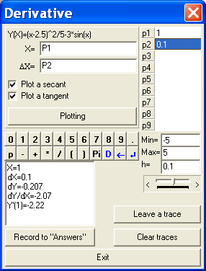
Fig. 17.1
In the window the expression of the object and the data input panel are displayed. In the line “Х=” one should input abscissa of the point where tangent or secant should be plotted (by default ). In the line “Δx=” one should input the increment of argument in the point (by default ).
In both expression of the dependence between the variables and and expressions that define point of contact and increment can be included one or several parameters, , …, .
If the point lies out of segment of definition of the dependence or the dependence is not defined in the point, a corresponding message is displayed.
After input of values and (or only ) one should choose one or two of the following commands (set corresponding check-boxes) in the auxiliary window:
“Plot a secant” – means to plot a secant through the points , . In this case the corresponding graph is displayed in the window “Graph”. After use the command “Record to Answers” values of abscissa of the point, the value of increment of the argument , the value , that corresponds to the value , and the value of angular coefficient of the secant will be written in the window “Answers”(Fig. 17.2).
“Plot a tangent” – means to plot a tangent to the graph in the assigned point. As a result of use this command the corresponding graph is displayed in the window “Graph” and message with value of the derivative is shown in the window “Answers” (Fig. 17.3).
One can plot both secant and tangent for a graph in one window (Fig. 17.4).
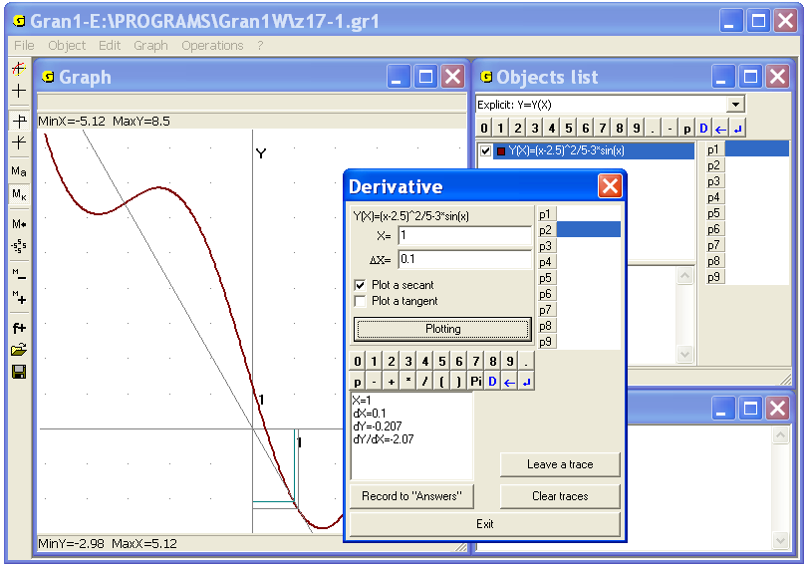
Fig. 17.2
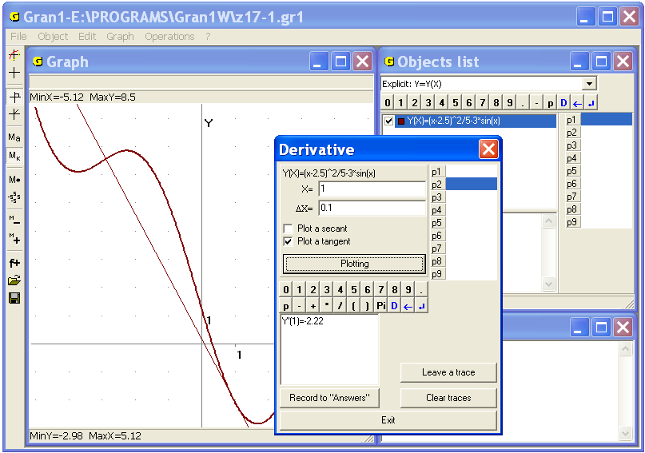
Fig. 17.3
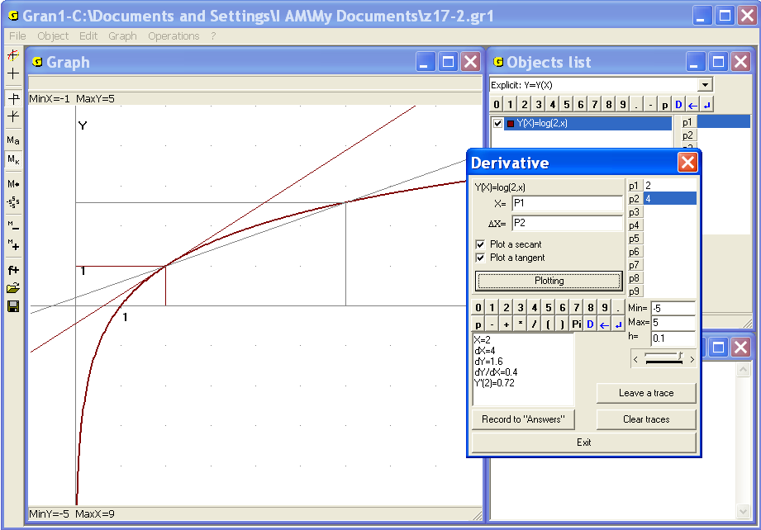
Fig. 17.4
The graph of function, for which a secant or a tangent should be plotted, must be previously plotted. Otherwise the command “Operations/Derivative” is inaccessible. Since with the help of the program the increment and the value of derivative for the current function are calculated, the use of the command automatically makes the function marked. After finishing the operation the check-box returns in the previous position.
When the user changes the values of parameters in the expression of function, the bounds and of argument, the contact point , the increment , in the program the corresponding values , , , are re-calculated and correspondingly the graphs are transformed (Fig. 17.4).
Examples
1. Find equation of a secant to graph of the function , that goes through the points (2, ), (6, ), and equation of a tangent to the graph in the point (2, ).
Use the command “Operations / Derivative...”, assign for the parameter , with that the abscissa of the contact point is defined, the value 2, assign for the parameter , with that the increment of the argument is defined, the value 4. Th us one can find the angular coefficient of the secant and the angular coefficient of the tangent (Fig. 17.4). Take into consideration the general form of equation of the line on that lies the assigned point and the angular coefficient of that line is : , and get required equation of the secant and equation of the tangent to the graph in assigned point .
In necessity to determine bounds of values of the function if the bounds of the argument are , or, vice versa, to determine bounds of the argument , if bounds of values of the function are , one can use the command of change the zoom in the window “Graph”. To see the bounds of , if is changing from to , it is enough to set user’s zoom so that in the rectangle in that the part of graph lies, the following values were shown: , .
In this case the upper and the lower sides of the rectangle ( and ) should be chosen so that they were minimally remote from each other but the rectangle contained all the points of the graph on the interval . The ordinates of points on the upper and lower sides of the rectangle determine the bounds of the function on the interval (Fig. 17.5, where , ).
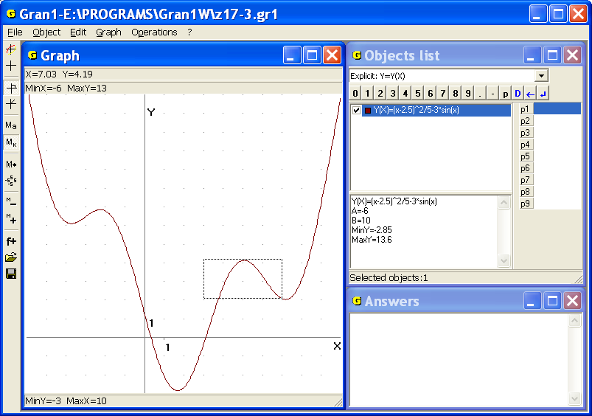
Fig. 17.5
This problem also can be solved with the help of the coordinate cursor for determination the minimum and the maximum values of on .
It is also possible to assign the bounds , of the interval where the function is assigned. Then in the program and are automatically determined on the interval .
If value of the function is changing on the interval , the bounds of the argument in the neighborhood of the point can be determined the same way (Fig. 17.6, where, ).
Another way is as follows. Plot graphs of the dependencies , , and define the longest interval , in that lies . In the points of this interval the value should stay in the bounds , (the graph of dependence doesn’t go out of the lines , ).
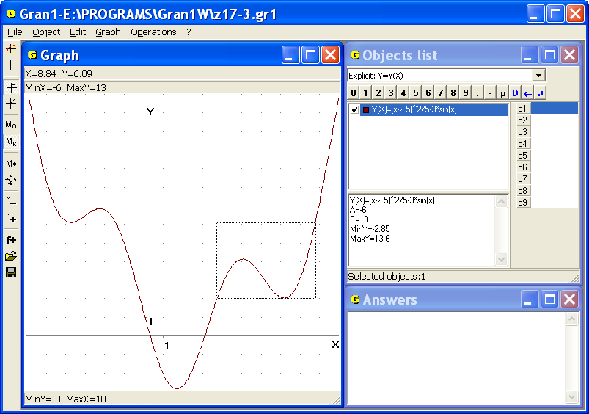
Fig. 17.6
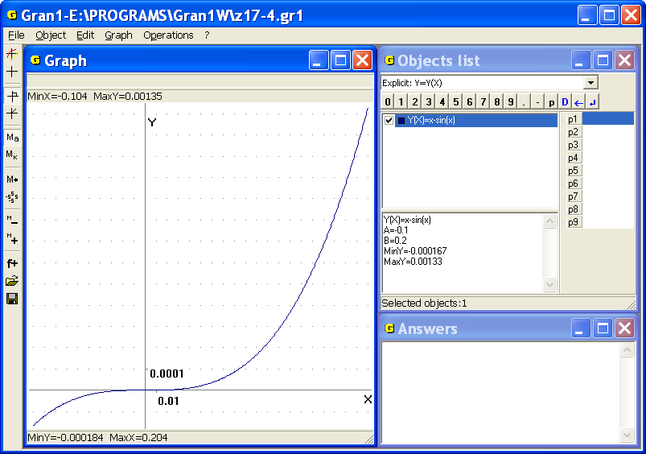
Fig. 17.7
The similar problems occur partially in the theory of errors of the approximate calculation and in many other cases.
2. Find bounds of values of the function , if the argument is changing on the interval .
Plot graph of the dependence on the interval to see that the values on the interval are changing in the bounds (Fig. 17.7).
Thus if we replace the value of function by the value of argument , the absolute value of error is no more than , if the values of argument of the function are in the bounds from to , and is no more than , if the values of argument of the function are in the bounds .

Questions for self-checking
- How with the help of GRAN1 one can plot a tangent to graph of the function in the point ?
- How with the help of GRAN1 one can determine the angular coefficient of the line that goes through the points , ?
- How one can determine graphically the point on the graph of dependence where the tangent is parallel to the secant that goes through the points , (the function is supposed to be differentiable in any point of the interval )?
- Can a tangent (if it exists) to the graph of a function convex downwards intersect with this graph in a point that is not a point of contact?
- Assume is function convex downwards, defined on the interval; – equation of the line on that exists no more than one common point with graph of the dependence . Can be true the inequality at least for one ?

Exercises for self-fulfillment
      - At what values of the argument it is possible to replace values of the function by values of the function with the error that is no more than 0.01?
      - Find equation of a tangent to graph of the function in the point with the abscissa .
      - Find equation of a line that goes through the points , , where , , .
      - Find equation of a line that goes through the points, , where .
      - Find out, at what values the value can be replaced by the value with the error that is no more than 0.1; 0.01; 0.00001.
      - Find out, at what values the value can be replaced by the value with the error that is no more than 0.00001; 0.0001; 0.001; 0.01; 0.1.

§18. Calculation of definite integrals
For calculation of definite integrals of the form one can use the command “Operations / Integrals / Integral...” (Fig. 18.1).
The command is intended for calculating of definite integrals of functions specified explicitly in the form , of polynomials, that approximate tabular given functions, of densities of distribution of statistical probabilities (whose graphs are histograms). The integral is being calculated for the function that is marked by the check-box. in the window “Objects list”. If no functions are marked in the window, the integral is being calculated for current function.
If several functions are marked, the values of found integrals are being added. Thus it is possible to calculate integrals for functions given by different expressions on different intervals. If the limits of integration are beyond the interval of definition of the function, the integral is being calculated on the common part of the interval. For example, if a function is defined on the interval [-5, 5], and integration limits are [0, 10], then the integral will be calculated on the interval [0, 5].
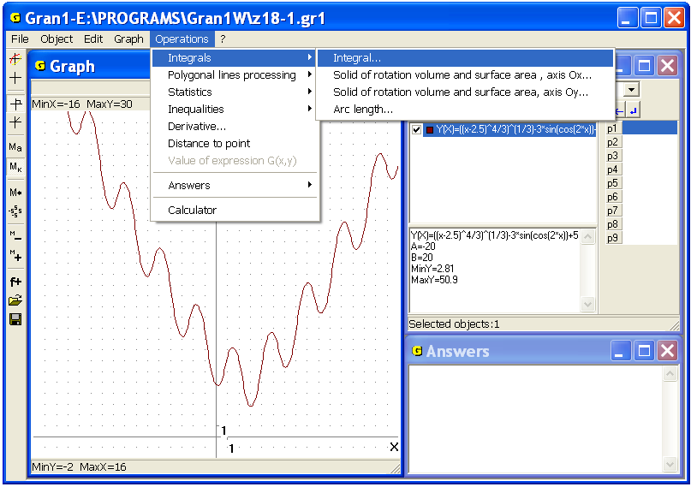
Fig. 18.1
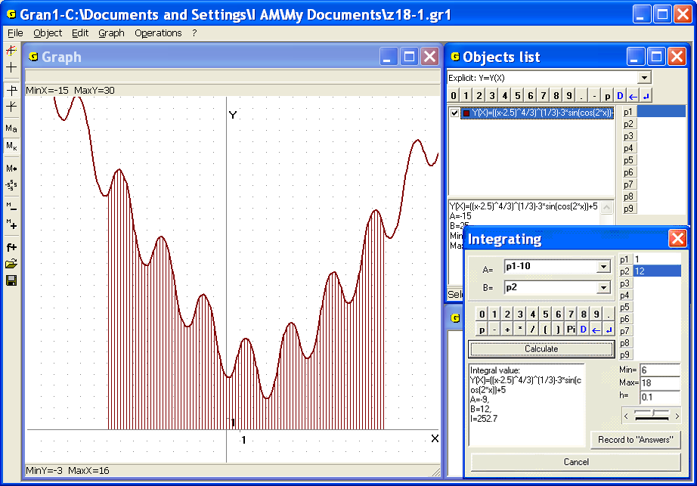
Fig. 18.2
After use the command “Operations/Integrals/Integral...” an auxiliary window “Integration” is displayed. In the window one should input the value “А=” – left integration limit and the value “В=” – right integration limit (Fig. 18.2).
In both the integrand and the integration limits can be included parameters , , …, (Fig.. 18.2).
Having used the command and having pressed the button “Record to "Answers" in the window “Answers” one can see the integrand, integration limits and value of the integral .
If the graph was plotted in the window “Graph”, the domain bounded by the graph, the axis and the lines , , will be shaded (Fig. 18.2).
Examples
1. Assume it is necessary to calculate an the area bounded by the lines , , , i.e. the definite integral .
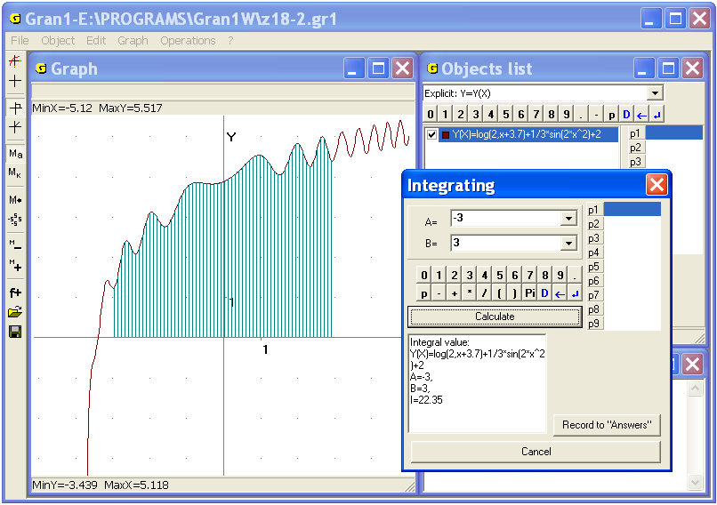
Fig. 18.3
Plot graph of the function on the interval [-5, 5], use the command “Operations / Integrals / Integral...” and input the integration limits , . As a result get (Fig. 18.3).
It should be noted that the integral can’t be calculated exactly because antiderivative of the integrand doesn’t exist in limited expressions. Therefore for calculation of similar integrals only approximate methods are used.
2. Calculate where
Plot graph of the function on the interval (on the interval – graph of the function , on the interval – , on the interval – ) and use the command “Operations / Integrals / Integral...” Input the integration limits , to obtain the value of integral (Fig. 18.4):
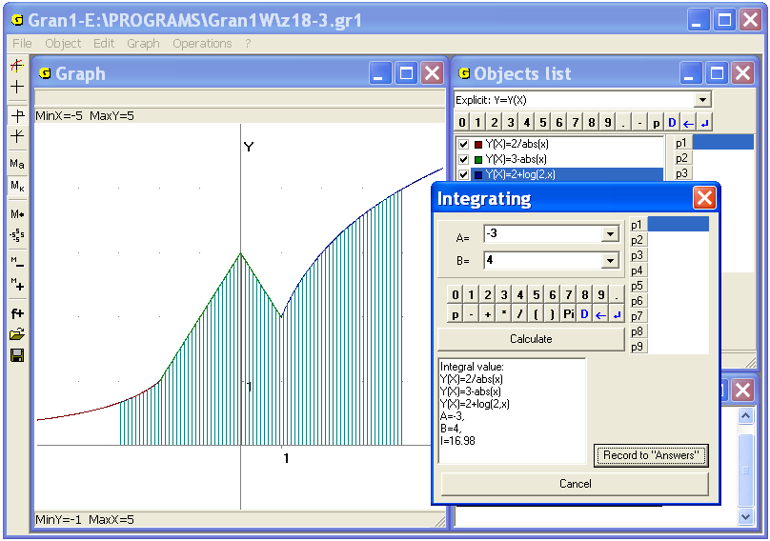
Fig. 18.4
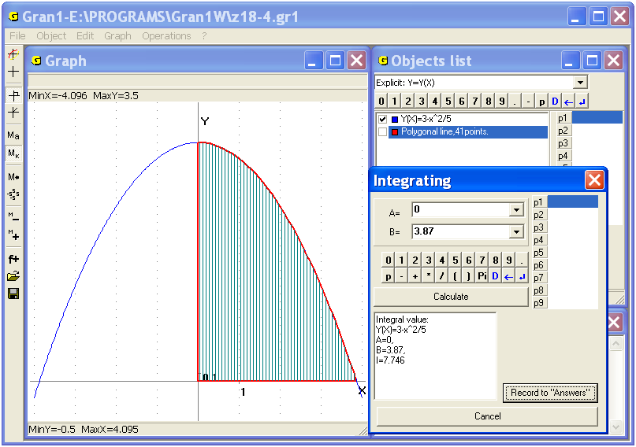
Fig. 18.5
.
The approximate value of the defined integral can be also obtained as area of the polygon bounded by the locked polygonal line with the tops , , , , ... , , , , , where the tops and their quantity are chosen so that the polygonal line is situated as near as possible to the curve on the interval .
3. Assume it is necessary to calculate approximately the area of curvilinear trapezoid between the parabola and the lines , .
Use the command “Operations / Integrals / Integral...” and input the integration limits , , to get (Fig. 18.5).
Plot the locked polygonal line with the vertices (0, 0), (0, 3), (0.1, 3.00), (0.2, 2.99), (0.3, 2.98), (0.4, 2.97), (0.5, 2.95), ..., (3.7, 0.26), (3.8, 0.11), (3.87, 0) ) and use the command “Operations / Polygonal lines processing / Polygon area” to get (Fig. 18.6).
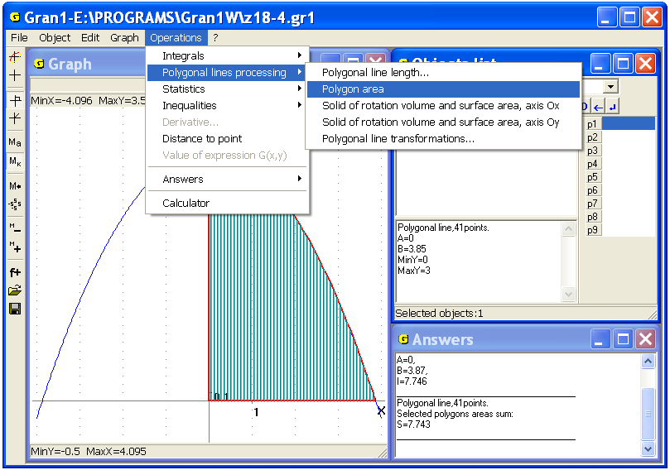
Fig. 18.6
The tops of polygonal line can be entered from the keyboard, from the table that was previously created in a file, from the screen. The distances between the tops can be various taking into account (visually) the curvature of the line on various parts, the sharp curves etc.
It should be kept in mind that for use the command “Operations / Integrals / Integral...” the integrands should be bounded. For approximate calculation of the improper integrals of the form where the function has a discontinuity point (of the second kind) on the interval such that at (or ), it is possible to use commands of the program for calculating integrals and where is sufficiently small.
If the integral is convergent, then with gradual decrease of obtained values will be progressively less differ. After obtaining of certain quantity of stable digits the process of calculations can be stopped. But the problem may demand addition analysis of integral convergence.
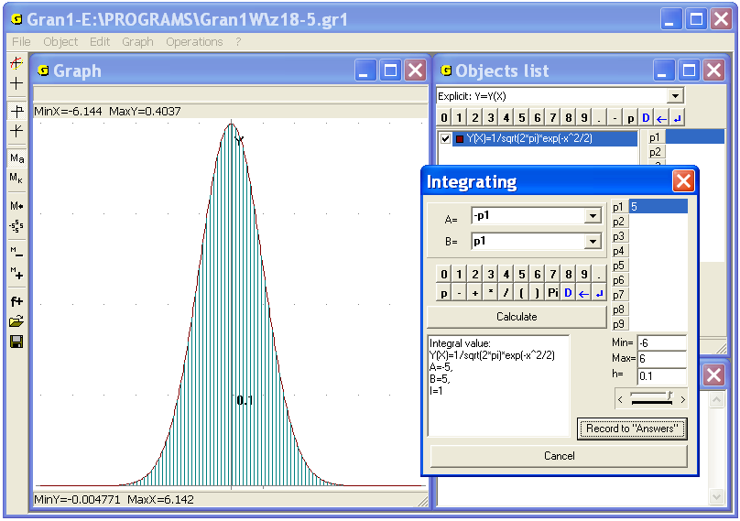
Fig. 18.7
Similarly for approximate calculation of principal value of improper integral of the form it is possible to calculate with gradual change of until stabilization of certain quantity of digits (if it is possible). In this case some additional analysis of integral convergence can be necessary as well.
4. Calculate the integral approximately.
Plot graph of the function on the interval and assign the integration limits: lower , upper (Fig. 18.7), and calculate the integrals , , , , , . As a result it is seen that for the given function the integrals on the intervals , , , are approximate equal one another and are equal to 1 with sufficiently high precision.
This result can be also obtained by analytical methods (but the antiderivative for the function doesn’t exist in precise expressions).
It can be shown that . This integral is called Euler-Poisson’s integral. The function is called Laplace’s function. For calculation values of this function special tables are created.
If it is necessary to solve equation of the form or of , where is some assigned number, one can use the command “Operations/Integrals/Integral…” and assign the integration limits as expressions in that a parameter is included. Then one should set some bounds and the increment for , and choose the value of so that the equality or would be as precise as possible.
5. Find the value of so that .
Input the integrand then use the command “Operations/Integrals/Integral…”, input the integration limits , , change the increment of if necessary. Choose so that the equality would be as precise as possible. The answer is (Fig. 18.8).
Considered integrals are widely applicable in the probability theory and mathematical statistics.

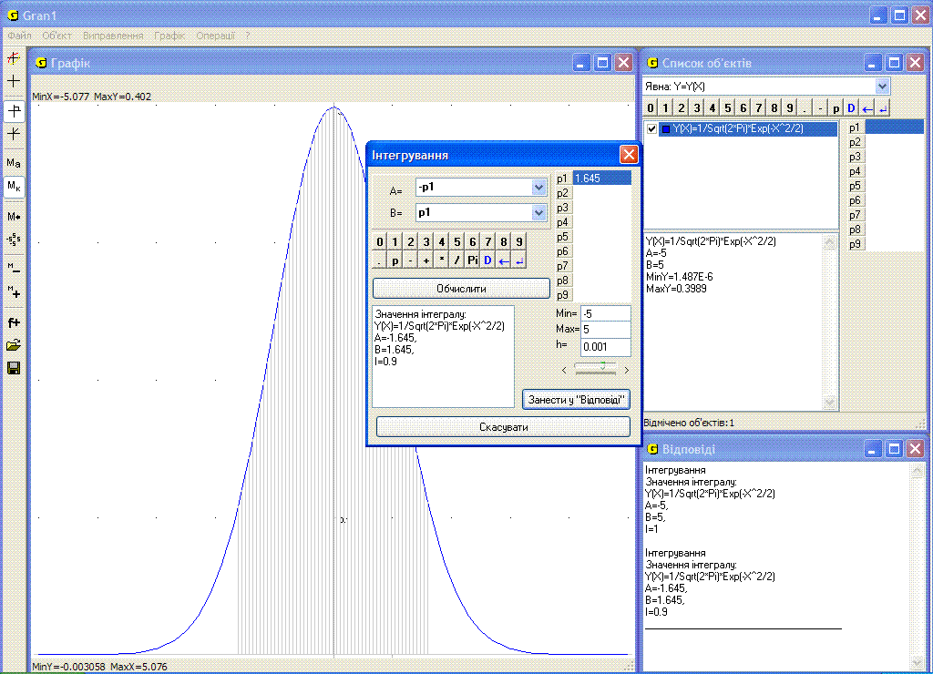
Fig. 18.8
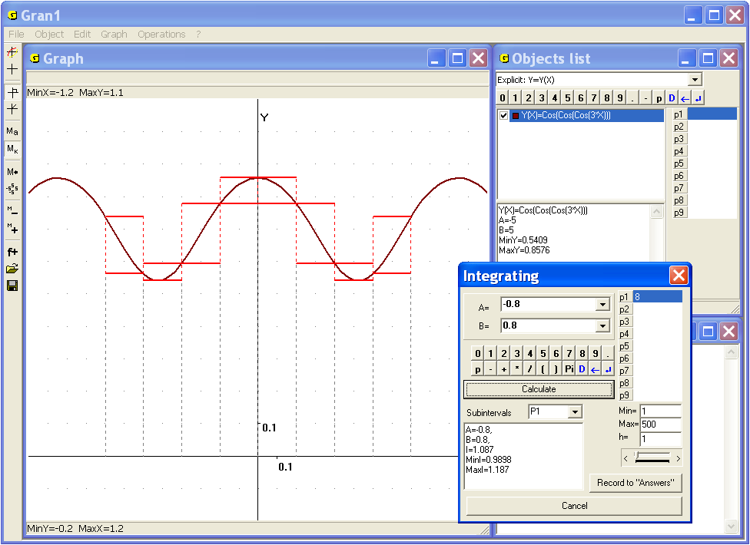
Fig. 18.9
The command “Operations /Integrals /Darboux amounts” is intended for calculation upper and lower Darboux amounts at given separation of the segment [a,b), where the integral is being calculated, on intervals , (Fig. 18.9).
Reducing the intervals, increasing value of one of the parameters Р1, Р2, ... , Р9, with the help of that will be defined quantity of intervals (Рис. 18.10), one can observe changing of upper and lower Darboux amounts that limit required value of integral above and below:
To specify a name of parameter for definition of number k of intervals , one should input one of the symbols P1, P2, ... , P9, in the line “Subintervals” (Fig. 18.10), then set the mouse cursor on corresponding line and input initial parameter value (the line will be painted light blue). Besides it is necessary to input minimal and maximal parameter values and also step of its change h in the lines “Min=”, “Max=”, “h=” (in this case all mentioned values should be integer).
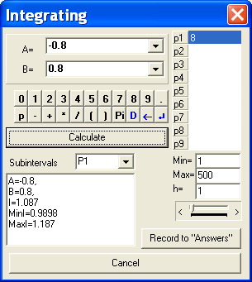
Fig. 18.10
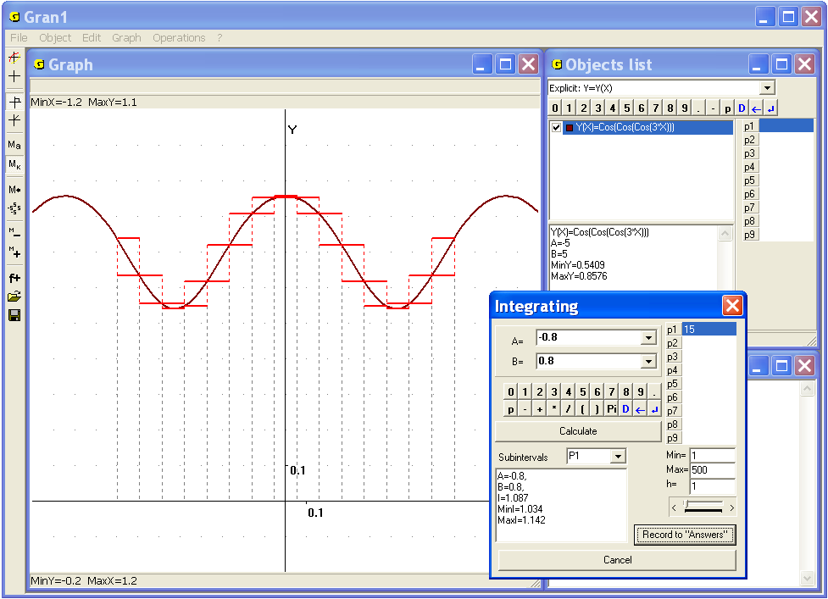
Fig. 18.11
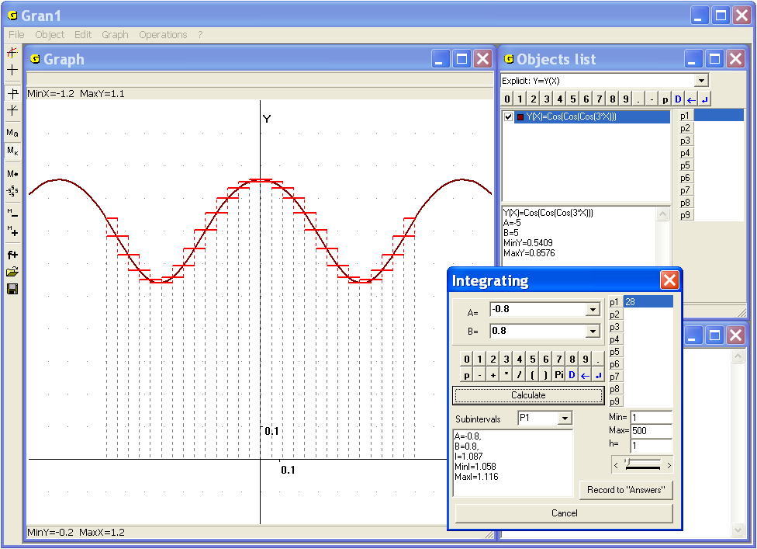
Fig. 18.12
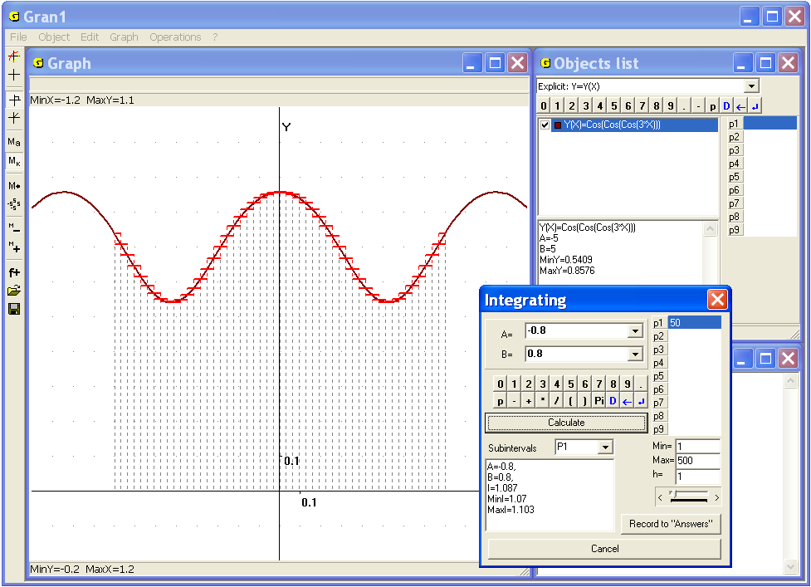
Fig. 18.13
For changing parameter value it is necessary to move a slider (under the inscription h= ...) right or left. As can be seen on Fig. 18.11, 18.12, 18.13, with reducing the intervals the lower Darboux amount is not being decreased, and the upper Darboux amount is not being increased, and the sums become less and less different when the number of intervals is being increased.
It is provided in the program GRAN1 that lengths of all the intervals are equal: , . When k is being increased (by change of the value of corresponding parameter (Fig. 18.10), the lengths of intervals are decreased correspondingly.
It should be noted, to provide the number of intervals as integer, the step change of corresponding parameter must be integer (Fig. 18.10).
The command “Operations /Integrals / Darboux amounts” can be used for study of notion of definite integral in the course “Algebra and analysis”.
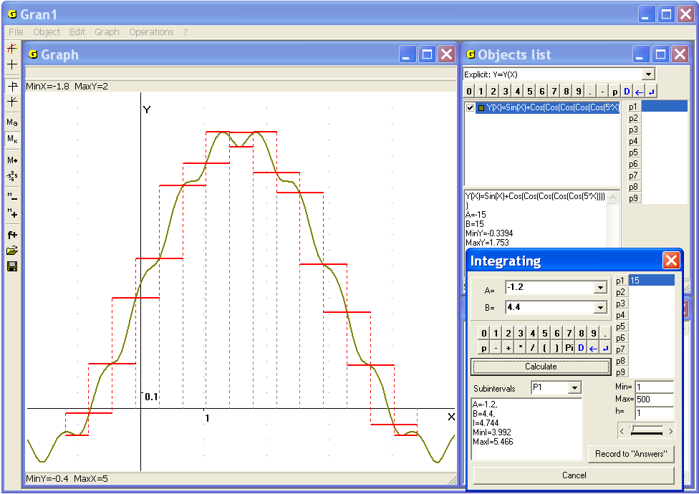
Fig. 18.14
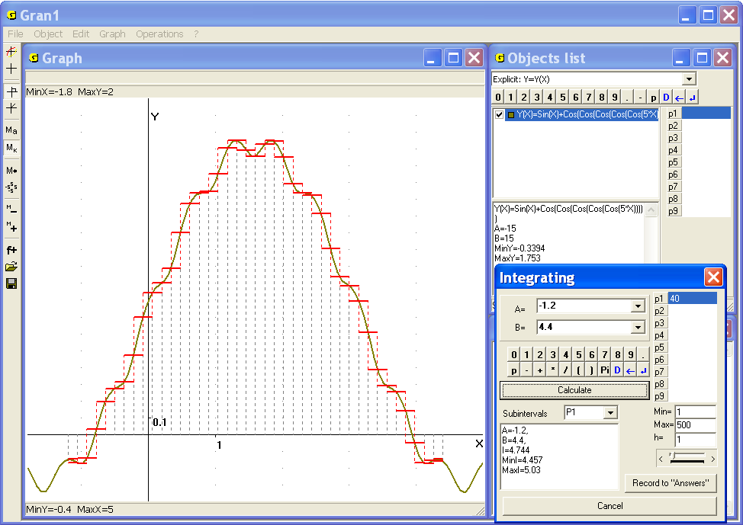
Fig. 18.15
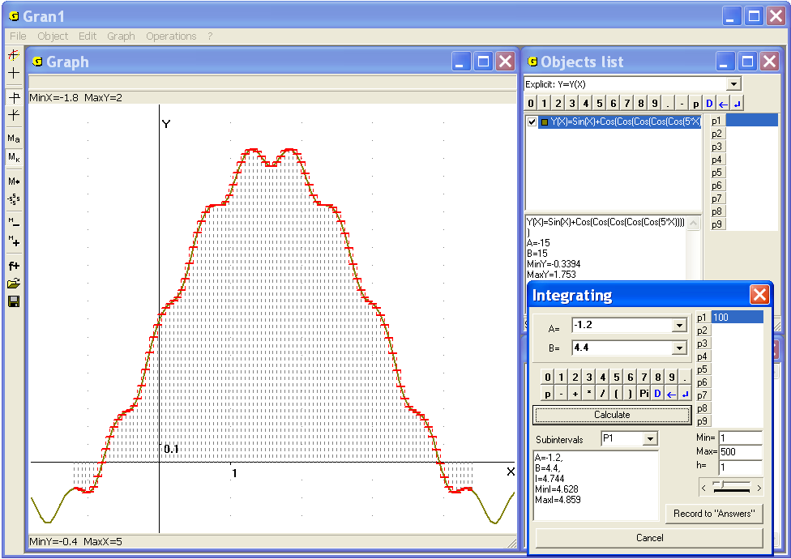
Fig. 18.16
The command “Operations /Integrals /Averaging by intervals” is intended for building a piecewise function on the interval , when , , , such that , (Fig. 18.14).
As can be seen on the Fig. 18.14, Fig. 18.15, Fig. 18.16, with reducing the intervals the difference between functions and is being decreased and
, when .

Questions for self-checking
- How to find approximate value of definite integral of the form using the program GRAN1?
- What value will be calculated in the case of use the command “Operations/Integrals/Integral…” if in the window “Objects list” several functions are marked?
- Is it necessary to plot graph of the function before use the command “Operations/Integrals/Integral…” for calculation the integral ?
- What additional plotting will be made with the help of GRAN1 if graph of the function has been plotted before use the command “Operations/Integrals/Integral…” ?
- How to find approximate value of a definite integral with the help of the command “Operations / Polygonal lines processing / Polygon area”?
- Is it possible to find integration limits by the value of definite integral of the function ?
- How to find approximate value of a definite integral with the help of the command “Operations / Integrals/Darboux amounts”?

Exercises for self-fulfillment
- Calculate the following definite integrals using the command “Operations/Integral/Integral…” of the program GRAN1:
- ; | - ;
- ; | - ;
- ; | - .
- Calculate area of the figure bounded by the lines:
- , ;
- , ;
- , .
- Define the integration limits , in order to the following equalities would be true:
- ;
- , ;
- ;
- .

§19. Calculation the arc length of a curve
The arc length of a curve in the bounds from point to point can be calculated by the formula
If the curve is assigned by equation of the form (,), the formula is as follows:
If the curve is assigned by equations of the form , , then
If the curve is assigned in the polar coordinates by equation of the form then:
, ,
, , , .
Examples
1. Calculate the arc length of the parabola from the point (0, 0) to the point (3, 9).
In the example the problem reduces to calculating the integral
.
Use the command “Operations / Integrals / Integral...” to get (Fig. 19.1, Fig. 19.2)
.
2. Calculate the arc length of the cycloid , where parameter is changing from 0 to 2π.
In this case the arc length can be calculated by the formula
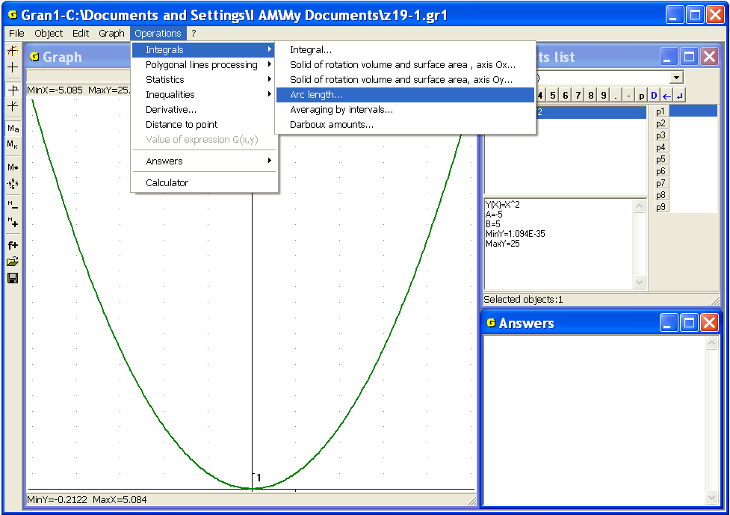
Fig. 19.1
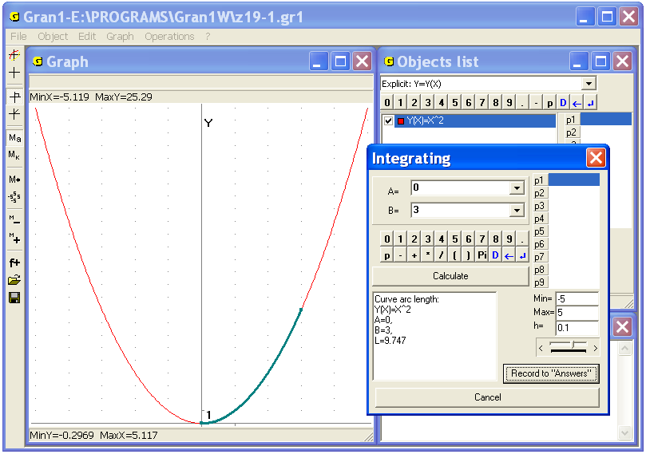
Fig. 19.2
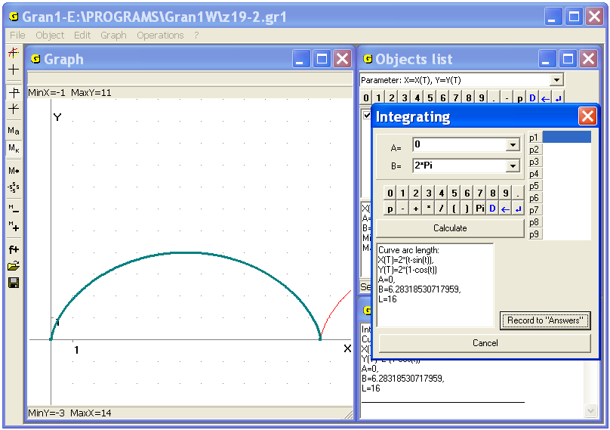
Fig. 19.3
For the concrete data of the example the following integral will be obtained
Use the command “Operations / Integrals / Integral...” to get (Fig. 19.3).
In the program GRAN1 there is the command “Operations / Integrals / Arc length...”, that helps to find the arc length between two given points (Fig. 19.1).
In this case corresponding dependence can be defined explicitly, parametrically, in the polar coordinates, in the form of a polynomial that approximates a tabular defined function.
To use the command one should input bounds of the argument like while calculating integral (Fig. 19.2)
Use the command “Operations / Integrals / Arc length...” for calculating the arc length of the parabola from to and get (Fig. 19.2). In this case color of the corresponding part of the arc in the window “Graph” will be changed. The result can be displayed in the window “Answers” if necessary.
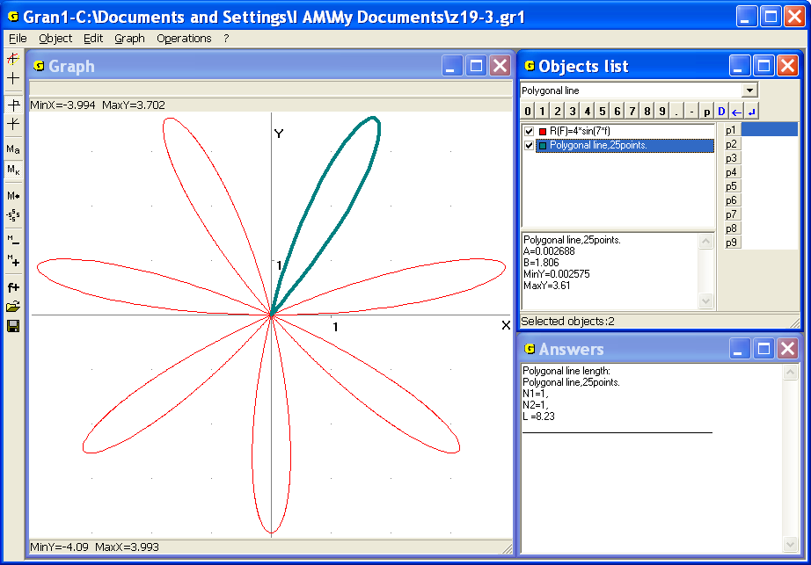
Fig. 19.4
For the arc length of the cycloid , where is changing from 0 to 2π, one can get (Fig. 19.3).
For any type of dependence the arc length can be approximately calculated with the help of the command “Operations / Polygonal lines processing / Polygonal line length...”, if tops of the polygonal line are placed as near as possible to the curve.
3. Assume it is necessary to define approximately the length of contour of one petal of seven-petalous rose. The equation of the rose in the polar coordinates is .
Place tops of the polygonal line along the contour of the petal as it is shown in the Fig. 19.4, then use the command “Operations / Polygonal lines processing / Polygonal line length...”, assign the same value 1 to start and end numbers of tops, and get the answer – the length of contour of one petal of seven-petalous rose approximately equals (Fig. 19.4).

Questions for self-checking
- How the arc length of the curve defined by equation in bounds from point to point can be calculated with the help of the command “Operations / Integrals / Integral/...”?
- How with the help of the command “Operations / Integrals / Integral/...” calculate arc length of the curve defined by equations , , in bounds from point to point ?
- How with the help of the command “Operations / Polygonal lines processing / Polygonal line length...” calculate approximately the arc length of a curve?
Exercises for self-fulfillment
- Calculate the arc length of the curve in the following bounds:
- where is changing from -2 to 3,
- where is changing from to 4,
- where is changing from 0 to 1,
- where is changing from 0 to 1,
- where is changing from to ,
- where is changing from to 8.
- Define at what value of the parameter the arc length in bounds from 0 to takes the value :
- , ;
- , , ;
- , ;
- , , .

§20. Calculation of volumes and surface areas of solids of rotation
For calculation surface areas and volumes of solids bounded by surfaces that are generated by rotation of polygonal lines around one of the coordinate axes in the program GRAN1 there are the commands “Operations / Polygonal lines processing / Solid of rotation volume and surface area, axis ” and “Operations / Polygonal lines processing / Solid of rotation volume and surface area, axis ”. Such polygonal lines shouldn’t cross the axis of rotation.
If the polygonal line is unlocked, using the program one can calculate the area of surface circumscribed by the polygonal line, and the volume of the solid that could be generated in a case of rotation of locked polygonal line. The locked polygonal line is made of unlocked one by projecting of its free endings on the axis of rotation and pasting these points-projections between free endings of the polygonal line (both points-projections are connected with each other and with their prototypes).
Examples
1. Calculate lateral area and volume of the cut cone with the radius of the bigger foundation 4, the smaller – 2, the height – 5.
Create the polygonal line of one segment with the coordinates of endings (0, 2) and (5, 4).
Assign the zoom to display the axis in the center of the window “Graph” and plot the polygonal line (Fig. 20.1).
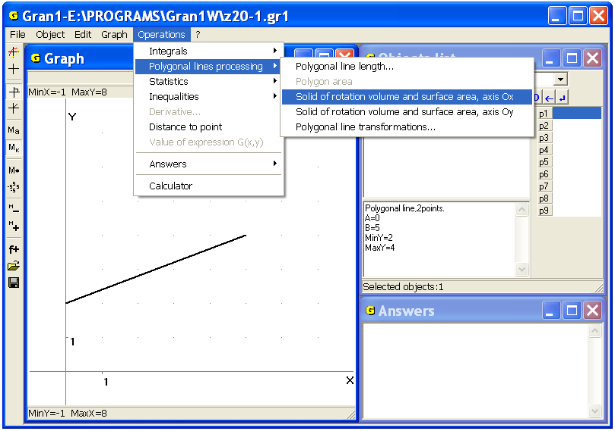
Fig. 20.1
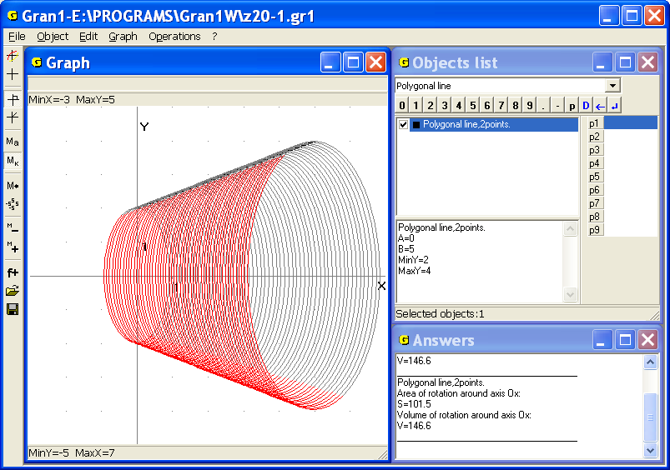
Fig. 20.2
Then use the command “Operations / Polygonal lines processing / Solid of rotation volume and surface area, axis (Fig. 20.1), and get in the window “Graph” the image of cone (the solid generated as a result of rotation of the polygonal line around the axis ), and in the window “Answers” – , (Fig. 20.2), where is the lateral area of the cut cone, is its volume.
Now plot unlocked polygonal line with the tops (0, 0), (0, 2), (5, 4), (5, 0), (Fig. 20.3) then use the command “Operations / Polygonal lines processing / Solid of rotation volume and surface area, axis ”, and get , , where is the area of whole surface of the cone (Fig. 20.4).
If the segment with tops (5, 4), (5, 0) is rotating around the axis (Fig. 20.5), the following results will be obtained: , , where is the area of lower (bigger) foundation of the cut cone (Fig. 20.6).
If the segment with tops (0, 0), (0, 2) is rotating around the axis , the following results will be obtained: , , where is the area of upper (smaller) foundation of the cut cone (Fig. 20.7).
If the segment to be rotated is not perpendicular to the axis of rotation, and one of its tops is lying on the axis, then after using the command “Operations / Polygonal lines processing / Solid of rotation volume and surface area, axis ”, the volume and lateral area of the cone will be obtained. If the segment is parallel to the axis of rotation, the volume and lateral area of the corresponding cylinder will be obtained.
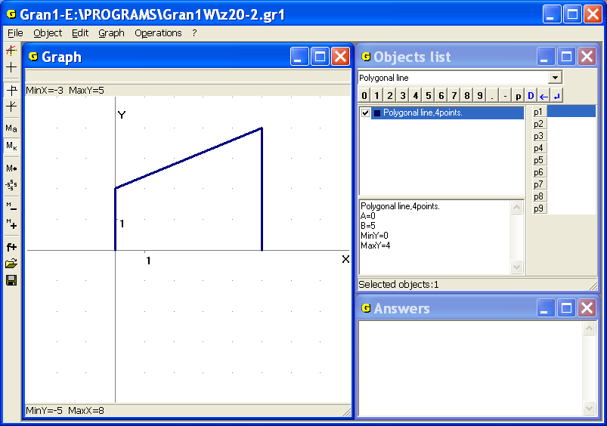
Fig. 20.3
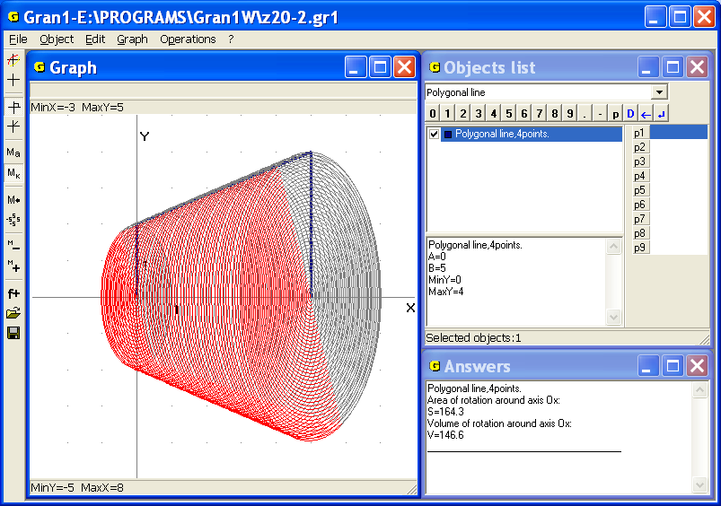
Fig. 20.4
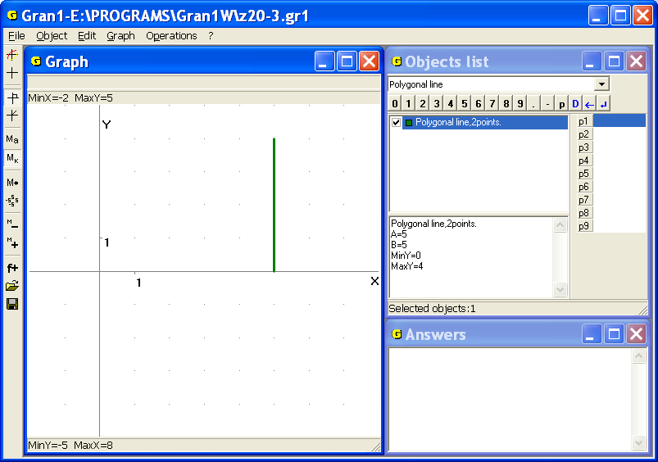
Fig. 20.5
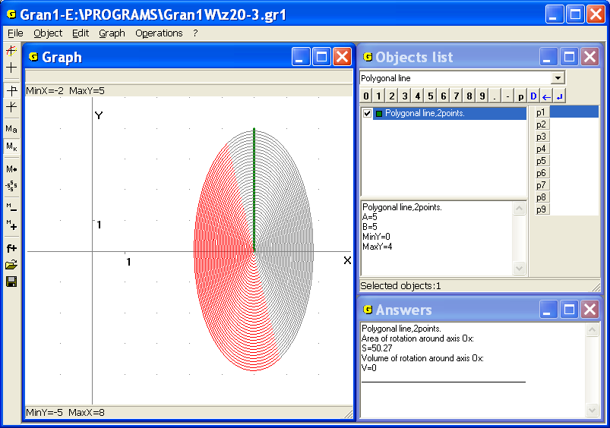
Fig. 20.6
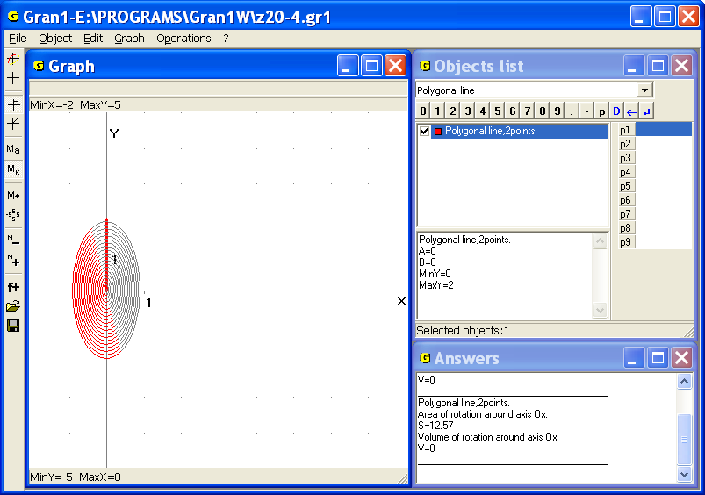
Fig. 20.7
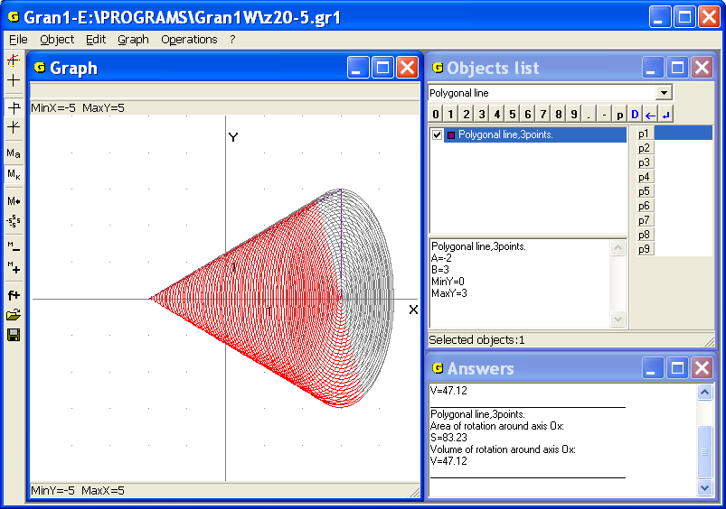
Fig. 20.8
2. The polygonal line is defined by three points (–2, 0), (3, 3), (3, 0), i.e. height of the cone equals to 5, radius of the foundation equals to 3. Use the command “Operations / Polygonal lines processing / Solid of rotation volume and surface area, axis ”, to get , (Fig. 20.8).
Using the command “Operations / Polygonal lines processing / Solid of rotation volume and surface area…” one can calculate approximately surface areas and volumes of solids of rotation, bounded by surfaces that are generated by rotation of arbitrary lines around one of the coordinate axes or . The lines shouldn’t cross the axis of rotation.
For this purpose one should plot a polygonal line in the given one so that to place them as near as possible and then use the command “Operations / Polygonal lines processing / Solid of rotation volume and surface area…”
3. Calculate approximately surface area and volume of the solid bounded by the surface generated as a result of rotation of the circle of radius 1 centered in the point (0, 2) around the axis .
Create a new object – “Circle” with given centre and radius. Use the command of a polygonal line creation and input tops from the screen. Inscribe the polygonal line in the circle so that to place them as near as possible. In this case it is convenient to set the following zoom: , , , (Fig. 20.9).
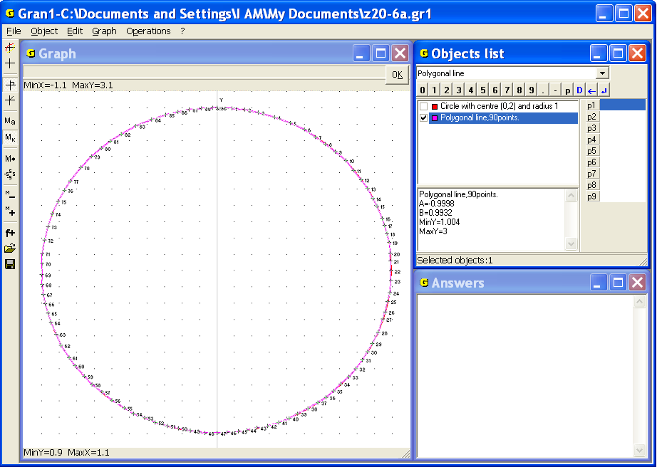
Fig. 20.9
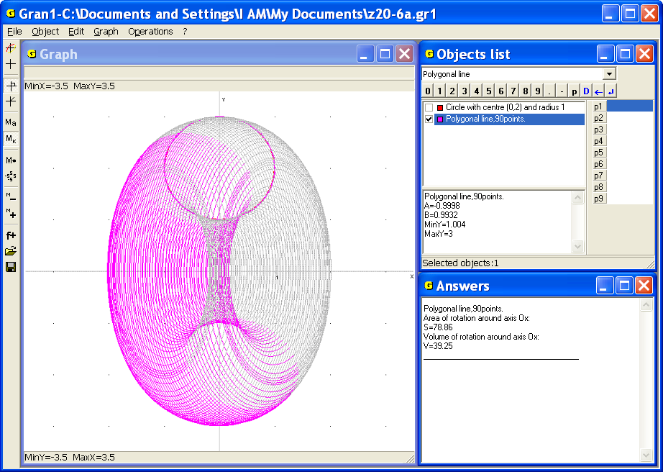
Fig. 20.10
Then set the following zoom , , , , and use the command “Operations / Polygonal lines processing / Solid of rotation volume and surface area, axis Ох”. As a result get , (Fig. 20.10). It should be noted that the more points of the polygonal line will be taken on the circle, the more precise will be the result.
For calculation the volume of the solid bounded by the surface that is generated by rotation of the line described by equation of the form , around the axis (or axis ), and by the surfaces , (or , ), in GRAN1 are intended corresponding commands as well.
The command “Operations / Integrals / Solid of rotation volume and surface area, axis Ох...” is destined for calculation of the volume and surface area of the solid bounded by the surfaces that are generated by rotation of graph of the dependence around the axis and the lines , . In this case corresponding dependence should be marked in the window “Objects list”(Fig. 20.11).
The command “Operations / Integrals / Solid of rotation volume and surface area, axis Оy...” is destined for calculation of the volume and surface area of the solid bounded by the surfaces that are generated by rotation of graph of the dependence around the axis and the lines , (Fig. 20.12).
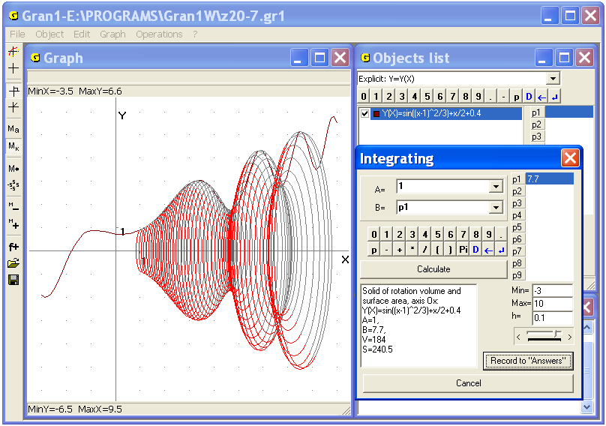
Fig. 20.11
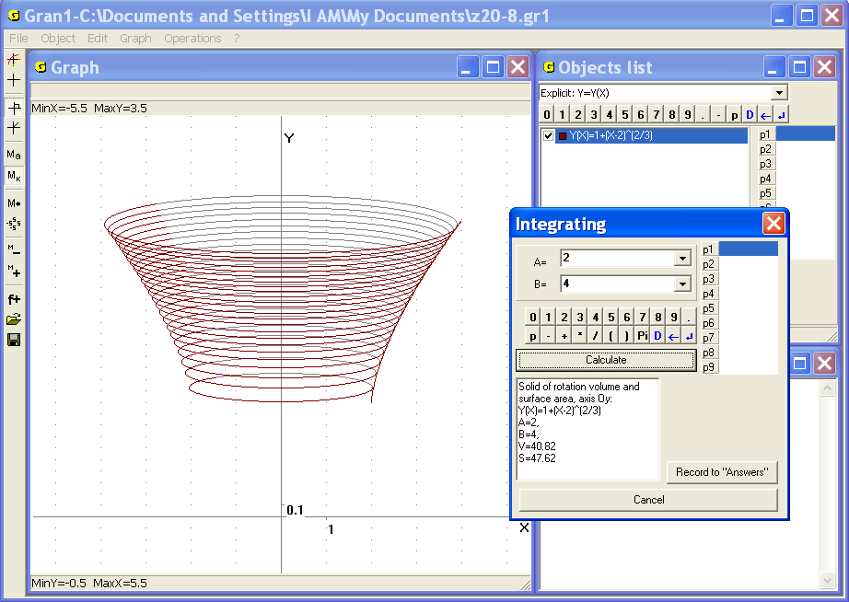
Fig. 20.12
If there are several marked dependencies in the window “Objects list”, then all the found volumes and surfaces areas are being added. The value of expression is calculated only on the segment of definition. This allows calculating volumes of the solids generated by rotation of graph of the dependence defined by various expressions of the form on adjoining segments around the axis .
It should be noted that volume of the solid bounded by the surface that is generated by rotation of the line described by equation of the form around the axis , and the surfaces , , can be also calculated with the help of the command “Operations / Integrals / Integral...” for calculating definite integral of the form whose value is the value of the required volume.
Analogously, volume of the solid bounded by the surface that is generated by rotation of the line described by equation of the form around the axis and the surfaces , (where , ) can be calculated with the help of the command “Operations / Integrals / Integral...” for calculating definite integral , or where is the function inverse to.
Volume of the solid generated by rotation of the figure bounded by the lines , , , (where ) around the axis can be also calculated by the formula
Surface area generated by rotation of the curve in bounds from the point to the point around the axis is calculated by the formula: if the curve is described by equality of the form , , then the corresponding formula is
4. Calculate volume of the solid bounded by the surface generated by rotation of the curve around the axis in the bounds from to .
Plot graph of the function, then use the command “Operations / Integrals / Solid of rotation volume and surface area, axis ...” and set integration limits , . As a result get , (Fig. 20.13).
5. Calculate volume of the cone generated by rotation of the figure bounded by the lines , around the axis .
Plot graph of the function . Use the command “Operations / Integrals / Solid of rotation volume and surface area, axis ...” and set integration limits , to get and also – Fig. 20.14.
6. Calculate volumes of the cones generated by rotation of segment of the line between the points (0, 1) and (1, 0) around the axis and the axis .
Plot graph of the dependence . Use the command “Operations / Integrals / Solid of rotation volume and surface area, axis and set integration limits , to get , (Fig. 20.15).
Then use the command “Volume, axis ” and set integration limits , again to get , (Fig. 20.16).
7. Calculate volume of the sphere generated by rotation of the semicircle of radius 2 centered in the origin around the axis .
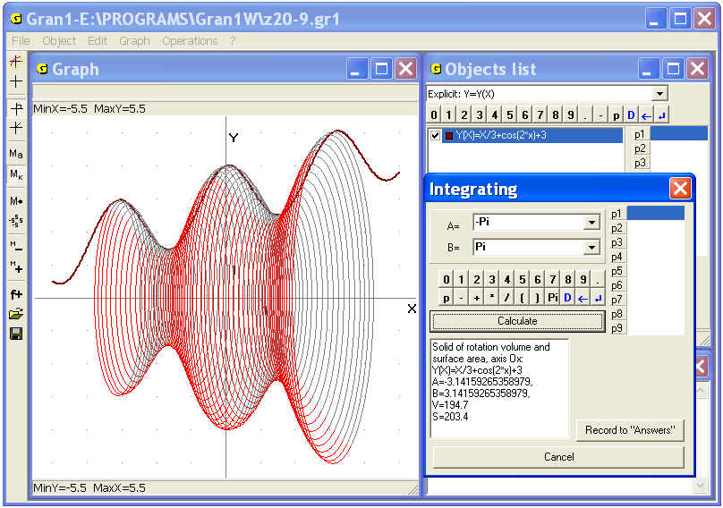
Fig. 20.13
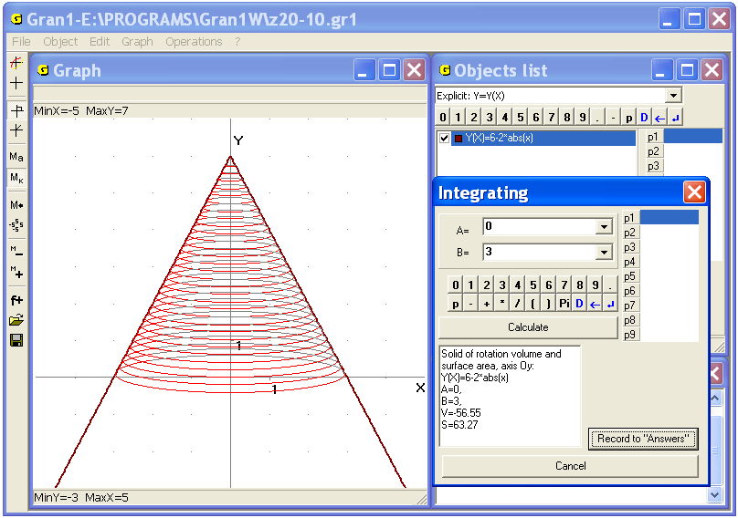
Fig. 20.14
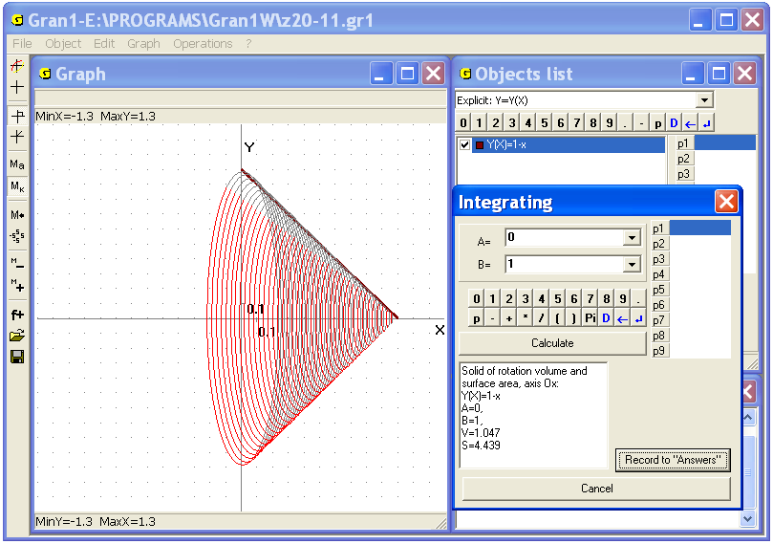
Fig. 20.15
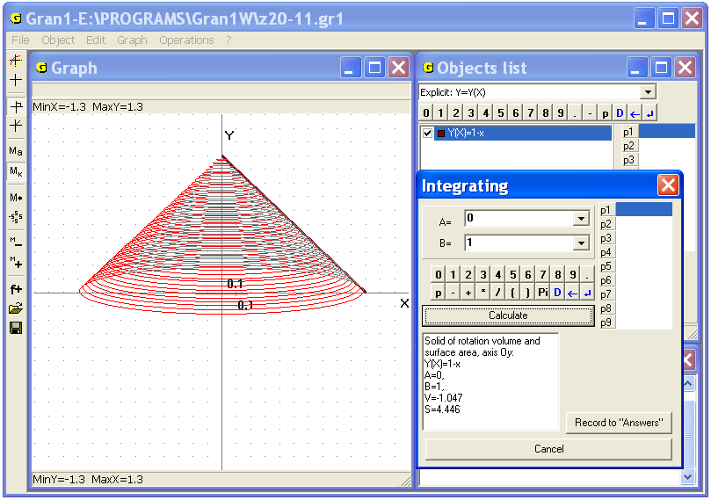
Fig. 20.16
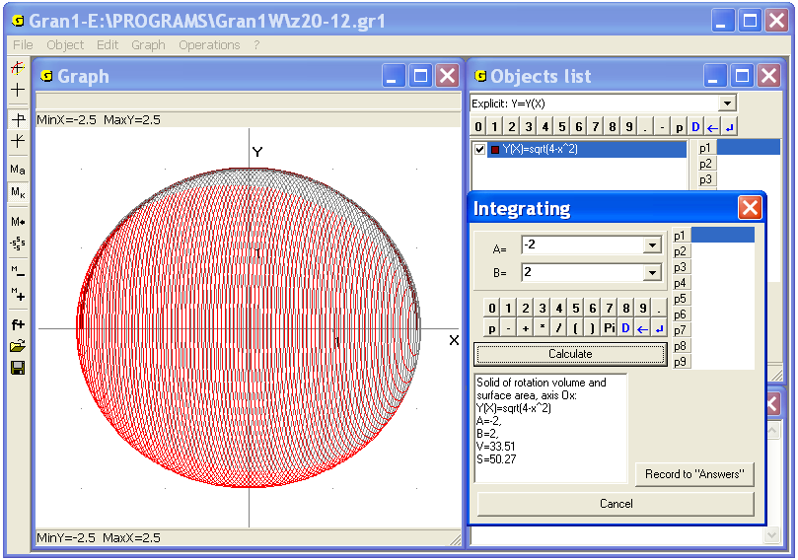
Fig. 20.17
Plot graph of the half-round that bounds given semicircle. Use the command “Operations / Integrals / Solid of rotation volume and surface area, axis ...” and set integration limits , to get , (Fig. 20.17).
Particularly, if the volume is calculated by the formula at , the following result will be obtained: .
8. Calculate volume of the solid generated by rotation of the circle of radius 1 centered in the point (0, 2) around the axis .
Plot graphs of the functions , then calculate the difference of the volumes and . For this purpose plot the both graphs. Then remove the check-box of the second dependency and calculate volume of the solid of rotation. (Fig. 20.18). Then remove the check-box of the first dependency and set the check-box at the second one to calculate volume of the solid of rotation. (Fig. 20.19). Subtract the second volume of the first one and get . Thus, the required volume is .
If we compare this result with the result obtained with the use of polygonal line (example 3, Fig. 20.10), we can see that accuracy of calculation volumes with the help of polygonal line is sufficiently high and depends of nearness between graph and polygonal line.
It should be noted that in the case of two chosen functions and the corresponding volumes are added.
9. It is known that height of a cylinder is twice as much that radius of foundation. Find height of the cylinder if its volume equals 100 cubic units.
To solve the problem it necessary to create function of the form , that is defined on the segment from 0 to . The graph of the function corresponds to lateral surface of the required cylinder.
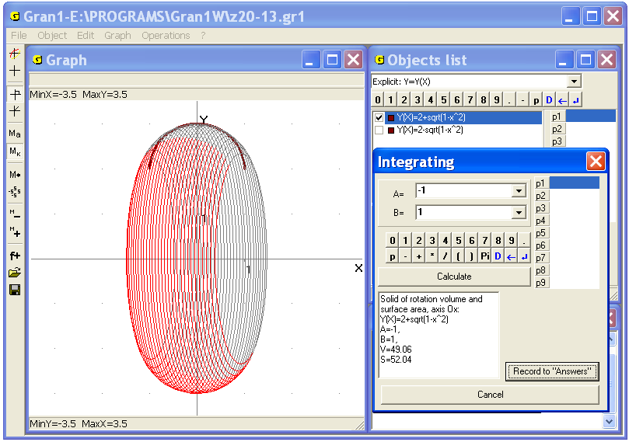
Fig. 20.18
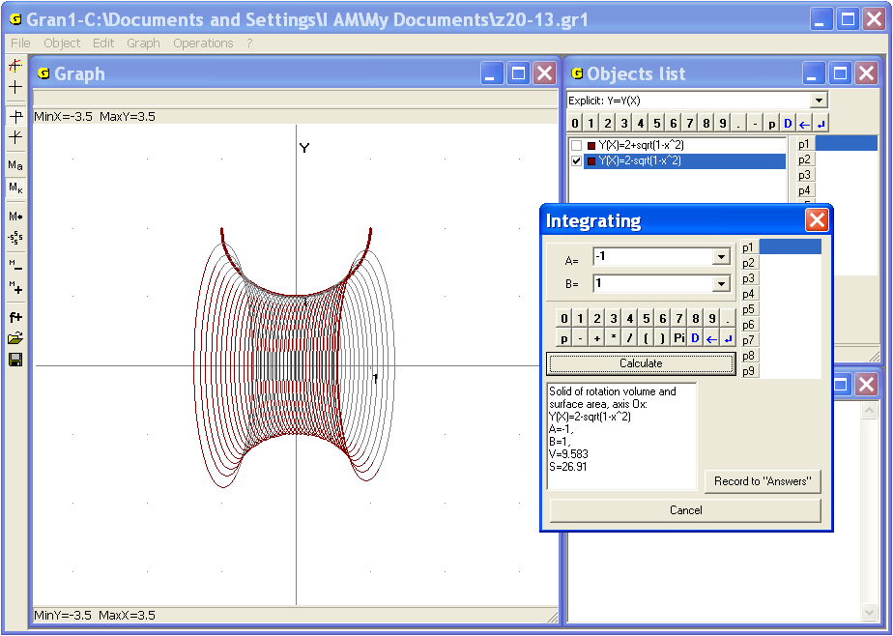
Fig. 20.19
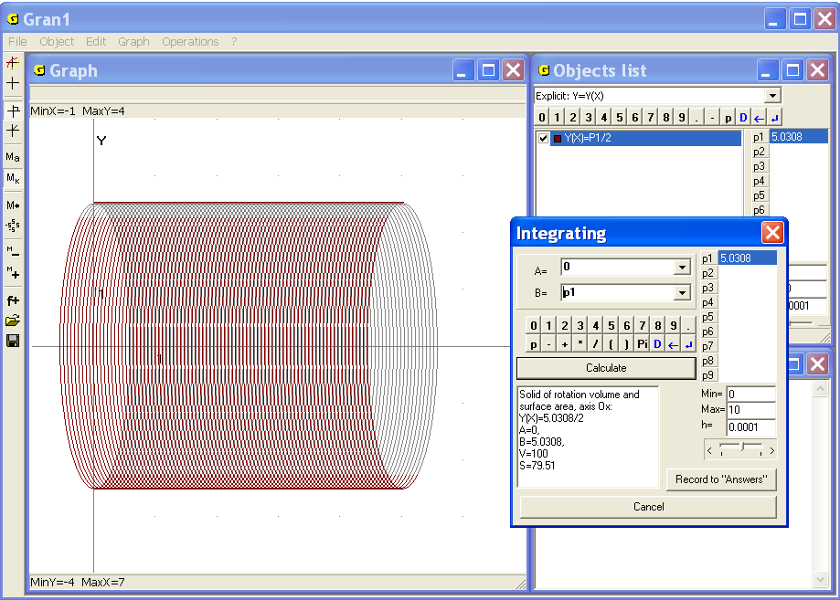
Fig. 20.20
Use the command “Operations / Integrals / Solid of rotation volume and surface area, axis ...” and set integration limits , and some value of the parameter P1 to calculate volume of the cylinder. Change gradually the parameter to find the value at that the volume equals to 100: (Fig. 20.20). This is the required height of the cylinder.

Questions for self-checking
- How to calculate volume of the solid bounded by the surface that is generated by rotation of a locked polygonal line around the axis ? around the axis ?
- Is it necessary to plot graphs of given functions before use the commands “Operations / Integrals / Solid of rotation volume and surface...”?
- How to calculate the volume and the surface area of the solid generated by rotation of the curve around the axis in bounds from to ?
- How to calculate volume and the surface area of the solid generated by rotation of the curve and the lines , , , around the axis with the help of GRAN1?
- How to calculate volume of the solid bounded of the surface of rotation of the curves , and the lines , around the axis ?
- What should be the curve in order to the volume of the solid bounded by the surface that is generated by rotation of the curve around the axis in bounds from to could be calculated properly?
- How to calculate volume of the solid bounded by the surface that is generated by rotation of the curve defined by parametric equations , around the axis (or the axis )?
- How to calculate area of the surface generated by rotation of the curve defined by parametric equations , around the axis (or the axis )?

Exercises for self-fulfillment
- Calculate volume of the solid generated by rotation of the rectangle , (at , and definite , , , )) around the axis .
- Calculate volume of the solid bounded by the surface that is generated by rotation of a segment of the line for in bounds from –3 to 3 around the axis .
- Calculate area of the surface that is generated by rotation of the circle of radius 2 centered in the point (0, 3) around the axis .
- Find volume of the cut cone generated by rotation of the trapezoid bounded by the lines , , , around the axis .
- Find volume of the solid bounded by the surfaces that are generated by rotation of the curve and the lines , around the axis .
- Find volume of the solid generated by rotation of the figure bounded by the lines , , , around the axis .
- Find volume and surface area of the solid generated by rotation of the figure bounded by the lines , , , around the axis .
- Calculate area of the surface that is generated by rotation of the curve in bounds from to around the axis .
- Define, at what value of the parameter the volume or the surface area of the solid of rotation takes preassigned value, if the argument is changing from 0 to :
- , ;
- , ;
- , ;
- , ;
- , ;
- , .

§21. The elements of statistical analysis of experimental data.
The main concepts
Suppose as a result of observations of some process or phenomenon, which can be repeated very many times if necessary, a certain set of values of certain characteristic of the process or phenomenon , , ... , . was obtained. Henceforth investigated characteristics we will denote by capital letters, , etc. The values of the characteristic will be called variants.
The set of obtained values is called statistical sample from the set of possible values of investigated characteristic. A precise regularity, that the values of investigated characteristic should meet, is unknown, thus it is impossible to predict what values will be observed in one moment or another. The problem is to set the regularity at least approximately by the result of analysis of observed values.
For example, it is impossible to determine in advance what harvest of some agricultural crop will be gathered if to introduce some quantity of fertilizers on 1 hectare, because it is impossible to predict and consider the influence of all the factors on the base of that one can determine harvest –atmospheric humidity and temperature of atmosphere and ground, neighborhood with other agricultural crops, presence of useful insects and pests etc.
One can give a lot of examples of processes and phenomena the characteristics of that cannot be predicted in advance.
However, if quantity of observations is sufficiently big, on the basis of them it is possible to say about certain bounds of the value of observed characteristic with high degree of certainty.
Let’s consider the following example. Suppose we have a hexahedral cube with biased center of mass. On the base of very big quantity of observations it is ascertained that different “digits” on the upper face turn out with different frequencies: “1”– in observations (relative frequency 0.05), “2” – in (relative frequency 0.05), “3” – in (relative frequency 0.10), “4” – in (relative frequency 0.10), “5” – in (relative frequency 0.20), “6” – in observations (relative frequency 0.50). We will say that in the experiment the event has happen, if on the upper face of the cube was found “1”, – if “2”, ... , – if “6”. Denote by the set of all possible results of the observation – one tossing of the cube: . The {} can be treated like one-element subsets of the set . Then on the base of the property of additivity of relative frequency (statistical probability) the relative frequency of falling into any subset equals
(here index means quantity of observations). If to draw a mechanical analogy between distribution of relative frequencies on the set and distribution of unit mass, so that on the point falls the mass , then in mechanical interpretation is the mass that falls on the set , i.e. the sum of masses that fall on the points from the set . It should be noted that formulas, used for calculation of relative frequencies (statistical probabilities), are quite similar to those used for calculation masses under given distribution of unit mass on some set of points.
Henceforth we will consider that as a result of every observation we choose one element (point) from a certain set of elements (points) at random (independently of observer). Appearance of one or another element is equated with occurring of corresponding elementary event. In that way we establish a bijection between the elements of the set and the elementary events. This allows regarding the set of elements and the set of elementary events as equivalent. The set of elementary events will be denoted as . For example as a result of tossing the coin one element of the two-element set can be chosen ={“heads”, “tails”}; as a result of tossing the hexahedral cube one element of the set ={“1”, “2”, “3”, “4”, “5”, “6”} can be chosen; as a result of shoot the round target of the radius 1 the distance between the centre of impact and the center of the target can take any value from 0 to 1 (it is meant that hit outside the target is impossible), then in such case we can consider that the point can be chosen at random from an infinite continuous set of dimension 1 – the interval =[0, 1]. If during shoot the target the coordinates and of the center of impact are fixed, we can consider that the point can be set at random from an infinite continuous set of dimension 2 – the circle etc.
If the point of the set is chosen at random as a result of observation and belongs to some subset of the set : , then it is said that the event has occurred. Thus events are equated with some subsets of the set . Obviously, the event corresponding to the set , takes place in every observation, therefore such event is called probable. The event corresponding to empty set is called impossible.
The operations of events processing are analogous to the operations on sets:
- The sum of events and means the union of the corresponding sets and is denoted (or ) .
- The product of events and means the intersection of the corresponding sets and is denoted (or ).
- The difference of events and means the difference of corresponding sets and is denoted .
- Event , opposite to the event , means the complement of the set to the set , i.e. .
The events and are considered like equal (equivalent), if every element of the set belongs to the set , i.e. , and in the same time every element of the set belongs to the set , i.e. . In this case it is written .
Suppose some event is observed and the series of tests, where the event could happen, has been realized. Suppose is quantity of the tests where the event has happen.
The ratio is called statistical probability (or relative frequency of occurring) of the event in the examined series of tests. The number is called absolute frequency of appearance of the event in the series of tests.
Obviously, has the following properties:
1_{р}. .
2_{р}. If , then .
3_{р}. .
The properties 1_{р}–3_{р} are called basic. All the other properties of the statistical probability are consequences of them:
4. If then .
5. , where .
6. If then .
7. because .
From 2 it follows that for any , , because , , , .
It should be noted that is the function of the set and is defined on some aggregate of subsets of such that the following requirements are met:
1_{s}. ;
2_{s}. if , then ;
3_{s}. if , then , .
It should be emphasized that in the aggregate must not be included all elementary events or all subsets of the set .
Collection of the objects is called probability space, the elements are called elementary events, the set is called the space of elementary events, elements of the aggregate are called events, the aggregate itself is called the events space, the numbers , , are called statistical probabilities of events from .
If probability space is specified, then it is said that there specified a distribution of statistical probabilities on the set (since there defined statistical probabilities of falling into subsets of the set , ).
Any function , that is defined on aggregate of subsets of the set , that meets the requirements 1_{s}–3_{s} , and meets the requirements 1_{р}–3_{р} , is called probability measure (or just probability) of events from .
Obviously, statistical probability , , is a probability measure on .
Suppose a lot of tests had been performed. During every test one of elementary events from a certain set of elementary events could take place. In the series of tests the elementary events , , ... , , had happen, where is elementary event that had happen in -th test.
We’ll distinguish the cases of discrete and finite set : and infinite and continuous set n : .
For example, in the case of tossing the hexahedral cube, where , (), it is quite possible that in a certain series of tests the following results could be obtained:
“5” | “6” | “6”
“6” | “4” | “3”
“5” | “2” | “6”
“4” | “5” | “6”
“5” | “6” | etc
It should be emphasized that in this case only results from the set of elementary events could be obtained.
Suppose tests had been performed and the event {} had occurred times, {} – times, ..., {} – times, and .
Then , , ..., .
Obviously, , .
Note that statistical probabilities are defined only for those subsets of the set , that belong to , i.e. .
It should be emphasized that to consider any subsets of the set as events is not always easy and correct.
We’ll consider that at any . From this for any , i.e. all subsets of belong to .
In this case statistical probability (relative frequency) of the falling into any subset , , , by the results of given observations equals
.
In this way the distribution of statistical probabilities (relative frequencies) on the finite set of elementary events is obtained.
The table of the form
...
...
is called series of distribution of statistical probabilities (relative frequencies) on the set of elementary events .
If every elementary events is perfectly associated with a point on the axis , so that elements of the set are in fact re-marked by , then the aggregate of the observed values , , ... , is called sample of size , elements of the sample are called variants, and series of observed values (sample elements) normalized by growth is called variational series.
In the example for series of 14 tests with playing cube the variational series is 2, 3, 4, 4, 5, 5, 5, 5, 6, 6, 6, 6, 6, 6, and the series of distribution of statistical probabilities (relative frequencies) on the set of elementary events on the set is:

 | 1 | 2 | 3 | 4 | 5 | 6
 | 0
It should be noted that in practice only the variants (elementary events), that had been observed at least once in the series of tests, are entered in the table. Entering the variants, that could be observed but hadn’t be observed, does not affect on the future results of calculation statistical probabilities (relative frequencies) of the falling into any subset of , numeral characteristics of distribution of statistical probabilities etc.
If we plot points (, ) on the coordinate plane and connect them by a polygonal line, we get so-called polygon of distribution of statistical probabilities (or relative frequency polygon, Fig. 21.1).
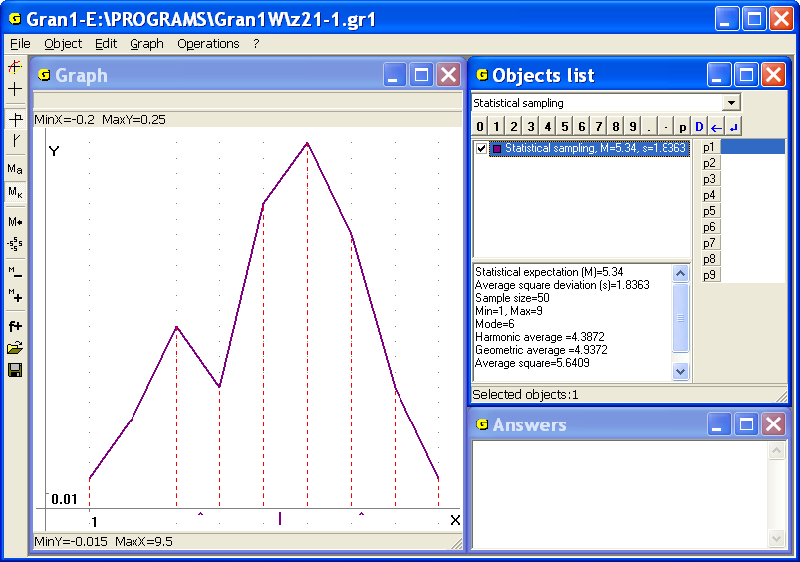
Fig. 21.1
Distribution of statistical probabilities (relative frequencies) on the finite set of elementary events such that for every , , is defined , , we will call on-points distribution. The same terms are used in the case of countable set (elements of the set can be numbered with the help of all natural numbers).
If the set consists of finite number of the elements (points) , , ... , , and the table contains absolute frequencies of appearance of the values , the results of observations can be represented in the form of the following table
 |  |  | ... |  | ,
 |  |  | ... |  | ,
where , (), are possible observed values, is quantity of appearance of among all the observed values , , ... , . It is possible that for certain .
As a rule, the values , , ... , are placed in the order of increase, where .
This table is called the series of distribution of absolute frequencies on the set of possible values of investigated magnitude. Obviously, the sum of absolute frequencies , equals to .
If instead absolute frequency of the value its statistical probability is entered in the table:
 |  |  | ... |  | ,
 |  |  | … |  | ,
then the table is called the series of distribution of statistical probabilities (or relative frequencies) on the set of possible values of investigated magnitude. Obviously, the sum of relative frequencies always equals to 1.
Now suppose is infinite set of elementary events and for this set there exists a bijection between its elements and points of interval of the form such that any value can be obtained during examinations. Suppose as a result of some prolonged series of tests some elementary events had happen. These events are perfectly associated with observed values, , ... , , (). In this case making a table of the form of series of frequency distribution is incorrect, because the frequency of falling into majority of the points is equal to zero and only for some observed points is nonzero, however there is no reason to prefer observed points to non-observed ones.
Particularly, if the number of observations is big and observed values are different, then relative frequency of any value is near to zero within the limits of calculation accuracy, especially if the accuracy is not high.
Since as a result of observation any values from the interval can be obtained, it is advisable to divide the interval into finite quantity of quite small intervals of equal length so that , , . Then it is recommended to find statistical probabilities (relative frequencies) of falling into such intervals. All possible unions of intervals : , , with the set should be considered as events. Thus, it is advisable to include , all intervals and all their unions by two, by three etc, into the aggregate and thereby put
.
The table of the form
...
...
is called on-intervals distribution of statistical probabilities (relative frequencies) on the set by intervals , .
Then for any , , , will be .
If to plot graph of the piecewise constant function , that equals to zero out of the interval and on the interval , , that is
then so-called histogram of on-intervals distribution of statistical probabilities (relative frequencies) of observed values of investigated magnitude on the set will be obtained (Fig. 21.2). The function is called averaged density of distribution of statistical probabilities (relative frequencies) on the set by intervals , .
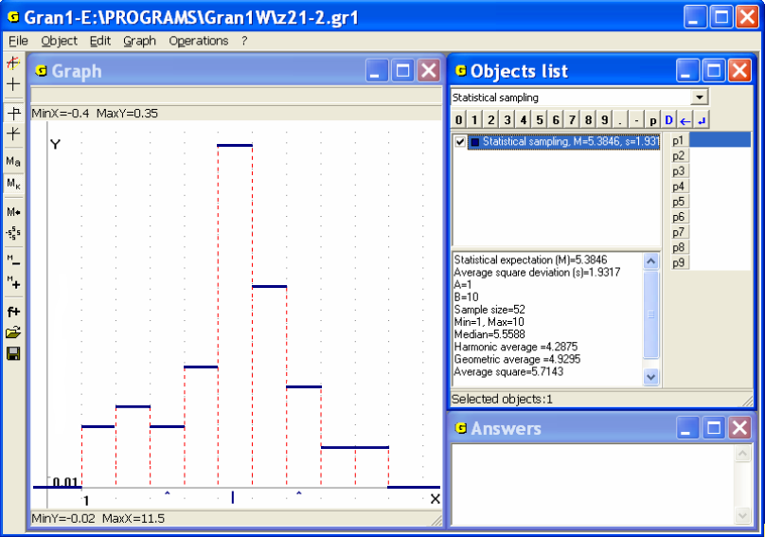
Fig. 21.2
Since in geometric interpretation for the value is the area of rectangle with foundation and height , then can be represented in the form:
.
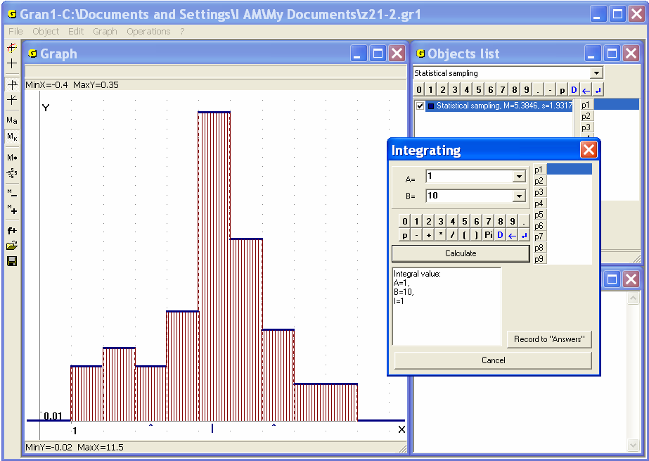
Fig. 21.3
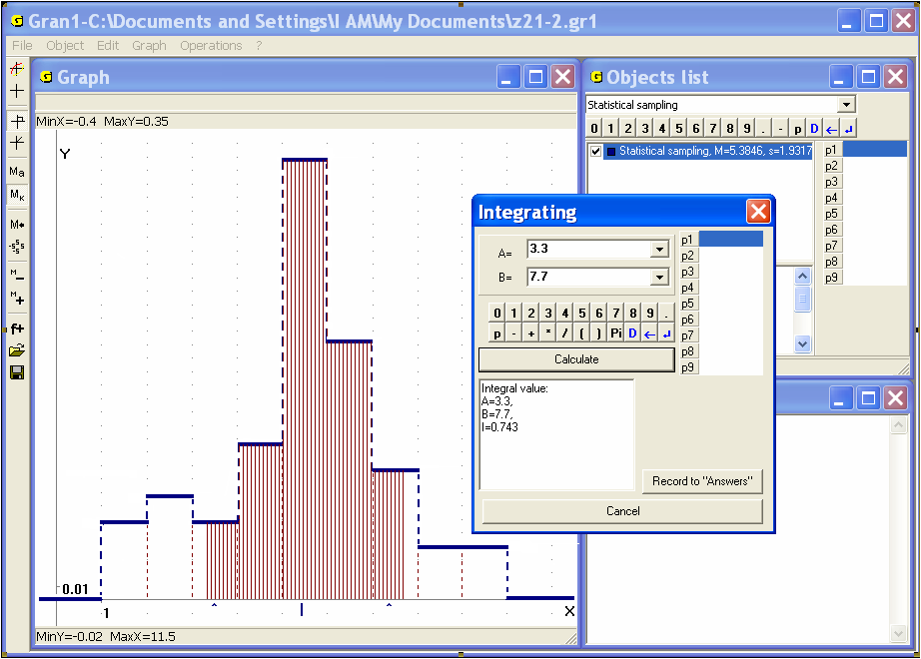
Fig. 21.4
Obviously, the function has the following properties:
- ,
- .
In geometric interpretation it means that the area under the graph of function (and on the axis) always equals to 1 (Fig. 21.3).
If we will consider the subset, that can be represented as union of
some of mentioned intervals , , then
.
It should be emphasized that also in the case of continuous set not any subsets of the set can be treated as events, but only those, that belong to the aggregate of subsets of ,.so-called measurable by the measure defined on : , . In the Fig. 21.4 is shown incorrect definition of integration limits, because , where , , , , .
As previously, the aggregate should meet the following requirements:
- ;
- if then ;
- if , then .
The consequence of the foregoing properties is as follows: if any sets and belong to the aggregate, then, , also belong to it, if the sets belong to the aggregate , then also belong to the aggregate. In particular, the aggregate includes various unions of finite or infinite quantity of intervals of the form ,, that don’t intersect in pairs when .
Denote as , as .
If is some set measurable by the measure т, is an aggregate of subsets of measurable by the measure т that meets the requirements 1_{s}-3_{s} , is any subset of , measurable by the measure т, then on the aggregate of sets, that are measurable by the measure т, it is natural to introduce a new probability measure , putting
.
where , , is not a statistical probability , , obtained as a result of series of п tests (by statistical data), but a probability measure introduced on the base of assumption (hypothesis) , that on every set statistical probabilities, obtained by statistical data (results of series of п tests), are distributed uniformly, i.e., if there are two subsets and of equal measure , then as well
,
Note, when , then for all .
In this way the probability measure ,, that is defined on the aggregate of events S, that is generated by the system of subsets , , is expanded (continued) onto the aggregate of sets that are measurable by the measure т. Obviously, for there is the equality .
Here we also make an assumption (hypothesis), that density of distribution of statistical probabilities on each of sets is constant, that is , , .
Indeed by results of tests (by statistical data) it can take place (if to fixate not only the number of points, that fall into set , but also the number of points that fall into different subsets of , ), that , when , , , , , therefore the probability measures
, ,
are hypothetical, that are introduced on the base of assumption, that on each set statistical probabilities are distributed uniformly, that is , when , , , , , and that , when , that is
, ,
when , , , that by statistical data may be wrong.
Further the probability measure of event А, , introduced on the base of assumption, that are based on the results of some series of п tests or several such series, we'll be denote , , and call generalized statistical probability or hypothetical probability measure or hypothetical probability or probability, if it will not cause any controversy, uncertainty or need for additional explanations.
If a hypothetical probability measure is defined on the aggregate S of subsets of set , that meets requirements 1_{s}-3_{s} , and is introduced arbitrarily, without any previous tests and collection of statistical data, and it is only required that such probability measure met requirements 1_{р}-3_{р} , then such a probability measure also will be called hypothetical probability measure or hypothetical probability or probability and also will be denoted ,.
In this case the probabilistic space is not associated with any definite tests and is only theoretical model of arbitrary probabilistic space. However, all theoretical positions follow from practice.
Note, also in the case of finite set it is not always correct to include any subsets of into the aggregate .
For example, if , where , , , , , , then although the set is finite, probably it is advisable to divide it on a practically accepted number of subsets , , , when . For example, one can put , , , , , , define , , and as events with consider only all possible unions of subsets , i.e. include into both and , . Then for every , , there will be , .
It should be emphasized, that in the case of small quantity of elements in the set including all subsets of the set into the aggregate is not always advisable. Suppose, for example, (the experiment consisted in throwing a gambling cube). Let on the base of large number of tests it is found , , . Then it is correct to include into the aggregate the empty set , the subsets , , , and all possible unions of them, id est put . In this case for arbitrary , , there will be , , namely: , , , , , , , . However at given conditions for the question: what is , , etc, that is how often there has fallen even number of points, odd number of points, number of points was not more than 3 etc there is no answer.
Suppose in the one-dimensioned coordinate space a discrete on-points distribution of statistical probabilities on the set is defined by the table 21.1:
Table 21.1.
х_{і} | х₁ | х₂ | ... | х_{k}
 |  |  | ...
As a space of events the broadest aggregate of subsets of the set is considered, i.e. .
Then at assumption, that , for any , that is the sets for any are the events from the space of events , where the probability measure , is defined, for every it is possible to find a number – generalized statistical probability of falling of observed values into the interval , that is equal to the sum of all , for what (or, that is the same, ), i.e.
.
For this statistical probability as a space of elementary events the set is considered, as a space of events – the space , that includes any intervals and their finite and countable unions and intersections and complements of these unions to . In particular, ∈ . However note, that , and therefore the expression is not correct, because the probability measure is defined only on the aggregate of subsets of the set .
The function
, , , (21.1)
is called function of distribution of generalized statistical probabilities (relative frequencies) on a finite set .
Example 21.1. Let a distribution of statistical probabilities is defined by the table 21.2.
Table 21.2
х_{і} | 1 | 2 | 3 | 4 | 5 | 6
 | 0
Then
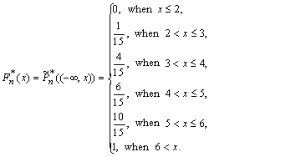
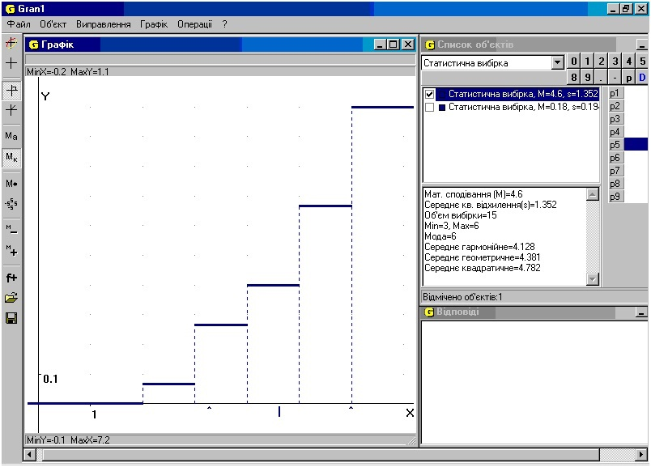
Fig. 21.5.
Since for all i, then as a statistical probability of impossible event, that means appearance of a value , that is less than .
Similarly, since for all i, then
as a statistical probability of probable event, that consists in falling of point into interval .
In the Fig. 21.5 it is represented the graph of the function of distribution of generalized statistical probabilities, defined by the table 21.2.
Note main properties of function of distribution of generalized statistical probabilities:
1. , as generalized statistical probability of event .
2. , as generalized statistical probability of impossible event , i.e. statistical probability of appearance of values , less than .
3. , as generalized statistical probability of possible event , i.e. statistical probability of appearance of values , less than .
4. If , then , i.e. function of distribution of generalized statistical probabilities is nondecreasing.
Indeed,
,
since for all і.
From the above, in particular, it follows, that
,
that is generalized statistical probability of falling of points into the interval equals to an increment of function of distribution of generalized statistical probabilities on that interval.
5. On each interval , containing no other points of the set , except the point х_{і} , the function of distribution of generalized statistical probabilities is constant, moreover , when .
Any function that meets the conditions 1–5, is called function of distribution of generalized statistical probabilities on the set , defined by on-points distribution of statistical probabilities , , on finite set .
Note, when the number k is very large, for example , etc, and all , , are equal or close with one another, then calculation immediately by he formula (21.1) become practically unacceptable, since all are practically equal to zero and for arbitrary will be , that leads to contradictions. For example, if all and remote from one another on the distance , and all are equal to each other, then for arbitrary practically will be , that leads to contradictions, since for arbitrary there must be .
In such cases it is advisable to replace the set by and divide this interval on practically acceptable number т of subsets , , where , , , , – quite small number, and define not , , but , , whereas approximately calculate by the formula:
, , .
Then for all х such that , there will be , whereas for all х such that , will be .
Note, that operations are similar in the case of continuous set .
Before consideration of definition of function of on-intervals distribution of generalized statistical probabilities on continuous set of points we recall some concepts of the set theory.
Let – some fixed non-empty set.
Definition. A system of subsets of the set is called algebra, if:
1)
2) from , it follows that ;
3) from and , it follows that .
It's easy to see, that all previously considered operations with a finite number of subsets, don't withdraw from the algebra .
Examples of algebras of subsets of the set are given below:
1. The aggregate – trivial or “the poorest” algebra of subsets of the set .
2. – the algebra of subsets, that is generated by the set .
3. The system of all subsets of the set – “the richest” algebra of subsets of the set .
4. Let are some subsets of the set such that , when , moreover , .
If to create a system of sets, that includes the empty set , all sets , all possible sums of sets of two, three, four etc summands, then such system of sets will be an algebra of sets. The algebra of sets is called generated by division of the set on subsets , that didn't intersect in pairs, i.e. , when . The sets in this case are called atoms of division . Thus, by the division the algebra is determined uniquely. Vice versa, by the algebra of sets generated by the division , one can recover the division, moreover, the unique one. Indeed, if is such that for any or or , then the aggregate of such will make the required division.
Definition. System of subsets from is called
σ–algebra, if:
1_{s}.
2_{s}. from it follows, that
3_{s}. from it follows, that .
It's easy to see that all considered operations with a finite or countable number of subsets don't withdraw from the σ–algebra . In particular, , when .
The example of σ–algebra is the aggregate of all subsets of the set .
The systems of sets , are both the algebras and the σ–algebras, moreover is a trivial, “the poorest” σ–algebra, whereas is “the richest” σ–algebra, that contains all subsets of the set . If is some countable division of the set by non-empty subsets
,
then the system , formed of the sets, that are the sums of finite or countable number of elements of and of connected to them empty set , is both the algebra and the σ–algebra.
It is clear, that every σ–algebra is also an algebra, but not vice versa.
Definition. Let is some system of subsets of .
σ–algebra is called the smallest containing the system , if:
1)
2) for any σ–algebra , that also contains the system , there is the following inclusion .
For any system of sets there exists the smallest σ–algebra , that contains the system . Indeed, there is at least one σ–algebra (namely ), that contains the system . The intersection of all σ–algebras, that contain the system , is the required σ–algebra. The system is called
σ–algebra, generated by the system of sets .
Let is a real straight line,
for all . In particular . Denote by the interval (for a complement to the of the interval was of the same type, i.e. open from the right and closed-up from the left).
Denote by the system of sets from , that consist of finite sums of intervals of the form :
, if
The system is an algebra, but not the σ–algebra, since if , then .
Definition. Let – the smallest σ–algebra , that contains a system . The elements of σ–algebra are called Borel sets, and the
σ–algebra itself is called σ–algebra of Borel sets in .
Since , single-point sets are Borel sets. The intervals , , are Borel sets. Every open set is a Borel set, since any open set in is a sum of a finite or a countable number of intervals. Every closed-up set is also a Borel set (a complement of a closed-up set to is an open set).
If and is a system of parallelepipeds of the form
then the smallest σ–algebra , that contains the system, is called the σ–algebra of Borel sets in .
Thus, if the set can be obtained on the base of closed-up and open sets, with the help of a finite or a countable number of operations of union and intersection, then the set will be a Borel set. A limited Borel set is called –measurable (measurable by Borel).
Let , , , , , , for all ,
, , is a
σ–algebra of Borel sets from , , and let on it is defined an on-intervals distribution of statistical probabilities by the table 21.3
Table 21.3
...
...
whence the averaged density of on-intervals distribution of statistical probabilities on the set by intervals , , takes the form
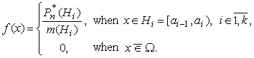
Since , , , then for all , i.e. values of the function are limited by some constant number .
Let , .
Put
, , (21.2)
where is a union of all unions such that , is an intersection of all unions such that
,
, , generalized statistical probability on - the probability measure on , obtained as extension of the measure , , from the space of events on the space .
Obviously , therefore .
It's easy to see, that the function has the following properties:
- , because , , .
- is a nondecreasing function, i.e. if , then .
Indeed, if , then , therefore , , , , whence .
- , if .
Indeed, when , then , therefore , , , , .
- , if .
Indeed, when , then , therefore for there will be , , , whence
.
Since , , , then
. (21.3)
Since , then
, when .
- If , , , , i.e. two different points and lie in the same interval, then , i.e. the function takes constant values on every interval .
Since , when , , when , then, when , there exist at least two adjacent intervals and such that , when , , even when .
It means when , then the function of on-intervals distribution of generalized statistical probabilities cannot be continuous and takes no more than values, where – is the number of intervals .
However, when , , i.e. the points and lie in adjacent intervals, then
,
because in the case of transition of the point from the interval into the next interval the value of function increases by amount , since to another interval is being added, the same like to . Therefore when , then , , i.e. at unlimited decreasing of , , the function of distribution of generalized statistical probabilities become practically continuous (see. Fig. 21.11 a) – 21.11 e)), i.e. for arbitrarily small and there will be inequality , when .
Besides, when , then also , , , , therefore, considering the formula (21.3), for will be obtained
.
Function , defined by the formula (21.2), is called the function of on-intervals distribution of generalized statistical probabilities on the set
, .
If the density of distribution of generalized statistical probabilities is limited, i.e. , then
.
Such function is continuous, and corresponding marginal on-intervals distribution of generalized statistical probabilities, when , is also called continuous.
Notice, when is a sufficiently small positive number, , then
, ,
whence
, ,
i.e. the value of averaged density of on-intervals distribution of statistical probabilities on the set characterizes the average rate of increase of the function during the transition from the point to the point . If , then and
,
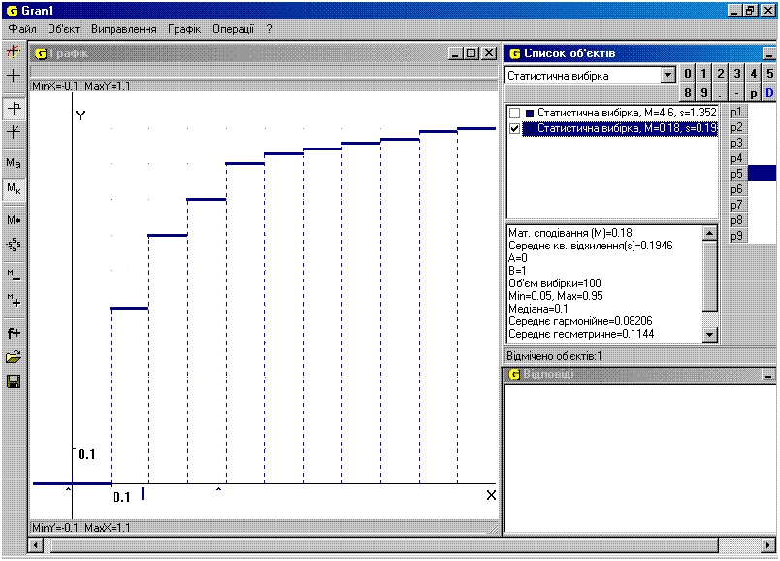
Fig. 21.6
i.e. in the case when is a continuous function on , then in all the points , for which there exists the limit , .
Example 21.2. If on-intervals distribution of statistical probabilities is defined by the table 21.4:
Table 21.4
 | 0.5 | 0.2 | 0.1 |  | 0.1 |  | 0.04
 | 0 | 0.02 |  | 0.01 |  | 0.02 |  | 0.01
then
In the Fig. 21.6 it is presented the graph of the function of on-intervals distribution of generalized statistical (hypothetical) probabilities, that are defined by the on-intervals distribution of statistical probabilities, that is defined by the table 21.4.
Since
then
.
Thus, by given function of on-intervals distribution of generalized statistical probabilities on the set , , it is possible to define statistical probabilities (relative frequencies of falling observed values into the intervals ) for any intervals , given in the table 21.3. Therefore with the help of the function of distribution of generalized statistical probabilities it is entirely determined the generalized statistical (hypothetical) probability of any event (measurable set) , as hypothetical probability of falling into union of intervals of the form , , the hypothetical probabilities of falling into that are calculated analogous to the formulas (21.2), 921.3) or by the formula
,
, i.e. as the sum of increments of the function of distribution of statistical probabilities on the intervals , .
If , , then
,
. (21.4)
Let there is defined the probabilistic space , , - the aggregate of subsets of the set , that meets the requirements 1_{s}-3_{s}, in particular contains the subsets for arbitrary , .
Denote as the sum of all events А from S such that . Obviously, the sum will belong to the aggregate S, i.e. will be an event.
Put
, , .
Obviously, the function is defined for all .
It is easy to see, that the function meets the following properties:
- as statistical probability of some event.
- as statistical probability of impossible event, since for arbitrary
, since .
- For arbitrary
, .
- The function is nondecreasing, i.e. if , then .
Indeed, let . Then
, ,
therefore according to the properties of the probability measure
,
i.e. .
Obviously
. (21.5)
However, it is not eliminated that , but . For example, when , the space of events S is generated by division of the set into the subsets , , that , , , i.e. , , , then there will be , however , since none of the intervals is a subset of the interval . Therefore it is not eliminated that
.
Since , then
Notice that records of the form , etc may be incorrect if the sets , etc are not elements of the space of events S, i.e. are not events, since the probability measure is defined only on the elements of the aggregate S of subsets of the set , that is on the events А from the space of events S.
From the equality (21.5) it follows that also for on-points distribution of statistical probabilities on a finite set , when as events together with empty set there are considered all possible unions , , , of subsets of the set such that , when , (in particular can be single-element subsets of the set ), and for the on-intervals distribution of statistical probabilities on the infinite continuous set , when as events together with empty set there are considered all possible unions , , of the intervals such that , when , , the function is piecewise constant, i.e. takes the same value , in all the points х from the interval , if , in particular when .
Obviously, when , , , and , , or when , , , and , , then there will be and .
Example 21.3. Let on the set there is defined a distribution of statistical probabilities by the series of distribution
 | 1 | 2 | 3 | 4 | 5
 | 0.05 | 0.20 | 0.50 | 0.20 | 0.05
As events together with empty set there will be considered all possible unions , , , , that is all possible subsets of the set . Thus .
Then for given distribution of statistical probabilities there will be:
- , when , since none of non-empty subsets , , , of the set is a subset of the set ;
- when there will be , then the set will include the subset of the set , therefore
, when ;
- when х will vary from 2 to 3 inclusive, i.e. there will be , then the set will include the subsets , , , that are the elements of the aggregate S, namely events, and the union of them will be a set, which is an element of the aggregate S, i.e. an event, besides it will be a subset of the set , when . Therefore
when , i.e. , when .
Arguing similarly, we'll find
- , when ;
- , when ;
- , when .
Finally we get
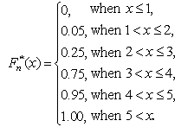
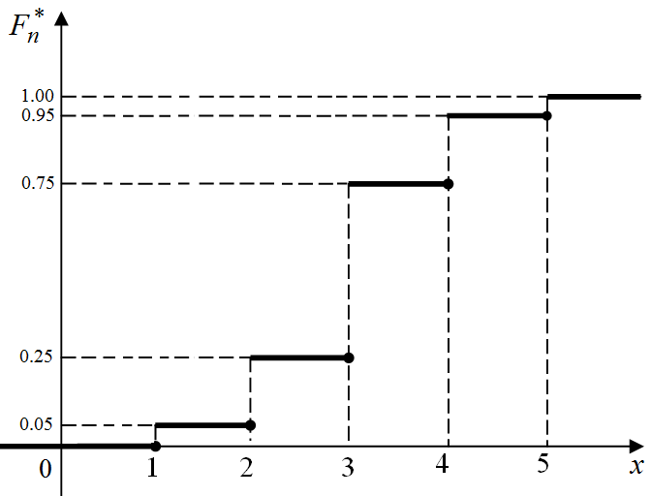
Fig. 21.7
The graph of the function for given discrete on-points distribution of statistical probabilities on the finite set of points is presented in the Fig. 21.7.
We emphasize that in this example the sets of the form are not events relatively to the probability space , since there aren't sets of such kind in the aggregate S of subsets of the regarded set , i.e. in the space of events, such contains the empty set , the subsets , , and sets , therefore records of the form in this example are incorrect.
Example 21.4. Let on the set there is defined an on-intervals distribution of statistical probabilities
]  ,  (  1  i  i  a  a  − | ]  1  ,  0  ( | ]  2  ,  1  ( | ]  3  ,  2  ( | ]  4  ,  3  ( | ]  5  ,  4  (
])  ,  ((  1  i  i  n  a  a  P  −  ∗ | 0.05 | 0.20 | 0.50 | 0.20 | 0.05
The graph of averaged density of this distribution of statistical probabilities by the intervals , , on the set is presented in the Fig. 21.8.
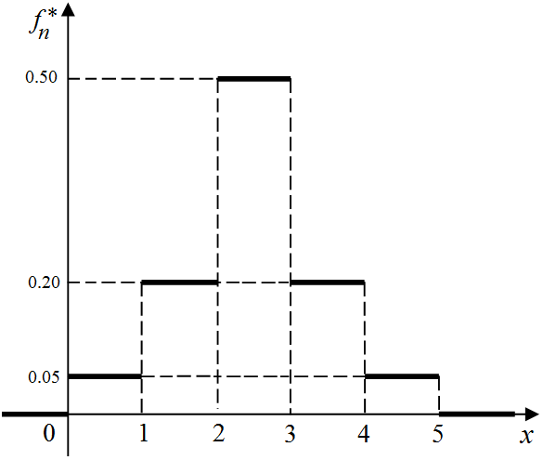
Fig. 21.8
As events together with the empty set we'll consider all possible unions of the intervals , i.e.
}}
5
,
4
,
3
,
2
,
1
{
,
]
,
(
|
{
1
⊂
=
=
∈
−
I
a
a
A
A
S
I
i
i
i
Let , . Then, taking into account the formula , , , for given on-intervals distribution of statistical probabilities we'll have: , when , since none of subsets , , is a subset of the set , when . When х will vary from 1 to 2 inclusive, i.e. x ∈ (1,2], then the interval (0,1] will be a subset of the set (–∞,x), therefore for x ∈ (1,2] there will be
, when .
When х will vary from 2 to 3 inclusive, i.e. , then the sum of events , , , that is will be a subset of the set , , therefore
=
+
=
=
=
=
∗
∗
∗
∗
∗
])
2
,
1
((
])
1
,
0
((
])
2
,
1
(
]
1
,
0
((
]))
2
,
1
(
]
1
,
0
((
]
2
,
1
(
]
1
,
0
((
)
(
n
n
n
n
n
P
P
P
P
x
F




,
when .
Arguing similarly, we'll find
, when ;
, when ;
, when .
Thus
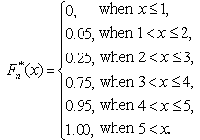
The form of the graph of function , defined such way, of on-intervals distribution of generalized statistical probabilities on the set , that had been considered in the example 21.4, will be the same as the form of the graph of the function of discrete on-points distribution of statistical probabilities on the set , that had been considered in the example 21.3 (see. Fig. 21.7, Fig. 21.11 a)). Representations of the functions of distribution of generalized statistical probabilities in both cases under consideration in examples 21.3 і 21.4 also have the same form.
Therefore in the cases of considered way of construction of the space of events S, , when as events together with empty set are considered all possible unions , , of subsets (possible single-point) , , of the finite set , , or all possible unions of subsets , of infinite set such that , when , , and for arbitrary , by the form of description of the function of distribution of generalized statistical probabilities it is impossible to determine, what kind of distribution of statistical probabilities is being considered: the on-points distribution of statistical probabilities on the finite set , or the on-intervals distribution of statistical probabilities on the infinite continuous set
, when .
Example 21.5. Let on the set there is defined an on-intervals distribution of statistical probabilities the same as in the example 21.4, whereas the space of events S is generated by the dividing of the set by 25 intervals of length 0.2, i.e. as events together with the empty set are considered all possible unions , of the intervals , , .
It means that there being considered a new space generated by the aggregate of intervals , the elements of which are sets of the form , . Obviously, all the events from the space S, that had been considered in the example 21.4, are also the elements of the space , that is . New probability measure on the space of events we'll define by the formula
where is the density of distribution of statistical probabilities, the same as in the example 21.4 (see. Fig. 21.8, Fig. 21.9).
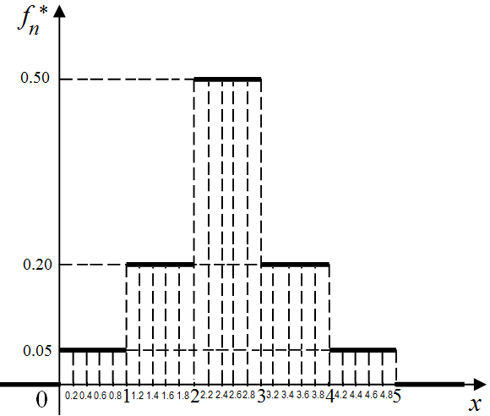
Fig. 21.9
Obviously, at the same averaged density of distribution of statistical probabilities, as in the example 21.4, the statistical probabilities of falling into the intervals, obtained by grinding intervals from the example 21.4 into 5 intervals of equal length, 5 times less, than the length of the initial intervals, will be 5 times less, than statistical probabilities of falling into initial intervals, and, as previously, will be calculated by the formula
Obviously, , when . In this case it is said, that the measure , , is an extension of the measure , , from the space S to the space .
If each of the intervals that make up the events , , will be divided into certain number of still smaller intervals of equal length, there will be obtained a new space of events and a new probability measure quite analogous to the previous. Such grinding of the intervals can be continued any length of time until the difference will be less than arbitrary small previously preassigned number . As a result of every reducing of length of the intervals the same for all і, we'll be obtain more and more new probability spaces , , (with the same and ).
Obviously, the function will take constant values on the intervals , , and in the case of pass through the point will get an increment
, (21.6)
Arguing similarly to the example 21.4 during plotting graph of the function of on-intervals distribution of generalized statistical probabilities on the set by the intervals in this example we get:
, when , , when ,
, when , , when ,
, when , , when ,
, when , , when ,
, when , , when ,
, when , , when ,
, when , , when ,
, when , , when ,
, when , , when ,
, when , , when ,
, when , , when ,
, when , , when ,
, when , , when .
In the Fig. 21.11 b) it is presented graph of the function defined in a such way – the function of on-intervals distribution of generalized statistical probabilities on the set , , , by the intervals , with the density (see Fig. 21.9, Fig. 21.10)
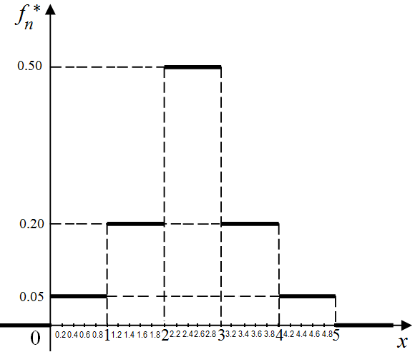
Fig. 21.10
Notice, in the program Gran1 there is a command destined for automatic rebuilding graph of a function , of on-intervals distribution of generalized statistical probabilities in the case of grinding corresponding intervals (due to increasing their quantity) (see Fig. 21.11 a) - Fig. 21.11 e)).
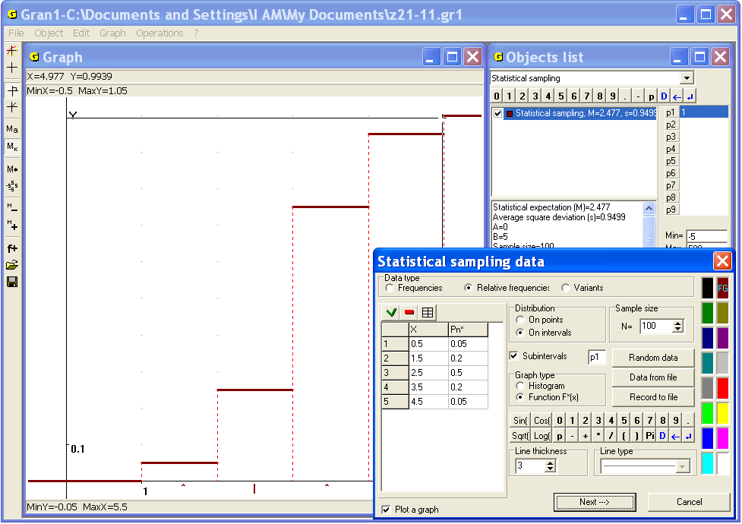
Fig. 21.11 a)
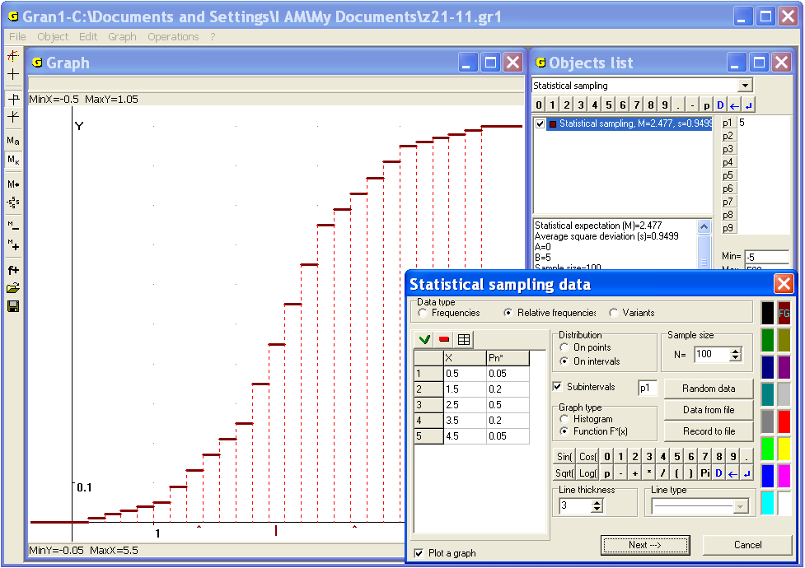
Fig. 21.11 b)
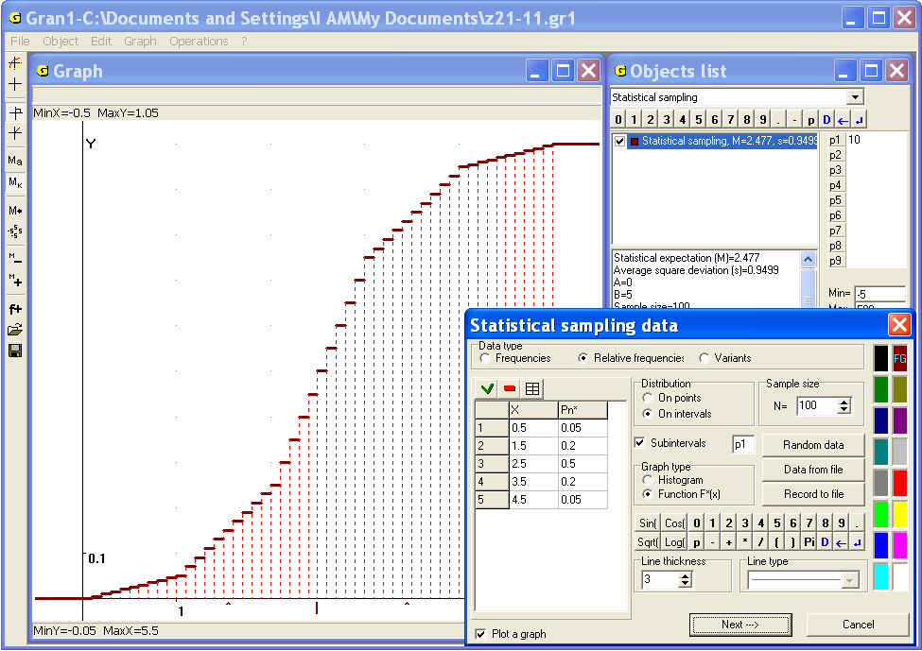
Fig. 21.11 c)
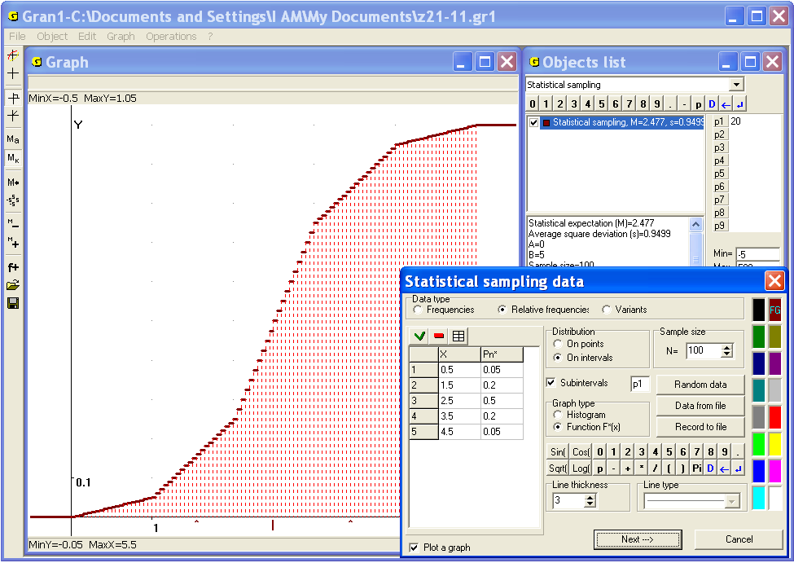
Fig. 21.11 d)
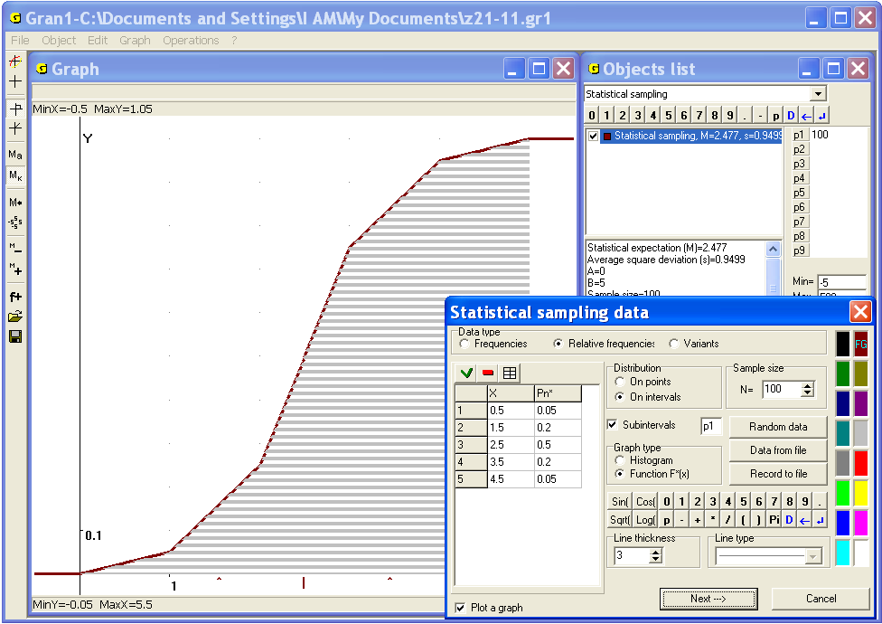
Fig. 21.11 e)
For increasing or decreasing quantity of the intervals by their grinding or enlargement with the help of the program Gran1, one should increase or decrease the value of corresponding parameter , selecting the step equal to 1, in order to the number of intervals was integer (see Fig. 21.11 b)).
In the Fig. 21.11 a) it is shown graph of the function of on-intervals distribution of generalized statistical probabilities on the interval when , whereas from the example 21.4 (Fig. 21.10), in the Fig. 21.11 b) - Fig. 21.11 e) are shown graphs of the functions of on-intervals distributions of generalized statistical probabilities on the same interval , when length of the interval is reduced accordingly in 5 times (Fig. 21.11 b)), in 10 times (Fig. 21.11 c)), in 20 times (Fig. 21.11 d)), in 100 times (Fig. 21.11 e)) (see values of the parameter Р1 in the figures), whereas is the same, as previously (Fig. 21.10).
Notice, in the case when for arbitrary the sets are events, i.e. elements of the space of events S, , (that means the following: as a space of elementary events we consider the set , as a space of events – ) then the formula (21.1) takes the form , . In this case by the form of the function it is possible to find out, whether the function is built by the on-points distribution of statistical probabilities on the finite set of points , or by the on-intervals distribution of statistical probabilities on the continuous set
Example 21.6. For the on-points distribution of statistical probabilities on the finite set , that had been considered in the example 21.3, under condition for arbitrary the function of distribution of statistical probabilities
, , ,
will be piecewise constant and will have the same form as previously, i.e.
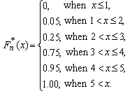
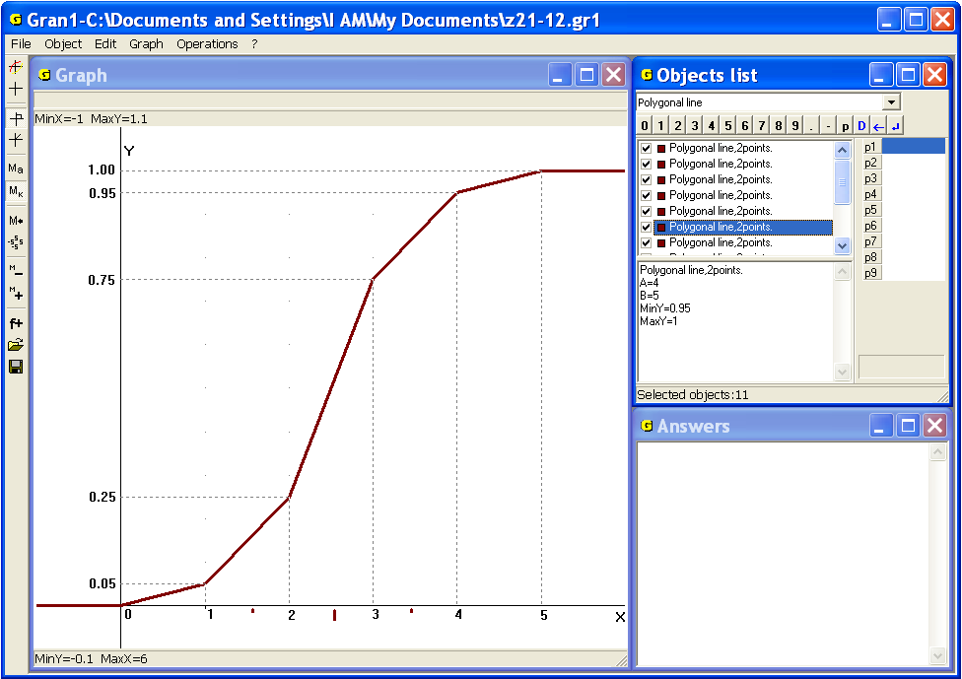
Fig. 21.12
The form of the graph of this function is the same, as in the Fig. 21.7.
However, for the on-intervals distribution of statistical probabilities on the set that had been considered in the example 21.4, under condition for arbitrary the function of distribution of statistical probabilities
, , ,
will be continuous and will be presented in the form
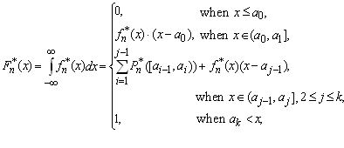
i.e. for the given data there will be
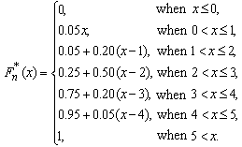
The graph of the last function is shown in the Fig 21.12.
Notice, when the averaged density of on-intervals distribution of generalized statistical probabilities is defined on the intervals , of fixed length h, such that when , (for example, on intervals of length , as in the example 21.4, see Fig. 21.8), and the space of events S is generated by dividing of the set on smaller and smaller intervals such that the length of the longest of them become smaller and smaller (see example 21.5, Fig. 21.11 a) – Fig. 21.11 e)), then the function of such on-intervals distribution of generalized statistical probabilities with assigned density with more and more grinding the intervals, on base of that the events are generated, further less and less will differ from the continuous function of on-intervals distribution of statistical probabilities, that is built under condition, that as events there are considered all possible sets , , i.e. the sets are the elements of the space of events (see examples 21.5, 21.6).
Notice, when is continuous, the distribution of generalized statistical probabilities on the set is called continuous, and for arbitrary . In the case, when , , , , , as follows from the properties 1_{s}-3_{s} of the space of events S, also is an element of the space of events S, i.e. , for if and , then according to the properties 1_{s}-3_{s} of the space of events S. Therefore, as can be seen from the formula (21.5), there will be , because in the case under consideration for such that , and such that , the following equality will take place
.
Notice, the probability measures , that had been considered in the examples 21.5 and 21.6, are hypothetical, found in assumption, that the density of distribution of statistical probabilities has the form (see Fig. 21.8, Fig. 21.10)
],
3
,
2
(
when
],
4
,
3
(
]
2
,
1
(
when
],
5
,
4
(
]
1
,
0
(
when
],
5
,
0
[
when
∈
∈
∈
∈
x
x
x
x


i.e. under assumption, that the density of distribution of statistical probabilities on the intervals (0,1], (1,2], (2,3], (3,4], (4,5] takes constant values correspondingly 0.05, 0.20, 0.50, 0.20, 0.05, and the value 0 outside the interval (0,5], that in reality can be wrong.
Not only the distributions of statistical probabilities are essential, but also some their numerical characteristics.
One of the most important numerical characteristics of the distribution of statistical probabilities (relative frequencies) of observed values is their arithmetic average
,
where is the number of tests, where the value had been observed.
This arithmetic average is more near to the values that occur more often, than to the values that occur seldom. Therefore the number is the value, near to that the majority of the values in future observations should be expected. In a certain sense this is the center of dispersion of statistical probabilities (relative frequencies) of observed values.
Besides the center of dispersion the characteristics of value of dispersion (or density) of statistical probabilities is important. That shows how the observed values can be remote from the center of dispersion, in what range (in most cases) they can be placed etc.
One of the characteristics of dispersion of statistical probabilities is the range of sample .
However more essential characteristics of dispersion of statistical probabilities around the centre of dispersion is so-called quadratic deviation of observed values from, i.e. from the center of dispersion. This quadratic deviation is calculated by the formula
.
The fact is the most essential for determination of the value of dispersion of statistical probabilities (relative frequencies) of observed values (at quite big quantity of tests) will be the values that occur in the sample the most often. The values with the small frequency of appearance in the sample practically have no influence on the characteristics of dispersion of statistical probabilities (relative frequencies) of the basic mass of observed values. Therefore the characteristics can be found somewhat inflated in the comparison with more essential characteristics .
Suppose, for example, among 10000 observed values the value –1 occurs once, the value +1 – once, and the value 0 – 9998 times. Obviously, . It is naturally to think that the dispersion of statistical probabilities (relative frequencies) of separate observed values around the center of dispersion is practically absent:
,
although . In this case the observed values –1 and +1 are inessential and practically have no influence on the characteristics of distribution of statistical probabilities (relative frequencies) of the basic mass of observed values.
Sometimes the average value is characterized not by the arithmetic average, but by the harmonic average:
.
Such characteristic can be more convenient in the case of definition of average speed of moving of a solid along a line from the point to the point , if it is known that the solid has passed the first unit of the way with the speed , the second unit – with the speed , … , -th unit – with the speed . Then the time spent on the first unit is , on the second unit – , ... , on the -th unit– . The whole time spent on units of the way, equals. Thus the average speed on the whole way of the length units equals
.
If the intervals of length 1, that the solid passes with the speed , appear times, with the speed – times etc, with the speed – times, then the average speed equals:
,
where are statistical probabilities (relative frequencies) of the intervals, that the solid passes with the speed .
In the case of examination of product of the values , , ... , the geometric average is used. Obviously, the logarithm of the geometric average equals to the arithmetic average of logarithms of the values , , ... , :
.
In the concrete situations some other characteristics of the sample, , ... , could be required.

Questions for self-checking
- What is called statistical sample?
- What is called variants?
- What is called frequency of appearance of the value in the sample , , … , ?
- What is called statistical probability (relative frequency) of appearance of the value in the sample , , … , ?
- What characteristic of the value is more informative – the frequency or statistical probability (relative frequency) ?
- What is called series of on-points distribution of statistical probabilities (relative frequencies) on finite set of values of the observed discrete magnitude?
- What is called on-intervals distribution of statistical probabilities of appearance of values of the observed continuous magnitude?
- What is the sum of statistical probabilities of appearance of all the observed values?
- What is called polygon of distribution of statistical probabilities (polygon of relative frequencies)?
- What is called histogram of on-intervals distribution of statistical probabilities (relative frequencies) of falling into defined intervals of values of investigated magnitude?
- What is the area under the histogram (over the axis )?
- What is called function of distribution of statistical probabilities (relative frequencies) of appearance of values of the observed magnitude?
- What minimum value can take the function ?
- What maximum value can take the function ?
- Can be true the inequality if ?
- What characterizes the arithmetic average of observed values , , … , ?
- Why the point with the abscissa is called the centre of dispersion of statistical probabilities (relative frequencies) of appearance of values of investigated magnitude?
- Can the value be equal to none of the values of the sample?
- What indices are used to characterize the value of dispersion of statistical probabilities (relative frequencies) of appearance of values of investigated magnitude?
- Why quadratic deviation should be considered as more correct characteristic of dispersion of statistical probabilities (relative frequencies) on the set of possible values , , … , of investigated magnitude than the characteristic of dispersion ?

Exercises for self-fulfillment
Do exercises 1-6, using the command “Operations / Calculator” or other commands of the program GRAN1 if necessary.
- Plot a polygon of distribution of statistical probabilities (relative frequencies polygon) of appearance of values of investigated magnitude, if the following distribution of absolute frequencies is given:
 | –3 | –2 | –1 | 0 | 1 | 2 | 3
 | 1 | 6 | 15 | 43 | 17 | 5 | 2
- By the data of the ex.1 plot a graph of the function of distribution of statistical probabilities of appearance of investigated values on the interval .
- By the data of the ex.1 find – arithmetic average of observed values of investigated magnitude.
- By the data of the ex.1 find – quadratic deviation of observed values of investigated magnitude of their arithmetic average.
- Plot a histogram of the on-intervals distribution of statistical probabilities (relative frequencies) on the aggregate of intervals of length 1, if in the table are given centers of the intervals and frequencies of falling into the intervals:
–4 | –3 | –2 | –1 | 0 | 1 | 2 | 3 | 4
1 | 8 | 12 | 34 | 57 | 36 | 14 | 6 | 2
- By the data of the ex.5 plot a function of the on-intervals distribution of statistical probabilities for intervals of length: 1; 0.2; 0.1; 0.05; 0.01.
- Define, how the function of on-intervals distribution of statistical probabilities will be changed, when instead the intervals the intervals will be considered. Find difference of the functions and of by-intervals distribution of statistical probabilities: – by intervals – by intervals Concrete calculations fulfill by the data of the exercise 5.
- It is given:
the measure defined on by density of distribution of statistical probabilities
a) Define the function of distribution of probabilities
b) Calculate
c) Define for the case, when as a space of events there is considered instead .
d) Calculate for the case, when as a space of events there is considered instead .
2)
The measure is defined on by density of distribution of statistical probabilities
a) Define the function of distribution of probabilities
b) Calculate
c) Define for the case, when as a space of events there is considered instead .
d) Calculate for the case, when as a space of events there is considered instead .
3) Define the difference for the cases:
a) is connected with the space of events
b) is connected with the space of events
4) Define the difference for the cases:
a) is defined by is defined by.
b) is defined by is defined by.

§22. Input of the experimental data
Some elements of statistical analysis of set of observed values of magnitude can be realized with the help of the program GRAN1. However formerly the data should be entered to the working file of the program from the keyboard, the data input panel or from a file.
Before input the data one should set the type of dependence “Statistical sampling” in the window “Objects list”. Then the command of creating of the new object should be used.
During creation of object of the type “Statistical sampling” according to the program the auxiliary window “Statistical sampling data” appears (Fig. 22.1). The form of the window can vary depending on the sample type and way of sample definition.
Use of the switch “Distribution” allows choosing one of two possible types of investigated distributions of statistical probabilities:
“On points” – means that the on-points distribution of statistical probabilities on a finite set of points is to be investigated. In this case it is impossible to plot histogram (graph of density of frequencies distribution) or continuous function of frequencies. During data input it is necessary to enter separate possible values of investigated magnitude and frequencies of appearance of the values, or to enter observed values one by one.
“On intervals” – means that the on-intervals distribution of statistical probabilities is to be investigated. In this case it is impossible to plot the frequency polygon. During data input it is necessary to enter equidistant centers of intervals (of equal length) and frequencies of falling into the interval, or to enter observed values one by one.
The set of observed values is entered equally in the both cases.
After assignment of the type of distribution one should set the data type (frequencies, relative frequencies or variants). The data type must be defined immediately before input of the data because in the case of changing of data type the table, in that the data are contained, will be cleared.
Entering data in the table is realized as well as in the case of entering tops of a polygonal line. For the on-points distribution of statistical probabilities:
in the case of input of frequencies, one should in the column “Х” input possible value of the investigated magnitude, in the column “n” – quantity of appearance of the value (Fig. 22.1);
in the case of input of relative frequencies, one should in the column “Х” input possible value of the investigated magnitude, in the column “Pn*” – relative frequency of appearance of the value. Besides it is necessary to input the sample size in the row “N=” (Fig. 22.2);
in the case of input of variants one should in the column “Х” input values of the variants (observed values) of the investigated magnitude (Fig. 22.3).
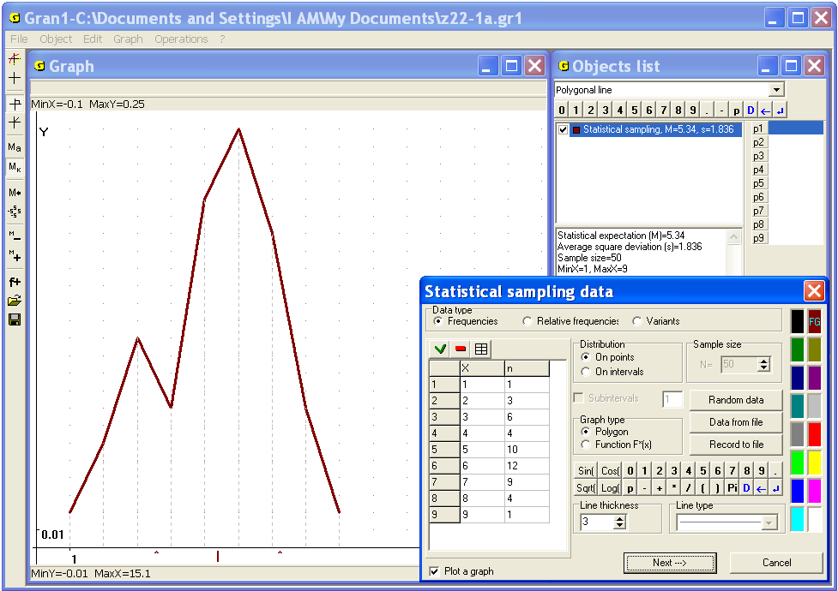
Fig. 22.1
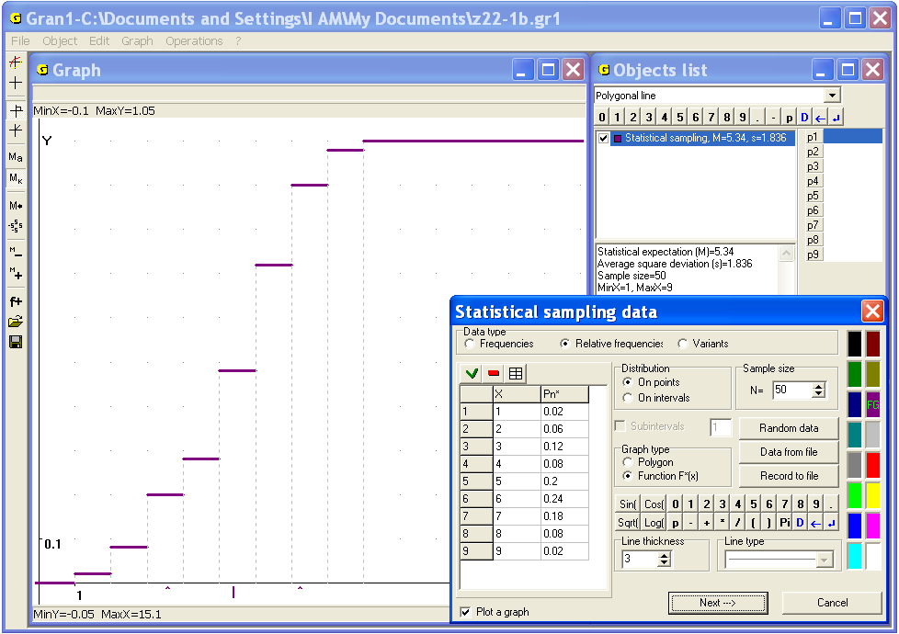
Fig. 22.2
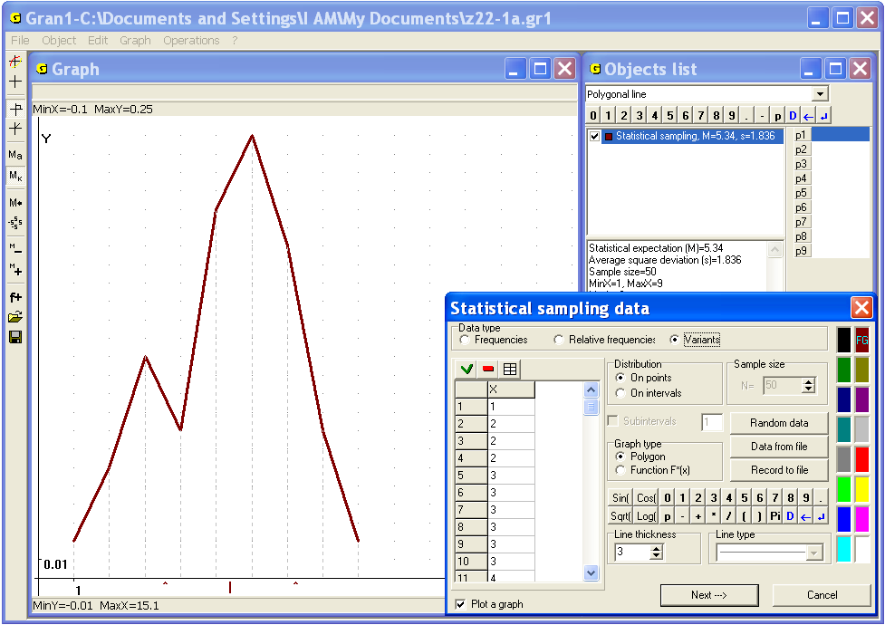
Fig. 22.3
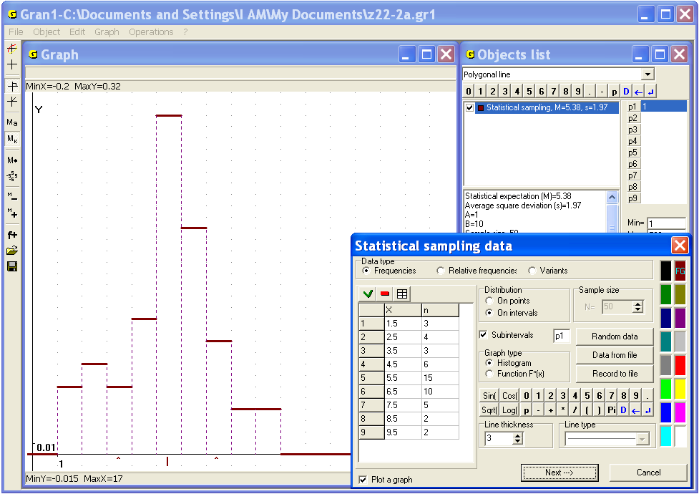
Fig. 22.4
For the on-intervals distribution:
in the case of input of frequencies, one should in the column “Х” input the center of the interval, that contains observed values, in the column “n” – quantity of falling of such values (variants) into the interval (Fig. 22.4);
in the case of input of relative frequencies, one should in the column “Х” input the center of the interval, that contains variants, in the column “Pn*” – relative frequency of falling variants into the interval. Besides it is necessary to input the sample size in the row “N=” (Fig. 22.5);
in the case of input of variants one should in the column “Х” input values of the variants (Fig. 22.6).
With the help of the switch “Graph type” one can set the graph type of the statistical sample. For the on-points frequencies distribution it is the polygon of distribution function (Fig. 22.1 – 22.3), for the interval one – the histogram or distribution function (Fig. 22.4 – 22.6).
After finishing data input one should press the button
“Next-->”. In the window “Objects list” the new object (statistical sample) will be indicated.
If the on-intervals distribution is assigned with the help of frequencies or relative frequencies, the centers of the intervals should be placed equidistantly (i.e. the lengths of the all intervals should be equal one to another). Quantity of the intervals is equal to quantity of entered centers of the intervals.
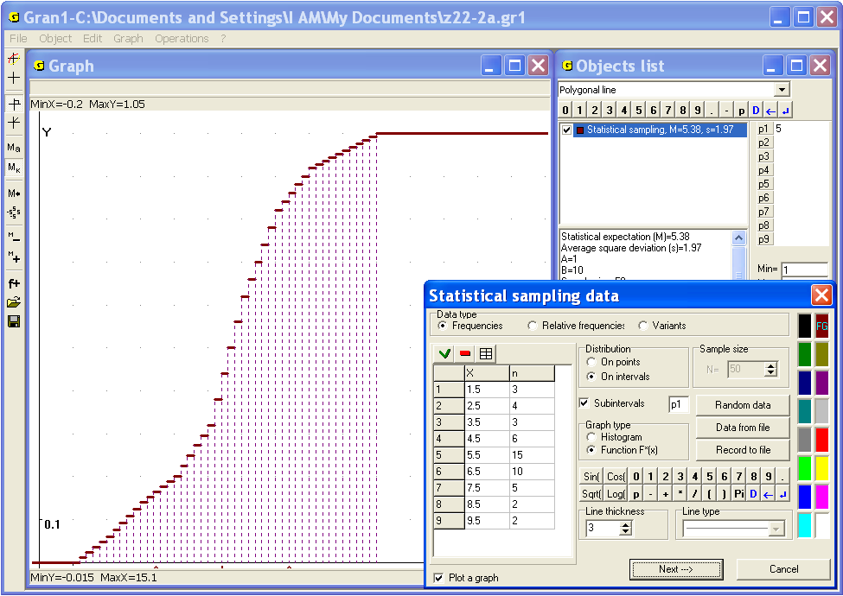
Fig. 22.5
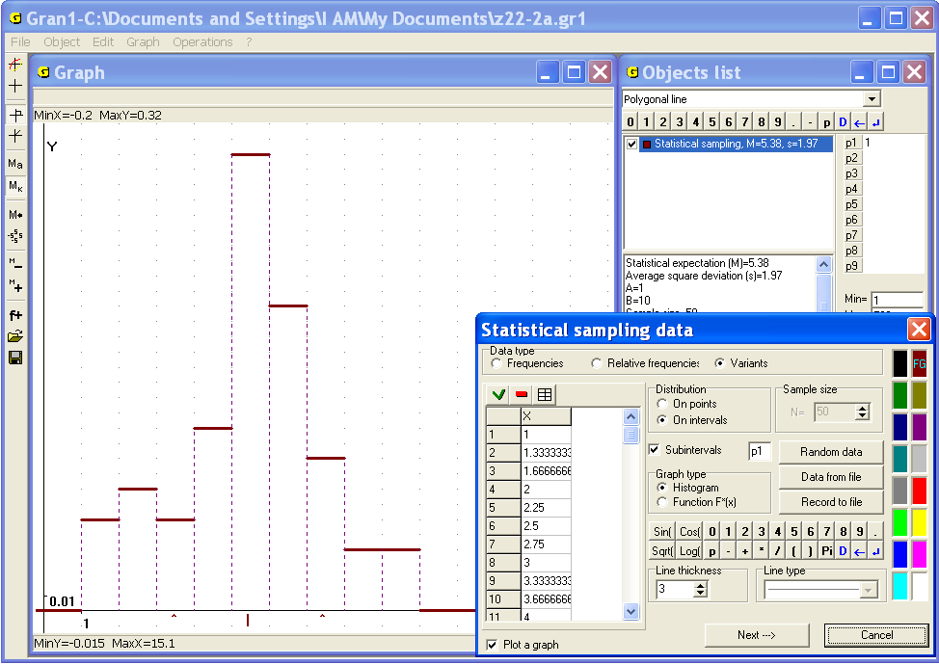
Fig. 22.6
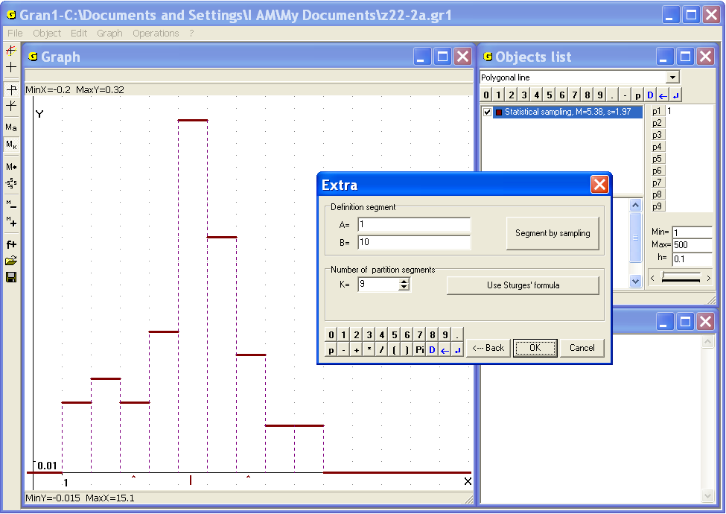
Fig. 22.7
However, if the on-intervals distribution is assigned by the variants, after pressing the button “Next-->” appears the auxiliary window “Extra” (Fig. 22.7). In this window one should input the segment that includes all entered values of the variants. Pressing the button “Segment by sampling” allows setting left and right endings of the segment and maximum and minimum variant values of the sample. Besides in the window one should input the quantity of partition segments (from 2 to 50), or use the button “Use Sturges' formula”, with the help of that will be calculated recommended quantity of partition segments, where – is the sample size. In necessity with the help of the button “<---Back” one can return to the mode of the sample data input.
A set of random values can be also entered with the help of the command of the program “Gran1” “Random Data” (Fig. 22.1 – Fig. 22.6). Answering the program requests, it is possible to input a desirable number of random values, distributed uniformly on the interval and further to analyze the on-intervals distribution of statistical probabilities, like before, to plot graphs of a density of the on-intervals distribution of statistical probabilities, the functions of the on-intervals distribution of statistical probabilities, to determine numeric characteristics of distribution of statistical probabilities etc.
The input of a sample can be realized from the existing text file as in the case of a polygonal line. For this purpose it is necessary to press the button “Data from file” during forming of a sample and then choose required file.
The data file is ordinary text file, where every line contains pair of values – variant and frequency, variant and relative frequency or only variant depending on the type of sample. The file can be created with the help of any text editor. The sample can be also written in the text file with the help of the button “Record to file” of the auxiliary window, that is used during entering of the sample data (Fig. 22.1 – 22.6).
The whole quantity of lines of the frequency table of the data input must be less than 10000. It should be kept in mind that the sum of relative frequencies must be equal to 1. Otherwise the message “Sum of relative frequencies <> 1!” and the value of current sum of relative frequencies are being displayed. After that the relative frequencies should be edited.
Taking into account size of the sample one can estimate the measure of probability of results represented in the table. The more is the sample size, the more probable are the results. Besides that the value of sample size is necessary for definition of accordance of the experimental data and various hypotheses about the real frequencies distribution (see §24).
In the window “Objects list” some characteristics of the sample are displayed: mathematical expectation (arithmetic average of observed values), statistical mean-square deviation, sample size, minimum and maximum values of variants, mode (for on-points distribution of statistical probabilities) or median (for on-intervals distribution), geometric mean, harmonic mean, quadratic mean, and also definition segment for on-intervals distribution (Fig. 22.8).
To change the sample one can use the command “Object / Modify”.
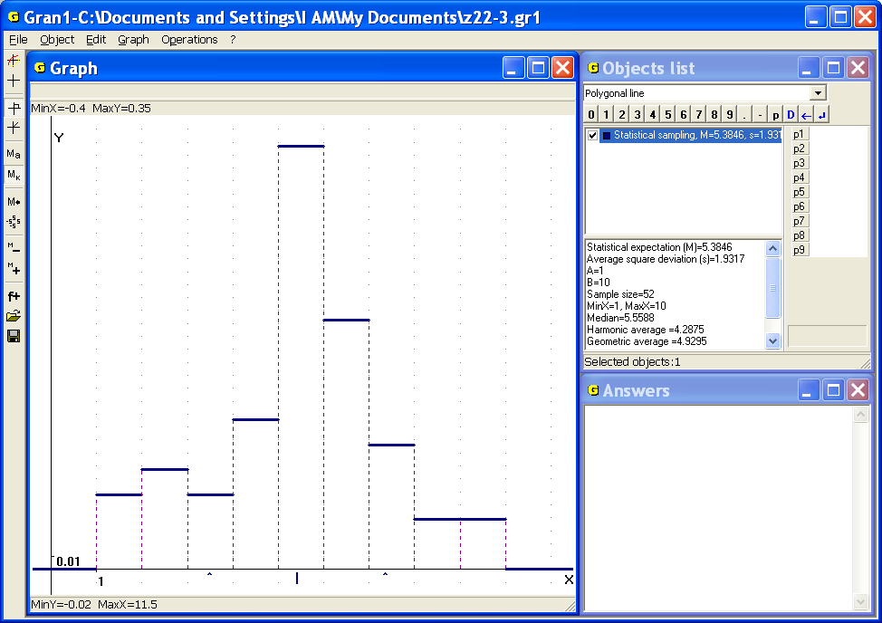
Fig. 22.8
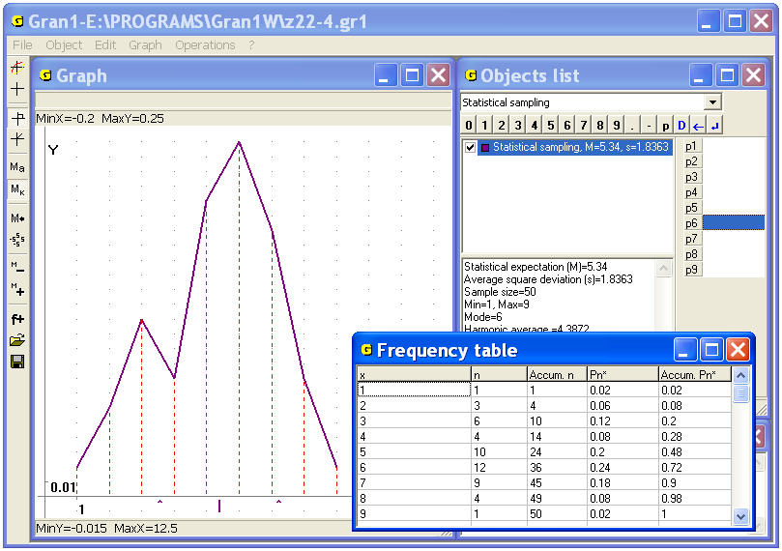
Fig. 22.9
In the case of analyzing on-points distribution of statistical probabilities on a finite set of points it is possible not only input new data or modify existing data, but also change data type (frequencies, relative frequencies or variants). This is impossible for the on-intervals distribution.
Use of the command “Object / Modify” can be also intended to change the graph type of statistical probabilities distribution: “polygon” – “distribution function” for on-points distribution or “histogram” – “distribution function” for interval one.
The command “Operations / Statistics / Frequency table” allows reviewing the frequency table of current sample. In the table five columns of numbers are presented (Fig. 22.9, 22.10):
- in the first column there are possible values of investigated magnitude (Fig. 22.9) or bounds of intervals of possible values of the magnitude (Fig. 22.10);
- in the second column there are frequencies of appearance of the values from the first column, or frequencies of falling into the intervals, whose bounds are indicated in the first column;
- in the third column there is the cumulative sum of all previous frequencies;
- in the fourth column there are relative frequencies of appearance of the values from the first column, or frequencies of falling into the intervals, whose bounds are indicated in the first column;
- in the fifth column there is the cumulative sum of all previous relative frequencies.
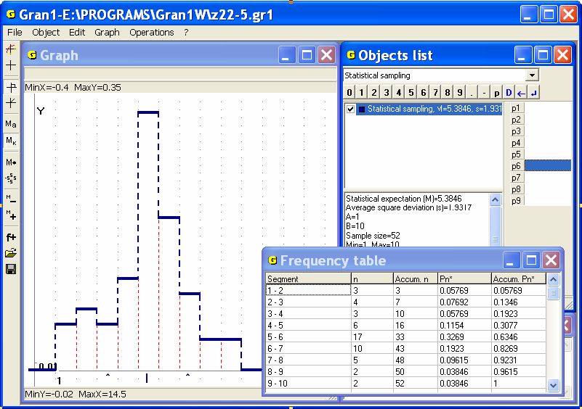
Fig. 22.10
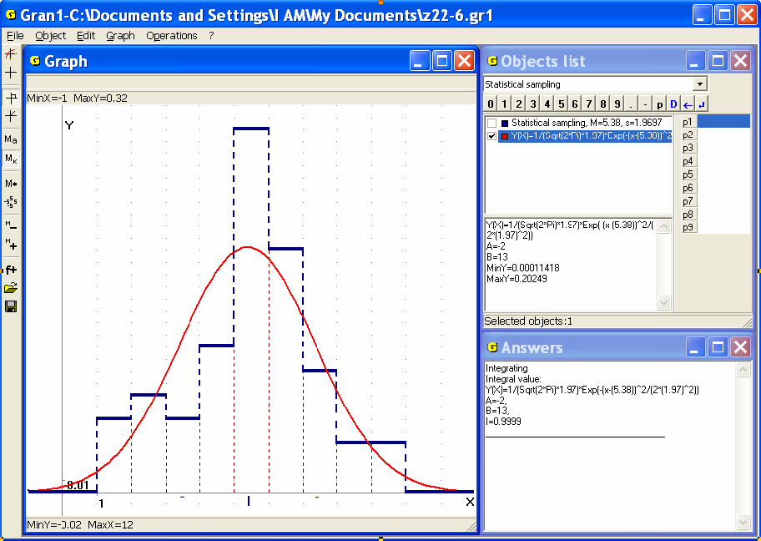
Fig. 22.11
The normal distribution of statistical probabilities is important in the theory of probability and mathematical statistics.
Normal distribution with the parameters and is continuous distribution of statistical probabilities on the set , whose density practically coincides with the function , where and are preassigned real numbers.
The program GRAN1 is provided with the command “Operations / Statistics / Normal distribution density by sampling”, use of that allows to plot for current on-intervals distribution of statistical probabilities a new object – function , where is statistical mathematical expectation, is statistical mean-square deviation for the sample (Fig. 22.11).

Questions for the self-checking
- What type of dependence should be assigned for statistical analysis of experimental data with the help of the program GRAN1?
- How to input the experimental data for their processing by GRAN1?
- Is it possible to use the program GRAN1 for separate investigation of on-points and on-intervals distribution of statistical probabilities (frequencies)?
- What are the differences between on-points and on-intervals distribution of statistical probabilities (frequencies)?
- How to input variants in the program GRAN1?
- What are the differences between inputting of variants in the case of on-points and on-intervals distribution of statistical probabilities?
- How to input frequencies in the program GRAN1?
- How to input relative frequencies (statistical probabilities) in the program GRAN1?
- What is the additional requirement for the relative frequencies (statistical probabilities) that are to be entered?
- What is the additional requirement for centers of the intervals during entering frequencies and statistical probabilities (relative frequencies) for the continuous distribution of statistical probabilities?
- How to enter data from a file?
- Are the structures of files for inputting variants and frequencies different?
- How to create a text file for input a sample data?
- How to review data in the file?
- How to edit the data?
- Is it possible to change the type of frequencies distribution during sample data modification?
- Is it possible to change the sample data type? Why?
- Is it possible to change the graph type of distribution of statistical probabilities?
- Is it possible to define type of distribution (on-points and on-intervals) by the frequency table?

Exercises for self-fulfillment
- Input from the keyboard in the working file of the program GRAN1 50 values taken at random from the interval [0, 1] to define on-points distribution of statistical probabilities.
- Execute ex. 1 for the case of on-intervals distribution of statistical probabilities. Set the number of partition segments with the help of the Sturges' formula.
- Input from the keyboard the following observed values of investigated magnitude and the corresponding frequencies:
 | –2 | –1 | 0 | 1 | 2 | 3 | 4 | 5 | 6 | 7
 | 2 | 8 | 14 | 20 | 37 | 42 | 18 | 16 | 5 | 1
- Execute ex. 3 for the case of continuous set of values .
- Input from the keyboard the series of distribution of relative frequencies of appearance of values of investigated magnitude, if it can take integer values from -5 to 5.
- Execute ex. 5 for the case of continuous set of values .
- Input the set of observed values from the file created before in the subfolder GRAN1.
- Input from the file, created before in the subfolder GRAN1, the series of distribution of frequencies of appearance of observed values of investigated magnitude.
- Input from the file, created before in the subfolder GRAN1, the series of distribution of relative frequencies of appearance of observed values of investigated magnitude.
- Input a set of 200 random values using the command “Random data” of the program GRAN1. Specify on-intervals distribution of statistical probabilities by 10 intervals.

§23. Graphical representation of the results of statistical analysis of experimental data
For graphical representation of polygons of distribution of statistical probabilities (frequency polygons), histograms, functions of distribution of statistical probabilities of appearance of values of the investigated magnitude, for obtaining some numeric characteristics of distribution of statistical probabilities etc one can use the command “Graph / Plot graph” (or corresponding item of the pop-up menu or the button on the toolbar).
While working with statistical samples the plotting of graphs is realized the same way as in the case of plotting graphs of any other types of dependencies.
Example
Suppose the distribution of frequencies of appearance of observed values of investigated magnitude is represented in the following table:
 | 1 | 2 | 3 | 4 | 5 | 6 | 7 | 8 | 9
 | 12 | 17 | 19 | 37 | 30 | 10 | 8 | 5 | 4
The values can be differently interpreted – as centers of the intervals of possible values of the observed magnitude, or as elements of the discrete set of possible values. Suppose that distribution of frequencies on continuous set is being explored and it is necessary to plot histogram of the on-intervals distribution of relative frequencies of observed values.
One should set the type of dependence “Statistical sampling” in the window “Objects list” and use the command “Object / Create”. In the new displayed window one should set the type of distribution “Intreval”, the data type – “Frequencies”, the graph type – “Histogram” and input the table of sample (Fig. 23.1).
As a result in the window “Objects list” in accordance with thee program displays the sign and some characteristics of the sample are being displayed (Fig. 23.2). After use the command “Graph / Plot graph” we obtain the histogram of on-intervals distribution of relative frequencies on the interval [0.5, 9.5), divided to 9 intervals of the length 1 centered in the points 1, 2, 3, ... , 8, 9 (Fig. 23.2).
In the window “Graph” the following characteristics of a sample can be also seen:
- the minimum and the maximum frequency values can be obtained with the help of the coordinates of corresponding points on the polygon or histogram;
- the relative frequencies of every possible value of discrete magnitude or falling into every interval can be defined with the help of the graph as corresponding ordinates of points (on the polygon or histogram);
- the cumulative relative frequencies for every variant can be defined with the help of graph of the function of distribution of statistical probabilities;
- the statistical mathematical expectation is marked on the abscissa axis by label “|”;
- the statistical mean-square deviation can be defined taking into account that on the abscissa axis the labels “^” mark the bounds of the segment .
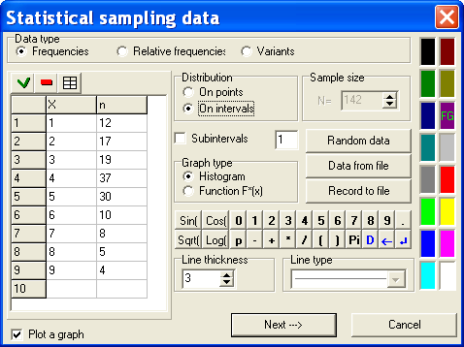
Fig. 23.1
On the axis the points with the abscissas (the center of dispersion, in the Fig. 23.2 this is the point on the axis with the abscissa ) and with the abscissas and (to the left and to the right of the center of dispersion is laid) are marked.
To make sure of the square under the histogram (over the axis ) equals to 1, one can use the command “Operations / Integrals / Integral...”. One can assign the integration limits , to get (Fig. 23.3).
To plot graph of the function of distribution of relative frequencies, one should use the command “Object / Modify...” and set the graph type “Function F*(x)”, after that plot graph of the object again. As a result we obtain graph of the function (Fig. 23.4).
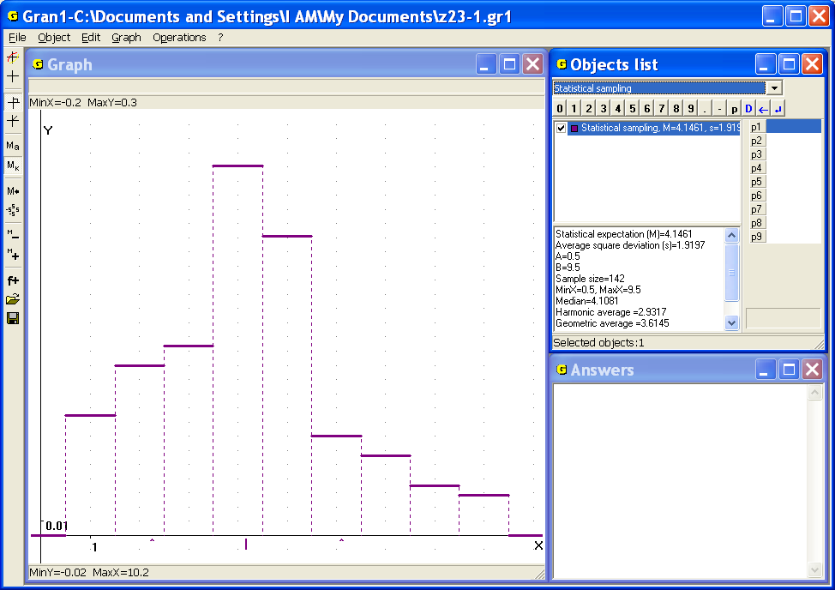
Fig. 23.2
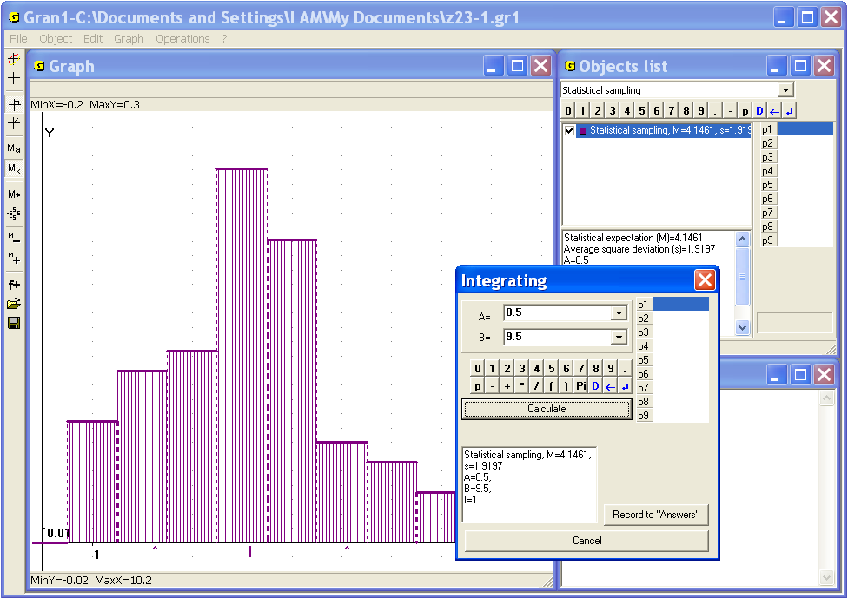
Fig. 23.3
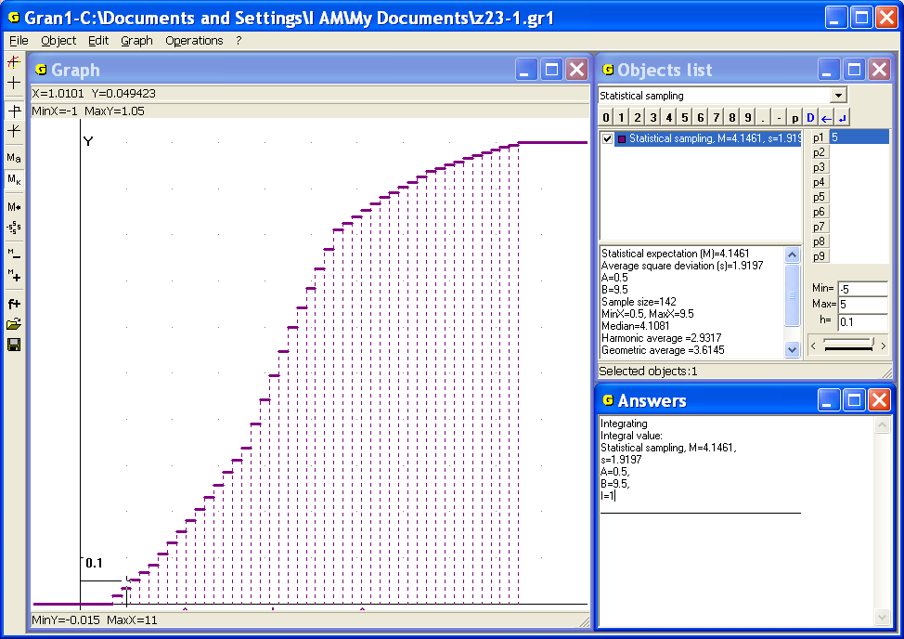
Fig. 23.4
The main numeric characteristics of the sample can be seen in the bottom of the window “Objects list”. The frequency table can be reviewed with the help of the command “Operations / Statistics / Frequency table” (Fig. 23.5).
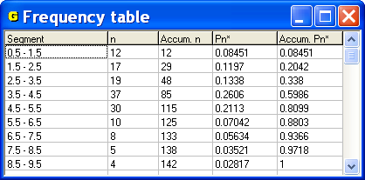
Fig. 23.5
Questions for self-checking
- How the following graphs can be plotted with the help of the program GRAN1:
The histogram of on-intervals distribution of statistical probabilities (relative frequencies) of appearance of observed values of investigated magnitude?
The function of on-points distribution of statistical probabilities on finite set of points?
The function of on-intervals distribution of statistical probabilities on limited continuous set of points?
The polygon of on-points distribution of statistical probabilities on finite set of points (the frequency polygon)?
- How to obtain the main numeric characteristics of investigated distribution of statistical probabilities with the help of GRAN1?
- How to define the maximum relative frequency and a corresponding value of investigated magnitude with the help of the frequency polygon?
- Is it necessary to make calculations before using commands of GRAN1 for statistical analysis of experimental data?
- How to define statistical probability (relative frequency) of falling of observed values of investigated magnitude into the interval ? Here and are correspondingly the lower and the upper bounds of the interval where the histogram is plotted. It is assumed that the intervals , where ordinates on the histogram are defined, are sufficiently small, and the interval consists of sufficiently big quantity of such intervals.
- For what type of distribution – on-points or on-intervals – the following graph is being plotted: the polygon of distribution of statistical probabilities (frequency polygon)? The histogram of distribution of statistical probabilities (relative frequencies)? The function of distribution of statistical probabilities (relative frequencies)?
Exercises for self-fulfillment
- Build the series of distribution and frequency polygon for the sample in that there contained deviations of results of measuring of distance between two points from true value of the distance: 50, 20, –10, 10, 20, –50, –20, –10, 40, –20, –30, –10, 10, 20, –40, 50, –10, 10, 50.
- For definition of error of measuring instrument 40 measuring are made. The following errors are fixed: –2.5; 3; 4; 2; 0.5; –1; 2; 4; –4; 0; –0.5; –0.5; 1; 0.5; 2.5; –0.5; 2; 1; –4; –2; –1; 1,5; 0.5; 4; –1.5; –1; 0; 1; 0; 1; –1.5; 1.5; 0.5; 0.5; –0.5; –1.5; –0.5; –1; 2; 0.5.
Build the on-intervals distribution of statistical probabilities and the histogram. Put the number of intervals equal to 8.
- 20 pupils taken at random have made high jumping. The following results are fixed: 137, 140, 143, 135, 142, 139, 141, 137, 142, 131, 145, 138, 141, 143, 130, 138, 140, 135, 137, 138.
Plot the series of distribution of statistical probabilities (relative frequencies), frequency polygon, function of distribution of statistical probabilities (relative frequencies), considering the set of values of investigated magnitude as finite.
- 10 7-th classes taken at random are observed. The quantity of excellent pupils in each class is: 5, 8, 3, 4, 5, 1, 6, 4, 2, 3.
Build the series of distribution of statistical probabilities (relative frequencies), frequency polygon, function of distribution of statistical probabilities (relative frequencies) for the investigated magnitude.
- 50 television sets are checked at random. The data of the checking are written in the table:

Error-free time, years | 0.5 | 1 | 1.5 | 2 | 2.5 | 3 | 3.5 | 4 | 4.5 | 5 | 5.5 | 6
Quantity of TV sets | 1 | 1 | 2 | 4 | 4 | 7 | 10 | 10 | 6 | 3 | 1 | 1
Build the function of on-intervals distribution of statistical probabilities and its graph. Consider points , , as centers of intervals.
- On 100 regions taken at random 100 saplings of fruit trees are planted. For the quantity of successful saplings the on-intervals distribution of statistical probabilities (relative frequencies) is built:
 | [0,10) | [10,20) | [20,30) | [30,40) | [40,50)
 | 0.05 | 0.08 | 0.12 | 0.14 | 0.15

 | [50,60) | [60,70) | [70,80) | [80,90) | [90,100]
 | 0.20 | 0.10 | 0.08 | 0.06 | 0.02
Define the value of function of on-intervals distribution of statistical probabilities (relative frequencies) in the endings of the intervals and plot its graph.
- On the each of 100 equivalent regions taken at random with equal volume of introduced fertilizers different harvest of grain are gathered. The results are written in the table:
Harvest (cent/ hect) | 14 | 15 | 16 | 17 | 18 | 19 | 20
Regions quantity | 6 | 10 | 18 | 28 | 20 | 12 | 6
Plot the frequency polygon. Define arithmetic average and mean-square deviation .
- Quantity of calls to office in one hour is random. During several days 1 hour-long periods between 21-00 and 24-00 was taken 10 times for observation. The following results are obtained:
№ | 1 | 2 | 3 | 4 | 5 | 6 | 7 | 8 | 9 | 10
Calls quantity | 280 | 320 | 315 | 300 | 285 | 270 | 300 | 330 | 310 | 290
Plot the frequency polygon. Define arithmetic average and mean-square deviation for the observed magnitude.
- The distance had been measured many times. The following results are obtained:
№ | 1 | 2 | 3 | 4 | 5 | 6 | 7 | 8 | 9 | 10
Measuring result | 41 | 39.5 | 40 | 40.2 | 39.9 | 40.2 | 39.8 | 40.1 | 40 | 39.9
Find numeric characteristics, of distribution of statistical probabilities (relative frequencies) on the set of observed values..
- For definition of the average time of error-free working of electrical appliance 100 devices were examined. The following series of distribution of statistical probabilities (relative frequencies) is obtained:
 | 1070 | 1120 | 1170 | 1220 | 1270 | 1320 | 1370 | 1420
 | 0.02 | 0.08 | 0.11 | 0.20 | 0.35 | 0.15 | 0.06 | 0.03
Plot the histogram and the function of on-intervals distribution of statistical probabilities (relative frequencies). Consider given values as centers of the intervals. Find numeric characteristics ,.

§24. Definition of accordance of observed data with hypotheses of frequencies distributions
In practice it is often necessary to define whether statistical data are in accord with the hypothesis that indeed a distribution of probabilities is described by density , i.e. that function can be approximately replaced by some non-negative function such that and for any , the value
will coincide with the value with sufficient accuracy, and the function tabular defined in such way can be approximately described by some analytic expression . Or to solve the problem of coordination between the statistical data and the hypothesis that on-points distribution of probabilities has preassigned (hypothetic) form.
One of the criteria of checking of hypothesis that function sufficiently well approximates function , is so-called Pearson criterion.
According to the criterion for all intervals , (), for values the approximations should be found by the formula , then the value should be estimated: , where are “weight” coefficients of the values , – the sample size.
The value is called the observed value (experimental).
However in various series of observations of a certain magnitude one could obtain different values . If the quantity of the series is very large, for the magnitude one can plot the functions and , analogous to the functions and , considered before, and in such way (for example, with the help of the function ) define, at what value the relative frequency of falling observed values of the magnitude into the interval will take the preassigned value :
, .
If equals, for example, 0.99, then the relative frequency of falling the values on the right of the value equals 0.01, i.e. falling the value on the right of the value can be considered practically impossible. Note, if the number of tests is very large, the average result of all the tests becomes predictable in quite precise bounds with sufficient certainty. Thus, if the observed value is more than , then the result should be considered practically impossible (improbable), and the hypothesis that the function is correct approximation of the function , should be rejected without risk of significant error, because in 99 cases of 100 the value is less than the value , if indeed correctly describes the distribution of statistical probabilities at very large number of tests.
The number is called significance level of the estimate . The values can be found in special tables, plotted for the magnitude . By these values and also preassigned significance level and number of the intervals it is possible to find the corresponding value . Sometimes is also called theoretical value of the estimate and labeled . Thus after calculation of and definition of , that corresponds to the preassigned significance level , one should compare and . If , then the hypothesis that the function is correct approximation of the function , should be rejected, because it does not correspond to the results of observations. If , then it is considered that the hypothesis does not contradict to the experimental data and there is no reason to reject it.
In the program GRAN1 it is provided checking the hypothesis about correctness of replacement the function by the function by the Pearson criterion. For this purpose the command “Operations /Statistics / Pearson criterion…” is used.
In the case of using the command in the window “Objects list” the explicit dependence and the sample must be marked by the check-box (or two samples that should be compared). In the case of other number of marked dependencies in the window “Objects list” the command “Operations /Statistics / Pearson criterion…” is inaccessible.
The domain of function must contain the domain of sample variants.
Use of the Pearson criterion allows to compare density of on-intervals distribution of statistical probabilities and function , two densities of on-intervals distributions of statistical probabilities for the samples, where variants has the same bounds (definition segments of the samples coincide), on-points hypothetic and experimental distributions assigned on the same finite set of possible values of investigated magnitude.
In the case of using the command “Operations /Statistics / Pearson criterion…” for comparison of the density of on-intervals distribution of statistical probabilities and the function according to the program two conditions are being checked:
The segment , where the hypothetic function is defined, must include the bounds and , , , where variants of the sample are being changed.
The following condition must be met: .
If the first condition is not met, in the window “Graph” the message “Definition segments mismatch!” is displayed. It means that the segment of function definition should be changed so that must be . For this purpose the command “Object / Modify” is used.
If the second condition is not met, the message “Integral on ”, and value of integral of the function on the segment are displayed.
Analogous messages are displayed in the case of attempt to compare by the Pearson criterion two on-intervals distributions with different definition segments, or two on-points distributions with different sets of possible values, or to compare on-points and on-intervals distributions.
If both the conditions and are met, the auxiliary window “Pearson criterion” is displayed (Fig. 24.1, 24.2). In the window one should point out, what of the previously defined objects ( from the object list) will be considered as hypothetic frequency distribution and what object describes statistical data. If the distribution density of statistical probabilities is to be compared with the function , the function is automatically chosen as hypothetic (Fig. 24.1). If two distribution densities of statistical probabilities should be compared, it is necessary to determine what is hypothetic and what is experimental one (Fig. 24.2).
In the window one should also assign the quantity of intervals for the experimental sample . It is necessary to assign freedom degrees quantity. It is recommended in the case of hypothesis of normal distribution of statistical probabilities to assign freedom degrees quantity , and in other cases . But other number may be assigned as well.
Besides one should set the significance level , for that will be defined. By default the value 0.95 is offered. The value also can be chosen from the list.
After pressing the button “ОК” in the window “Answers” one can see the message with significance level, freedom degrees quantity, values and , and message whether the hypothesis is confirmed or not (Fig. 24.3, 24.4).
If the hypothesis that the function correctly approximates the function , or that two samples belong to the same general population (two functions are compared), is not coordinated with statistical data, in the window “Answers” one can see the message “Hypothesis is not confirmed” (Fig. 24.3). If the hypothesis is coordinated with statistical data, in the window “Answers” one can see the message “Hypothesis is confirmed” (Fig. 24.4).
Note, a certain hypothesis could be confirmed or not depending on the significance level or the sample size. In the case of large sample size the observed frequency distribution should little differ from the hypothetic in the mentioned sense. Otherwise the hypothesis of correctness of approximation of the function by the function will not be confirmed.
Similarly to the previous, one can check the hypothesis that on-points distribution of statistical probabilities on finite set at very large has the form
…
…
where , (Fig. 24.5).
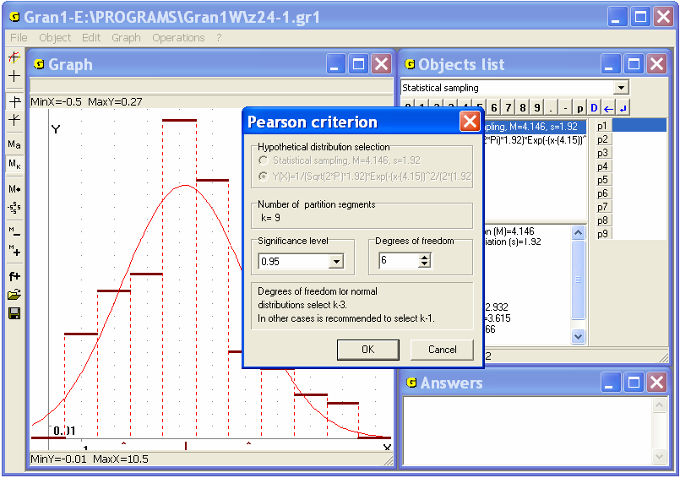
Fig. 24.1
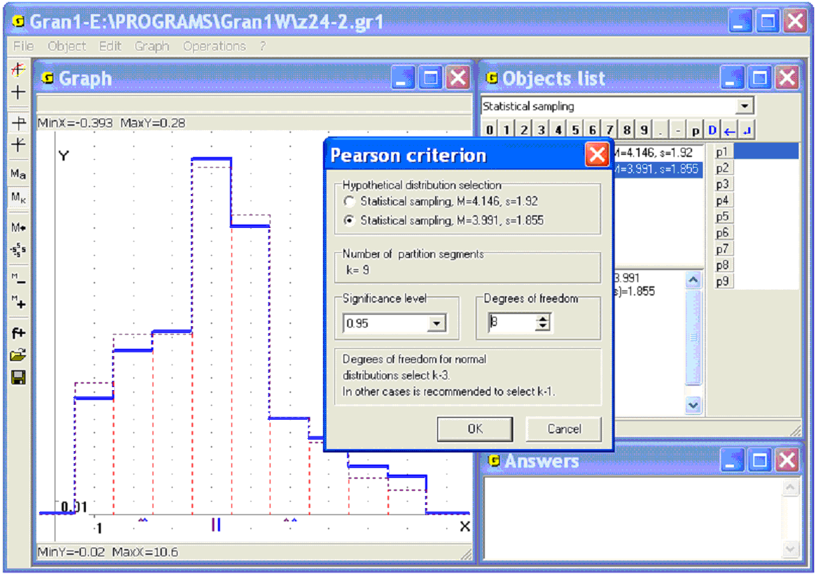
Fig. 24.2
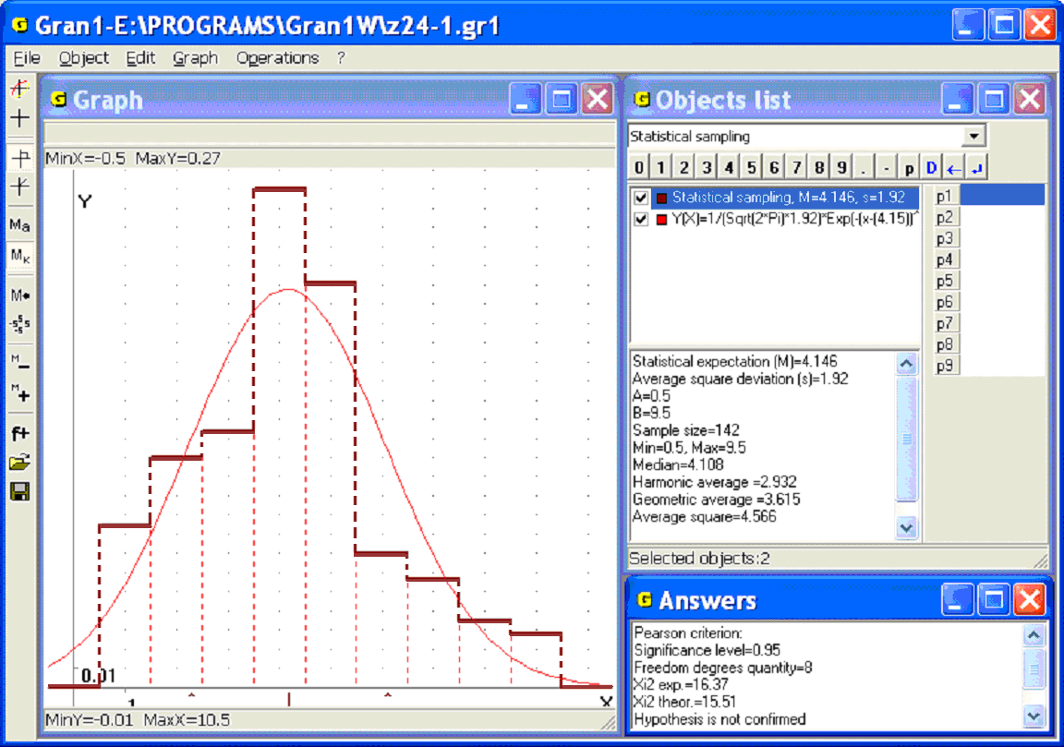
Fig. 24.3
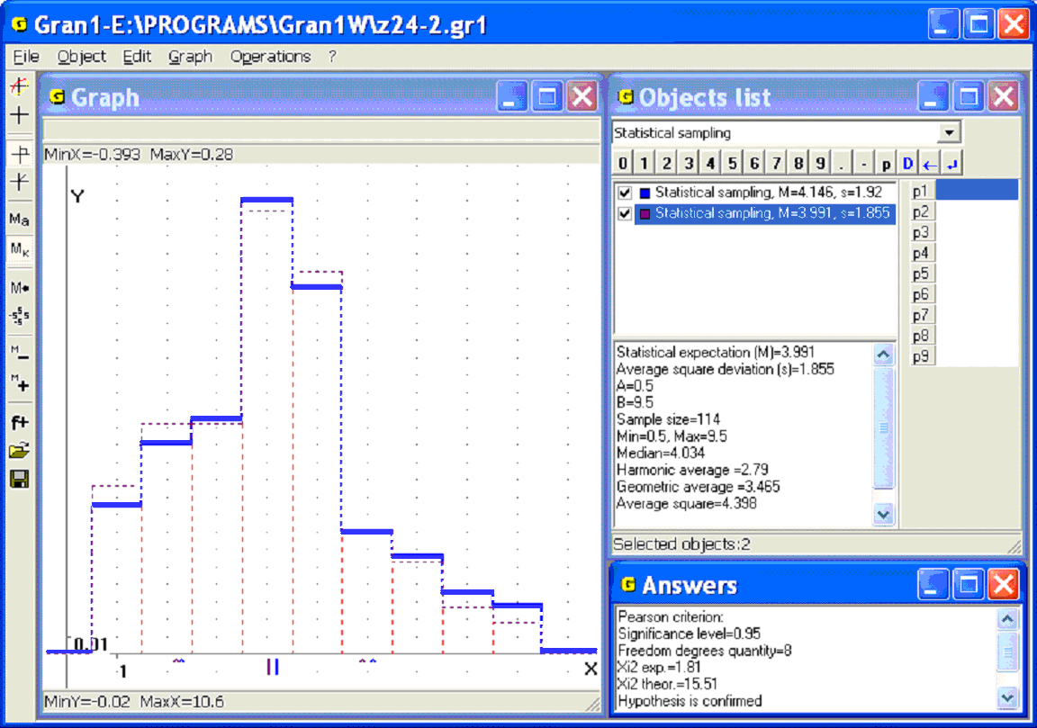
Fig. 24.4
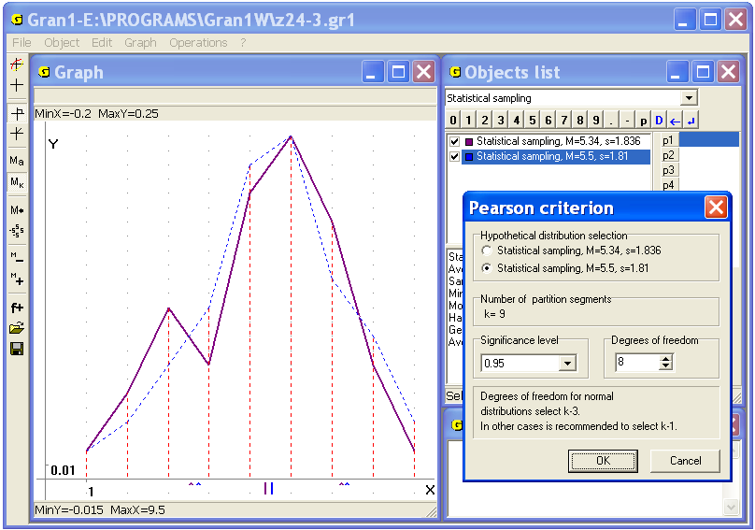
Fig. 24.5
The proximity of such hypothetic on-points distribution of statistical probabilities on finite set of points and the experimental distribution at certain number of tests
…
…
is estimated like before with the help of the value :
.
Further, like previously, the value (critical) is defined at preassigned quantity of freedom degrees and significance level , then the values and are compared. If it is found , then it is considered that the hypothesis that at very high the distribution of statistical probability will have a presumed (hypothetic) form, contradicts with experimental data at concrete .
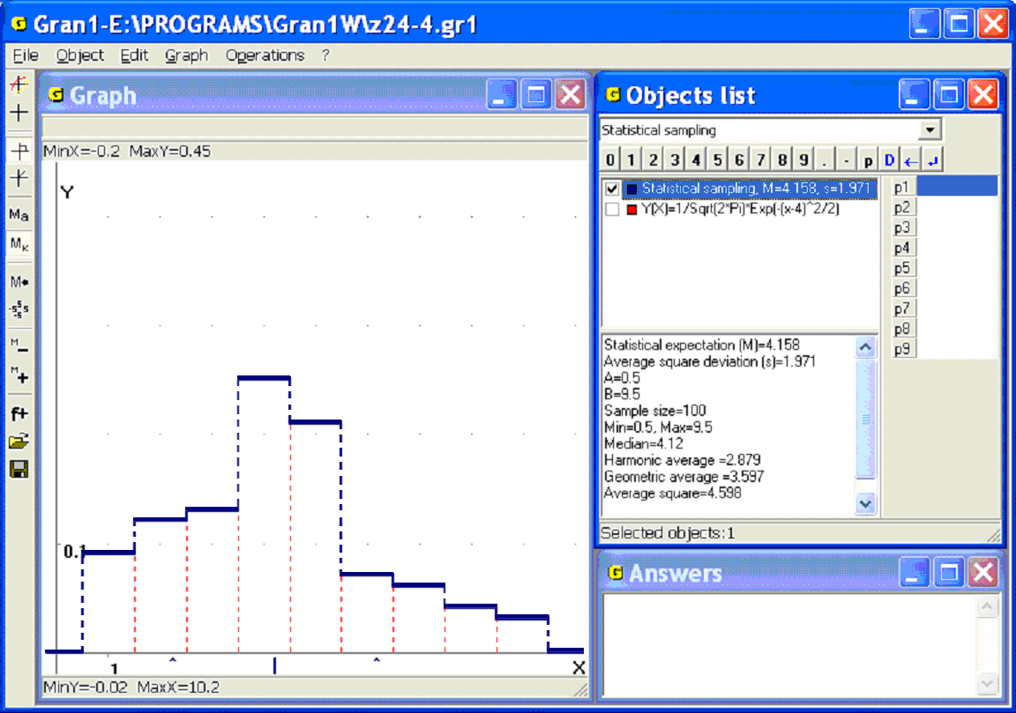
Fig. 24.6
Examples
1. Suppose it is necessary to check the hypothesis about correctness of replacement of the function , whose graph is shown in the Fig. 24.6, by the function of the form , defined on the interval . Firstly put , , , and plot graphs of dependencies and (Fig. 24.7). Then use the command “Operations / Statistics / Pearson criterion...”. As a result the message “Definition segments mismatch!” is displayed (Fig. 24.8).
Then choose the function , put , , , . Now the definition segment [–3, 11] of the function includes the definition segment [0.5; 9.5] of the function and with sufficient accuracy (Fig. 24.9). As a result of usage the
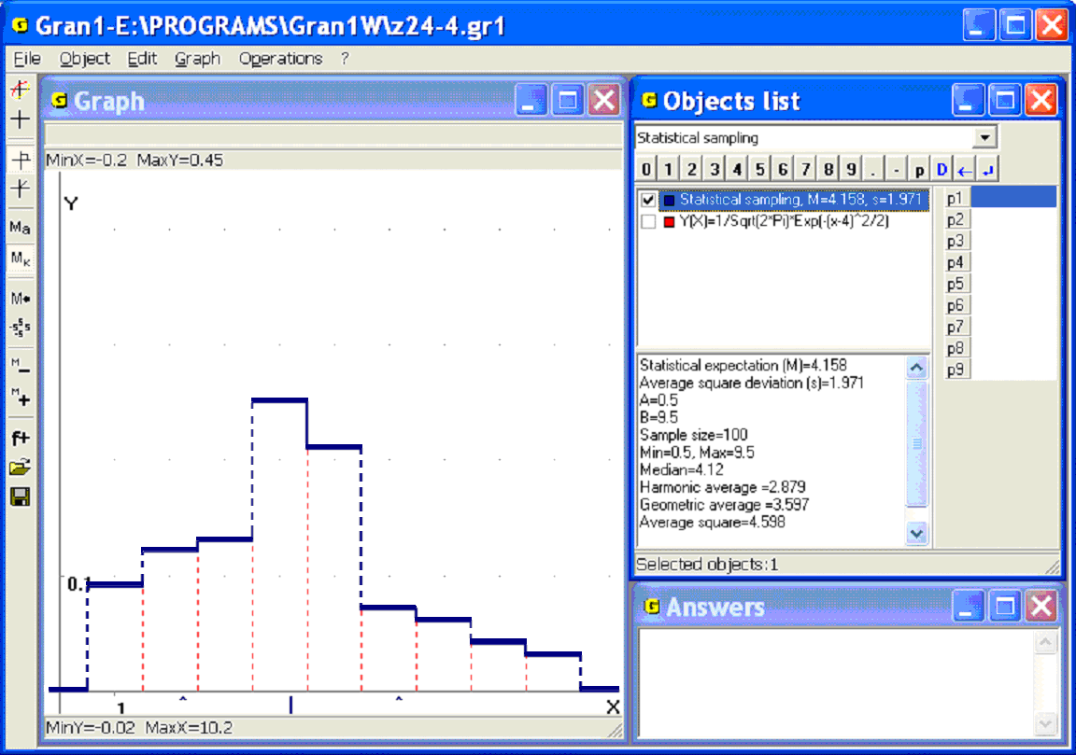
Fig. 24.7
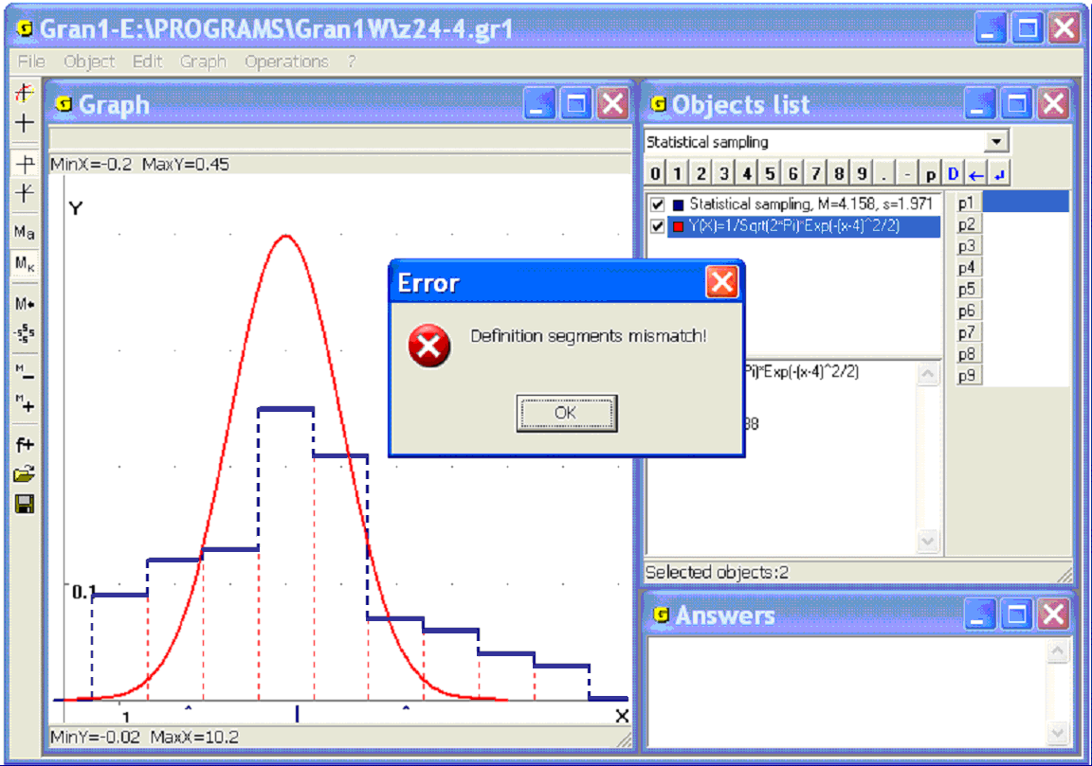
Fig. 24.8
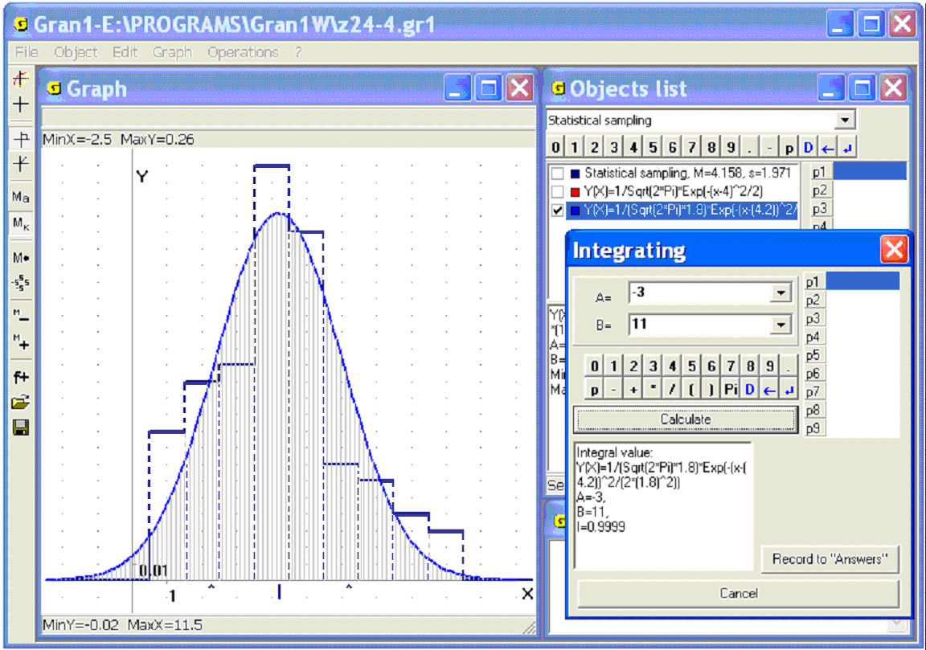
Fig. 24.9
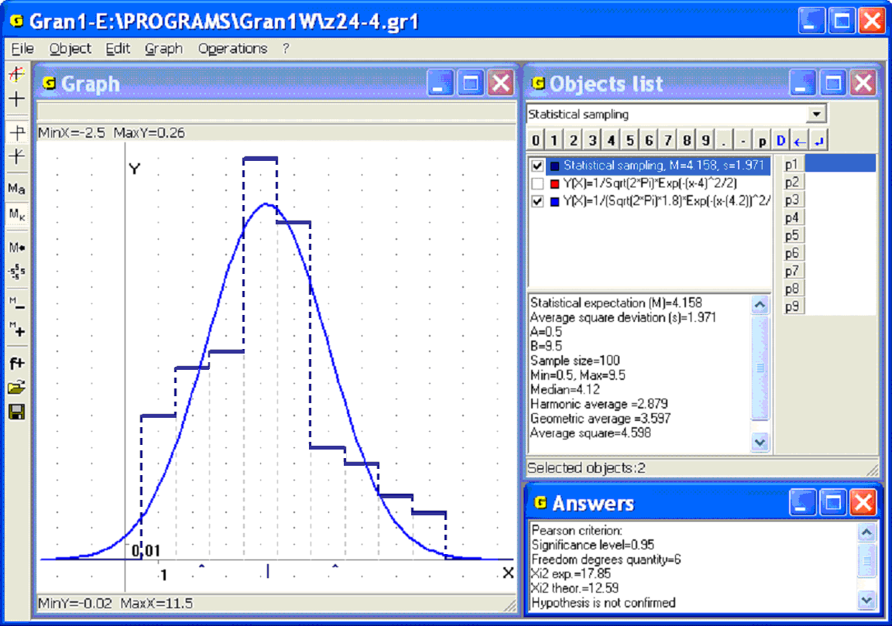
Fig. 24.10
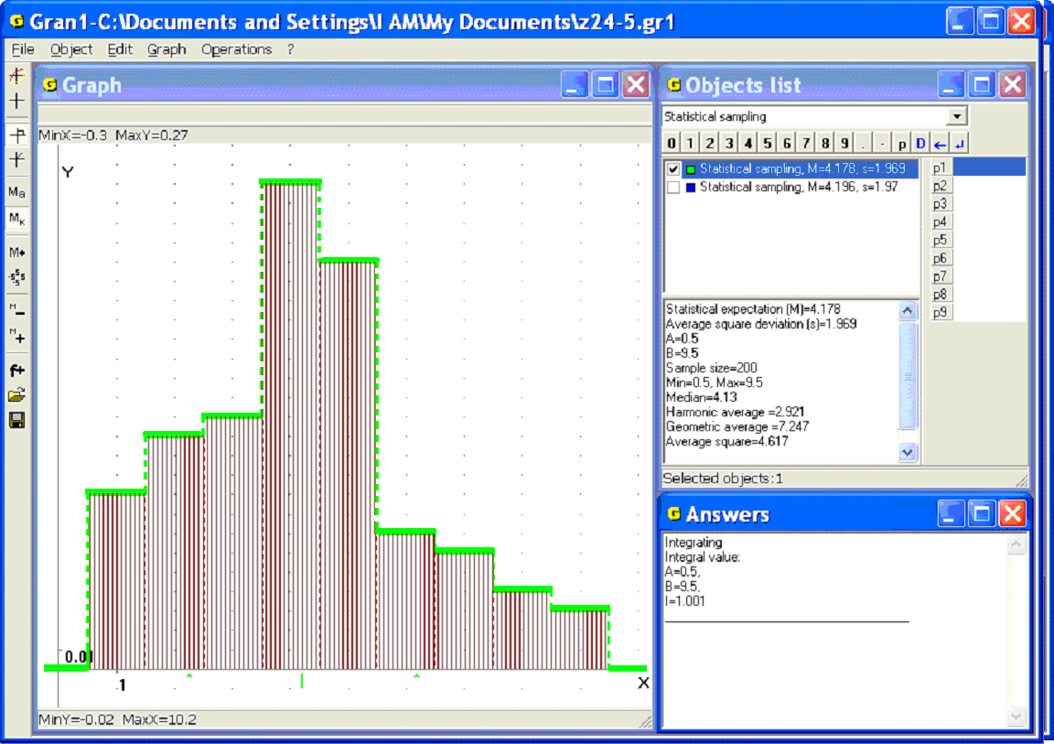
Fig. 24.11
command “Operations / Statistics/ Pearson criterion” instead messages about mismatch of definition segments or that the integral is not equal to 1 one can see the window “Pearson criterion”, where it is necessary to assign significance level and freedom degrees quantity. Choose and set , to get the result in the window “Answers” (Fig. 24.10):
,
.
The hypothesis is not confirmed.
2. Two samples are taken from a certain file with a list of variants and relative frequencies. The volume of one of them is assigned as “N=200”, of the other – “N=1000”. Compare the samples by the Pearson criterion.
Compare Fig. 24.11 and 24.12 to see that in general the numeric characteristics of the samples coincide, and the graphs superimposed on each other.
This time the hypothesis, that the function can be correctly replaced by itself, is doubtless. This obvious result is also confirmed by the Pearson criterion (Fig. 24.13).
3. Gambling cube was tossed 150 times. The result was written in the following of number of spots that had dropped on the sides of the cube:
 | 1 | 2 | 3 | 4 | 5 | 6
 | 14 | 23 | 24 | 22 | 21 | 46
Check by the Pearson criterion the hypothesis that at very large quantity of tests the discrete distribution of statistical probabilities will have the form
 | 1 | 2 | 3 | 4 | 5 | 6
 | 0.1 | 0.15 | 0.15 | 0.15 | 0.15 | 0.3
Enter in the program two samples: the first is defined by frequencies, the second – by relative frequencies. Put the number of elements of the second sample “N=10000”. Use the command “Operations / Statistics / Pearson criterion…”, set significance level and freedom degrees quantity . As a result the message about confirmation of the hypothesis will be displayed in the window “Answers” (Fig. 24.14).
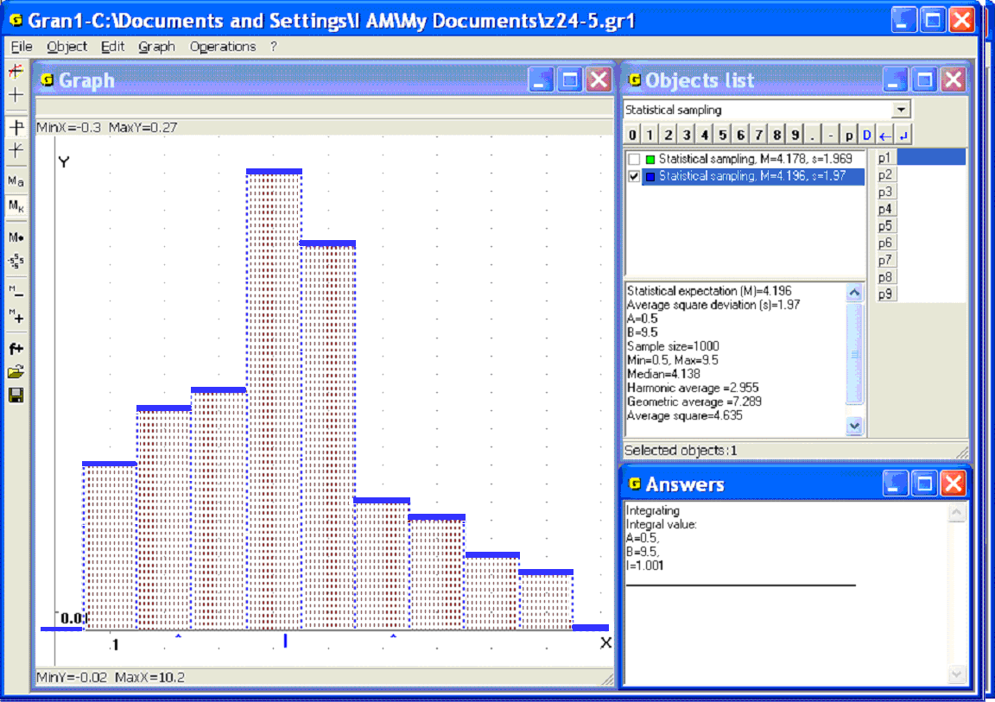
Fig. 24.12
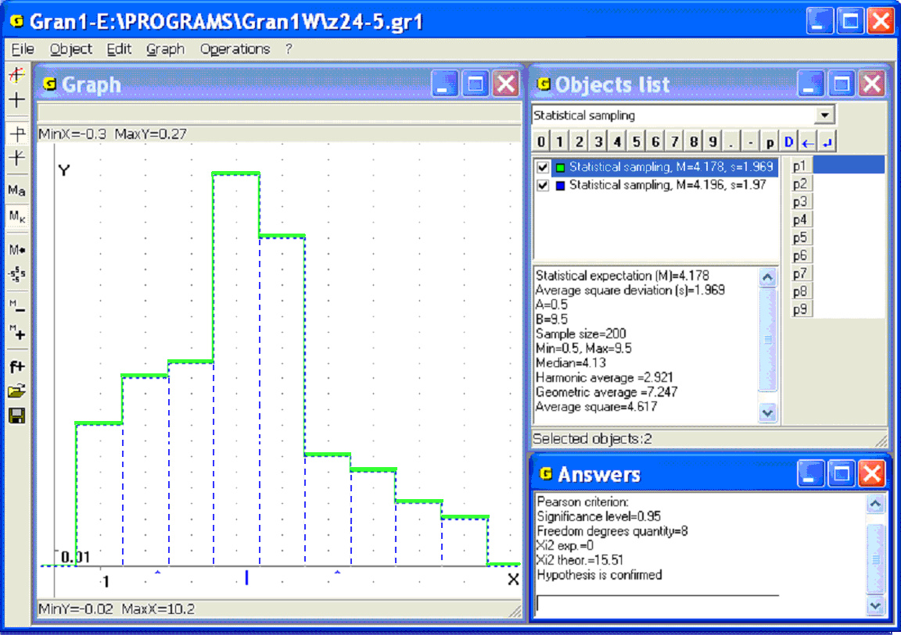
Fig. 24.13
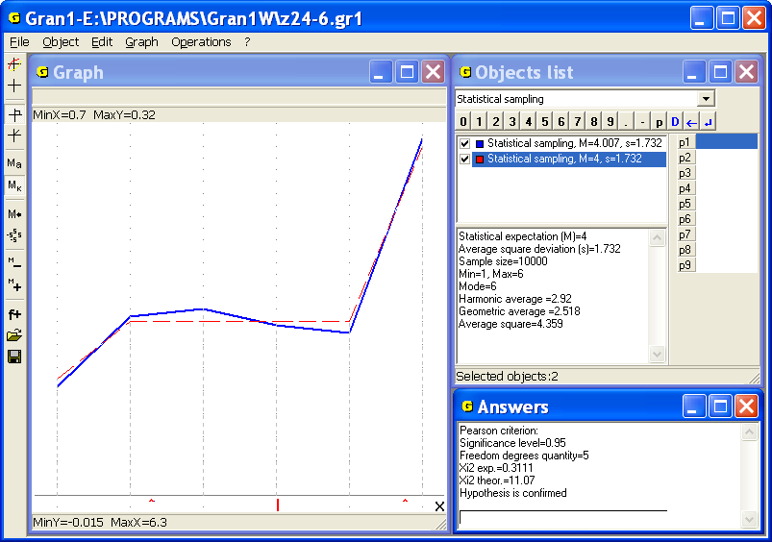
Fig. 24.14
Questions for self-checking
- How to find statistical probability (relative frequency) of falling values of investigated magnitude into the interval , if density of on-intervals distribution of statistical probabilities is known?
- What is the value ?
- How to find statistical probability (relative frequency) of falling values of investigated magnitude into the interval , if the function is known?
- What characterizes relatively to ?
- How to find , if is known?
- How to find in the case of interval frequency distribution, if is known?
- What are the values: , ?
- Can take negative values?
- Can take negative values?
- Can the function be decreasing if increases?
- Can the function be decreasing if increases?
- Is it necessary that , if ?
- How with the help of the Pearson criterion one can define correctness of the assumption that the function can be replaced by function , i.e. the distribution of probabilities is indeed described by the density ?
- What are the requirements for the function , that is offered to replace approximately the function ?
- How to estimate the proximity of the functions and by the Pearson criterion? How to calculate the measure of the proximity?
- What value is called observed value of measure of proximity of the functions and , that is estimated by the Pearson criterion?
- How to define critical value for preassigned significance level, on the right of which appearance of observed values is practically impossible?
- In what cases it is considered that the hypothesis of correctness of replacement of the function by the function by the Pearson criterion does not correspond to the experimental data?
- How to check by the Pearson criterion the hypothesis of correctness of replacement of the function by the function with the help of the program GRAN1?
- If several samples and several functions are entered, what of them will be analysed by the Pearson criterion at using the command “Operations / Statistics / Pearson criterion”?
- How to define the values and for preassigned significance level with the help of the program GRAN1?
- How to assign a significance level when using the command “Operations / Statistics / Pearson criterion” to solve the problem of correspondence of the hypothesis of correctness of approximate replacement of the function by the function to the experimental data?
- Can the hypothesis of correctness of replacement of the function by the same function be confirmed or not in different cases? What it depends on?
- How with the help of the Pearson criterion one can check the hypothesis that on-points distribution of statistical probabilities on the finite set of points at very large quantity of tests has a preassigned form?

Exercises for self-fulfillment
- The on-intervals distribution of statistical probabilities (relative frequencies) of appearance of observed values of investigated magnitude is given in the following table:
 | [–4, –3) | [–3, –2) | [–2, –1) | [–1, 0) | [0, 1) | [1, 2) | [2, 3) | [3, 4)
 | 0.002 | 0.019 | 0.144 | 0.335 | 0.321 | 0.156 | 0.022 | 0.001
Write analytic expressions for the functions and .
- Write the data in the working file (enter instead the abscissas of ending of each interval the abscissa of its center).
- Plot graphs of the functions and with the help of GRAN1.
- Plot the frequency polygon, where the centers of the intervals are the representatives of all the points of corresponding intervals. By this way transform the on-intervals frequency distribution into the on-points one.
- For the functions and define statistical probabilities (relative frequencies) of falling observed values of the investigated magnitude into the intervals: [–4, –3); [–3, –2); [–2, –1); [–1, 0); [0, 1); [0, 2); [0, 3); [1, 2); [1, 3); [2, 3), [0.25, 0.75); [2.5, 3.5).
- Define and of the distribution of statistical probabilities (relative frequencies) of the ex.5 with the help of GRAN1.
- Define by the Pearson criterion whether the on-intervals distribution of statistical probabilities from the ex.5 corresponds to the hypothesis that the function can be correctly replaced by the function , defined on the interval [–5, 5], when the sample size ; ; ; .
- Do tasks of the exercise 7 for the on-intervals distribution of statistical probabilities:
[–4, –3.5) | [–3.5, –3) | [–3, –2.5) | [–2.5, –2) | [–2, –1.5) | [–1.5, –1) | [–1, –0.5)
0.0001 | 0.0010 | 0.0047 | 0.0164 | 0.0440 | 0.0920 | 0.1500

[–0.5, 0) | [0, 0.5) | [0.5, 1) | [1, 1.5) | [1.5, 2) | [2, 2.5) | [2.5, 3) | [3, 3.5) | [3.5, 4)
0.1918 | 0.1918 | 0.1500 | 0.0920 | 0.0440 | 0.0164 | 0.0047 | 0.0010 | 0.0001
- Check by the Pearson criterion the hypothesis that at very large number of tests the discrete distribution of statistical probabilities will have the form
 | 0 | 1 | 2 | 3 | 4 | 5 | 6 | 7 | 8 | 9
 | 0.1 | 0.1 | 0.1 | 0.1 | 0.1 | 0.1 | 0.1 | 0.1 | 0.1 | 0.1
if as a result of 100 tests the following distribution is obtained
 | 0 | 1 | 2 | 3 | 4 | 5 | 6 | 7 | 8 | 9
 | 0.08 | 0.12 | 0.05 | 0.10 | 0.16 | 0.06 | 0.09 | 0.11 | 0.15 | 0.08

Bibliography
- М.І. Жалдак. Комп’ютер на уроках математики: Посібник для вчителів. – Київ: Техніка, 1997. – 303 с.: іл.
- М.І. Жалдак, Ю.В. Горошко, Є.Ф. Вінниченко. Математика з комп’ютером: посібник для вчителів. – К.: РННЦ «ДІНІТ». – 2004. – 255 с.
- М.І. Жалдак., Н.М. Кузьміна, Г.О. Міхалін. Теорія ймовірностей і математична статистика. Підручник для студентів фізико-математичних та інформатичних спеціальностей педагогічних університетів. Видання 3-тє, перероблене і доповнене. – Київ: НПУ імені М.П. Драгоманова. 2015. – 705 с.
Contents
Preface 3
§1. Start of working with the program.
Use of services of the program 7
§2. Data input 12
§3. Coordinate plane. Rectangular and polar coordinates 20
§4. Polygonal line. Length of a polygonal line 26
§5. Transformations of a polygonal line 36
§6. Polygon area. Polygon angles 44
§7. The simplest planimetric problems.
Calculation of triangles 52
§8. Plotting graphs of dependencies. Evaluation of
expressions 76
§9. Implicit dependencies 89
§10. Inverse dependencies and their graphs 99
§11. Parametric definition of dependencies 106
§12. Dependencies in the polar coordinates 114
§13. Tabular-defined functions and their approximation
by polynomials 121
§14. Graphical solution of equations and systems of equations 132
§15. Graphical solution of inequalities and systems of inequalities 155
§16. Finding of maximum and minimum values of functions
on given set of points 163
§17. Plotting secants and tangents to graphs of functions 174
§18. Calculation of definite integrals 182
§19. Calculation the arc length of a curve 197
§20. Calculation of volumes and surface areas of solids of rotation 202
§21. The elements of statistical analysis of experimental data.
The main concepts 218
§22. Input of the experimental data 266
§23. Graphical representation of the results of statistical analysis
of experimental data 277
§24. Definition of accordance of observed data
with hypotheses of frequencies distributions 284
Bibliography 303

